Business Studies 2004 Paper 7 Question 13

A software project has two phases, each with three tasks.
They are expected to take the following amount of effort:

Phase 1:
Analysis: 3 weeks
Code: 2 weeks
Test: 1 week
Phase 2:
Analysis: 1 week
Code: 2 weeks
Test: 3 weeks.

Within a phase a task cannot start until the previous task completes.
A task in Phase 2 cannot start until the corresponding task in phase 1 has completed.

Draw the PERT and Gannt charts for the project What is the minimum elapsed time? [5 marks]

Pert Chart: critical path in bold.
Minimum elapsed time is 10 weeks.

Phase 1
Phase 2
Task

Earliest StartEarliest FinishLetest Start Latest
Finish
Analysis: 3 w

0303
Code: 2w

3535
Test: 1w

5667
Analysis: 1w

3434
Test: 3w

710710
Code: 2w

5757
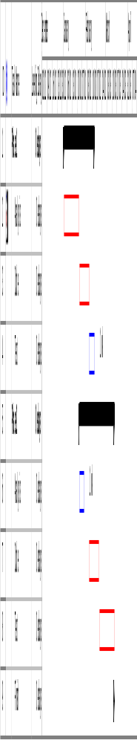
Two staff are assigned to the project, and analyst and a programmer. The analyst also acts as test engineer. How long will the project take with this staffing? [5 marks]
Since the analysis and test tasks do not clash in time, one person can complete both. There is no need for a levelling process. The project will thus take 10 weeks

The analyst is charged out at a fixed rate of £500/day and the programmer at £300/day, including overheads. How much should you quote for the project? [5 marks]
Analyst: 8 weeks = 40 days = £20K
Programmer: 4 weeks = 20 days = £6K

Total charge-out is £26K

The amount charged to the customer will depend on circumstances and the competitive position, and what experience tells about the accuracy of forecasts. Some have the standard practice of multiplying by 30% to 50% to allow for contingencies, etc. In the absence of other information some allowance is prudent, so answers in the range £30K to say £50K would be acceptable.

Explain how you would monitor such a project? How would you turn the result into a product? [5 Marks]

Regular meetings and milestones: The milestones are defined by the tasks in the project. Meetings to report progress can conveniently be held at some fixed time every week.
Good practice would include the use of a source control system such as CVS, with specifications, design documents, test procedures and code versions being controlled documents. A bug tracking database an project logbook should also be in place. Managerial time has not been allowed in the project as described, except as overhead.

Productisation involves considerable effort over the original development, often estimated as three times the original work. It includes

- Generalisation
  - Does the product work on all target systems?
    - Hardware variants/constraints
    - O/S variants
  - Internationalisation
    - Language, number, date and time formats
- Documentation
  - Installation, User Guide, Reference Manual, Help texts, examples, training
  - System manual, maintenance documentation
  - Conformance
- Legals
  - IPR generated (Copyright, trademark)
  - IPR used
  - Licence, contract, liability
- Packaging
  - Artwork, Box, Deliverables
- Manufacture
  - Reproduction, Manual printing, Stocking
  - Distribution set-up
- Marketing Materials
  - Leaflets, brochures, advertisements
    - Text, Artwork, approvals
- Testing
  - Usability
  - Market
  - Standards and approvals
- Maintenance
  - Organisation setup and training
  - Help desk - staff, facilities,, FAQs, training
  - Report forms, database and summaries

There then still remains the difficulty of marketing and selling the program, which can consume up to ten times the original effort.

