**Domain**: Flipkart.com

**Test1:**

* Get lowest price Product from Top Offers
  + 

**Test2:**

* Get Total Products from Top Offers

**Test 3:**

* Go to mobile
* In next page Set price range to 250000
* Select **Brand** RealMe
* Select Customer Rating 3* Above
* Select Ram 6GB & Above
* Select Internal Storage 64-127.9 GB
* Filter by Price Low to High
* Get Mobile Name and Price which is not **flipkart Assured**
* 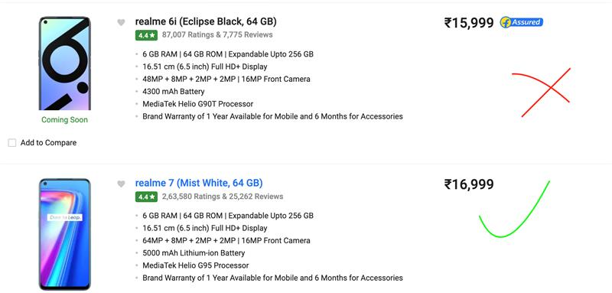

You need to create framework from scratch and implement **POM** with **pageFactory**. And keep all values as parameters. And these tests should be executed in **FF** and **Chrome** from **TestNG**.