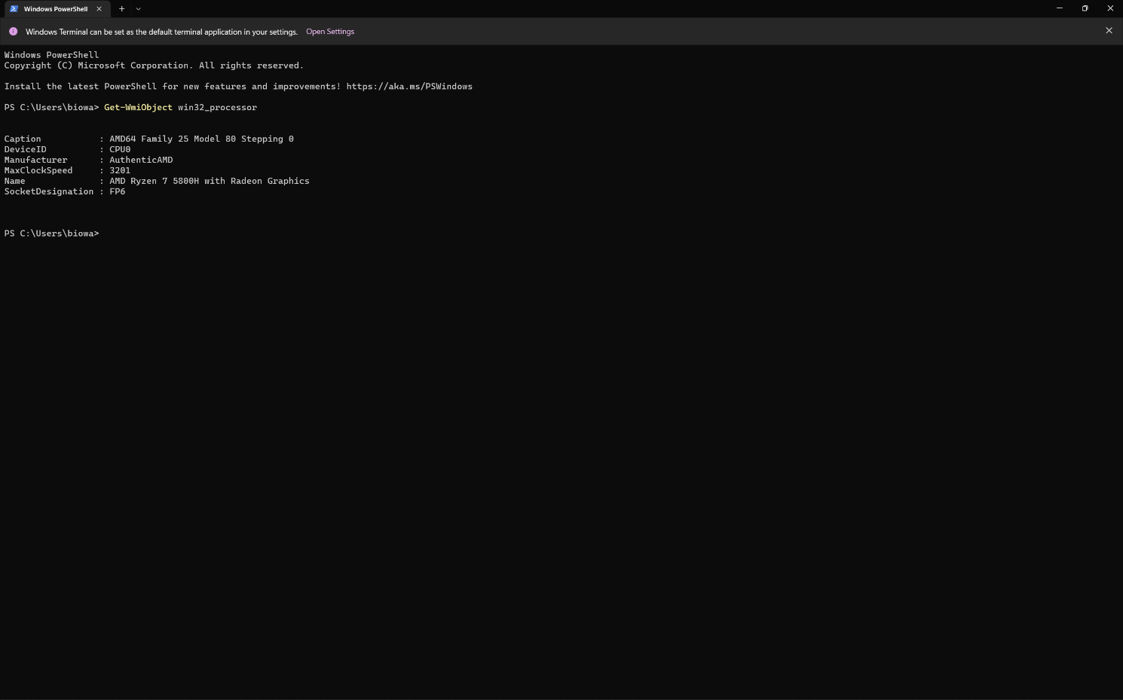By the looks of it this command line Gets the information of the processor though its more generic stuff rather then things like its core count threads, memory and power draw.