**Nba Rookies By Year, Average of Min, Grouped by Pts**

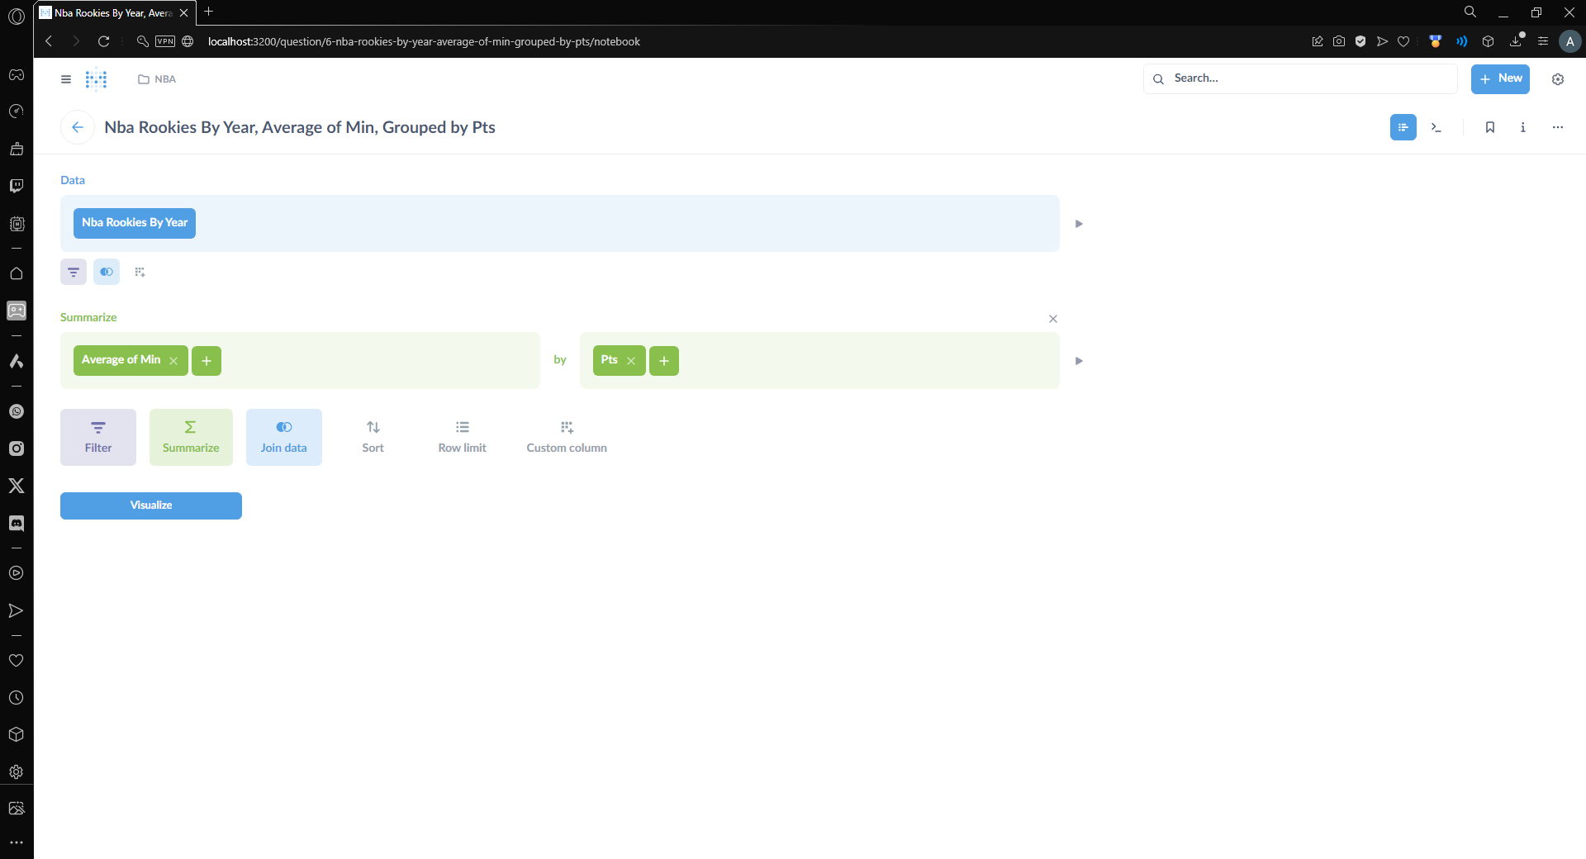

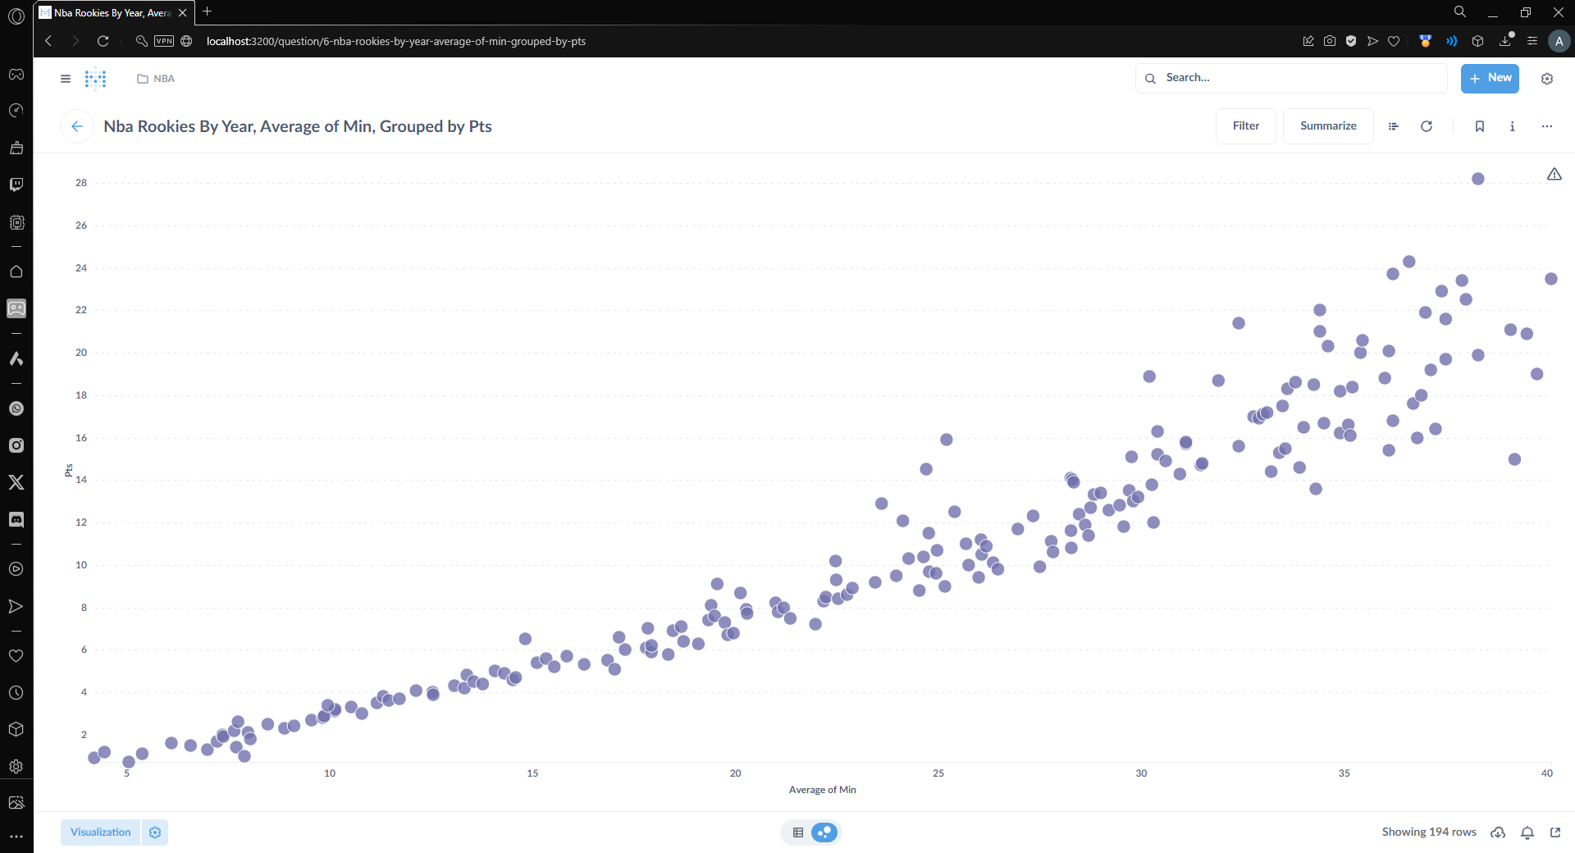

This shows on average the more minutes a rookie plays the more points they score with the points scored becoming more dispersed as the number of minutes goes up.

**SQL**

SELECT

"source"."pts" AS "pts",

AVG("source"."min") AS "avg"

FROM

(

SELECT

"PUBLIC"."nba_rookies_by_year_20240415064734"."_mb_row_id" AS "_mb_row_id",

"PUBLIC"."nba_rookies_by_year_20240415064734"."index" AS "index",

"PUBLIC"."nba_rookies_by_year_20240415064734"."name" AS "name",

"PUBLIC"."nba_rookies_by_year_20240415064734"."year_drafted" AS "year_drafted",

"PUBLIC"."nba_rookies_by_year_20240415064734"."gp" AS "gp",

"PUBLIC"."nba_rookies_by_year_20240415064734"."min" AS "min",

"PUBLIC"."nba_rookies_by_year_20240415064734"."pts" AS "pts",

"PUBLIC"."nba_rookies_by_year_20240415064734"."fgm" AS "fgm",

"PUBLIC"."nba_rookies_by_year_20240415064734"."fga" AS "fga",

"PUBLIC"."nba_rookies_by_year_20240415064734"."fg_" AS "fg_",

"PUBLIC"."nba_rookies_by_year_20240415064734"."3p_made" AS "3p_made",

"PUBLIC"."nba_rookies_by_year_20240415064734"."3pa" AS "3pa",

"PUBLIC"."nba_rookies_by_year_20240415064734"."3p_" AS "3p_",

"PUBLIC"."nba_rookies_by_year_20240415064734"."ftm" AS "ftm",

"PUBLIC"."nba_rookies_by_year_20240415064734"."fta" AS "fta",

"PUBLIC"."nba_rookies_by_year_20240415064734"."ft_" AS "ft_",

"PUBLIC"."nba_rookies_by_year_20240415064734"."oreb" AS "oreb",

"PUBLIC"."nba_rookies_by_year_20240415064734"."dreb" AS "dreb",

"PUBLIC"."nba_rookies_by_year_20240415064734"."reb" AS "reb",

"PUBLIC"."nba_rookies_by_year_20240415064734"."ast" AS "ast",

"PUBLIC"."nba_rookies_by_year_20240415064734"."stl" AS "stl",

"PUBLIC"."nba_rookies_by_year_20240415064734"."blk" AS "blk",

"PUBLIC"."nba_rookies_by_year_20240415064734"."tov" AS "tov",

"PUBLIC"."nba_rookies_by_year_20240415064734"."eff" AS "eff"

FROM

"PUBLIC"."nba_rookies_by_year_20240415064734"

) AS "source"

GROUP BY

"source"."pts"

ORDER BY

"source"."pts" ASC

**Nba Rookies By Year, Sum of 3p Made, Grouped by Year Drafted**

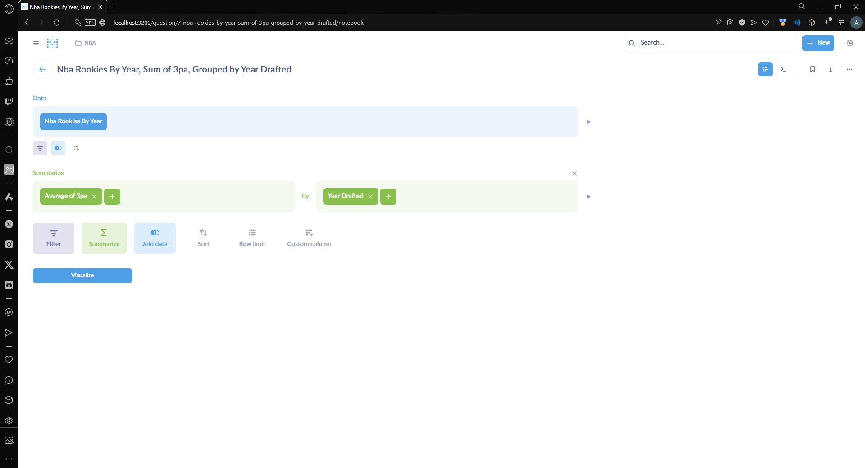

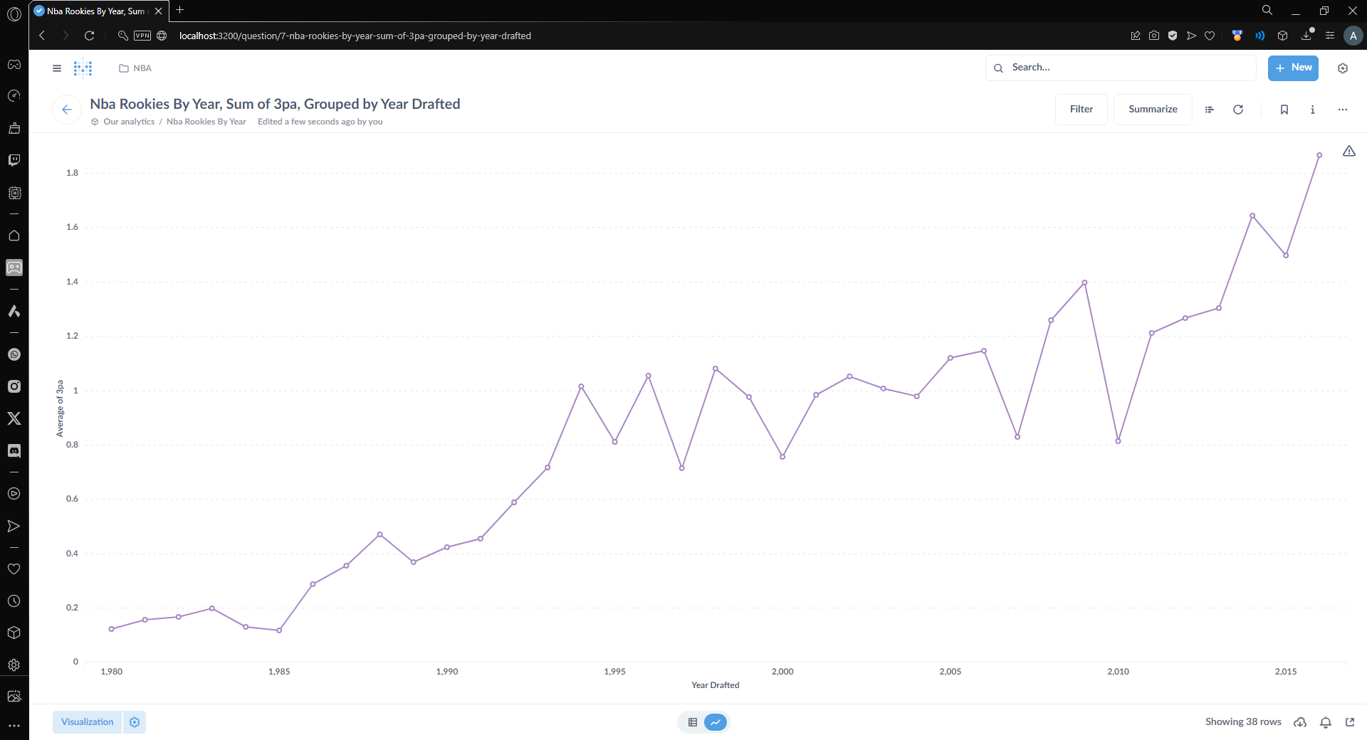

This line graph shows how the game has evolved over time with every year the amount of 3pt attempts has continued to increase. With this graph a trend can be easily seen with the amount of 3pt attempts increasing every year.

**SQL**

SELECT

"source"."year_drafted" AS "year_drafted",

AVG("source"."3pa") AS "avg"

FROM

(

SELECT

"PUBLIC"."nba_rookies_by_year_20240415064734"."_mb_row_id" AS "_mb_row_id",

"PUBLIC"."nba_rookies_by_year_20240415064734"."index" AS "index",

"PUBLIC"."nba_rookies_by_year_20240415064734"."name" AS "name",

"PUBLIC"."nba_rookies_by_year_20240415064734"."year_drafted" AS "year_drafted",

"PUBLIC"."nba_rookies_by_year_20240415064734"."gp" AS "gp",

"PUBLIC"."nba_rookies_by_year_20240415064734"."min" AS "min",

"PUBLIC"."nba_rookies_by_year_20240415064734"."pts" AS "pts",

"PUBLIC"."nba_rookies_by_year_20240415064734"."fgm" AS "fgm",

"PUBLIC"."nba_rookies_by_year_20240415064734"."fga" AS "fga",

"PUBLIC"."nba_rookies_by_year_20240415064734"."fg_" AS "fg_",

"PUBLIC"."nba_rookies_by_year_20240415064734"."3p_made" AS "3p_made",

"PUBLIC"."nba_rookies_by_year_20240415064734"."3pa" AS "3pa",

"PUBLIC"."nba_rookies_by_year_20240415064734"."3p_" AS "3p_",

"PUBLIC"."nba_rookies_by_year_20240415064734"."ftm" AS "ftm",

"PUBLIC"."nba_rookies_by_year_20240415064734"."fta" AS "fta",

"PUBLIC"."nba_rookies_by_year_20240415064734"."ft_" AS "ft_",

"PUBLIC"."nba_rookies_by_year_20240415064734"."oreb" AS "oreb",

"PUBLIC"."nba_rookies_by_year_20240415064734"."dreb" AS "dreb",

"PUBLIC"."nba_rookies_by_year_20240415064734"."reb" AS "reb",

"PUBLIC"."nba_rookies_by_year_20240415064734"."ast" AS "ast",

"PUBLIC"."nba_rookies_by_year_20240415064734"."stl" AS "stl",

"PUBLIC"."nba_rookies_by_year_20240415064734"."blk" AS "blk",

"PUBLIC"."nba_rookies_by_year_20240415064734"."tov" AS "tov",

"PUBLIC"."nba_rookies_by_year_20240415064734"."eff" AS "eff"

FROM

"PUBLIC"."nba_rookies_by_year_20240415064734"

) AS "source"

GROUP BY

"source"."year_drafted"

ORDER BY

"source"."year_drafted" ASC

**Nba Rookies By Year, Average of Eff, Grouped by Year Drafted**

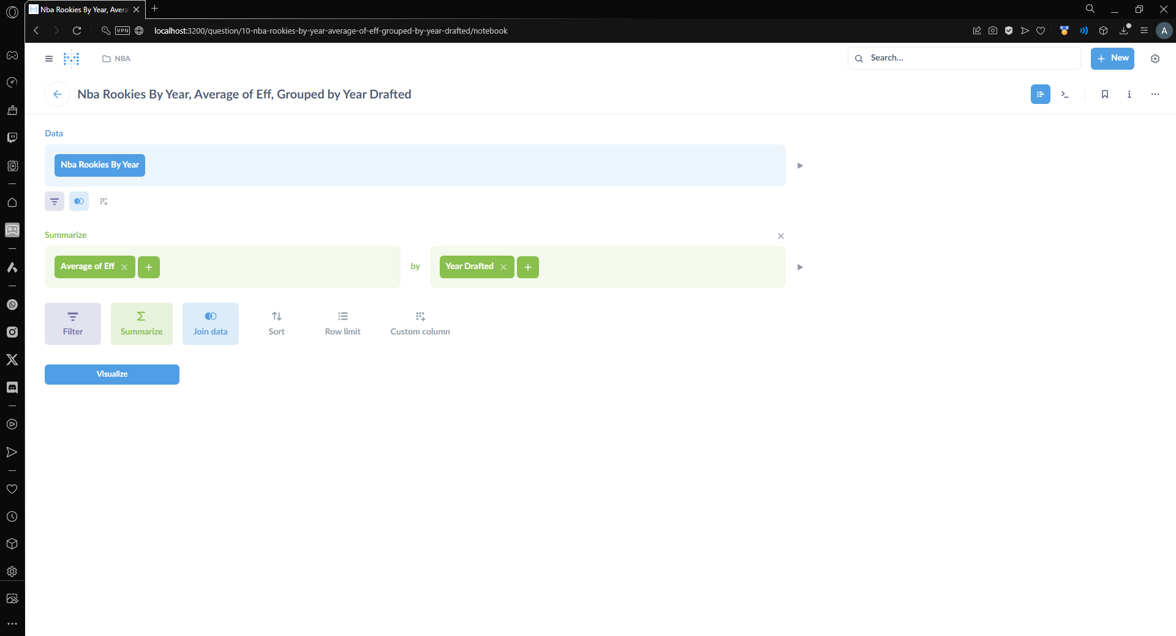

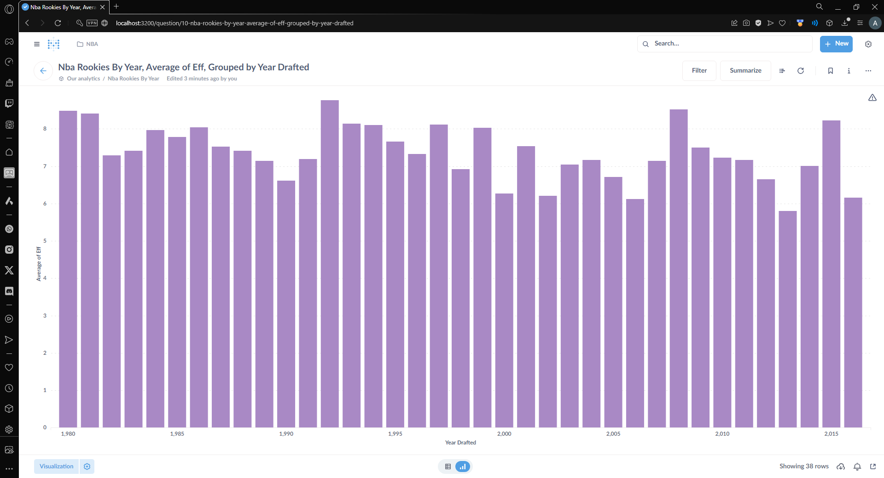

This bar graph shows how during the big draft classes where there were stars like Shaq, Kevin Durant, and Devin Booker the average efficiency of that year for the rookies is higher where as the weaker draft classes reflect a lower efficiency.

**SQL**

SELECT

"source"."year_drafted" AS "year_drafted",

AVG("source"."eff") AS "avg"

FROM

(

SELECT

"PUBLIC"."nba_rookies_by_year_20240415064734"."_mb_row_id" AS "_mb_row_id",

"PUBLIC"."nba_rookies_by_year_20240415064734"."index" AS "index",

"PUBLIC"."nba_rookies_by_year_20240415064734"."name" AS "name",

"PUBLIC"."nba_rookies_by_year_20240415064734"."year_drafted" AS "year_drafted",

"PUBLIC"."nba_rookies_by_year_20240415064734"."gp" AS "gp",

"PUBLIC"."nba_rookies_by_year_20240415064734"."min" AS "min",

"PUBLIC"."nba_rookies_by_year_20240415064734"."pts" AS "pts",

"PUBLIC"."nba_rookies_by_year_20240415064734"."fgm" AS "fgm",

"PUBLIC"."nba_rookies_by_year_20240415064734"."fga" AS "fga",

"PUBLIC"."nba_rookies_by_year_20240415064734"."fg_" AS "fg_",

"PUBLIC"."nba_rookies_by_year_20240415064734"."3p_made" AS "3p_made",

"PUBLIC"."nba_rookies_by_year_20240415064734"."3pa" AS "3pa",

"PUBLIC"."nba_rookies_by_year_20240415064734"."3p_" AS "3p_",

"PUBLIC"."nba_rookies_by_year_20240415064734"."ftm" AS "ftm",

"PUBLIC"."nba_rookies_by_year_20240415064734"."fta" AS "fta",

"PUBLIC"."nba_rookies_by_year_20240415064734"."ft_" AS "ft_",

"PUBLIC"."nba_rookies_by_year_20240415064734"."oreb" AS "oreb",

"PUBLIC"."nba_rookies_by_year_20240415064734"."dreb" AS "dreb",

"PUBLIC"."nba_rookies_by_year_20240415064734"."reb" AS "reb",

"PUBLIC"."nba_rookies_by_year_20240415064734"."ast" AS "ast",

"PUBLIC"."nba_rookies_by_year_20240415064734"."stl" AS "stl",

"PUBLIC"."nba_rookies_by_year_20240415064734"."blk" AS "blk",

"PUBLIC"."nba_rookies_by_year_20240415064734"."tov" AS "tov",

"PUBLIC"."nba_rookies_by_year_20240415064734"."eff" AS "eff"

FROM

"PUBLIC"."nba_rookies_by_year_20240415064734"

) AS "source"

GROUP BY

"source"."year_drafted"

ORDER BY

"source"."year_drafted" ASC

**Nba Rookies By Year, Sum of Fgm and Average of 3p Made, Grouped by Year Drafted**

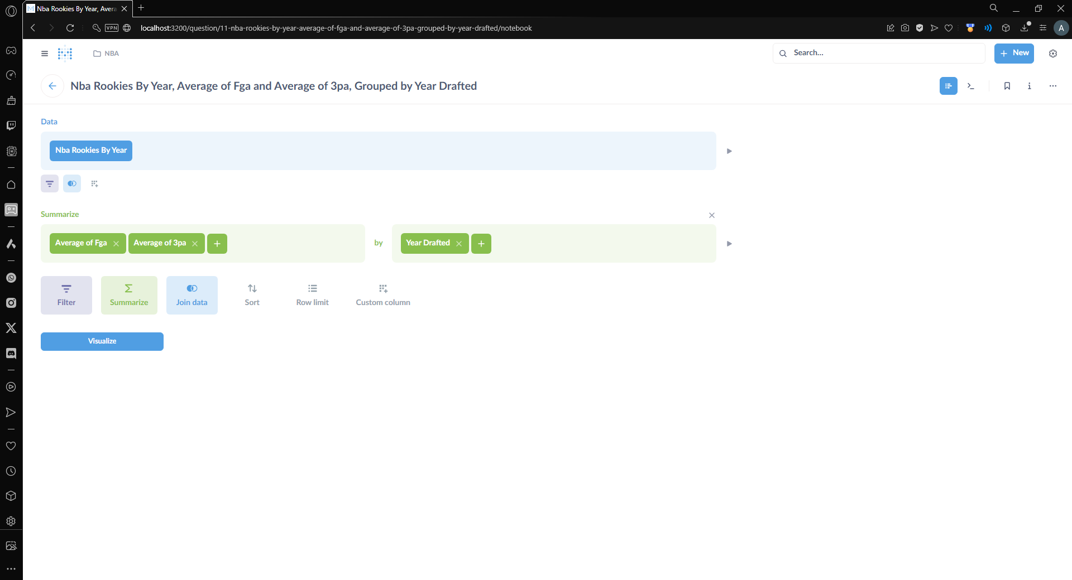

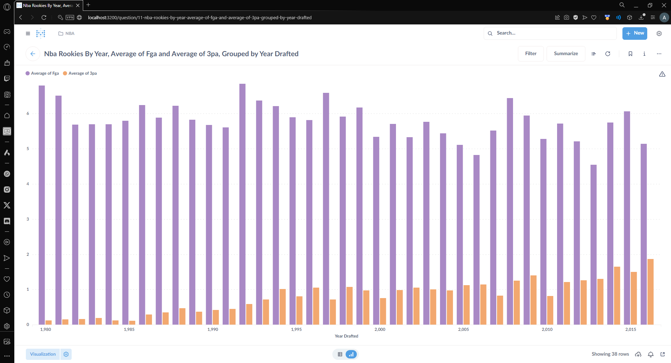

This bar graph shows the average amount of field goal attempts and 3pt attempts per year. With this graph a trend can be spotted as each year passes with each year the number of field goal attempts falls and the number of 3pt attempts rises which shows how rookies are taking less field goals and going for more 3pt shots.

**SQL**

SELECT

"source"."year_drafted" AS "year_drafted",

AVG("source"."fga") AS "avg",

AVG("source"."3pa") AS "avg_2"

FROM

(

SELECT

"PUBLIC"."nba_rookies_by_year_20240415064734"."_mb_row_id" AS "_mb_row_id",

"PUBLIC"."nba_rookies_by_year_20240415064734"."index" AS "index",

"PUBLIC"."nba_rookies_by_year_20240415064734"."name" AS "name",

"PUBLIC"."nba_rookies_by_year_20240415064734"."year_drafted" AS "year_drafted",

"PUBLIC"."nba_rookies_by_year_20240415064734"."gp" AS "gp",

"PUBLIC"."nba_rookies_by_year_20240415064734"."min" AS "min",

"PUBLIC"."nba_rookies_by_year_20240415064734"."pts" AS "pts",

"PUBLIC"."nba_rookies_by_year_20240415064734"."fgm" AS "fgm",

"PUBLIC"."nba_rookies_by_year_20240415064734"."fga" AS "fga",

"PUBLIC"."nba_rookies_by_year_20240415064734"."fg_" AS "fg_",

"PUBLIC"."nba_rookies_by_year_20240415064734"."3p_made" AS "3p_made",

"PUBLIC"."nba_rookies_by_year_20240415064734"."3pa" AS "3pa",

"PUBLIC"."nba_rookies_by_year_20240415064734"."3p_" AS "3p_",

"PUBLIC"."nba_rookies_by_year_20240415064734"."ftm" AS "ftm",

"PUBLIC"."nba_rookies_by_year_20240415064734"."fta" AS "fta",

"PUBLIC"."nba_rookies_by_year_20240415064734"."ft_" AS "ft_",

"PUBLIC"."nba_rookies_by_year_20240415064734"."oreb" AS "oreb",

"PUBLIC"."nba_rookies_by_year_20240415064734"."dreb" AS "dreb",

"PUBLIC"."nba_rookies_by_year_20240415064734"."reb" AS "reb",

"PUBLIC"."nba_rookies_by_year_20240415064734"."ast" AS "ast",

"PUBLIC"."nba_rookies_by_year_20240415064734"."stl" AS "stl",

"PUBLIC"."nba_rookies_by_year_20240415064734"."blk" AS "blk",

"PUBLIC"."nba_rookies_by_year_20240415064734"."tov" AS "tov",

"PUBLIC"."nba_rookies_by_year_20240415064734"."eff" AS "eff"

FROM

"PUBLIC"."nba_rookies_by_year_20240415064734"

) AS "source"

GROUP BY

"source"."year_drafted"

ORDER BY

"source"."year_drafted" ASC

**Dashboard**

