***Friends of Union Gap Library & Community Center 501 c 3***

Presents…….**LEGACY BRICKS Fundraiser** 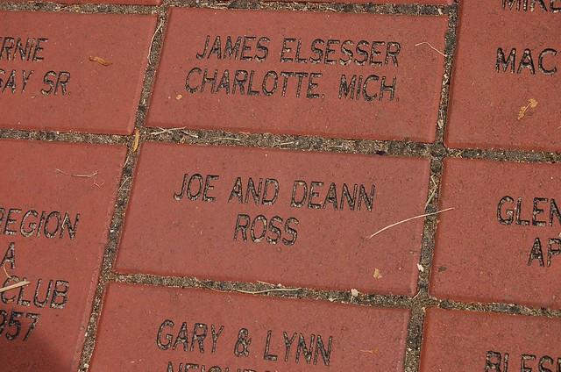

**\*Each brick is 11 1/2 inches wide x 3 1/2 inches tall (CM/project manager)**

**\*There may be up to 20 spaces per line and two lines are included**

**with the price.**

**1st line__________________________________________**

**2nd line__________________________________________**

**3rd line __________________________________________ $10.00 extra**

**Special intro price $75.00 per brick (for a limited time by July 1, 2021). Legacy Bricks regular price is $100.00 per brick.**

**Name of Purchaser _________________________________________________**

**Address___________________________________________________________**

**city ______________________state _______zip___________________**

**Form of purchase payment – CASH_____ CHECK______**

**Please remit to : Friends of UGL&CC 201 c 3 P.O. Box 3132 Union Gap, WA 98903**

**Or drop the application and payment off at**

**Heritage Bank 2205 S. First Street Yakima, 98903**