Which outcome label should a platinum-response classifier use? Coverage, agreement and validity of candidate labels in TCGA-OV
Aaron Michael Anuroop Chintala¹*, Christopher Lockhart¹
Short title: Platinum-response labels in TCGA-OV
¹ School of Systems Biology, George Mason University, Manassas, VA, USA
* Corresponding author: michaelanuroop@gmail.com (AMAC). ORCID (AMAC): 0009-0009-0062-6453

Abstract
Machine-learning studies that predict response to platinum-based chemotherapy from The Cancer Genome Atlas ovarian cancer cohort (TCGA-OV) define “response” in different ways. In 489 platinum-treated patients we compared five candidate labels: TCGA’s published platinum status, a platinum-free interval re-derived from the TCGA Clinical Data Resource, first-course response, and death before 18 or 24 months (overall-survival, OS, thresholds). We measured coverage and agreement, evaluated OS thresholds as tests for platinum resistance, tested associations with characteristics linked to platinum response and prognosis, and trained cross-validated expression classifiers on four of the labels. Platinum status was available for 277 patients (57%); the re-derived interval agreed with it closely (κ 0.97) and, combined with it, labelled 394. At 18 and 24 months the OS thresholds flagged 21% and 39% of platinum-resistant patients, largely because few patients die that early; of flagged patients with a known status, 82% and 74% were resistant, against 31–32% expected without platinum information, but about half of flagged patients had no status. No threshold between 6 and 60 months agreed better than moderately with platinum status (highest κ 0.47, at 36 months). BRCA1/2 variants and CCNE1 amplification pointed the same way under every label, although only large differences between labels were detectable. In post hoc exploratory analyses, BRCA1/2, CCNE1 and aneuploidy were associated mainly with the platinum-free interval, whereas age and bulky residual disease were associated with survival after progression, and a model of age, stage and residual disease predicted the OS labels (AUC 0.62–0.64) but not platinum status (0.48). Expression classifiers predicted every label modestly (AUC 0.61–0.68). OS thresholds thus appear to combine early platinum failure with prognostic factors acting after progression. Studies should state the label definition and class sizes and prefer platinum-specific labels, which the re-derived interval can extend.

Introduction
High-grade serous ovarian cancer (HGSOC) is usually diagnosed at an advanced stage and treated with cytoreductive surgery and platinum-based chemotherapy [1]. Most patients respond initially, but many relapse with platinum-resistant disease, and no pre-treatment genomic test of platinum response is in routine use. The TCGA-OV cohort [1] has therefore been used repeatedly to study expression-based prediction of platinum response (Table 1). A meta-analysis of machine-learning models for platinum response in ovarian cancer reported pooled concordance indices of 0.81 in training and 0.83 in validation cohorts [2], and an earlier systematic review of chemoresistance prediction found that overall survival, progression-free survival and response to chemotherapy were all used as end-points, and that most studies predicted survival or prognosis rather than response to treatment [3].
A classifier learns whatever its label measures. Clinically, platinum response has been judged by the time since the last platinum dose, which predicts response to platinum re-treatment [4], with a six-month cut-off conventionally used to define resistance, as in TCGA’s own platinum status [1]; the Gynecologic Cancer InterGroup has since replaced this dichotomy with the therapy-free interval for trial design [5], but a classifier still needs a binary label. In TCGA-OV several candidate labels are available: the platinum status published with the 2011 data, a platinum-free interval that can be re-derived from the TCGA Clinical Data Resource (TCGA-CDR) [6], the response recorded after first-line therapy, and thresholds on overall survival (OS), the most complete outcome in the cohort. Survival-defined groups have been used as proxies for chemoresistance, for example short-term survivors with resistant disease [7], and a review of 44 expression studies found 12 different definitions of platinum resistance [8]. Reporting guidelines for prediction models require the outcome definition to be reported, and risk-of-bias tools treat it as a distinct source of bias [9,10]; in the meta-analysis above, only 4 of 39 platinum-response models were rated at low risk of bias in the outcome domain [2]. In measurement terms, each label is an operationalisation of an unobserved construct, and whether it measures that construct is separate from how well a model predicts it [11].
Earlier work re-annotated TCGA-OV treatment outcomes and related platinum sensitivity and first-line response to overall survival [12]; most closely, Cocchi et al. cross-tabulated re-derived platinum-free-interval categories against TCGA’s platinum status and showed that patient selection and interval definitions change the genes reported [13]; the TCGA-CDR recommends the progression-free interval as generally more informative than OS in pan-cancer analyses [6], OS has been described as a noisy outcome label because it includes deaths from non-cancer causes [14], and label choice affects drug-response prediction in cell lines [15]. To our knowledge, however, no study has quantified agreement across the families of candidate labels in TCGA-OV — platinum-based, survival-based and response-based — within the same patients, evaluated OS thresholds as tests for platinum resistance, or compared what classifiers trained on each label learn.
We therefore asked: for training a platinum-response classifier on TCGA-OV, how do the candidate labels differ (i) in how many patients they cover and which patients they call resistant, (ii) in their associations with characteristics linked to platinum response and to prognosis, and (iii) in what expression classifiers trained on them predict? Our aim is not to evaluate any individual study.

Materials and methods

Data and cohort
This is a secondary analysis of publicly available data. Clinical, treatment, mutation, copy-number and expression data for TCGA-OV were obtained from cBioPortal [16,17] (PanCancer Atlas 2018 release, study ov_tcga_pan_can_atlas_2018, and the TCGA 2011 release, ov_tcga_pub) and from the TCGA-CDR [6]. Of 585 patients in the PanCancer Atlas clinical file, 496 had a treatment-timeline record, and 489 had carboplatin or cisplatin recorded as the agent; these 489 form the cohort. The 89 patients without any treatment record were excluded because their treatment could not be established; their median overall survival was 27.6 months, against 47.7 months in the cohort. Expression values were RNA-Seq by Expectation-Maximization (RSEM) estimates from the PanCancer Atlas release; 251 platinum-treated patients had RNA-seq data. Cohort characteristics are given in S4 Table. The study used only publicly available, de-identified data released by TCGA under its consent and governance procedures; no further ethics approval or consent was required.

Labels
Five labels were constructed for the 489 patients, each coded 1 for non-response or resistance and 0 otherwise (Table 2).
Platinum status. TCGA’s published platinum status [1], taken unchanged from the ov_tcga_pub release. The TCGA definition measures the platinum-free interval from the last primary platinum dose and states that “Platinum status was defined as resistant if the platinum free interval was less than six months and the patient had progressed or recurred” [1, Supplementary Methods S1]; sensitive tumours had an interval of six months or more, and patients without progression who had been followed for less than six months after the last dose were excluded. Patients in the release’s “Tooearly” category, with missing status, or absent from the 2011 release were treated as undetermined.
Platinum-free interval from first-line platinum. A re-derivation from different source fields: the TCGA-CDR progression-free interval time [6] minus the stop date of the last platinum regimen recorded with an adjuvant indication, both measured in days from diagnosis. Patients with progression less than 183 days after the end of platinum were labelled resistant and patients with an interval of 183 days or more sensitive; patients censored before 183 days were undetermined. Patients whose recorded progression preceded the end of platinum (a negative interval) were classed resistant (n = 8); those censored before the end of platinum were undetermined (n = 11). TCGA-CDR counts death with tumour as a progression event and dates progression by new-tumour-event records [6]. A combined label used platinum status where it was determinate and this interval otherwise.
First-course response. Stable or progressive disease versus complete or partial response after primary therapy, taken from the TCGA-CDR treatment-outcome field, then from the ov_tcga_pub release, then from the PanCancer Atlas timeline; this order was fixed after a survey of the three sources, which agreed in 365 of 365 and 141 of 142 shared patients.
OS thresholds. Death before 18 or 24 months from diagnosis versus survival beyond the threshold, with patients censored before the threshold excluded. These two thresholds are those used in our own earlier classifier analyses of this cohort; a 12-month threshold is reported in the Supporting information, and all thresholds from 6 to 60 months were examined in the agreement analysis.

Coverage and agreement
For each label we counted the platinum-treated patients in whom it was determinate. Patients with and without a determinate platinum status were compared on overall survival (Kaplan–Meier medians, log-rank test), death before 18 and 24 months, the re-derived interval and first-course response (Fisher’s exact test). For each pair of labels, agreement was measured in patients with both labels determinate by Cohen’s κ [18], with 95% confidence intervals from 2,000 bootstrap resamples of patients, together with the maximum κ attainable given the pair’s marginal frequencies. The 18- and 24-month OS thresholds were evaluated as tests for platinum resistance, with platinum status as the reference: sensitivity, specificity, positive predictive value (PPV) and negative predictive value, with Wilson 95% intervals [19]. After internal review we added, as exploratory analyses, the same evaluation at every threshold from 6 to 60 months; comparison with the values expected if the OS label carried no information about platinum status (PPV equal to the prevalence of resistance; specificity equal to the proportion of patients the label does not flag) and with the highest sensitivity the label’s prevalence allows; and bounds on sensitivity and PPV obtained by assigning all OS-labelled patients without a status to resistant or to sensitive.

Known-groups associations
A platinum-response label should separate patients by characteristics known to be associated with platinum response. Germline and somatic BRCA1/2 variants are associated with platinum response and with survival in ovarian carcinoma [20,21], and CCNE1 amplification with primary treatment failure [22]. Carriers were patients among the 272 sequenced platinum-treated patients in the 2011 release with a germline or somatic truncating or splice-site BRCA1 or BRCA2 variant (55 carriers, 44 with a germline variant); CCNE1 amplification was a GISTIC call of 2 in the same release. Each label was also tested against characteristics linked to prognosis: residual disease after surgery (more than 1 cm versus less, as defined by TCGA [1], and, as an alternative coding, any versus none), stage IV disease, Aneuploidy Score, tumour mutational burden (TMB) and age. Binary characteristics were tested by Fisher’s exact test with conditional odds ratios (OR) for non-response, and continuous ones by the Mann–Whitney U test with rank-biserial correlation (r). For the five pre-specified clinical and tumour characteristics, P values were adjusted by the Benjamini–Hochberg method [23] within each label. To compare labels directly, the patients with platinum status and both OS thresholds determinate were analysed together; differences between labels in the log OR for BRCA1/2 (platinum label minus OS label) and for residual disease and in r for aneuploidy (OS label minus platinum status) were estimated with 95% intervals from 2,000 bootstrap resamples. The smallest difference detectable with 80% power was derived from each interval in an exploratory analysis added after review.

Classifiers
Logistic regression (L2 penalty), random forest (300 trees) and a radial-basis-function support vector machine were fitted, each with balanced class weights and fixed random seeds, in scikit-learn 1.9.0 [24]. Expression was log2(RSEM + 1)-transformed and restricted to the 15,994 genes also measured on the external platform described in the Supporting information; the 500 genes with the highest variance and the standardisation parameters were computed on training data only. For four training labels (platinum status, platinum-free interval, OS at 18 and 24 months), models were trained and evaluated by five-fold stratified cross-validation repeated five times over the 251 patients with RNA-seq data. Each model scored all held-out patients, and pooled out-of-fold scores were evaluated against every label, giving a train-label by test-label matrix of AUCs. We report the mean AUC over three models and five repeats and its range. A pre-specified rule compared platinum status’s own AUC with the AUC of OS-trained models for platinum status, judging a difference of 0.05 or more as evidence that the label mismatch matters.

Exploratory analyses
Three analyses were added after the main results had been seen, at the request of internal reviewers, and are reported as exploratory. First, overall survival was divided into the platinum-free interval and survival after progression (among patients who progressed), and Cox models of each were fitted for age, stage, residual disease, BRCA1/2, CCNE1 and Aneuploidy Score. Second, a logistic regression on age, stage IV and residual disease (> 1 cm), with five-fold cross-validation repeated five times, was used to ask how far each label can be predicted from clinical characteristics alone. Third, the re-derived interval was recomputed without the 38 patients whose TCGA-CDR record is marked as redacted. The threshold sweep, reference bounds, minimum detectable differences and an alternative coding of residual disease (any versus none) were added at the same time. The clinical-only models used logistic regression only.

Supplementary analyses
Three further analyses are reported in the Supporting information: transfer of the TCGA-trained classifiers to an independent microarray cohort, GSE63885 [25]; the 10 genes of Chen et al. [26] and the 5 genes of Gao et al. [27] used as fixed inputs to the same pipeline and compared with 1,000 random gene sets of the same size; and the AUC inflation produced by selecting genes on the full dataset before splitting, a well-documented error [28–31], measured with OS-threshold labels and the pipeline’s own simpler preprocessing (untransformed RSEM values for all 20,531 genes).

Literature review
For TCGA-OV studies of expression-based platinum-response prediction identified in an initial literature search and an additional targeted search (neither systematic) [26,27,32–41], we recorded from the full text and supplements the label used, its stated definition and source, the number of patients in each class, the validation design and the reported discrimination. Items not reported were recorded as “not stated”; no definition was inferred.

Pre-specification and analysis history
Predictions and decision rules were written into the header of each analysis script before it was run. The scripts for the analyses of BRCA1/2 and CCNE1, of patients without a platinum status, and of prognostic characteristics in the full cohort were deposited in the public code repository before they were run (commits d5bd844 and e98b3d9); the other headers are archived with the code but were not timestamped externally. The study’s interpretation changed during the work. An earlier draft concluded, from somatic BRCA1/2 variants and from OS labels analysed only in patients with RNA-seq data, that OS thresholds measure survival rather than platinum response; the publicly deposited analyses with germline variants and the full cohort did not support that conclusion, and the paper was revised. The descriptive full-cohort tables (agreement, coverage, threshold sweep, cohort characteristics) and the exploratory analyses above were added afterwards. All predictions and their outcomes, including those that failed, are listed in S1 Text. All scikit-learn analyses were run in one pinned environment (Python 3.14.5, scikit-learn 1.9.0, NumPy 2.4.6), except the exploratory clinical-only models (Python 3.10, scikit-learn 1.7.2); Cox models used R 4.6.0 (survival 3.8.6) and, for the exploratory analyses, lifelines 0.30.0. Reporting follows the STROBE statement [42], and STARD 2015 for the evaluation of OS thresholds as tests for platinum resistance [43] (S2 Text).

Results

Studies label patients in different ways
Twelve studies of expression and platinum response that used TCGA-OV, or a cohort used alongside it, applied at least five label constructions, and none used an overall-survival threshold (Table 1). Five labelled patients by progression or recurrence within six months of the end of platinum or chemotherapy, but differed in the reference point and in whether intermediate patients were excluded [26,32,34,35,37]; one compared platinum-refractory disease with no progression within two years [40]; one used progression-free survival as a surrogate [36]; and two used class counts identical to those of TCGA’s published platinum status (90 resistant, 197 sensitive) without stating a definition [38,39]. Four did not fully state how their TCGA patients were labelled [27,33,38,39]. The proportion of TCGA patients labelled resistant ranged from 19% to 44% (S1 Table).

Platinum status covers just over half of treated patients
TCGA’s platinum status was determinate for 277 of the 489 platinum-treated patients (57%; 87 resistant, 190 sensitive), and for 145 of the 251 with RNA-seq data (Fig 1A, Table 2). The remaining 212 were recorded as missing (87), too early to classify (57) or were absent from the 2011 release (68). Among patients in the 2011 release, those without a determinate status did not differ in overall survival from those with one (median 47.5 versus 47.7 months; log-rank p = 0.37), but the group was mixed: patients with missing status had a median survival of 39.0 months, whereas only 10 of 57 patients classed as too early had died. Patients without a status were more often dead before 18 months (16 of 96 versus 22 of 268; OR 2.23, 95% CI 1.04–4.70) and, less clearly, before 24 months (24 of 95 versus 43 of 259; OR 1.70, 0.92–3.09), and more often had stable or progressive disease after first-line therapy (28 of 114 versus 28 of 255; OR 2.63, 1.41–4.91), but were less often resistant by the re-derived interval (13 of 68 versus 89 of 272; OR 0.49, 0.23–0.96). The re-derived interval was determinate for 389 patients (358 without the redacted TCGA-CDR records; κ with platinum status 0.964 versus 0.966), and the combined label for 394 (113 resistant). The OS thresholds were determinate for 419 patients at 18 months (47 non-responders) and 401 at 24 months (78 non-responders).

OS thresholds agree at best moderately with platinum status
The published and re-derived platinum labels agreed in 268 of 272 patients (κ 0.97, 95% CI 0.93–0.99; Fig 1B). Agreement of the OS thresholds with platinum status was low: κ 0.24 (0.14–0.35) at 18 months and 0.37 (0.25–0.49) at 24 months, against maximum attainable values of 0.33 and 0.59. At 18 months the OS threshold flagged 18 of 84 resistant patients (sensitivity 0.21, 0.14–0.31) and 4 of 184 sensitive patients (specificity 0.98); at 24 months it flagged 32 of 83 resistant (0.39, 0.29–0.49) and 11 of 176 sensitive patients (specificity 0.94; Fig 1C). These values are largely set by how few patients die early: with no information about platinum status, the same labels would have specificities of 0.92 and 0.83, and their prevalence allows sensitivities of at most 0.26 and 0.52. The informative quantity is the PPV: of the flagged patients with a determinate status, 18 of 22 (0.82, 0.61–0.93) and 32 of 43 (0.74, 0.60–0.85) were resistant, against 0.31 and 0.32 expected without platinum information. However, 25 of the 47 patients flagged at 18 months and 35 of the 78 flagged at 24 months had no platinum status; if all of them were sensitive or all resistant, the PPV would lie between 0.38 and 0.91 at 18 months and between 0.41 and 0.86 at 24 months. Across thresholds from 6 to 60 months (exploratory), sensitivity rose and specificity and PPV fell, and agreement was at best moderate: κ was highest at 36 months (0.47; sensitivity 0.64, specificity 0.83, PPV 0.65; S2 Table). The two OS thresholds agreed with each other (κ 0.71), and first-course response agreed weakly with every other label (κ 0.21–0.26).

Characteristics linked to platinum response point the same way under every label
BRCA1/2 carriers were less often labelled non-responders under every label except first-course response (Fig 2A, Table 3): 7 of 37 carriers versus 54 of 149 non-carriers by platinum status (OR 0.41, 95% CI 0.14–1.04), 8 of 47 versus 64 of 179 by the re-derived interval (0.37, 0.14–0.87), 1 of 51 versus 23 of 195 by OS at 18 months (0.15, 0.004–0.97) and 3 of 50 versus 43 of 192 by OS at 24 months (0.22, 0.04–0.75). In the 180 patients with platinum status and both OS thresholds determinate, the difference in log OR between platinum status and the OS thresholds was +1.12 (95% CI −0.16 to +2.00) at 18 months and +0.95 (−0.52 to +2.71) at 24 months; these comparisons could detect only a ratio of odds ratios of about 4.7 and 10 with 80% power, so they do not show that the labels behave alike (S3 Table). CCNE1 amplification was associated with non-response in the same direction under every label (OR 1.11–2.01; Fig 2B).
Residual disease and aneuploidy behaved similarly (Fig 2C and 2D, Table 3). With residual disease coded as more than 1 cm, it was associated with non-response under both OS thresholds (OR 2.86, 1.30–6.29, and 2.41, 1.28–4.50) and first-course response (2.55, 1.31–4.91), but not under platinum status (1.12, 0.59–2.09); with any residual disease versus none, it was associated with platinum status (3.22, 1.40–8.35), the re-derived interval (3.04, 1.44–7.03) and OS at 24 months (2.78, 1.12–8.29). Aneuploidy Score was higher in non-responders under both OS thresholds (r = 0.20 and 0.25) and the re-derived interval (r = 0.21), and weakly under platinum status (r = 0.13, q = 0.26). In the same patients, none of the contrasts between platinum status and the OS thresholds could be distinguished from zero (difference in r for aneuploidy −0.06, −0.35 to +0.21, at 18 months and +0.11, −0.09 to +0.31, at 24 months; difference in log OR for residual disease > 1 cm +0.37, −0.66 to +1.25, and +0.50, −0.23 to +1.21), and again only large differences were detectable. Older age was associated with both OS thresholds (r = 0.26 and 0.28) but not with platinum status (r = 0.07), as predicted in advance for the 24-month threshold in patients with RNA-seq data (S1 Text). Full results, including raw P values, are in S5 Table. First-course response was the only label with no BRCA1/2 association and no association with aneuploidy (r = −0.03).

Exploratory: OS combines the platinum-free interval with survival after progression
When overall survival was divided into the platinum-free interval and survival after progression (S10 Table), BRCA1/2 carriers had a longer platinum-free interval (hazard ratio 0.55, 95% CI 0.38–0.79), and CCNE1 amplification (1.56, 1.19–2.06) and higher Aneuploidy Score (1.20 per SD, 1.07–1.35) a shorter one, with weaker or no associations with survival after progression (Fig 4). Age and residual disease > 1 cm showed the opposite pattern: they were associated with shorter survival after progression (1.26 per 10 years, 1.12–1.42; and 1.41, 1.03–1.93) but not clearly with the platinum-free interval (1.08, 0.98–1.19; and 1.11, 0.85–1.44). Any residual disease was associated with both. Consistent with this, a logistic regression on age, stage and residual disease predicted death before 18 and 24 months (cross-validated AUC 0.64 and 0.62) but not platinum status (0.48), the re-derived interval (0.52) or the combined label (0.49).

Classifiers trained on each label predict modestly
Within TCGA, expression classifiers predicted each label modestly (Fig 3): mean cross-validated AUC was 0.63 for platinum status (range over models and repeats 0.56–0.69; S6 Table), 0.61 for the re-derived interval, 0.63 for OS at 18 months and 0.68 for OS at 24 months. Models trained on the OS thresholds predicted platinum status with AUCs of 0.55 and 0.60. By the pre-specified rule, the difference between platinum status’s own AUC and that of OS-trained models (+0.06) indicated that the label mismatch matters, but the difference reached 0.05 in only three of five cross-validation repeats, so it is not robust. Models trained on platinum status predicted OS at 24 months with an AUC of 0.63. On GSE63885, models predicted its platinum-resistance label weakly whichever label they were trained on (mean AUC 0.56–0.63); on its clinical-response label, which has 10 non-responders, models trained on the platinum labels scored higher (0.67 and 0.71) than OS-trained models (0.49 and 0.52), a comparison that was not pre-specified (S1 Fig, S7 Table). As fixed inputs to the same pipeline, the 10 genes of Chen et al. separated platinum-resistant from sensitive TCGA patients better than random gene sets (AUC 0.735) but not GSE63885 patients (0.499), and the 5 genes of Gao et al. did not differ from random sets (S8 Table). Selecting genes on the full dataset before splitting raised mean AUC at the 18- and 24-month thresholds by +0.21 with supervised selection and by +0.006 with unsupervised selection (S2 Fig, S9 Table).

Discussion
The candidate platinum-response labels in TCGA-OV differ in coverage, in which patients they call resistant, and in what they measure. The two platinum labels agree almost perfectly but cover just over half of treated patients, or about four-fifths when combined. The OS thresholds cover more patients, but at no cut-off do they agree better than moderately with platinum status. At 18 and 24 months they flag an early-failure group: most flagged patients with a known status are platinum-resistant, but most resistant patients are not flagged, because platinum-resistant disease is compatible with survival beyond two years, and half of the flagged patients have no platinum status to check against. At longer thresholds they catch more resistant patients at the cost of flagging sensitive ones.
The exploratory decomposition, added after review, suggests a reason. Overall survival comprises the time to the end of first-line platinum, the platinum-free interval and survival after progression. Characteristics linked to platinum response — BRCA1/2, CCNE1 and aneuploidy — were associated mainly with the first part, whereas age and bulky residual disease were associated with the second, and clinical characteristics alone predicted the OS labels but not platinum status. Any residual disease was associated with both parts. If confirmed, this would mean that an OS-threshold label mixes early platinum failure with prognostic factors that act after progression, and that a classifier trained on it is asked to learn both. This also explains why markers of platinum response cannot validate the labels against one another: BRCA1/2 and CCNE1 are associated with survival as well as with platinum response [20–22], so they point the same way under every label, and our same-patient comparisons could detect only large differences. With somatic variants alone, the OS labels showed no clear BRCA1/2 association, because only 12 carriers had an OS label; including germline variants, which account for most BRCA1/2 alterations in HGSOC [1] and for 44 of the 55 carriers here, made the association visible under every label. First-course response behaved differently from all other labels — it agreed weakly with each of them and showed no BRCA1/2 association — consistent with a measure of response to surgery and chemotherapy together.
Within TCGA, expression predicted every label with cross-validated AUCs near 0.6–0.7. By our pre-specified rule, OS-trained models predicted platinum status less well than models trained on platinum status, although the difference was small and unstable. With a standard, untuned pipeline and 41 resistant patients, these estimates are imprecise and describe what this pipeline achieves rather than an upper bound for the data. They are nonetheless well below the figures commonly reported [2,26,27,38]; selecting genes before splitting, one documented route to higher figures [28–31], inflated AUC by about 0.2 here.
These results add to earlier work on TCGA-OV outcomes. Villalobos et al. re-annotated the cohort’s treatment outcomes and found median overall survival of 27 months in platinum-resistant patients [12], which fits our finding that most resistant patients survive beyond the usual OS thresholds; Cocchi et al. showed that platinum-free-interval definitions alone change which genes TCGA-OV studies report [13]. Patients without a platinum status are a mixed group — some died early or never responded, others were simply followed too briefly — so the missing values are unlikely to be random; re-deriving the interval from TCGA-CDR recovers about half of them, and where both labels are available they agree closely.
Several recommendations follow for studies of platinum response in TCGA-OV. State the label, its definition, its source field and the number of patients in each class. Prefer a platinum-specific label, and extend TCGA’s platinum status with the platinum-free interval re-derived from TCGA-CDR where status is missing. If an OS threshold is used, report it as a survival end-point that combines early platinum failure with other prognostic factors, and expect low sensitivity for platinum resistance at short thresholds and poor specificity at long ones. Do not relabel first-course response as platinum resistance. Confine every data-dependent step, including gene selection, to training data.

Limitations
All analyses use one resource, and the primary label is available for only 145 patients with RNA-seq data (41 resistant), which limits the precision of every classifier result. The same-patient comparisons of labels were underpowered, and their wide intervals do not establish that the labels are equivalent. Platinum status depends on the completeness of treatment and follow-up records, the re-derived interval shares TCGA’s progression dates and counts death with tumour as progression, and their close agreement shows consistency rather than independent truth. Sensitivity and PPV of the OS thresholds are conditional on patients having a platinum status, and the bounds we report are wide. The cohort definition excludes 89 patients without a treatment record, whose survival was poorer than the cohort’s (median 27.6 months) and only five of whom had a platinum status; the finding that patients without a platinum status did not have shorter survival holds only within the defined cohort. Both platinum labels use the six-month dichotomy that clinical consensus has replaced with a continuous therapy-free interval [5], and neither separates platinum-refractory from platinum-resistant disease. Excluding patients censored before an OS threshold can bias threshold labels [44]. BRCA1/2 carriers were limited to truncating and splice-site variants called in the 2011 release; missense variants of uncertain significance and homologous-recombination-deficiency scores were not assessed. The decomposition of overall survival, the clinical-only models, the threshold sweep and the reference bounds were exploratory and were added after the main results were known. Several pre-specified predictions failed, including the predictions that BRCA1/2 would show no clear association with the OS thresholds, that patients without a platinum status would have shorter survival and would more often be resistant by the re-derived interval, and that the 24-month threshold would have a sensitivity of 0.30 or less; all outcomes are reported in S1 Text. TCGA expression data were processed centrally before any split we made, so batch effects introduced upstream cannot be controlled by our pipeline.

Conclusion
In TCGA-OV, platinum-specific labels are consistent but cover only part of the cohort; overall-survival thresholds cover more of it but agree at best moderately with platinum status, and exploratory analyses suggest that they combine early platinum failure with prognostic factors acting after progression; expression predicts all of them modestly. Which label a classifier is trained on determines how many patients it learns from and what it is asked to find; stating that choice, with class sizes, is a precondition for comparing models of platinum response built on these data.

Data and code availability
TCGA data were obtained from cBioPortal (ov_tcga_pan_can_atlas_2018, ov_tcga_pub) and the TCGA-CDR supplementary table [6] (Genomic Data Commons file 1b5f413e-a8d1-4d10-92eb-7c4ae739ed81). GSE63885 is available from the Gene Expression Omnibus. All code, analysis outputs, pre-specified predictions and figures are available at https://github.com/AaronC-bioinfo/ovarian-cancer-platinum-response and are archived at Zenodo ([[ZENODO_DOI]]).

Author contributions
AMAC: conceptualization, data curation, formal analysis, methodology, software, visualization, writing – original draft. CL: methodology (guidance on the framing of the label-validity, leakage and validation analyses), writing – review and editing.

Funding
The authors received no specific funding for this work.

Competing interests
The authors have declared that no competing interests exist.

Use of AI tools
Claude (Anthropic), an AI assistant, was used to write and run analysis and figure scripts under the first author’s direction, to extract and check quotations from the literature, to audit the provenance of reported numbers, and to edit manuscript text. The first author reviewed all AI-assisted work against the analysis outputs and takes responsibility for the content. AI tools are not authors of this work.

Acknowledgments
The results shown here are in whole or in part based upon data generated by the TCGA Research Network: https://www.cancer.gov/tcga.

Figure legends
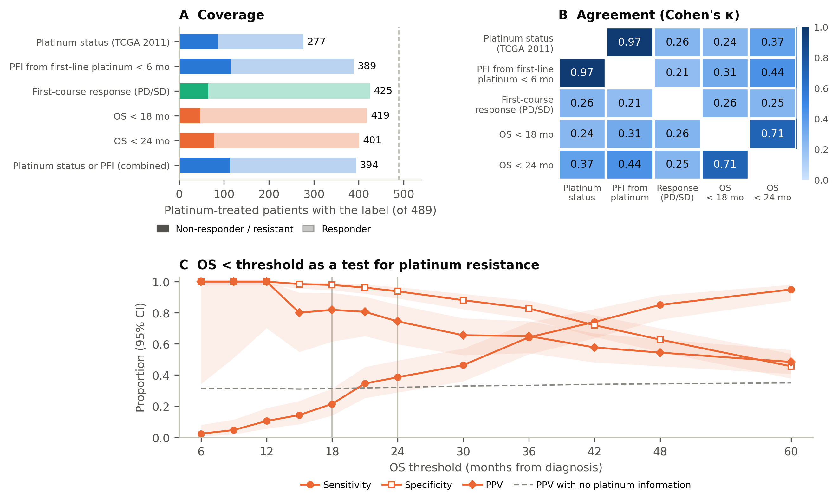
Fig 1. Coverage and agreement of candidate labels in 489 platinum-treated TCGA-OV patients. (A) Number of patients in whom each label is determinate; dark segment, non-responders or resistant; light segment, responders. The combined label uses platinum status where available and the re-derived platinum-free interval otherwise. (B) Cohen’s κ for each pair of labels, in patients with both labels determinate. (C) Sensitivity, specificity and positive predictive value (PPV) of death before each threshold as a test for platinum resistance, with TCGA platinum status as the reference; shaded bands, Wilson 95% confidence intervals; dashed line, PPV expected if the OS label carried no information about platinum status; vertical lines, 18 and 24 months.
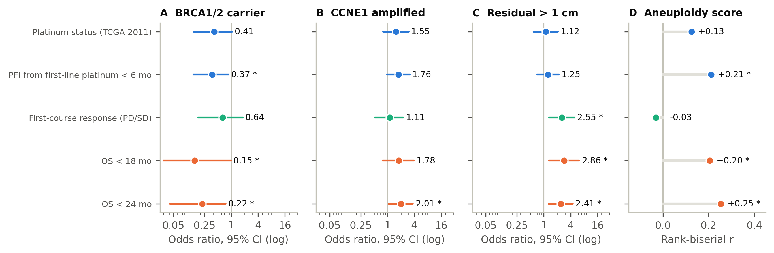
Fig 2. Characteristics associated with platinum response and prognosis under each label. Odds ratio (95% CI, log scale) for being labelled a non-responder in (A) carriers of a germline or somatic truncating or splice-site BRCA1/2 variant (272 sequenced patients), (B) tumours with CCNE1 amplification and (C) patients with residual disease > 1 cm. (D) Rank-biserial correlation between Aneuploidy Score and non-response (positive, higher in non-responders). Each label uses all platinum-treated patients in whom it is determinate. A–C: * 95% CI excludes 1; lower bounds below 0.03 are drawn at 0.03. D: * Benjamini–Hochberg q < 0.05 within label (five characteristics). Colour denotes label family: platinum labels (blue), first-course response (teal), OS thresholds (orange).
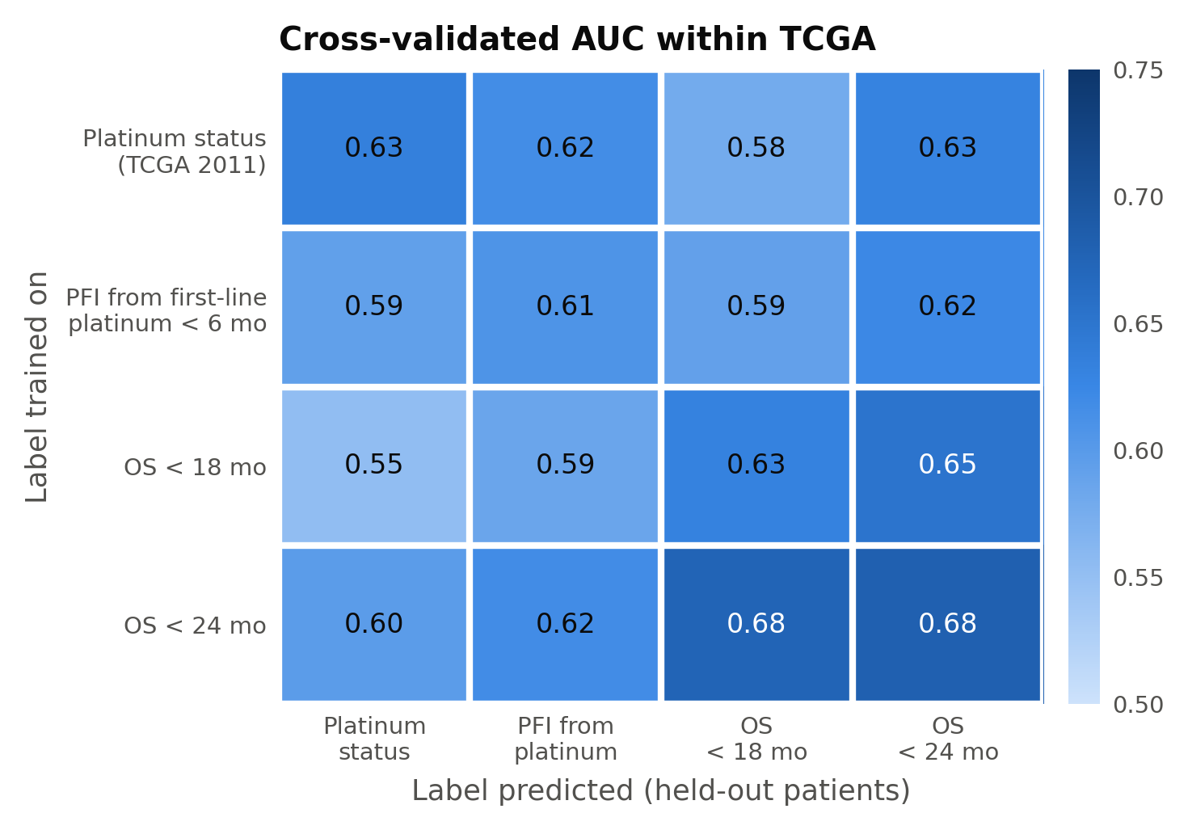
Fig 3. What classifiers trained on each label predict within TCGA. Mean cross-validated AUC (three models, five repeats of five-fold cross-validation, 251 patients with RNA-seq data) for each training label (rows) against each label in held-out patients (columns).
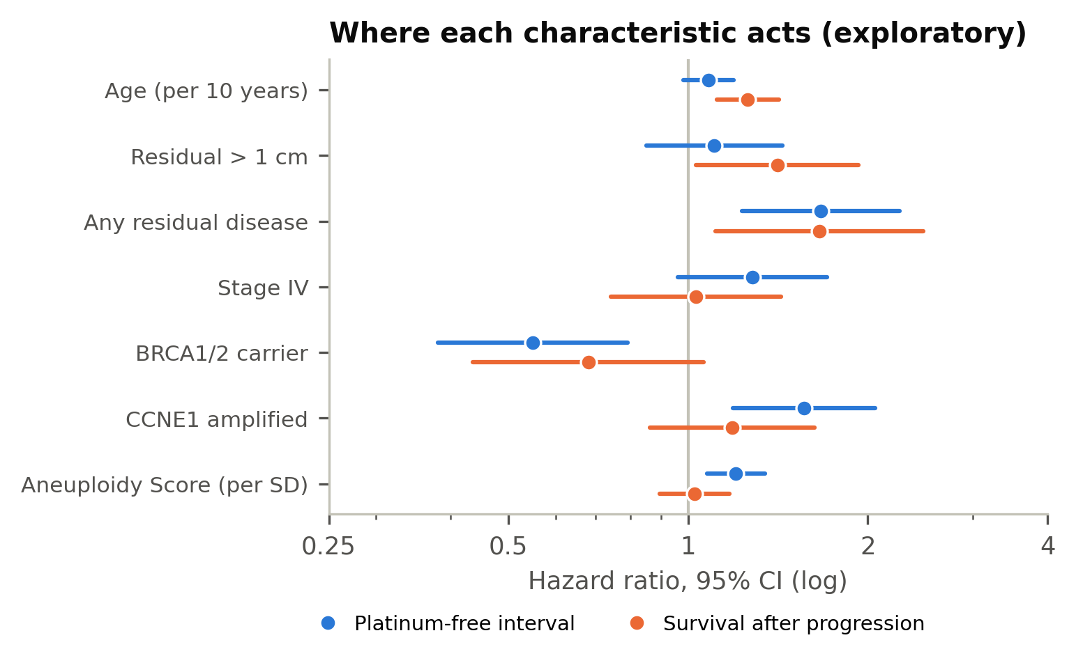
Fig 4. Where characteristics act: platinum-free interval versus survival after progression (exploratory). Hazard ratios (95% CI, log scale) from univariable Cox models of the platinum-free interval from the end of first-line platinum (blue) and of survival after progression among patients who progressed (orange). Times from TCGA-CDR.

Tables
Table 1. Labels used by studies of expression and platinum response in TCGA-OV and related cohorts.
Study | TCGA-OV label and stated definition | TCGA n (resistant / sensitive) | External or other cohorts | Design | Reported discrimination
Gonzalez Bosquet 2016 [32] | Complete response, progression-free 6 months after first platinum-based treatment, vs refractory or recurrence within 6 months of completion | 158 / 292 | Six GEO/EBI cohorts recoded to the same classes | 34 genes selected on the full TCGA set; internal cross-validation type not stated | AUC 0.64–0.79 (TCGA), 0.45–0.73 (external)
Sun J 2019 [33] | “Chemo-response information”; definition not stated | Not stated (TCGA n = 557, microarray) | Several GEO cohorts | Rank-based score, cut-off 0 | No AUC
Choi 2020 [34] | Recurrence < 6 months vs > 12 months after last primary chemotherapy; 6–12 months excluded | 110 / 160 | GSE9891 (survival only) | No classifier | Not applicable
Gonzalez Bosquet 2021 [35] | Progression-free ≥ 6 months after first platinum-based treatment; ≥ 6 months of follow-up required | 149 / 189 (validation set) | Trained on 88 patients from one institution | Clinical and multi-omic lasso models; TCGA used for validation | TCGA AUCs not reported numerically
Sun X 2021 [36] | No response label (progression-free survival used as surrogate) | — | GSE131978, 7 / 4; GSE51373, 10 / 13 | No classifier | Not applicable
Guo & Li 2021 [37] | Relapse within 6 months after completing chemotherapy | 49 / 205 | — | Single-gene ROC analysis | Per-gene AUC 0.58–0.60
Chen 2022 [26] | Platinum-free interval < 6 months from end of first chemotherapy course; TCGA field not stated | 69 / 161 | GSE63885, 34 / 41 | Genes selected on the full labelled set; no held-out TCGA split; SVM with 100-fold CV | AUC 0.971 (TCGA), 0.926 (GSE63885)
Li 2022 [38] | “Known platinum sensitivity” from cBioPortal; definition not stated | 90 / 197 (supplement; equal to TCGA 2011 platinum status) | GSE15622, 6 / 9 | Held-out split and CV not stated | AUC 0.841 (TCGA), 0.796 (GSE15622)
Wang C 2024 [39] | Definition not stated (counts equal to TCGA 2011 platinum status) | 90 / 197 | Public cohorts via ROC-plotter | Single-gene ROC analysis | Per-gene AUC > 0.6
Gao 2025 [27] | Source of bulk TCGA labels not stated (interval < 6 months stated for single-cell cohort) | 287 TCGA in a pooled 404 (pooled counts as printed: 71 sensitive / 333 resistant) | GSE63885, n = 75 | Random 8:2 split of pooled data; five-fold CV for hyperparameters | AUC 0.993 (test), 0.989 (GSE63885)
Kilim 2025 [40] | Refractory (progression or stable disease within six cycles) vs no progression within 2 years; proteomics and histology, not mRNA | 127 patients; classes not stated | PTRC-HGSOC | Train on one cohort, test on the other; five-fold CV | AUC 0.752 (PTRC → TCGA), 0.613 (TCGA CV)
Wang C 2025 [41] | No TCGA; GEO labels, definition not stated | — | Merged GSE114206, GSE51373, GSE63885; GSE30161 (test) | Selection on the merged set; no held-out split | Per-gene AUC 0.66–0.72 (merged), 0.55–0.75 (GSE30161)
Table 2. Candidate labels in platinum-treated TCGA-OV patients.
Label | Definition (1 = non-responder) | Source | Platinum cohort, n (1 / 0) | With RNA-seq, n (1 / 0)
Platinum status | Platinum-free interval < 6 months from last primary platinum dose, with progression | TCGA 2011 [1] | 277 (87 / 190) | 145 (41 / 104)
Platinum-free interval | Progression < 183 days after end of first-line platinum | TCGA-CDR + treatment timeline | 389 (115 / 274) | 188 (53 / 135)
Combined platinum label | Platinum status where determinate, otherwise platinum-free interval | As above | 394 (113 / 281) | 189
First-course response | Stable or progressive vs complete or partial response | TCGA-CDR, then TCGA 2011 | 425 (65 / 360) | 219 (35 / 184)
OS < 18 months | Death before 18 months vs survival beyond | PanCancer Atlas clinical | 419 (47 / 372) | 206 (22 / 184)
OS < 24 months | Death before 24 months vs survival beyond | PanCancer Atlas clinical | 401 (78 / 323) | 199 (36 / 163)
Table 3. Association of each label with characteristics linked to platinum response and prognosis.
Characteristic | Platinum status | Platinum-free interval | First-course response | OS < 18 months | OS < 24 months
BRCA1/2 carrier, OR | 0.41 (0.14–1.04) | 0.37 (0.14–0.87)† | 0.64 (0.18–1.80) | 0.15 (0.004–0.97)† | 0.22 (0.04–0.75)†
CCNE1 amplified, OR | 1.55 (0.80–2.97) | 1.76 (0.98–3.15) | 1.11 (0.52–2.26) | 1.78 (0.78–3.89) | 2.01 (1.06–3.75)†
Residual > 1 cm, OR | 1.12 (0.59–2.09) | 1.25 (0.71–2.18) | 2.55 (1.31–4.91)* | 2.86 (1.30–6.29)* | 2.41 (1.28–4.50)*
Any residual, OR | 3.22 (1.40–8.35)† | 3.04 (1.44–7.03)† | 1.54 (0.67–3.99) | 2.93 (0.87–15.43) | 2.78 (1.12–8.29)†
Stage IV, OR | 1.02 (0.46–2.17) | 1.09 (0.57–2.03) | 1.25 (0.57–2.57) | 1.75 (0.76–3.79) | 1.55 (0.78–2.97)
Aneuploidy Score, r | 0.13 | 0.21* | −0.03 | 0.20* | 0.25*
TMB, r | −0.16 | −0.06 | −0.03 | −0.08 | −0.08
Age, r | 0.07 | 0.15 | 0.06 | 0.26* | 0.28*
OR, conditional odds ratio for non-response (95% CI); r, rank-biserial correlation (positive = higher in non-responders). Each label uses all platinum-treated patients in whom it is determinate; BRCA1/2 and CCNE1 in sequenced and copy-number-profiled patients. Any residual versus none was an alternative coding added after review. † 95% CI excludes 1. * Benjamini–Hochberg q < 0.05 within label across the five pre-specified clinical and tumour characteristics.

References
- The Cancer Genome Atlas Research Network. Integrated genomic analyses of ovarian carcinoma. Nature. 2011;474:609–615. doi:10.1038/nature10166
- Wang Q, Chang Z, Liu X, Wang Y, Feng C, Ping Y, et al. Predictive value of machine learning for platinum chemotherapy responses in ovarian cancer: systematic review and meta-analysis. J Med Internet Res. 2024;26:e48527. doi:10.2196/48527
- Lloyd KL, Cree IA, Savage RS. Prediction of resistance to chemotherapy in ovarian cancer: a systematic review. BMC Cancer. 2015;15:117. doi:10.1186/s12885-015-1101-8
- Markman M, Rothman R, Hakes T, Reichman B, Hoskins W, Rubin S, et al. Second-line platinum therapy in patients with ovarian cancer previously treated with cisplatin. J Clin Oncol. 1991;9:389–393. doi:10.1200/JCO.1991.9.3.389
- Wilson MK, Pujade-Lauraine E, Aoki D, Mirza MR, Lorusso D, Oza AM, et al. Fifth Ovarian Cancer Consensus Conference of the Gynecologic Cancer InterGroup: recurrent disease. Ann Oncol. 2017;28:727–732. doi:10.1093/annonc/mdw663
- Liu J, Lichtenberg T, Hoadley KA, Poisson LM, Lazar AJ, Cherniack AD, et al. An integrated TCGA pan-cancer clinical data resource to drive high-quality survival outcome analytics. Cell. 2018;173:400–416.e11. doi:10.1016/j.cell.2018.02.052
- Yang SYC, Lheureux S, Karakasis K, Burnier JV, Bruce JP, Clouthier DL, et al. Landscape of genomic alterations in high-grade serous ovarian cancer from exceptional long- and short-term survivors. Genome Med. 2018;10:81. doi:10.1186/s13073-018-0590-x
- Talijanovic M, Lopacinska-Jørgensen J, Høgdall EV. Gene expression profiles in ovarian cancer tissues as a potential tool to predict platinum-based chemotherapy resistance. Anticancer Res. 2025;45:11–26. doi:10.21873/anticanres.17389
- Collins GS, Moons KGM, Dhiman P, Riley RD, Beam AL, Van Calster B, et al. TRIPOD+AI statement: updated guidance for reporting clinical prediction models that use regression or machine learning methods. BMJ. 2024;385:e078378. doi:10.1136/bmj-2023-078378
- Wolff RF, Moons KGM, Riley RD, Whiting PF, Westwood M, Collins GS, et al. PROBAST: a tool to assess the risk of bias and applicability of prediction model studies. Ann Intern Med. 2019;170:51–58. doi:10.7326/M18-1376
- Jacobs AZ, Wallach H. Measurement and fairness. In: Proceedings of the 2021 ACM Conference on Fairness, Accountability, and Transparency. 2021. p. 375–385. doi:10.1145/3442188.3445901
- Villalobos VM, Wang YC, Sikic BI. Reannotation and analysis of clinical and chemotherapy outcomes in the ovarian data set from The Cancer Genome Atlas. JCO Clin Cancer Inform. 2018;2:1–16. doi:10.1200/CCI.17.00096
- Cocchi S, Talijanovic M, Høgdall EV, Lopacinska-Jørgensen J. Assessing the impact of patient selection and analytical methods on mRNA biomarker identification in ovarian cancer using TCGA data. Cancer Control. 2026;33:10732748261468094. doi:10.1177/10732748261468094
- Yousefi S, Shaban A, Amgad M, Chandradevan R, Cooper LAD. Learning clinical outcomes from heterogeneous genomic data sources. arXiv:1904.01637 [Preprint]. 2019.
- Bayer I, Groth P, Schneckener S. Prediction errors in learning drug response from gene expression data – influence of labeling, sample size, and machine learning algorithm. PLoS ONE. 2013;8:e70294. doi:10.1371/journal.pone.0070294
- Cerami E, Gao J, Dogrusoz U, Gross BE, Sumer SO, Aksoy BA, et al. The cBio Cancer Genomics Portal: an open platform for exploring multidimensional cancer genomics data. Cancer Discov. 2012;2:401–404. doi:10.1158/2159-8290.CD-12-0095
- Gao J, Aksoy BA, Dogrusoz U, Dresdner G, Gross B, Sumer SO, et al. Integrative analysis of complex cancer genomics and clinical profiles using the cBioPortal. Sci Signal. 2013;6:pl1. doi:10.1126/scisignal.2004088
- Cohen J. A coefficient of agreement for nominal scales. Educ Psychol Meas. 1960;20:37–46. doi:10.1177/001316446002000104
- Wilson EB. Probable inference, the law of succession, and statistical inference. J Am Stat Assoc. 1927;22:209–212. doi:10.1080/01621459.1927.10502953
- Pennington KP, Walsh T, Harrell MI, Lee MK, Pennil CC, Rendi MH, et al. Germline and somatic mutations in homologous recombination genes predict platinum response and survival in ovarian, fallopian tube, and peritoneal carcinomas. Clin Cancer Res. 2014;20:764–775. doi:10.1158/1078-0432.CCR-13-2287
- Yang D, Khan S, Sun Y, Hess K, Shmulevich I, Sood AK, et al. Association of BRCA1 and BRCA2 mutations with survival, chemotherapy sensitivity, and gene mutator phenotype in patients with ovarian cancer. JAMA. 2011;306:1557–1565. doi:10.1001/jama.2011.1456
- Etemadmoghadam D, deFazio A, Beroukhim R, Mermel C, George J, Getz G, et al. Integrated genome-wide DNA copy number and expression analysis identifies distinct mechanisms of primary chemoresistance in ovarian carcinomas. Clin Cancer Res. 2009;15:1417–1427. doi:10.1158/1078-0432.CCR-08-1564
- Benjamini Y, Hochberg Y. Controlling the false discovery rate: a practical and powerful approach to multiple testing. J R Stat Soc Series B Stat Methodol. 1995;57:289–300. doi:10.1111/j.2517-6161.1995.tb02031.x
- Pedregosa F, Varoquaux G, Gramfort A, Michel V, Thirion B, Grisel O, et al. Scikit-learn: machine learning in Python. J Mach Learn Res. 2011;12:2825–2830.
- Lisowska KM, Olbryt M, Dudaladava V, Pamuła-Piłat J, Kujawa K, Grzybowska E, et al. Gene expression analysis in ovarian cancer — faults and hints from DNA microarray study. Front Oncol. 2014;4:6. doi:10.3389/fonc.2014.00006
- Chen S, Wu Y, Wang S, Wu J, Wu X, Zheng Z. A risk model of gene signatures for predicting platinum response and survival in ovarian cancer. J Ovarian Res. 2022;15:39. doi:10.1186/s13048-022-00969-3
- Gao T, Zhao P, Han S. Integrating bulk RNA-seq and scRNA-seq analyses with machine learning to predict platinum response and prognosis in ovarian cancer. Sci Rep. 2025;15:19123. doi:10.1038/s41598-025-99930-9
- Ambroise C, McLachlan GJ. Selection bias in gene extraction on the basis of microarray gene-expression data. Proc Natl Acad Sci U S A. 2002;99:6562–6566. doi:10.1073/pnas.102102699
- Vabalas A, Gowen E, Poliakoff E, Casson AJ. Machine learning algorithm validation with a limited sample size. PLoS ONE. 2019;14:e0224365. doi:10.1371/journal.pone.0224365
- Teschendorff AE. Avoiding common pitfalls in machine learning omic data science. Nat Mater. 2019;18:422–427. doi:10.1038/s41563-018-0241-z
- Whalen S, Schreiber J, Noble WS, Pollard KS. Navigating the pitfalls of applying machine learning in genomics. Nat Rev Genet. 2022;23:169–181. doi:10.1038/s41576-021-00434-9
- Gonzalez Bosquet J, Newtson AM, Chung RK, Thiel KW, Ginader T, Goodheart MJ, et al. Prediction of chemo-response in serous ovarian cancer. Mol Cancer. 2016;15:66. doi:10.1186/s12943-016-0548-9
- Sun J, Bao S, Xu D, Zhang Y, Su J, Liu J, et al. Large-scale integrated analysis of ovarian cancer tumors and cell lines identifies an individualized gene expression signature for predicting response to platinum-based chemotherapy. Cell Death Dis. 2019;10:661. doi:10.1038/s41419-019-1874-9
- Choi J, Topouza DG, Tarnouskaya A, Nesdoly S, Koti M, Duan QL. Gene networks and expression quantitative trait loci associated with adjuvant chemotherapy response in high-grade serous ovarian cancer. BMC Cancer. 2020;20:413. doi:10.1186/s12885-020-06922-1
- Gonzalez Bosquet J, Devor EJ, Newtson AM, Smith BJ, Bender DP, Goodheart MJ, et al. Creation and validation of models to predict response to primary treatment in serous ovarian cancer. Sci Rep. 2021;11:5957. doi:10.1038/s41598-021-85256-9
- Sun X, Liu Q, Huang J, Diao G, Liang Z. Transcriptome-based stemness indices analysis reveals platinum-based chemo-theraputic response indicators in advanced-stage serous ovarian cancer. Bioengineered. 2021;12:3753–3771. doi:10.1080/21655979.2021.1939514
- Guo K, Li L. Prediction of key candidate genes for platinum resistance in ovarian cancer. Int J Gen Med. 2021;14:8237–8248. doi:10.2147/IJGM.S338044
- Li Y, Nie Y, Guo H, Guo H, Ha C, Li Y. Establish of an initial platinum-resistance predictor in high-grade serous ovarian cancer patients regardless of homologous recombination deficiency status. Front Oncol. 2022;12:847085. doi:10.3389/fonc.2022.847085
- Wang C, Chen C, Chen X, Luo J, Su Y, Liu X, et al. Identification of genes predicting chemoresistance and short survival in ovarian cancer. Transl Cancer Res. 2024;13:4354–4371. doi:10.21037/tcr-23-2157
- Kilim O, Olar A, Biricz A, Madaras L, Pollner P, Szállási Z, et al. Histopathology and proteomics are synergistic for high-grade serous ovarian cancer platinum response prediction. NPJ Precis Oncol. 2025;9:27. doi:10.1038/s41698-025-00808-w
- Wang C, Peng C, Xie C. Unveiling novel biomarkers for platinum chemoresistance in ovarian cancer. Open Med (Wars). 2025;20:20241084. doi:10.1515/med-2024-1084
- von Elm E, Altman DG, Egger M, Pocock SJ, Gøtzsche PC, Vandenbroucke JP. The Strengthening the Reporting of Observational Studies in Epidemiology (STROBE) statement: guidelines for reporting observational studies. Lancet. 2007;370:1453–1457. doi:10.1016/S0140-6736(07)61602-X
- Bossuyt PM, Reitsma JB, Bruns DE, Gatsonis CA, Glasziou PP, Irwig L, et al. STARD 2015: an updated list of essential items for reporting diagnostic accuracy studies. BMJ. 2015;351:h5527. doi:10.1136/bmj.h5527
- Vock DM, Wolfson J, Bandyopadhyay S, Adomavicius G, Johnson PE, Vazquez-Benitez G, et al. Adapting machine learning techniques to censored time-to-event health record data: a general-purpose approach using inverse probability of censoring weighting. J Biomed Inform. 2016;61:119–131. doi:10.1016/j.jbi.2016.03.009

Supporting information
S1 Fig. Transfer of TCGA-trained classifiers to GSE63885, by training label.
S2 Fig. Feature-selection leakage: AUC inflation from supervised and unsupervised gene selection before data splitting.
S1 Table. Full literature extraction for Table 1, with verbatim quotations and their page locations.
S2 Table. Pairwise agreement and OS-threshold test characteristics: full cohort, patients with RNA-seq data, against the combined label, and at every threshold from 6 to 60 months.
S3 Table. BRCA1/2 and CCNE1 associations for every carrier definition (primary, any non-silent variant, germline only, somatic only, BRCA1 and BRCA2 separately), with same-patient differences between labels and minimum detectable differences.
S4 Table. Cohort characteristics, cohort flow, and patients with and without a determinate platinum status, with bounds under the missing reference standard.
S5 Table. Associations with clinical and tumour characteristics, with raw P values and q values, in all determinate patients and in the same patients.
S6 Table. Within-TCGA cross-label AUC for each model and repeat.
S7 Table. Transfer to GSE63885: AUC with 95% bootstrap intervals for every training label, model and GEO label.
S8 Table. Published gene sets as fixed inputs, with the random-gene-set null distribution.
S9 Table. Feature-selection leakage at the 12-, 18- and 24-month thresholds.
S10 Table. Exploratory analyses: decomposition of overall survival, clinical-only models and the redaction sensitivity analysis; Cox models of the progression-free interval.
S1 Text. Pre-specified predictions and decision rules for each analysis, with observed outcomes.
S2 Text. Reporting checklists (STROBE; STARD 2015 for the OS-threshold analysis).

