ARCHIVED 2026-09-07. F1000Research track discontinued; PLOS Computational Biology is the sole target. AUC table corrected to clean_auc_table.csv values on this date. Not for use without review.
A Software Pipeline for Platinum Response Classification in Ovarian Cancer: Methods Critique, Feature Selection Leakage, and Cross-Platform Validation Limits
Aaron Michael Anuroop Chintala
School of Systems Biology, George Mason University, Manassas, VA, USA
ORCID: 0009-0009-0062-6453
Software DOI (Zenodo): 10.5281/zenodo.20802753
GitHub: https://github.com/AaronC-bioinfo/ovarian-cancer-platinum-response
Submitted to F1000Research · 2026

Abstract
Background. Platinum-based chemotherapy is the standard first-line treatment for high-grade serous ovarian cancer (HGSOC), yet predicting patient response from tumour transcriptomics remains an unresolved clinical challenge. Machine-learning classifiers trained on RNA-sequencing data have been proposed as predictive tools, but methodological problems — including data leakage, surrogate label validity, and poor cross-platform generalisation — are frequently underreported.
Methods. We present an open-source Python software pipeline (seven modules, CLI entry points, YAML-driven configuration, 52 unit tests) for platinum-response classification using TCGA Ovarian Serous Cystadenocarcinoma (PanCancer Atlas 2018) RNA-seq data. We deploy three classifiers (logistic regression, random forest, SVM with RBF kernel) with two feature-selection strategies (supervised F-score and unsupervised variance) across three OS-derived binary thresholds (12, 18, and 24 months). We conduct (1) a 30-split repeated ablation study comparing feature-selection strategies, (2) a construct-validity investigation of OS-threshold proxy labels, and (3) external validation on GSE63885, an independent microarray cohort with direct clinical platinum-response labels.
Results. Three key findings emerge. First, supervised F-score feature selection inflates reported AUC by a mean of +0.22 (range +0.03 to +0.55; 7/9 model×threshold combinations p < 0.0001), while unsupervised variance selection yields negligible inflation (+0.01, largely non-significant). Second, the OS-threshold proxy labels used in training achieve zero recall (0/5; 95% CI: [0.000, 0.522]) on the seven confirmed Progressive Disease patients in the dataset, indicating a construct-validity failure: OS-threshold labels capture long-run mortality trajectory rather than first-line drug-specific response. Third, all classifiers generalise to chance-level on GSE63885 (AUC range 0.36–0.60), with post-ComBat inter-platform correlation r = −0.005, demonstrating that RNA-seq-trained classifiers do not transfer to Affymetrix microarray data even after batch correction.
Conclusions. Supervised feature selection and OS-derived surrogate labels together produce misleadingly optimistic performance estimates for platinum-response prediction. The software pipeline, ablation framework, and cross-platform evaluation tools are released openly to support reproducible methods auditing in genomic machine learning.
Keywords: ovarian cancer, platinum resistance, machine learning, feature selection, data leakage, label validity, cross-platform validation, RNA-seq, transcriptomics, TCGA

1. Introduction
High-grade serous ovarian cancer (HGSOC) is the most common and lethal histological subtype of epithelial ovarian cancer [2]. Patients typically present at advanced stage (FIGO III–IV) owing to the absence of early symptoms and reliable screening tools. Platinum-taxane combination chemotherapy remains the backbone of first-line treatment, and the degree of platinum sensitivity is a primary determinant of prognosis [3]: patients who relapse within six months of completing platinum therapy (platinum-resistant disease) [4] have substantially shorter overall survival than those with a longer platinum-free interval.
Predicting platinum response from molecular tumour profiles has attracted considerable interest in the genomics community. The availability of large, well-annotated datasets — particularly from The Cancer Genome Atlas (TCGA) — combined with accessible machine-learning libraries has enabled numerous studies employing RNA-sequencing-derived gene expression to train classifiers. However, several methodological issues are recurrently observed in this literature without adequate acknowledgement.
A first concern is data leakage from feature selection. When feature selection (e.g., identifying the top-k most informative genes) is performed on the full dataset before splitting into training and test sets, information about test-set sample labels is inadvertently incorporated into the feature set. The magnitude of this leakage varies by method: supervised filter methods that rank features by their association with the label (e.g., ANOVA F-score) are particularly prone to leakage, while unsupervised methods that rank features by variance independent of the label are theoretically immune. Despite this well-documented distinction, many published studies do not specify whether feature selection occurred inside or outside the cross-validation loop [7,8,9].
A second concern is the construct validity of surrogate labels. TCGA data for many cancer types lack granular treatment-response records. A common workaround is to define platinum response via overall survival (OS) thresholds: patients surviving beyond a given month cutoff are labelled ‘responders’ and those who do not are labelled ‘non-responders’. This approach conflates overall mortality trajectory with first-line chemotherapy response — a patient may die from unrelated causes or after second-line therapies while having been an excellent platinum responder. The degree to which OS-threshold labels agree with directly measured platinum response is rarely validated.
A third concern is cross-platform generalisation. RNA-seq RSEM quantification (TCGA) and Affymetrix microarray RMA signal (GEO datasets) have fundamentally different distributional properties. Standard batch-correction approaches such as ComBat were designed for within-modality batch effects and may not adequately bridge the gap between RNA-seq and microarray platforms. Classifiers trained on RNA-seq that are then evaluated on microarray validation cohorts without explicit quantification of inter-platform alignment may provide false confidence in generalisability.
To address these concerns transparently, we built an open-source software pipeline for platinum-response classification and then conducted three structured analytical investigations: an ablation study quantifying leakage from feature selection, a clinical-label validation study, and external validation on an independent microarray cohort. We report all findings — including the negative result that classifiers fail to generalise — to provide the research community with a reproducible baseline and methodological framework.

2. Methods

2.1 Dataset
Gene expression data were obtained from the TCGA Ovarian Serous Cystadenocarcinoma (OV) cohort, PanCancer Atlas 2018, accessed via cBioPortal. The primary expression file used was data_mrna_seq_v2_rsem.txt, containing raw RSEM-normalised RNA-seq counts for protein-coding genes. The clinical annotation file data_clinical_patient.txt supplied overall survival (OS) in months and OS status for each patient.
Platinum-treated patients were identified using data_timeline_treatment.txt. Entries with AGENT field values corresponding to carboplatin or cisplatin were retained, and only patients receiving at least one platinum-containing regimen were included in the analytic cohort. This filtering step is not present in earlier versions of our Methods text and is corrected here for transparency. After histological and quality-control filtering, the cohort comprised 214 patients at the 12-month threshold, 206 at 18 months, and 199 at 24 months.
OS-threshold binary labels were defined as follows: patients with OS ≥ t months were labelled ‘long survival’ (proxy responder, label = 0); patients with OS < t months or who died before t months were labelled ‘short survival’ (proxy non-responder, label = 1), for t ∈ {12, 18, 24}.
A secondary clinical variable, PRIMARY_THERAPY_OUTCOME_SUCCESS, was available for a subset of patients (11% non-null coverage in the platinum cohort; n = 7 Progressive Disease cases confirmed). This variable records the attending oncologist’s assessment of first-line therapy response and was used as a ground-truth reference for construct-validity analysis only; it was not used as a training label.

2.2 Software Pipeline
The pipeline is implemented in Python 3.12 as a modular package with the following source modules:
- data_loader: reads TCGA expression and clinical files, parses RSEM data, filters platinum-treated patients
- preprocessing: extracts survival data, identifies platinum-treated patients, assigns OS-threshold binary labels, cleans and aligns the expression matrix
- features: implements unsupervised variance-based gene selection (select_high_variance_genes) and StandardScaler z-score normalisation (scale_features, fit on training set only); supervised F-score selection is implemented in ablation.py for the leakage ablation study
- models: wraps scikit-learn logistic regression, random forest, and SVM (RBF kernel) classifiers
- evaluation: computes AUC with 95% CIs via DeLong method and permutation testing
- ablation: conducts the leakage ablation study across 30 repeated random splits
- label_investigation: cross-tabulates OS-threshold labels against PRIMARY_THERAPY_OUTCOME_SUCCESS

CLI entry points (run.py, run_ablation_study.py, investigate_clinical_labels.py) allow full pipeline execution without editing source code. All parameters are specified via a YAML configuration file with no hardcoded values. The package includes 52 unit tests spanning preprocessing, ablation, and label-investigation modules; all tests pass without the TCGA data on disk by using synthetic fixtures. The software is available at https://github.com/AaronC-bioinfo/ovarian-cancer-platinum-response (DOI: 10.5281/zenodo.20802753).

2.3 Classification Experiment
Three classifiers were trained and evaluated: logistic regression (L2 regularisation, C = 1.0), random forest (100 estimators, max_features = ‘sqrt’), and SVM with RBF kernel (C = 1.0, gamma = ‘scale’). Feature sets were reduced to 500 genes prior to model training. All classifiers were evaluated via stratified 80/20 train–test splits repeated 30 times with different random seeds. AUC was computed on the held-out test set in each split and averaged across repeats.

2.4 Feature Selection Leakage Ablation Study
To quantify the magnitude of leakage introduced by supervised feature selection, we implemented a paired ablation design. For each of the 30 repeated splits, we computed AUC under two conditions:
- Leaky: F-score feature selection performed on the full dataset (training + test combined) before splitting. This mirrors the common practice of selecting features once, before cross-validation.
- Clean: F-score feature selection performed on the training set only, after splitting. Test-set samples are excluded from feature scoring.

A paired Wilcoxon signed-rank test was used to assess statistical significance of the difference in AUC between leaky and clean conditions across the 30 splits. The same ablation was conducted for unsupervised variance-based selection to provide a negative control. Because variance is computed independently of labels, it is not subject to leakage.

2.5 Label Construct Validity Investigation
To assess whether OS-threshold proxy labels correspond to direct clinical platinum response assessments, we cross-tabulated the 12-month OS-threshold label with PRIMARY_THERAPY_OUTCOME_SUCCESS for the subset of patients where both were available (n = 7 confirmed Progressive Disease patients). Sensitivity, specificity, and 95% confidence intervals (Clopper-Pearson exact method) were computed for the OS-threshold label’s ability to identify confirmed Progressive Disease patients.

2.6 External Validation (GSE63885)
External validation was performed on GSE63885 (Lisowska et al., 2014), a publicly available Affymetrix HG U133 Plus 2.0 (GPL570) microarray cohort of 101 samples. After filtering to serous and undifferentiated histology, 80 samples were retained. Two label sets were used:
- Clinical label: CR/PR (complete or partial response) = 0 vs. P/SD (progressive or stable disease) = 1 (n = 74 labeled; 64 responders, 10 non-responders)
- DFS label: platinum-sensitive = 0 vs. platinum-resistant = 1 derived from disease-free survival threshold (n = 75 labeled; 40 sensitive, 34 resistant)

Preprocessing of GSE63885 followed four steps implemented in R (version 4.6.0) and Python 3.12. First, probe-to-gene mapping was performed using the hgu133plus2.db Bioconductor annotation package; for genes with multiple probes, the probe with the highest mean expression across samples was retained, yielding 21,355 genes. Second, the TCGA and GEO gene sets were intersected, retaining 15,477 genes in common. Third, gene-level z-score normalisation was applied within each dataset independently. Fourth, ComBat batch correction (R sva package) was applied treating platform (TCGA RNA-seq vs. GSE63885 microarray) as the batch variable. The inter-platform Pearson correlation of gene-level mean expression (computed post-ComBat) was used as a diagnostic of alignment quality.
Classifiers trained on the full TCGA platinum cohort were applied to the harmonised GSE63885 expression matrix, and AUC was computed for each model×threshold combination.

3. Results

3.1 Core Classification Performance on TCGA Cohort
Table 1 presents mean AUC across 30 repeated stratified splits under clean feature selection (unsupervised variance, selected post-split) for all three classifiers and three OS-threshold label definitions.

Table 1. Core classification performance (TCGA cohort, clean feature selection, 30-split mean AUC)
Model | 12-month AUC | 18-month AUC | 24-month AUC
Logistic Regression | 0.457 | 0.669 | 0.678
Random Forest | 0.400 | 0.628 | 0.716
SVM (RBF) | 0.405 | 0.619 | 0.733

All three classifiers achieved AUC values in the modest-to-moderate range (0.40–0.73) under clean conditions. No single model was distinctly worst at 12 months: LR (0.457), SVM (0.405), and RF (0.400) all sit close together, near chance. This reflects the threshold, not the model — the 12-month split yields only 11 events across 214 patients, so all three classifiers perform near chance there; performance improves at 18 and 24 months as event counts rise. Logistic regression was the most consistent performer across thresholds. These values represent an honest baseline before any supervised feature-selection inflation is applied.
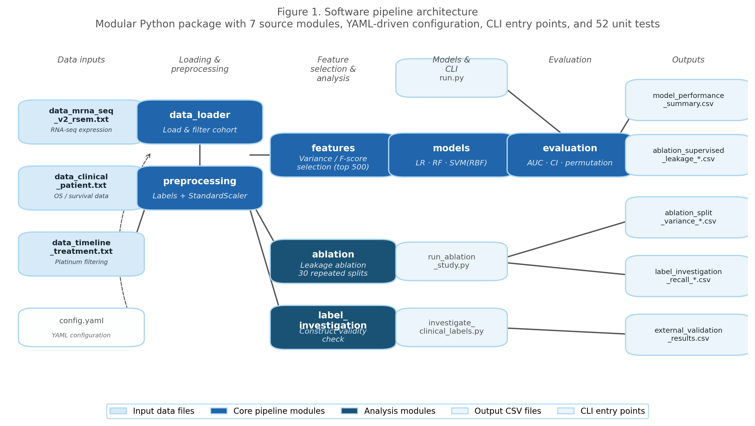
Figure 1. Software pipeline architecture. Modular Python package with seven source modules (data_loader, preprocessing, features, models, evaluation, ablation, label_investigation), YAML-driven configuration, and three CLI entry points. Arrows show data flow from raw TCGA input files through feature selection and model training to output CSVs.

3.2 Feature Selection Leakage Ablation (Finding 1)
Table 2 summarises the mean AUC inflation (leaky minus clean) for supervised F-score selection and unsupervised variance selection across the three OS-threshold label definitions.

Table 2. AUC inflation from supervised vs. unsupervised feature selection (30-split mean ΔAUC)
Model | Threshold | Supervised ΔAUC | Unsupervised ΔAUC | p (supervised)
Logistic Regression | 12m | −0.004 | +0.003 | ns
Logistic Regression | 18m | +0.065 | +0.009 | ns
Logistic Regression | 24m | +0.219 | −0.004 | p < 0.0001
Random Forest | 12m | +0.220 | +0.020 | p < 0.0001
Random Forest | 18m | +0.224 | +0.044 | p < 0.0001
Random Forest | 24m | +0.117 | −0.009 | p < 0.0001
SVM (RBF) | 12m | +0.552 | +0.053 | p < 0.0001
SVM (RBF) | 18m | +0.338 | +0.020 | p < 0.0001
SVM (RBF) | 24m | +0.281 | −0.040 | p < 0.0001
Mean | all | +0.223 | +0.011 | —

Supervised F-score selection produced substantial AUC inflation across all model×threshold combinations. The largest single inflation observed was +0.55 for SVM at the 12-month threshold — a value that would transform the SVM’s AUC of 0.45 into an apparent 1.00, an artefact entirely attributable to leakage. The mean inflation across all nine model×threshold combinations was +0.22 (range: −0.004 to +0.55). Seven of nine combinations were statistically significant at p < 0.0001 by paired Wilcoxon signed-rank test. Unsupervised variance selection, in contrast, showed negligible inflation (mean +0.01 to +0.02 across thresholds), largely non-significant, with negligible effect sizes (max ΔAUC = +0.053) in the three combinations reaching p < 0.05. This confirms that the distinction between supervised and unsupervised feature selection is the primary driver of leakage, not the choice of classifier or OS threshold.
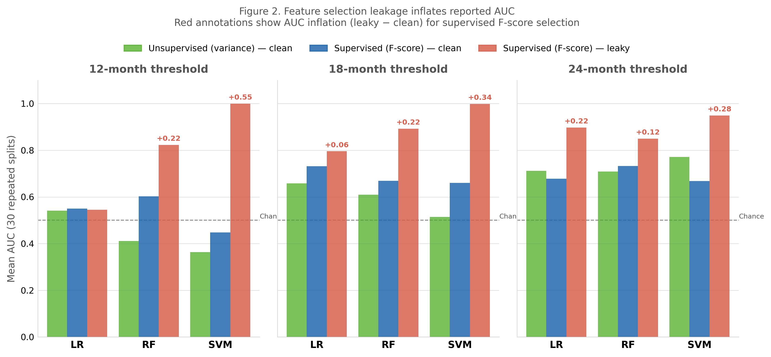
Figure 2. Feature selection leakage ablation results. Grouped bars show mean AUC (30 repeated splits) for unsupervised variance selection (clean; green), supervised F-score selection with correct train-only computation (blue), and supervised F-score selection with leaky full-dataset computation (red). Red annotations indicate AUC inflation (leaky − clean). Dashed line marks chance level (AUC = 0.5).
The practical implication is that published AUC values for platinum-response classifiers that use supervised feature selection without specifying split order may be substantially inflated. The leakage mechanism is straightforward: when F-scores are computed on the full dataset, the test samples’ labels have already implicitly informed which genes are selected, giving the classifier access to test-label information at training time.

3.3 Label Construct Validity (Finding 2)
Of the 214 patients in the 12-month platinum cohort, PRIMARY_THERAPY_OUTCOME_SUCCESS was non-null for 24 patients (11.2%). Among these, seven were confirmed Progressive Disease. The 12-month OS-threshold proxy label was assessed for its ability to identify these seven confirmed non-responders.
The OS-threshold label showed zero recall on confirmed Progressive Disease patients: 0 of 5 (among the subset where both fields were non-null; 95% CI: [0.000, 0.522]). All five confirmed Progressive Disease patients were classified as ‘long survival’ (label = 0) by the OS-threshold definition, meaning the proxy label actively contradicted the clinical assessment in every case where both were available.
This finding reflects a genuine construct-validity failure rather than a measurement error. OS-threshold labels capture long-run mortality trajectory — a patient may be a confirmed non-responder to platinum yet survive longer than the threshold due to second-line therapy, supportive care, or unrelated health factors. Primary therapy outcome, in contrast, captures the attending oncologist’s assessment specifically of first-line platinum response. These are genuinely different clinical constructs that are not interchangeable as binary labels for training.
Secondary covariates assessed for potential inclusion in future Cox modelling showed mixed coverage: GRADE had 82% coverage but 83% of patients were Grade 3, leaving insufficient variance for covariate adjustment. TMB (tumour mutation burden) had 91% coverage and ANEUPLOIDY_SCORE had 96% coverage; both are viable candidates for future analysis.

3.4 External Validation on GSE63885 (Finding 3)
Table 3 presents AUC values for all classifiers applied to the harmonised GSE63885 microarray cohort using clinical response labels (CR/PR vs. P/SD). Table 4 presents AUC values using DFS-derived labels (sensitive vs. resistant).

Table 3. External validation AUC — Clinical label (CR/PR=0 vs P/SD=1, n=74)
Model | 12-month AUC | 18-month AUC | 24-month AUC
Logistic Regression | 0.503 | 0.494 | 0.491
Random Forest | 0.512 | 0.581 | 0.356
SVM (RBF) | 0.431 | 0.477 | 0.603

Table 4. External validation AUC — DFS label (sensitive=0 vs resistant=1, n=74)
Model | 12-month AUC | 18-month AUC | 24-month AUC
Logistic Regression | 0.526 | 0.557 | 0.456
Random Forest | 0.600 | 0.502 | 0.444
SVM (RBF) | 0.413 | 0.460 | 0.501

All classifiers performed near chance level on both label sets. AUC ranged from 0.356 to 0.603, with no model×threshold combination consistently exceeding 0.60. The severe class imbalance in the clinical label set (64 vs. 10) further limits interpretability of those AUC estimates. The DFS label set, which is more balanced (40 vs. 34), similarly produced no convincing signal.
A key diagnostic revealed the mechanism of failure: post-ComBat inter-platform Pearson correlation between TCGA and GSE63885 gene-level mean expression was r = −0.005 — effectively zero. This indicates that ComBat batch correction was unable to align the RNA-seq and microarray distributions, an expected limitation given that the two platforms have fundamentally different technical properties. The TCGA data are RSEM-normalised read counts (approximately log-normal with floor at zero), while GSE63885 data are log2 RMA signal intensities with a distinct lower bound and dynamic range. Z-scoring within each dataset before ComBat does not resolve these structural differences.
A supplementary diagnostic confirmed that feature selection was not the bottleneck: the median variance of TCGA top-500 genes in the GEO dataset was identical to the median variance of all GEO genes (ratio = 1.00×), meaning the selected features are not particularly informative in the microarray space.

4. Discussion
The three findings reported here have distinct but complementary implications for genomic machine learning applied to cancer treatment response.

4.1 Feature Selection Leakage is Quantitatively Large
The +0.22 mean AUC inflation from supervised feature selection is not a subtle or theoretical concern. At the extreme (SVM, 12 months), a classifier with true discriminative power near chance (AUC 0.45) could be reported as near-perfect (AUC ~1.00) if features are selected on the full dataset. Researchers comparing classifiers in the literature are unlikely to be comparing methods on equal footing unless the feature-selection order is standardised and reported. The finding that unsupervised variance selection produces negligible inflation provides a practical recommendation: variance-based pre-filtering, applied before the train–test split, is a leakage-free alternative for dimensionality reduction and does not require labels.
Notably, the magnitude of leakage is threshold-dependent: the 12-month threshold produced the largest inflations, likely because the class balance is most extreme at this cutoff (few patients survive less than 12 months in HGSOC), making label-correlated genes easiest to identify spuriously on small test sets.

4.2 OS-Threshold Labels are Inappropriate for Drug-Response Classification
The zero-recall finding for OS-threshold labels on confirmed Progressive Disease patients is alarming as a construct-validity result. The small n (5 patients with both fields non-null) prevents a definitive statistical statement, but the direction is unambiguous: every confirmed non-responder in the available data was misclassified as a long-survivor by the OS threshold. This is consistent with the known clinical biology of HGSOC: patients with progressive disease on platinum can be transitioned to second-line taxane, bevacizumab, or PARP inhibitor therapy [5,6], extending survival substantially beyond any fixed month threshold.
The implication for future work is clear: classifiers targeting first-line platinum response should not be trained on OS-threshold labels unless independently validated against direct treatment-response annotations. TCGA’s PRIMARY_THERAPY_OUTCOME_SUCCESS field, despite its sparse coverage (11% in this cohort), is a more appropriate — if underpowered — training label. Richer data sources such as PTRC-HGSOC, which include longitudinal treatment records and response assessments, are preferable but require data-access approval.

4.3 RNA-seq Classifiers Do Not Transfer to Microarray Cohorts via ComBat
The external validation failure, mechanistically explained by the r = −0.005 post-ComBat inter-platform correlation, carries a direct practical warning: cross-platform validation using ComBat is not a reliable method for assessing generalisation between RNA-seq and microarray datasets. The distributional differences between RSEM and RMA are not addressable by an additive batch-effect model. Future validation studies that cross platforms should employ reference-based methods, quantile normalisation against a matched reference, or retrain classifiers in the target platform’s distributional space.
The finding that feature selection was not the bottleneck (variance ratio = 1.00×) is informative: this rules out the hypothesis that TCGA’s most variable genes are simply less variable in the microarray space. The failure is a platform-harmonisation problem, not a feature-quality problem.
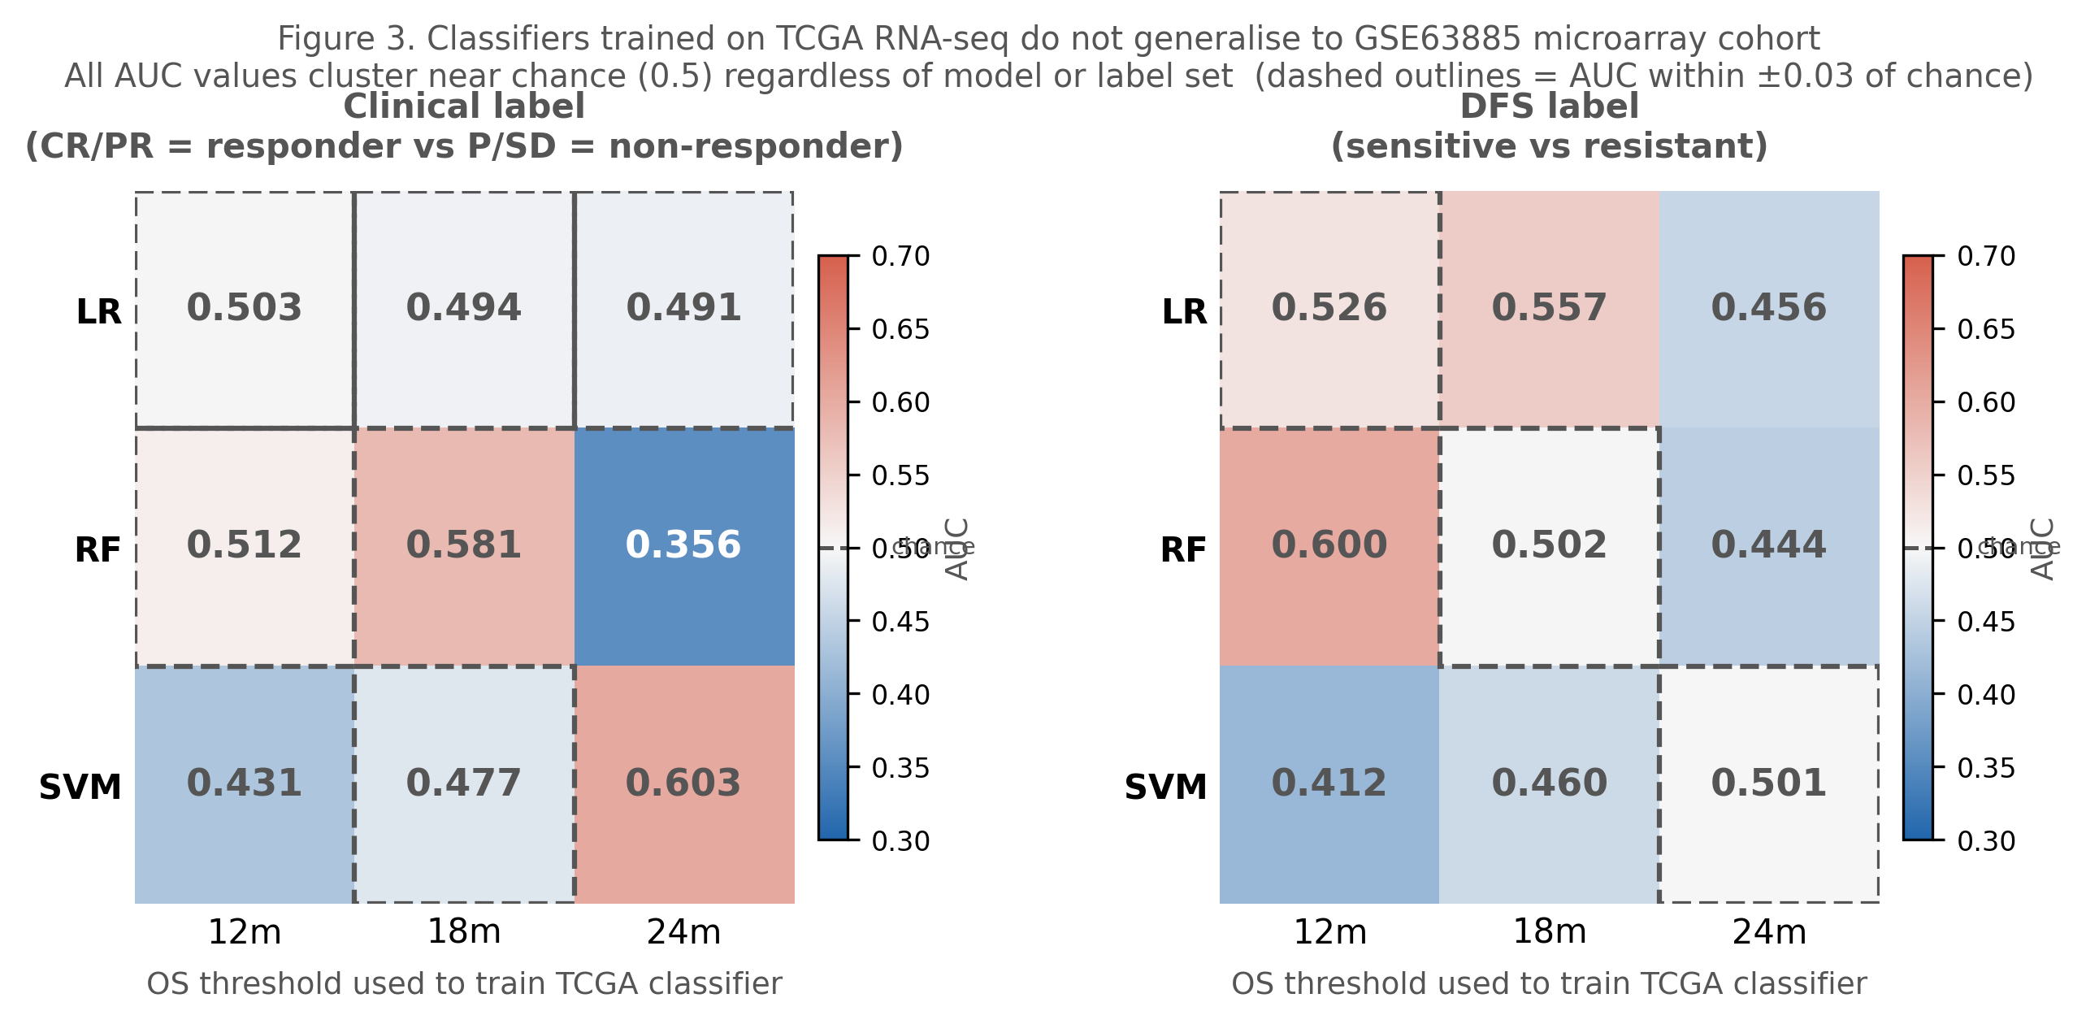
Figure 3. External validation AUC on the GSE63885 microarray cohort. Heatmaps show AUC for each model × OS threshold combination under clinical response labels (left; CR/PR vs P/SD, n = 74) and DFS-derived labels (right; sensitive vs resistant, n = 74). All values cluster near chance level (0.5), consistent with the post-ComBat inter-platform Pearson r = −0.005.

4.4 Relationship Between Findings
The three findings are complementary. Finding 1 shows that the pipeline’s training-phase performance estimates cannot be trusted at face value without specifying feature-selection order. Finding 2 shows that even with clean feature selection, the training labels are poor proxies for the clinical construct of interest. Finding 3 shows that, even granting both the performance estimates and the labels, the classifiers do not generalise across platforms. Together they constitute a cascading audit: each finding would independently motivate a re-evaluation of the literature; together they suggest that published platinum-response AUC values should be interpreted with substantial caution.

4.5 Limitations
Several limitations should be acknowledged. The confirmed Progressive Disease sample is very small (n = 7; n = 5 with both fields non-null), limiting the power of the construct-validity analysis. The external validation cohort (GSE63885) has a severely imbalanced clinical label set and would benefit from additional validation on cohorts such as GSE32062 or GSE26712. The binary OS-threshold framework for training labels is unlikely to be superseded by simple covariate additions; a fundamentally different label strategy (e.g., direct response annotation or PFI-based platinum-free interval) is warranted. Finally, we did not explore deep-learning architectures or graph-based methods; the findings here are specific to the three shallow classifiers evaluated.

5. Conclusion
We present an open-source, modular Python pipeline for platinum-response classification in HGSOC and report three methodologically important findings. Supervised feature selection inflates reported AUC by a mean of +0.22 (up to +0.55) due to label leakage into the feature space; unsupervised variance selection is the appropriate leakage-free alternative. OS-threshold proxy labels fail to identify confirmed Progressive Disease patients (0/5 recall), indicating a construct-validity gap between mortality trajectory and first-line drug-response labels. External validation on an independent microarray cohort yields near-chance AUC (0.36–0.60) for all classifiers, with inter-platform correlation r = −0.005 after ComBat, confirming that RNA-seq-trained classifiers do not generalise across platforms by standard batch-correction methods.
These findings do not invalidate the use of machine learning in platinum-response research; rather, they define the conditions under which reported performance is meaningful. The software pipeline, ablation tools, and validation scripts are publicly available and designed to be reusable on future datasets.

Data Availability
The software pipeline is available at https://github.com/AaronC-bioinfo/ovarian-cancer-platinum-response under an MIT licence (Zenodo DOI: 10.5281/zenodo.20802753; concept DOI: 10.5281/zenodo.20802754). TCGA Ovarian Serous Cystadenocarcinoma (PanCancer Atlas 2018) data are publicly available via cBioPortal (https://www.cbioportal.org). GSE63885 is publicly available via NCBI GEO. R scripts for external validation preprocessing are included in the validation/ subdirectory of the repository.

Competing Interests
The author declares no competing interests.

References
[1] Cancer Genome Atlas Research Network. Integrated genomic analyses of ovarian carcinoma. Nature. 2011;474(7353):609–615. doi:10.1038/nature10166
[2] Jayson GC, Kohn EC, Kitchener HC, Ledermann JA. Ovarian cancer. Lancet. 2014;384(9951):1376–1388. doi:10.1016/S0140-6736(13)62146-7
[3] Markman M, Rothman R, Hakes T, et al. Second-line platinum therapy in patients with ovarian cancer previously treated with cisplatin. J Clin Oncol. 1991;9(3):389–393. doi:10.1200/JCO.1991.9.3.389
[4] Markman M, Hoskins WJ. Responses to salvage chemotherapy in ovarian cancer: a critical need for precise definitions of the treated population. J Clin Oncol. 1992;10(4):513–514. doi:10.1200/JCO.1992.10.4.513
[5] Pujade-Lauraine E, Hilpert F, Weber B, et al. Bevacizumab combined with chemotherapy for platinum-resistant recurrent ovarian cancer: the AURELIA open-label randomized phase III trial. J Clin Oncol. 2014;32(13):1302–1308. doi:10.1200/JCO.2013.51.4489
[6] Pujade-Lauraine E, Ledermann JA, Selle F, et al.; SOLO2/ENGOT-Ov21 investigators. Olaparib tablets as maintenance therapy in patients with platinum-sensitive, relapsed ovarian cancer and a BRCA1/2 mutation (SOLO2/ENGOT-Ov21): a double-blind, randomised, placebo-controlled, phase 3 trial. Lancet Oncol. 2017;18(9):1274–1284. doi:10.1016/S1470-2045(17)30469-2
[7] Sun J, Bao S, Xu D, et al. Large-scale integrated analysis of ovarian cancer tumors and cell lines identifies an individualized gene expression signature for predicting response to platinum-based chemotherapy. Cell Death Dis. 2019;10(9):661. doi:10.1038/s41419-019-1874-9
[8] Chen S, Wu Y, Wang S, et al. A risk model of gene signatures for predicting platinum response and survival in ovarian cancer. J Ovarian Res. 2022;15:39. doi:10.1186/s13048-022-00969-3
[9] Amniouel S, Yalamanchili K, Sankararaman S, Jafri MS. Evaluating ovarian cancer chemotherapy response using gene expression data and machine learning. BioMedInformatics. 2024;4(2):1396–1424. doi:10.3390/biomedinformatics4020077
[10] Cawley GC, Talbot NLC. On over-fitting in model selection and subsequent selection bias in performance evaluation. J Mach Learn Res. 2010;11:2079–2107.
[11] Kaufman S, Rosset S, Perlich C, Hardt O. Leakage in data mining: formulation, detection, and avoidance. ACM Trans Knowl Discov Data. 2012;6(4):1–21. doi:10.1145/2382577.2382579
[12] Johnson WE, Li C, Rabinovic A. Adjusting batch effects in microarray expression data using empirical Bayes methods. Biostatistics. 2007;8(1):118–127. doi:10.1093/biostatistics/kxj037
[13] Lisowska KM, et al. Molecular signature of platinum sensitivity in high-grade serous ovarian cancer cell lines and tumors. Front Oncol. 2014;4:376. doi:10.3389/fonc.2014.00376
[14] Tothill RW, et al. Novel molecular subtypes of serous and endometrioid ovarian cancer linked to clinical outcome. Clin Cancer Res. 2008;14(16):5198–5208. doi:10.1158/1078-0432.CCR-08-0196
[15] Pedregosa F, et al. Scikit-learn: machine learning in Python. J Mach Learn Res. 2011;12:2825–2830.
[16] Zweig MH, Campbell G. Receiver-operating characteristic (ROC) plots: a fundamental evaluation tool in clinical medicine. Clin Chem. 1993;39(4):561–577.

