Aaron Ciantar
IMAD PROPOSAL

FitTracker App

The application I will be working on is a workout planner called FitTracker. This app will help people who lack to keep their workouts up to date. Users will be able to create workouts, add exercises with sets and repetitions, and view their workouts in a structured format while also having the option to add, view, edit or delete workouts. The application will include multiple screens, allowing users to navigate using a tab menu and router links. Each workout can be opened to display its exercises, where users can also mark exercises as completed using checkboxes.

Workout Page

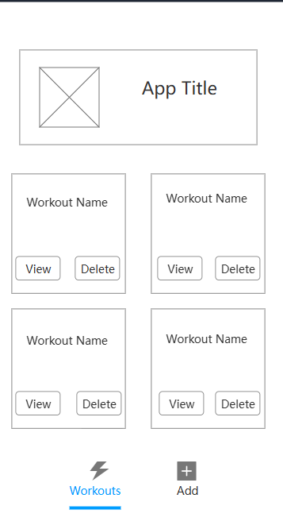

Add Page

v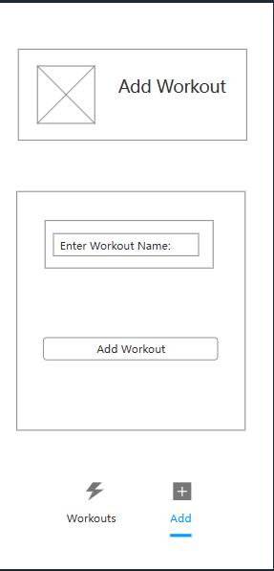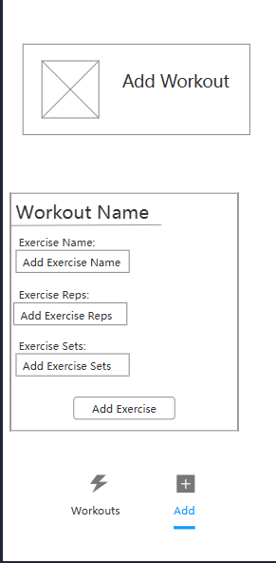

View/Work out details Page
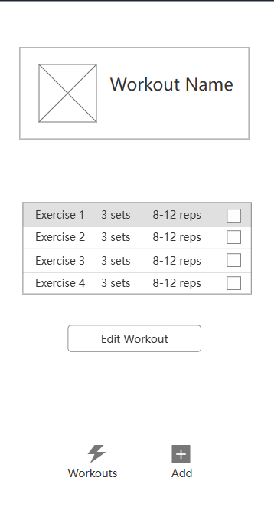

Delete Confirmation
