**System Analysis Use Cases**

**ITIS 6112**

**Scott Souza, Aaron Crandall, Emil Kozicki**

**Use Case 1**

Title: "See a crime"

Actor: any user.

Use Case: A person sees a crime occurring through the window right outside their apartment complex. They grab their phone and go to Surrounded by Crime’s website to report it, so that other residents of the complex are aware that something has happened.

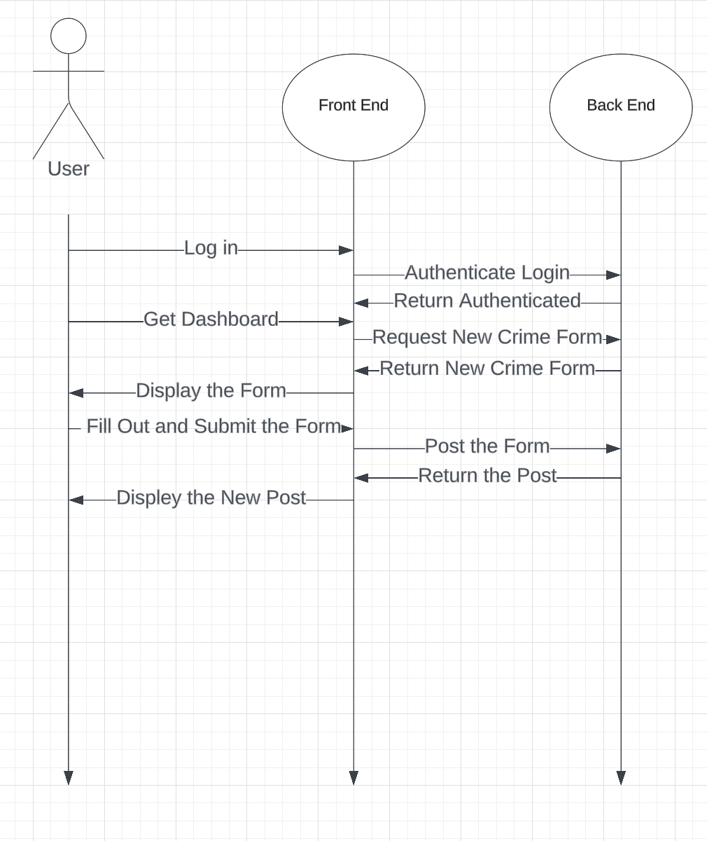

**Use Case 2**

Title: “Wants to know about crime”

Actor: any user.

Use Case: A person desires to know if any crime has happened within 15 miles of their current location. They go to “Surrounded by Crime” and log in or make a new account if the user is new. Once logged in they can set their preference for 15 miles. They will then see a list of all crimes reported within 15 miles of their location.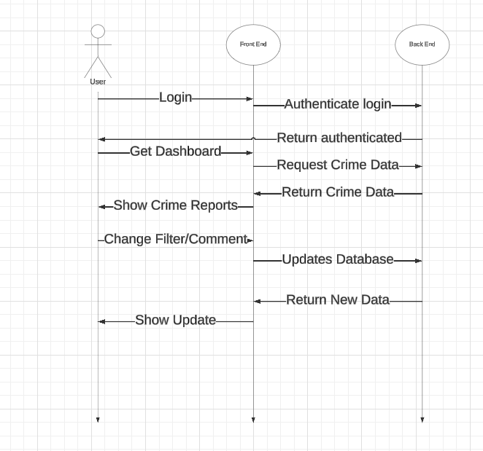

**Use Case 3**

Title: "Talk about crime"

Actors: two users both within the range to see the same crime.

Use case: A person using the application logs in and views the crimes that have been recently reported. They want to be able to see what other people are saying about the reported crime and comment themselves if they have any additional info on the event.

