**Project : creating a browser-based cookie clicker game**

**Core functionality (core tasks/features of the program)**

- Clicking the cookie increase the "score" aka amount of cookies by a certain amount.

*Check*

- The passive amount/amount per click is modified via purchaseable upgrades.

1. more points per click

2. passive amount over time with an autoclicker

*Check*

- Visual cue if upgrade is possible/not possible depending on border color

Green : can afford upgrade

Red : cannot yet afford upgrade

*Check*

- Milestone every so often, Eddy Wally pops up and says "waw"

**Check, BUT needs to disappear after like 2 seconds, interval callback function and remove on click?**

- Clicks per second tracking

(Optional (feasible??) : Button with 2x points for a given duration randomly pops up on the screen)

**Roadmap**

1) Make the core elements in HTML. Give said elements clear classes/ID's.

2) Declare the necessary variables in the script.js file.

Cookies, clicks, buttons,...

3) Get basic funtionality going :

- clicking cookie increases total score.

- clicking the upgrade buttons gives feedback

- score modifier via upgrades works

…

4) Get a raw CSS template to visualize where everything will go.

5) Code the more extensive core functionalities.

6) Finalize the CSS.

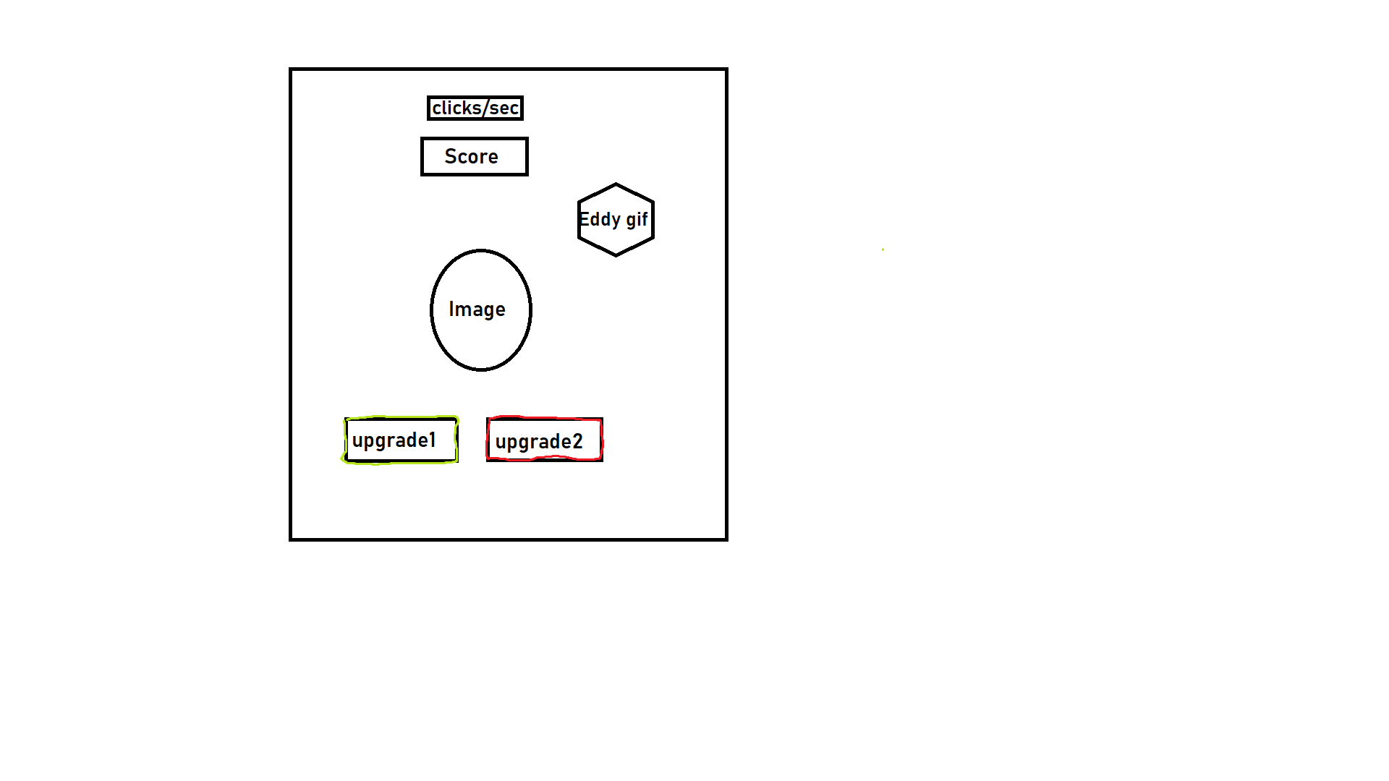**CSS TEMPLATE**