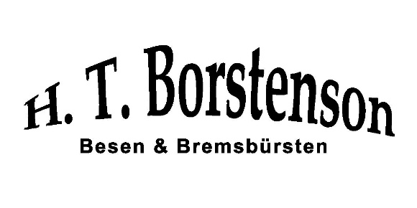**Borstenson Pricelist 2018**

**Pot Brushes**

Over 100 tufts of high quality synthetic fiber help the brush to keep its shape and make cleaning both easier and more efficient. It’s available in two sizes: 9” and 20” both with a 2” trim.

|  |  |  |
| --- | --- | --- |
| Product Number | Description | Price |
| BOP.214.91901 | White Epoxy Set Scrub 9” long | $11.30 |
| BOP.214.42919 | White Epoxy Set Scrub 20” long Also available in staple set 9197 | $12.60 |
| BOP.214.19887 | Showcase Brush Green Synthetic Staple Set | $22.71 |
| BOP.098.22312 | Half Gallon Brush Synthetic 16” long, 3 1/2” dia. | $89.10 |
| BOP.214.88751 | Metal Polish/Cleaner 16 0z. | $33.23 |
| BOP.214.00031 | White Scrub Brush 6 1/2” long with 1 1/4” trim | $98.60 |
| BOP.214.29983 | Medium Muffin Pan Brush 2 3/4” top dia | $34.90 |
|  |  |  |

**Brooms and Dust Pans**

Premium quality carpet broom has a long, hard and specially treated fibers bristles that removes dust and dirt easily from surfaces. Can be used to clean carpets, mats, home interiors, car seats, sofa covers etc. It can be used to even delicate surfaces as it does not scratch or damage them. It can be used repeatedly and is long lasting. Its bristles can be cleaned from time to time.

|  |  |  |
| --- | --- | --- |
| Product Number | Description | Price |
| BOP.003.13401 | Polyguards Carpet Broom - 13010, Assorted Color | $31.30 |
| BOP.003.12419 | LIAO Dustpan - Plastic With Broom Set Oval With Steel Stick • Brand-Liao • Type-Broom set • Model no-C130006 • Colour-Red & Grey • Material-Plastic/Nylon bristle • Weight-360 gm • Dimension-25X24.5X92(LxWxH) Cm • No of pcs-2 pcs. | $19.60 |
| BOP.003.77687 | Milton Plastic Microfiber Zero Dust Broom MILTON SPOTZERO Zero-Dust broom is made from synthetic fibers. It is stronger and more durable than traditional grass brooms. Its handle is made from quality virgin plastic. It is suitable for cleaning dry as well as wet surface. It is washable after use | $29.74 |
| BOP.098.22313 | Nakoda Mr. Clean Dust Pan & Bin - Big | $18.12 |
| BOP.003.68757 | Micky Broom - Plastic | $31.34 |

[sales@borstenson.com](mailto:sales@borstenson.com)