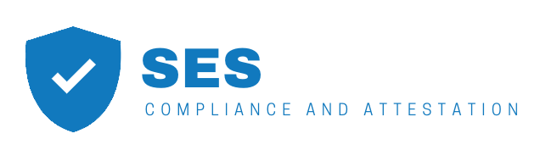

page1image30049024

**CERTIFICATE OF REGISTRATION**

Information Security Management System - ISO/IEC 27001:2013

page1image30049024

The Certification Body of SES hereby certifies that the following organization operates an Information Security Management System that conforms to the requirements of ISO/IEC 27001:2013

**HackerBay, Inc.**

**2711 Centerville Road, Wilmington, Delaware 19808**

for the following scope of registration

**The scope of the ISO/IEC 27001:2013 certification covers the information security management system (ISMS) supporting the information assets, business operations and physical location of HackerBay, Inc., and in accordance with the Statement of Applicability dated May 25, 2018 and aligned with ISO/IEC 27017:2015 and ISO/IEC 27018:2014. The scope of the ISMS includes:**

Fyipe Platform

* Fyipe Native Client Applications
* Fyipe Web Applications and Services
* Fyipe Application Programming Interfaces (“APIs”)

which includes the following in-scope location(s) on page 2 of 2

**The ISMS also includes the cloud based infrastructure located in all regions in the United States hosted by Amazon Web Services (AWS), Microsoft Azure (Azure), and the Google Cloud Platform (GCP).**

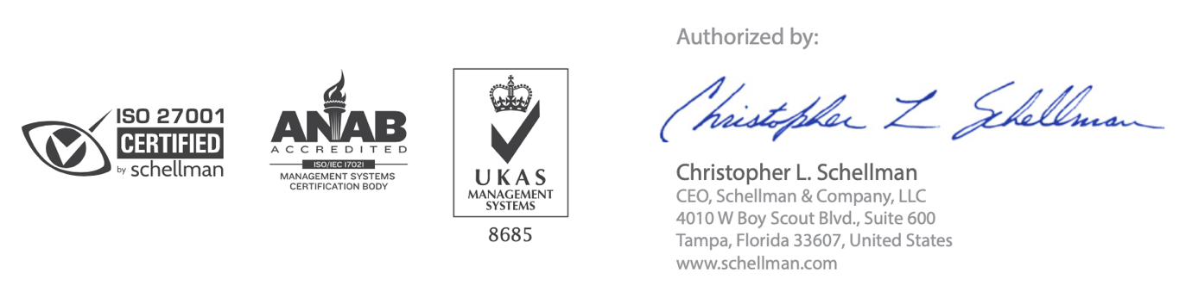Certificate Number: **1203812-2** 

Authorized By

**Kamrin Danielle**

Attestation Officer, SES Compliance and Attestaton. 25 Broadway 9th Floor, New York, NY 10004, United States.

Website: www.sesattest.com

**October 12, 2019 October 3, 2018 October 9, 2021 2**

Certificate Number: **1203812-2** page2image30007936

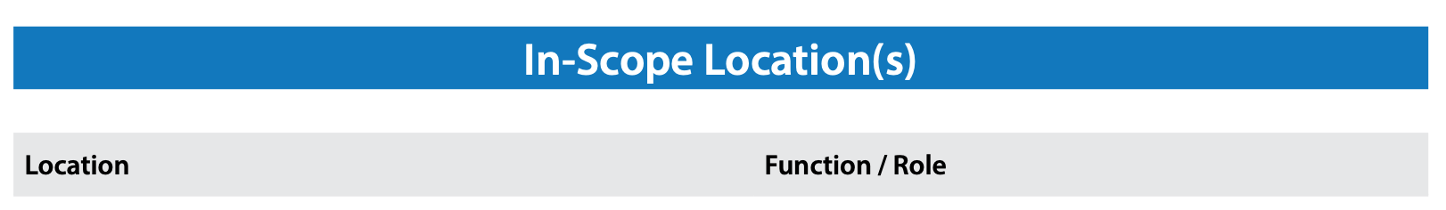

|  |  |
| --- | --- |
| Boston, MA United States | Management activities for HackerBay, Inc. Information Security Management System (“ISMS”) and operations supporting Fyipe Platform |

page2image30007936

CONDITIONS & LIMITATIONS:  
1. The aforementioned organization has a perpetual responsibility to maintain compliance with ISO/IEC 27001:2013 during the period of certification.

1. This certificate is subject to the satisfactory completion of annual surveillance audits by SES
2. ISO/IEC 27001:2013 compliance audits are not designed to detect or prevent criminal activity or other acts that may result in an information security breach. As such, this certification should not be

construed as a guarantee or assurance that an organization is unsusceptible to information security breaches.

1. The information in this document is provided “AS IS”, without warranties of any kind. SES expressly disclaims any representations and warranties, including, without limitation,

the implied warranties of merchantability and fitness for a particular purpose.

1. This certificate is the property of SES and is bound by the conditions of contract. The authenticity of this certificate can be validated by contacting SES