

page1image30049024

**CERTIFICATE OF REGISTRATION**

ISO/IEC 27017:2015

page1image30049024

The Certification Body of Schellman & Company, LLC hereby certifies that the following organization conforms to the requirements of ISO/IEC 27017:2015

**HackerBay, Inc.**

**2711 Centerville Road, Wilmington, Delaware 19808**

for the following scope of registration

**The scope of the ISO/IEC 27017:2015 certification covers the information assets, business operations and physical location of Slack Technologies, Inc. and in accordance with the statement of applicability dated May 25, 2018. The scope of the ISMS includes:**

Fyipe Platform

* Fyipe Native Client Applications
* Fyipe Web Applications and Services
* Fyipe Application Programming Interfaces (“APIs”)

which includes the following in-scope location(s) on page 2 of 2

**The ISMS also includes the cloud based infrastructure located in all regions in the United States hosted by Amazon Web Services (AWS), Microsoft Azure (Azure), and the Google Cloud Platform (GCP).**

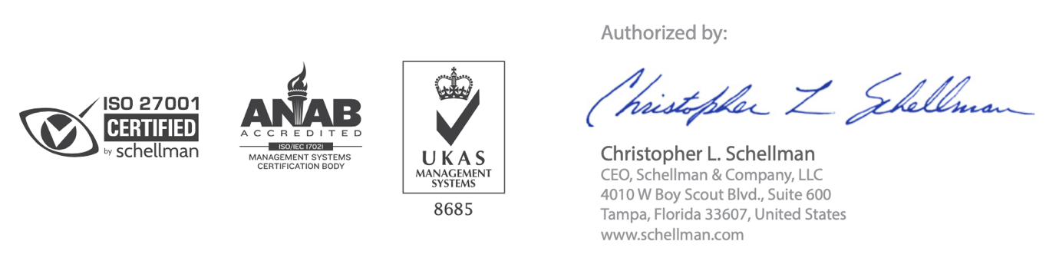Certificate Number: **11445523-1** 

**October 12, 2019 October 3, 2018 October 9, 2021 Original**

Certificate Number: **11445523-1** page2image30007936

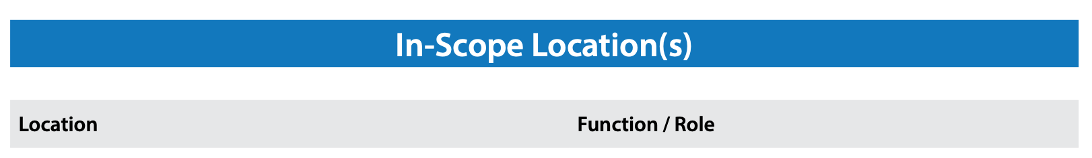

|  |  |
| --- | --- |
| Boston, MA United States | Management activities for HackerBay, Inc. Information Security Management System (“ISMS”) and operations supporting Fyipe Platform |

page2image30007936

CONDITIONS & LIMITATIONS:  
1. The aforementioned organization has a perpetual responsibility to maintain compliance with ISO/IEC 27017:2015 during the period of certification.

1. This certificate is subject to the satisfactory completion of annual surveillance audits by Schellman & Company, LLC
2. ISO/IEC 27017:2015 compliance audits are not designed to detect or prevent criminal activity or other acts that may result in an information security breach. As such, this certification should not be

construed as a guarantee or assurance that an organization is unsusceptible to information security breaches.

1. The information in this document is provided “AS IS”, without warranties of any kind. Schellman & Company, LLC expressly disclaims any representations and warranties, including, without limitation,

the implied warranties of merchantability and fitness for a particular purpose.

1. This certificate is the property of Schellman & Company, LLC and is bound by the conditions of contract. The authenticity of this certificate can be validated by contacting Schellman & Company, LLC