CP471 Assignment 1

Lexical Analyser Documentation

Aaron Exley (160589710)

Finishing the definition of the language:

$$<multiDigit> :≔ <digit>|<multiDigit><digit>$$

$$<integer> :≔ <multiDigit>$$

$|<multiDigit>e<multiDigit>$

$|<multiDigit>e<multiDigit>$

$$<decimalDigit> ∷=<multiDigit>.<multiDigit>$$

$$<double> ∷= <decimalDigit>$$

$|<decimalDigit> e<multiDigit>$

$|<decimalDigit> e-<multiDigit>$

Lexical analyser diagrams and Implementation:

Main decision based on current the current char that has been read. (Note: \* indicates put last char back into input stream.

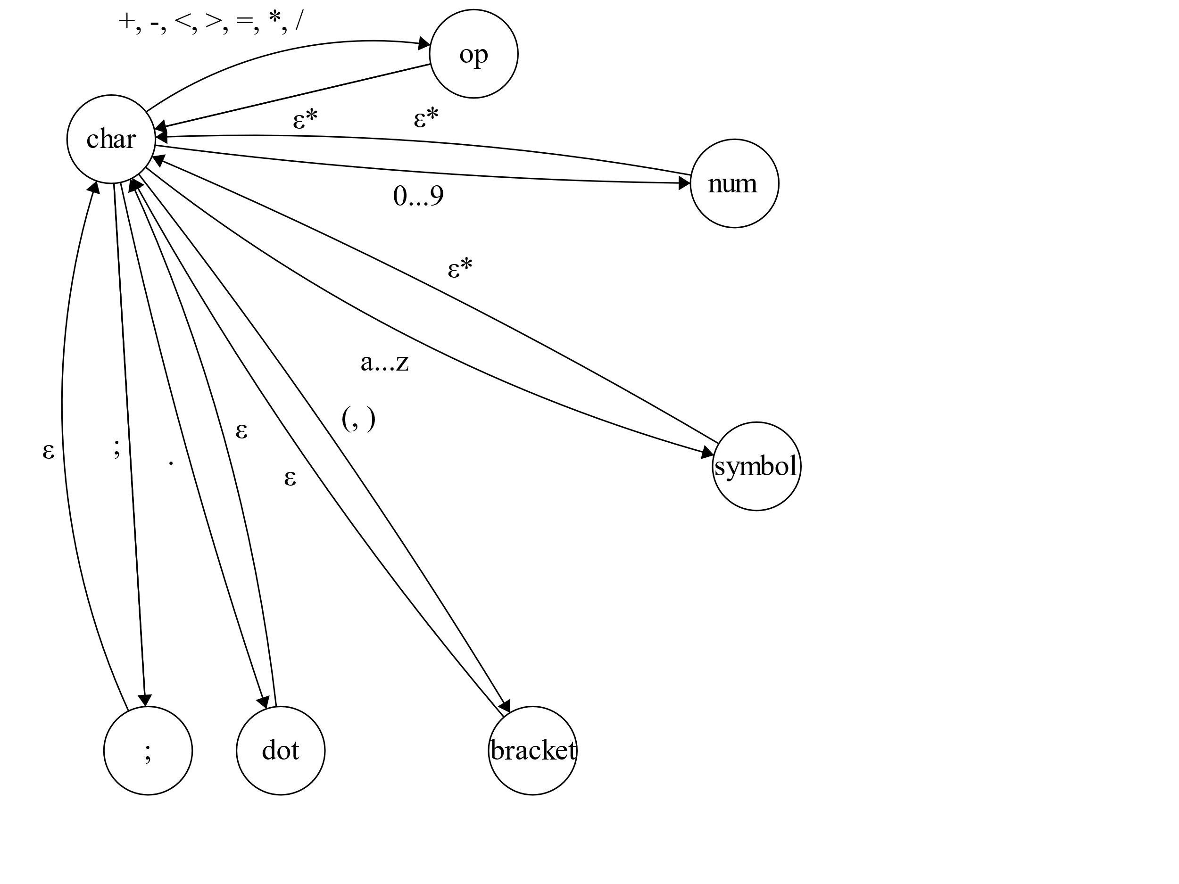

When in the num state continue here. When in one of the accepting states install the token and return to the main diagram.

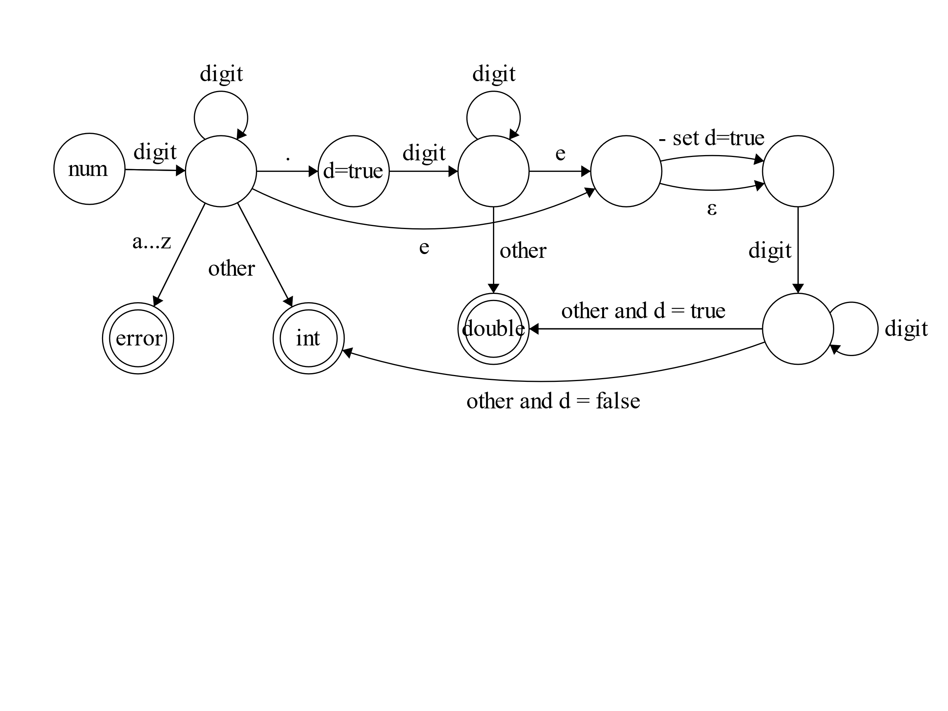

When in the symbol state continue here. When in one of the accepting states install the token and return to the main diagram.

