CALIFORNIA STATE UNIVERSITY, NORTHRIDGE

Edge Detection in FPGA: Sobel Filter Design

A graduate project submitted in partial fulfillment of the requirements
For the degree of Master of Science in Computer Engineering

By
Aaron Guadalupe Funes

December 2026
(Official end of the semester)

The graduate project of Aaron Funes is approved:

_______________________________ _____________
Professor Aaron Nanas Date

_______________________________ _____________
Dr. Myung Cho Date

_______________________________ _____________
Dr. Shahnam Mirzaei, Chair Date

Table of Contents
Signature Page ii
List of Tables iv
List of Figures v
Abstract vi
Introduction 1
Design Decisions
Results

List of Tables
No table of figures entries found.
List of Figures
Figure 1 : Original Image 1
Figure 2 : Post-processed image with edge detection applied 1
Figure 3: X and Y Filter 2
Figure 4 : Filter Operation 2

Acronym List
FPGA | Field-Programmable Gate Array
PL | Programmable Logic
AP SOC | All-Programmable System-On-Chip
PS | Processing System

Abstract

Edge Detection in FPGA: Sobel Filter Design
By
Aaron Guadalupe Funes
Master of Science in Computer Engineering

Edge detection algorithms are an important image processing technique used in our current world. They are used across many applications, medical devices, surveillance systems, and autonomous systems for example. The Sobel Filter is an edge detection algorithm that applies a 3x3 filter upon a subsection of an image to find any edges that may exist. When performed in software the filter is applied consecutively through the data of the image. With the use of a Field-Programmable Gate Array (FPGA), the filter could be applied in parallel allowing the edge detection process to be sped up. In this project, an image will be loaded to the Zybo Z7-20 development board, where the filter design will exist in the programmable logic (PL), have the filter applied to the image, and output the updated image with the edge detection applied.

Introduction
Edge detection algorithms are an important image processing technique used in our current world. They are used across many applications, medical devices, surveillance systems, and autonomous systems for example. An example of edge detection is shown in Figure 1, the original image, and Figure 2, the post image processing image.
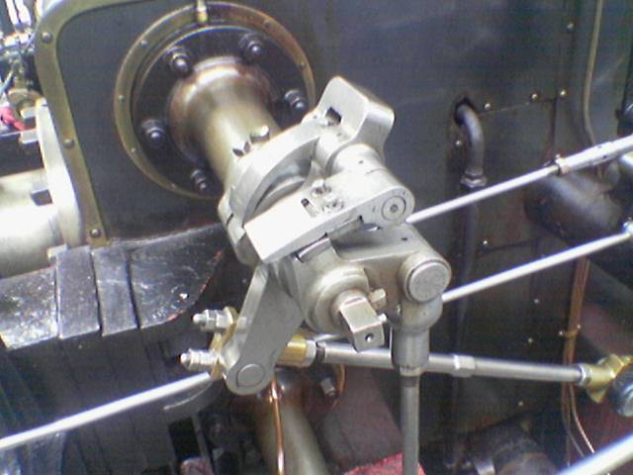
Figure 1 : Original Image
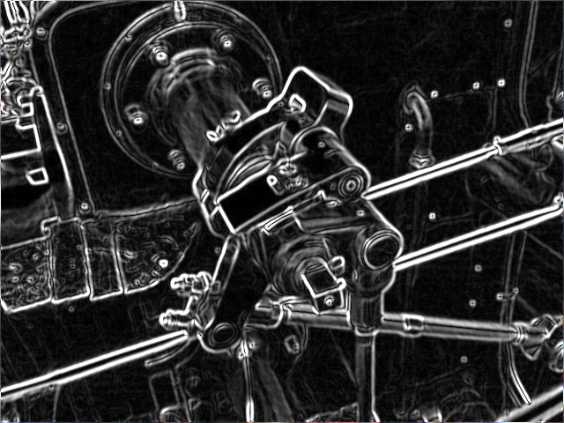
Figure 2 : Post-processed image with edge detection applied

The Sobel Filter is an edge detection algorithm that applies a 3x3 filter upon a subsection of an image to find any edges that may exist. The filter is performed by applying an X-direction derivative and a y-direction derivative, as shown in Figure 3.
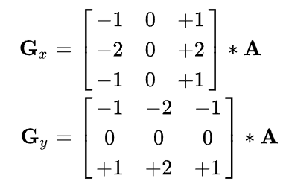
Figure 3: X and Y Filter
Once the convoluted values are found for G_{x} and G_{y}, the following equation, shown in Figure 4, is performed to get the gradient magnitude at the current position of the filter in the image.
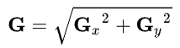
Figure 4 : Filter Operation

The Zybo Z7-20 development board is used for the application of this project. The Zybo Z7 is a All Programmable System-on-Chip (AP SoC) device. It contains a dual-core ARM Cortex-A9 processor with Field Programmable Gate Array (FPGA) logic. The board can be broken down in to two sections, programmable logic and the processing system (PS).
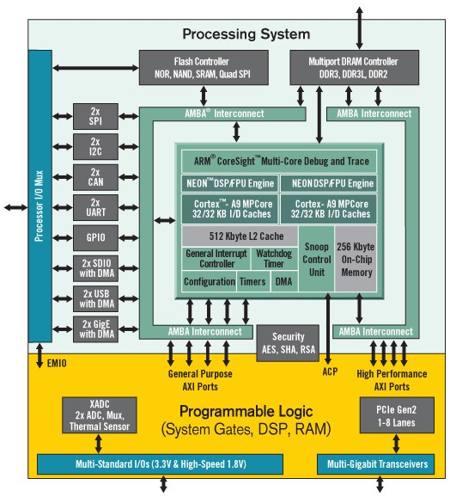
Figure 5: Zybo Block Diagram¹
In order to access the PL design for the Sobel filter, Advanced eXtensible Interface (AXI) buses are used to establish communsications with PS portion.

