

# Aaron Gavendo Assignment 3

# 300603352

# November 7th 2014

# Table of contents

Version History p. 3-4

Detailed Game Description p. 5

Controls p. 5

Interface Sketch p. 5

Screen Descriptions p. 5

Characters/Vehicles/Enemies p. 6

Scoring p. 6

Sound Index p. 7

Art / Multimedia Index p. 7

# Version History

#1

Commit Boiler Plate

#2

Add Death Sound Effect

Make Canvas side suitable for the game

Preload Background Image

Preload Tank

Make Tank Class and Draw Tank

Make Tank follow Mouse

#3

Add Enemy Pictures

Have Enemy move across the screen

Reset Enemy

#4

Add an obstacle

#5

Speed variance for enemy

#6

Add Multiple Enemy

Add Multiple Obsitical

#7

Add Enemy reset when hit by tank

Add obstacle reset when hit by tank

Add death and boom sound effects

#8

Add lives

Add a kill counter

#9

Move Classes into there own files

#10

Put Preload to its own class

#11

Add enemy variety

Make PNG transparent

#12

Make game over text

# Detailed Game Description

In this game the user contorls a tank that they use to run over enemy soliders. If they hit the solider they get a kill point. If they miss any they get miss points that are bad. There is also TNT that they must avoid. If they hit the TNT they will lose a life point. They only get three life points and then the game is over. If they get a certain amount of miss points the game is also over.

# Controls

The user manuvers the tank using the mouse. The tank follows the mouse on the screen.

# Interface Sketch

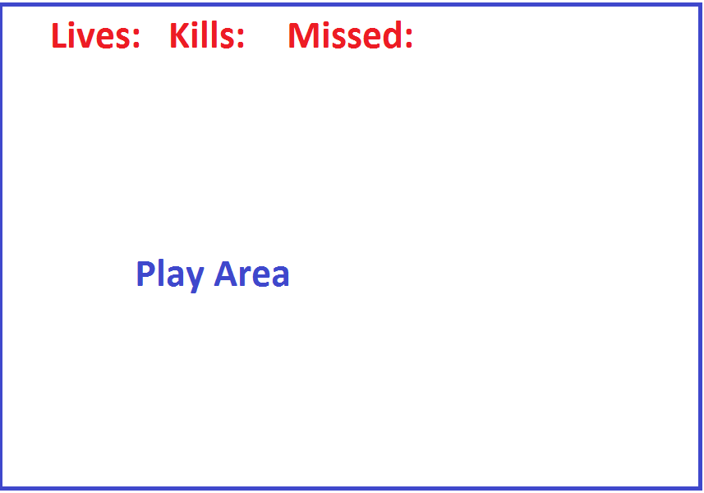

# Screen Description

## Play Screen

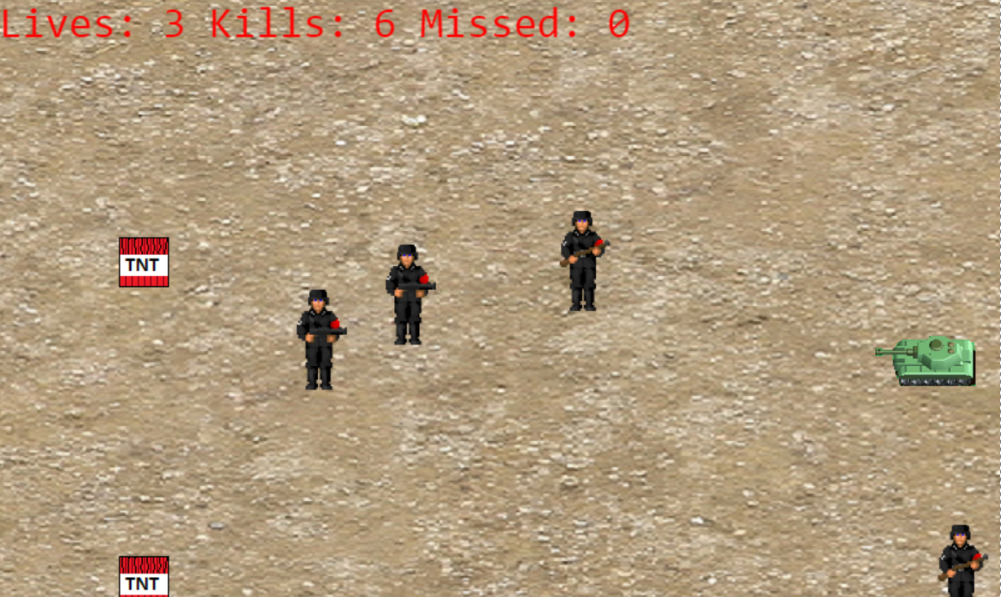

In this screen you can see four enemy soliders and two TNT. The player is trying to hit the soilders and miss the TNT. The Lives, killed and missed are also scored at the top.

# Characters/Vehicles/Enemies

The main character is a tanks that run over enemies. The enemies are soliders that are trying to get behind the tank. No character have personality, although the enemys resemble Nazi soliders so the player can root for themselves. The game will randomly pick one of three looks for the enemy soliders.

# Scoring

The user gets a point for every soilder they hit. They also get a miss point for the soilders that they miss. The points are for the user refernce but the user can't accumulate to much miss points or they lose.

# Sound Index

Death Sound: http://www.freesound.org/people/minian89/sounds/195954/

Boom Sound: http://www.freesound.org/people/Aiwha/sounds/250712/

Engine Sound: http://www.freesound.org/people/JoniHeinonen/sounds/161894/

# Art/Multimedia Index

Tank: http://cdn.scratch.mit.edu/static/site/projects/thumbnails/11/2398.png

Nazi: http://www.wolfenstein3d.co.uk/wsjallgemeinepic.gif

Grass: http://blendernerd.com/wp-content/uploads/2011/04/SoilSand0018_1_S.jpg

TNT: Self Made