Trends and Heterogeneity in Interracial Marriage in the United States, 1960-2023
Abstract
While scholars recognize that interracial marriage in the United States has grown exponentially since the 1960s, our understanding of this trend for specific racial pairings is piecemeal and thin, owing to issues with data comparability and lack of information on marriage timing between 1980 and 2007. In this article, I use log-linear models of Census and American Community Survey data to analyze trends in interracial marriage from 1960 to 2023 across major single-race groups, as well as important subgroups and large multiracial groups. Weights are applied to match the joint age distribution of currently married partners to the age distribution of newlyweds in the same time period. While the overall trend is one of exponential increase, important heterogeneity is visible when examining particular racial pairings or subgroups. Most notably, the likelihood of interracial marriage for East/Southeast Asian and American Indian/Alaska Native spouses plateaued by the end of the 20th century and has not continued to grow. On the other hand, the likelihood of interracial marriage for Black spouses, although far lower than any other group at the start of the period, has increased more rapidly than any other group. Overall, these results indicate an ongoing transformation of group boundaries.

Introduction
Since the 1960s, the frequency of marriage between spouses who identify with different racial groups has risen at an unprecedented pace (Gullickson 2006a; Rosenfeld 2008). This trend over roughly the last half century has contributed substantially to the changing racial demography of the United States. Interracial marriage is widely seen as the engine of the “biracial baby boom” in which an increasing number of people desire to identify with more than one race (Root 1992). It is a general presumption among the public that interracial marriage rates are growing rapidly and will continue to rise for the foreseeable future, signaling diminishing racial boundaries. This belief in the inevitability of interracial marriage helps to inform conceptions of a “post-racial” America in which everyone is mixed to some degree or another.
Given its importance, our knowledge of trends in interracial marriage over this period remains surprisingly piecemeal and thin. We lack a systematic examination of the trend in interracial marriage between most specific racial groups over the entire time period. Qian and Lichter (2011), which is one of the most cited scholarly treatments of the subject, only examines two points in time, 1980 and 2008. Rosenfeld (2008) only measures endogamy rather than the likelihood of specific interracial combinations (e.g. Black/White, Black/Asian). Gullickson (2006a) only examines interracial marriage between White and Black partners. None of these studies examine data beyond 2008. The most comprehensive recent analysis comes from the Pew Research Center (Livingston and Brown 2017). This report also uses two points in time, 1980 and 2015 and focuses on simple outmarriage ratios that do not account for group size differences and do not measure the frequency of particular interracial pairings.
In this article, I develop a systematic examination of the trends in interracial marriage from 1960 to 2023, using data from the US Census and the American Community Survey. I address the primary methodological challenge in developing such measures - the lack of comparable information on marital duration for much of the time period - by the use of weights that make each sample representative of the joint distribution of newlyweds in the same time period. Additionally, I handle a variety of other methodological challenges arising from changes in measurement across the time period, including the switch to a multiple check-off response to the race question since 2000. The goals of this paper are largely descriptive. However, given the overall importance of these trends and the piecemeal nature of our existing body of knowledge, such a comprehensive descriptive analysis is long overdue.
Many of my findings echo and reinforce previous work. I find, for example, that the likelihood of interracial marriage between Black and non-Black spouses has been lower than for other types of interracial marriage, but has also grown the fastest over time. However, importantly, I also find that the story of uninterrupted weakening of boundaries is inaccurate for some groups. The likelihood of exogamy for Asian/Pacific Islanders and for American Indian/Alaska Natives increased in the early period under observation, but plateaued by 1990 and has not increased since. Further analysis across a variety of subgroups reveals important heterogeneity in trends and levels of interracial marriage.

Background
The significance of interracial marriage to social systems is twofold. First, the likelihood of interracial marriage is seen as a key indicator of the social distance between groups and the strength and rigidity of the boundary separating those groups (Gordon 1964). Interracial marriage provides a window into the assimilation and integration of groups within the most intimate sphere of social life. For example, the almost complete social (and often legal) prohibition on marriage between Black and White partners for much of US history is a testament to the stark impermeability of the White/Black boundary (Moran 2001; Kennedy 2003).
Second, an increase in the likelihood of interracial marriage is seen as a harbinger of intergenerational change because the children from such unions can plausibly claim possession of both group identifications (Root 1992). Such children then potentially represent another source by which group boundaries can be weakened. The “biracial baby boom” resulting from rising interracial marriage in the post-Civil Rights period has played an important role in restructuring our understanding, and even measurement, of racial boundaries (Lee and Bean 2004), as well as the potential growth of a “majority-minority” society (Alba 2020).
Measuring the frequency of interracial marriage is complicated by differences in group size. Group size plays an important role in who marries whom, because it determines the racial distribution of potential partners. Whether or not group size is accounted for in a measure of interracial marriage can lead to substantial differences in our assessment of its frequency. A popular measure of interracial marriage is the outmarriage ratio. Typically, the outmarriage ratio measures the percent of individuals from a given group that are married to someone belonging to a different group, although it can also be measured across the population at large. The measure is intuitive and easy to understand. However, it is also heavily influenced by relative group size.
A toy example easily demonstrates why this is so. Imagine a population divided by two groups A and B, where A constitutes 85% of the population and B constitutes the remaining 15%. Among B members looking for a romantic partner, 85% of the possible partners they can choose will belong to the other group, while among A members only 15% of possible partners will belong to the other group. The two groups have very different opportunities for intergroup partnership. If both groups were to prefer an outgroup marriage to an ingroup marriage, we would expect a 100% outmarriage rate for group B, whose members can easily find a partner among the larger group A, while the outmarriage rate for group A is limited to 15% even when all group B members marry a member of group A. This difference in outmarriage rates between groups tells us nothing useful except that the groups differ in size.
For this reason, most analyses of intergroup marriage use an odds ratio to measure the likelihood of group exogamy and endogamy. The odds ratio implicitly controls for the marginal distribution of groups and thus provides a measure that is independent of group size differences. In the example above, a single odds ratio would estimate the likelihood of marriage between groups A and B.
Because it adjusts for group size, the odds ratio is considered a superior measure of underlying social distance. However, the outmarriage ratio also provides important information about the experience of intergroup contact across different populations. The tension between these two measures reflects the two primary reasons for studying intermarriage noted above. The odds ratio provides a better measure of the strength and rigidity of boundaries, while the outmarriage ratio provides a better measure of the actual frequency of interracial families in the population.
Scholars also differ in whether they measure the likelihood of group endogamy/exogamy or the likelihood of specific pairings of racial groups. Rosenfeld (2008) and Livingston and Brown (2017), for example, only measure general patterns of endogamy/exogamy for each focal racial group. These general patterns are easier to estimate because they pool the specific racial outgroups together, but they also make it impossible to detect different trends for specific pairings of groups, such as White/Black or Black/Asian interracial marriage. Qian and Lichter (2011) provide estimates of exogamy for specific pairings of racial groups in their log-linear models, but only report results for pairings involving a White partner, meaning we know little about trends or even levels of interracial marriage for dual minority pairings.
Despite different measurement approaches and the piecemeal nature of prior work, some important but somewhat tentative results have been identified across studies. First, the racial exogamy of Black partners is historically lower than for other groups, but exogamy has increased faster for Black partners than for other groups, implying some convergence over time (Rosenfeld 2008; Qian and Lichter 2011; Livingston and Brown 2017; Gullickson 2022).
Second, while the outmarriage ratios for American Indians tend to be higher than for all other groups, the likelihood of exogamy for American Indians has changed very little since at least 1980 (Qian and Lichter 2007; Qian and Lichter 2011), regardless of how this likelihood is measured. However, due to small sample size, relatively few studies focus on the interracial marriage patterns for American Indians.
Third, the outmarriage ratios of both Asian and Latino partners may have slowed down or stalled out in more recent years, even as odds ratios continued to increase. Qian and Lichter (2007) find declines in the outmarriage ratio for Asians and Hispanics between 1990 and 2000. Qian and Lichter (2011) find no change in the outmarriage ratio for US-born Asians and only moderate increases in the outmarriage ratio for US-born Hispanics between 1980 and 2008. Livingston and Brown (2017) find a decline in the outmarriage ratio for Asians and no change for Hispanics between 1980 and 2015. However, both Qian and Lichter (2007) and Qian and Lichter (2011) find increasing odds ratios of exogamy for Asian and Hispanic partners over the time period of their respective studies. Similarly, Rosenfeld (2008) finds increasing exogamy as measured by the odds ratio for Hispanic partners between 1970 and 2000 and increasing exogamy for Asian partners over the same time period, except for a leveling off between 1990 and 2000.
The disparate results for Asians and Hispanics by type of measurement imply that changing group size has played an important role in the trends for these groups. In particular, rising rates of immigration have substantially increased the size of Asian and Hispanic populations and provided more co-ethnic partner options (Qian and Lichter 2007). These changes in composition will affect the outmarriage ratio but not the odds ratio. However, rising immigration may also have a more substantive effect on interracial marriage patterns by reinforcing cultural traditions and strengthening intergroup boundaries for both native-born and foreign-born partners (Qian and Lichter 2007; Qian and Qian 2020), although Jiménez (2008) shows that the effects of migration on boundaries and identity can be complex.
Several other limitations are present in our existing body of knowledge. First, many studies use two time points, starting from 1980 (Qian and Lichter 2011; Livingston and Brown 2017; Gullickson 2022). However, two time points do not allow us to fully extrapolate a trend. The reason for this approach is the lack of information on marital duration in many data sources. Ideally, to measure trends in interracial marriage, researchers would use information on newlyweds. However, information on marital timing was removed after the 1980 Census and only re-introduced to the American Community Survey from 2008 onward. Furthermore, the 1980 data only provided marital duration for first marriages, making the comparison between 1980 and more recent years somewhat difficult.
Second, while odds ratios adjust for group size, they only do so at the national level. Because racial groups are not equally distributed throughout the US, these national differences in group size may not reflect the actual distribution of groups in a person’s local marriage market (Harris and Ono 2005). These differences will tend to make interracial marriage appear less common than it is in practice. Furthermore, shifts in the geographic distribution of racial groups over time could be misinterpreted as trends in interracial marriage.
Third, existing work has largely focused on large single race groups, for reasons of sample size. We know relatively little about how these trends might change by analyzing subgroups within these larger aggregates, nor do we have much knowledge of trends or tendencies in interracial marriage for multiracial groups. Gullickson (2022) analyzes patterns of interracial marriage for Asian and Hispanic ethnonational groups and finds substantial differences in the patterns and trends for East/Southeast Asians and South Asians, but this analysis only uses two points in time (1980 and 2014-2018). Littlejohn (2019) and Gullickson and Bratter (2025) both examine the marriage choices of multiracial individuals, but only at one point in time.
Fourth, the rise in cohabitation and same-sex marriage over this time period may complicate our overall understanding of interracial union formation. Prior work has shown that exogamy across a variety of characteristics is more common in cohabitation than marriage (Blackwell and Lichter 2004; Joyner and Kao 2005), likely reflecting a winnowing process as individuals move toward more permanent unions. However, the rising prevalence of cohabitation may increasingly offer an alternative form of union for interracial couples and thus affect overall trends in interracial marriage.
Early work on same-sex cohabitors demonstrated that same-sex unions are less exogamous than comparable opposite-sex unions (Jepsen and Jepsen 2002; Rosenfeld and Kim 2005; Schwartz and Graf 2009) and more recent data on same-sex marriages has found similar results (Manning, Westrick-Payne, and Gates 2022; Hirschl, Schwartz, and Boschetti 2024; Song 2025). The greater exogamy observed in same-sex unions might reflect differential availability of partners, more liberal attitudes overall, or the fact that the transgression of one norm may increase the likelihood of other transgressions. As same-sex marriage becomes more normalized in American discourse, we might expect the gap in exogamy between same-sex and opposite-sex couples to diminish. Yet, existing work has largely used simple tabular comparisons at a single point in time.
In the following analysis of trends in interracial marriage over time from 1960 to 2023, I attempt to resolve many of these shortcoming. By using weights to adjust extant marriages to the joint age distribution of newlywed partners, I am able to produce accurate results for the entire time period, and leverage larger sample sizes to examine interracial marriage and cohabitation across a wider variety of groups.

Data and Methods
Data for this analysis are derived from the microdata Census samples for Census 1960, 1970, 1980, 1990, and 2000, and American Community Survey (ACS) data from 2001 to 2023, with the exception of 2020. All data were extracted via the Integrated Public Use Microdata Sample system (Ruggles et al. 2025). ACS data from 2020 is removed due to issues with data collection during the COVID pandemic. To improve statistical power for the smaller ACS samples, single year samples are pooled into intervals from 2001-2005, 2006-2010, 2011-2015, 2016-2019, and 2021-2023. The midpoint of the interval is used for analyzing trends.
The primary data used for analysis include all extant heterosexual married couples. I focus primarily on heterosexual marriages because this is the only union type that is consistently identifiable throughout the entire time period. Cohabiting partners can also be identified since 1990 at which point “unmarried partner” was provided as an option for relationship to head of household. Same-sex marriages can be identified since 2013 when the Census Bureau stopped recoding same-sex married partners. To compare the trends for these union types with heterosexual married couples, I also analyze trends in overall interracial coupling for opposite-sex cohabitations from 1990 to 2023 and same-sex marriages from 2013-2023. Table 1 shows the sample size of each union type by time period for the full analysis.
[Table 1 about here]
For most of the analysis, I also restrict the sample to couples in which both partners are native born. Foreign-born individuals may have been married prior to arrival in the US. Even in cases where foreign-born individuals arrived in the US unmarried, they will have substantial preferences for ethnonational endogamy that could easily be conflated with racial preferences. Section S6 of the supplementary materials shows how the results would change for single-race groups when including the foreign-born population. While the overall odds of interracial marriage would decline substantially for pairings involving Asian and Hispanic partners, the trends are generally similar.

Measuring Race
In order to measure the frequency of marriage across groups, I first need to establish what those groups will be. Ideally, group distinctions would capture meaningful and salient ideas of where group boundaries lie. However, over the substantial period of time analyzed here, the meaning, placement, salience, and measurement of boundaries can change. For these reasons, I confine most of the analysis to the large single race groups of White, Black, American Indian/Alaska Native (AIAN), Asian/Pacific Islander (API), and Hispanic, where conceptual and methodological changes are less likely to cause discrepancy over time.
Nonetheless, several changes in Census coding of race are noteworthy. First, Hispanic identification is not determined by a category on the race question but by a separate question on Hispanicity that precedes the race question. This question was not asked on all Census forms until 1980. Thus, I cannot measure Hispanic interracial marriage patterns prior to 1980 and Hispanics in the 1960 and 1970 Censuses will instead appear in other racial categories. From 1980 onward, I classify individuals who identified as Hispanic on the Hispanicity question as Hispanic regardless of their response to the race question. I also conduct a supplementary analysis that uses Hispanic subgroups identified by their response to the race question. For this supplementary analysis, I use the three largest categories of White, Black, and Other. While some scholars have treated this approach as synonymous with race or skin tone (Qian and Cobas 2004; Choi 2020), I do not assume that here as racial identification choices among Hispanics are complex, multi-faceted, and fluid (Rodriguez 2000). Nonetheless, these identification choices likely reflect some role of both phenotype and cultural assimilation into the American racial schema.
Second, combining all Asian and Pacific Islander respondents into a single category is less than ideal because of a great deal of heterogeneity within this panethnic group. Prior work has found that although South Asians are nominally categorized as Asian, their actual racial placement in the US is more ambiguous and they are less attached to Asian panethnic identity (Kibria 1996; Morning 2001; Schachter 2014). Pacific Islander populations were aggregated into the API category based on the now defunct 1977 Office of Management and Budget (OMB) standards, yet share a history of settler colonialism more similar to other indigenous groups (Sasa and Yellow Horse 2022). Although it is possible to identify more specific ethnonational identities (e.g. Chinese, Indian, Hawaiian) in the data, the categories included in a given year are not consistent across time. Furthermore, the sample size of specific ethnonational groups would preclude analysis for most groups. For most of the analysis, I therefore rely upon the Asian/Pacific Islander (API) aggregate. However, in supplementary analyses, I also explore trends where this group is broken into three subgroups of East/Southeast Asian, South Asian, and Pacific Islander.
Third, starting in 2000, individuals are allowed to check all categories that apply in response to the race question. This shift will likely affect trends in interracial marriage, but not in a manner that is easy to predict a priori, because we don’t know who is mostly likely to change their race response. For the main analysis, I separate multiracial respondents from monoracial respondents and I measure trends in interracial marriage for the largest multiracial groups of White-Black, White-AIAN, and White-API. In a supplementary analysis, I consider trends in interracial marriage among single race groups under different counterfactual scenarios where multiracial respondents are forced back into a single race option.
Finally, from 2020 onward, the Census and ACS substantially changed the format of the race and Hispanicity question, although the large panethnic groups used here remained the same. However, the Census Bureau changed its method of allocation of race responses in such a way that the number of multiracial respondents increased explosively (Starr and Pao 2024; Ventura and Flores 2025). This increase was most notable for individuals who identified as Hispanic and were placed in a multiracial category that included the “Other” category. Because I am identifying Hispanics by the Hispanicity question regardless of their answer to the race question, this measurement issue should not lead to large discrepancies in the results presented here, but any substantial changes after 2020 could be driven in part by this change.
As a sensitivity test, Section S1 of the supplementary materials analyzes the distribution of spousal race for the two five year periods immediately prior to the 2020 shift in comparison to the 2021-2023 period. For most groups, the shifts are minimal, but the multiracial White-Black and White-AIAN groups do substantially increase in size. Therefore, shifts in the last period involving these groups should be viewed with some caution.

Measuring Interracial Marriage
[Table 2 about here]
To help fix ideas, Table 2 shows the frequency of interracial marriage for three abstract groups where marriages are cross-tabulated by the race of husband and wife. From this table, I can calculate either outmarriage ratios or odds ratios. For example, the outmarriage ratio for husbands from Group 1 would be:
$$\text{outmarriage}\text{ ratio}=\frac{F_{12}+F_{13}}{F_{11}+F_{12}+F_{13}}(1)$$
This outmarriage ratio measures the proportion of Group 1 husbands who are married to a member of a different group. Parallel outmarriage ratios can be constructed for wives. An outmarriage ratio for all marriages can also be calculated by taking the sum of the off-diagonal cells in Table 2 divided by the total number of marriages.
As discussed earlier, the outmarriage ratio provides a useful summary of the experience of interracial marriage but can be heavily influenced by relative group size. For this reason, the odds ratio is often preferred as a measure of social distance because it factors out relative group size. The odds ratio can be calculated as the inverse cross-product between any two groups in Table 2. For example, the odds ratio of marriage between Groups 1 and 2 is given by:
$$\text{odds ratio}=\frac{F_{12}F_{21}}{F_{11}F_{22}}(2)$$
This cross-product can be interpreted as the odds ratio of an individual from one of the groups having a partner from the other group relative to those same odds for an individual from the other group. If this cross-product is equal to one then group membership is not a factor in partner selection. Values lower than one indicate barriers to interracial marriage.
Although this odds ratio and its standard error can be estimated directly, I instead use a log-linear model to estimate these values for the analysis. By using a model, I can condition the results on other factors, discussed below. The log-linear model has long been used by sociologists to estimate association in contingency tables of varying dimension. Log-linear models differ from more familiar models because they predict the cell frequencies of a contingency table and association between variables is determined by interaction terms rather than main effects. For Table 2 above, I could estimate a null model that predicts cell frequencies by the marginal distribution of husband’s and wife’s races:
$$log(F_{ij})=λ+λ_{i}+λ_{j}(3)$$
where $F_{ij}$ is the frequency count in row $i$ (husband’s race) and column $j$ (wife’s race). This model assumes there is no association between the row and column variables. The model is typically estimated by a poisson generalized linear model with dummy coding of the row and column categories. Fitted cell counts from this model predict the number of marriages expected under the assumption that individuals partner without regard for race. These fitted cell counts will be identical to those used for a chi-squared test of independence for contingency tables.
To account for the association between husband’s and wife’s race, a two-way interaction term can be added:
$$log(F_{ij})=λ+λ_{i}+λ_{j}+λ_{ij}(4)$$
The $λ_{ij}$ interaction term contains $(I-1)(J-1)$ parameters, where $I$ and $J$ are the number of categories for the row and column variables, respectively. These interaction parameters saturate the model, such that the fitted values will exactly match the observed frequency counts for the contingency table. The interaction parameters themselves identify all of the non-redundant log-odds ratios that can be derived from the contingency table.
Default dummy coding of categories will not produce $λ_{ij}$ estimates that are directly interpretable as the log odds ratios between each racial pairing. Instead, I use a custom parameterization as follows:
$$log(F_{ij})=λ+λ_{i}+λ_{j}+β_{ij}+α_{ij}(5)$$
The $β_{ij}$ parameters estimate the desired log odds ratios for each non-endogamous pairing of husband’s and wife’s race. The $α_{ij}$ parameters are nuisance parameters required to completely saturate the model and constrain the $β_{ij}$ parameters to equal the desired log odds ratios. More details on this parameterization are provided in Section S2 of the supplementary materials.
One advantage of log-linear models is that they naturally extend to higher-dimensional contingency tables. I take advantage of this property to estimate models based on a four-way contingency table defined by husband’s race, wife’s race, state of residence, and year. The full model is given by:
$$log(F_{ijkt})=λ+λ_{i}+λ_{j}+λ_{k}+λ_{t}+λ_{ik}+λ_{jk}+λ_{it}+λ_{jt}+λ_{ikt}+λ_{jkt}+β_{ijt}+α_{ijt}(6)$$
where $k$ is the state of residence and $t$ is the time period. All the two and three way interactions between each partner’s race, time, and state are added to the model and the $β$ and $α$ parameters themselves vary by time.
This specification allows the $β$ parameters to vary over time, allowing for an analysis of trends. Including state of residence adjusts for geographic differences in the racial composition of local populations. This geographic adjustment is important although imperfect as states are usually too large to serve as a marriage market and I only have the state of residence at the time of data collection, not at the time of marriage. Nonetheless, adjusting for state variation will account for much of the geographic variation in population distribution by race. Section S4 of the supplementary materials compares results with and without controls for state composition. In general, controlling for state racial composition increases the odds of racial exogamy. This increase is largest for pairings involving the API group in the early period of the analysis.

Measuring Stocks vs. Flows
Ideally, I would use data on the “flow” of recent marriages rather than the “stock” of extant marriages. The stock of extant marriages includes marriages that were formed decades prior to the date of data collection and thus will indicate the conditions of that time period rather than the current time period. Furthermore, extant marriages reflect not only marriage patterns but also, implicitly, patterns of marriage dissolution through divorce or widowhood. Scholars have theorized that crossing racial boundaries may put greater stress on interracial marriages, leading to a higher rate of divorce (Zhang and Van Hook 2009). However, empirical work has found somewhat mixed and inconclusive evidence of differential dissolution for interracial spouses (Bratter and King 2008; Zhang and Van Hook 2009; Fu and Wolfinger 2011).
Unfortunately, information on marital timing is not available for a substantial subset of the time period. From 1960 to 1980, the Census asked about the age of first marriage for all married respondents. Marital duration questions were removed from Census 1990. A question on the year of the current marriage was added to the ACS in 2007. Thus, between 1990 and 2006, I have no way to identify recent marriage cohorts and in the period before 1990, I can only identify timing of marriage for first marriages.
This issue has often been addressed by restricting the sample by the age of one or both partners (Qian 1997; Blackwell and Lichter 2000; Gullickson 2006b). By selecting younger partners, we can be assured that the marriage was relatively recently formed. However, this approach can also introduce a host of other biases as younger couples may differ in other ways from the full set of recent marriage cohorts. Furthermore, the age of marriage for both husbands and wives has increased substantially over this time period, meaning that any static restriction by age will lead to different kinds of couples across the time period.
Rather than subset by age, I take all extant marriages but apply weights to each couple to match the joint age distribution of newlywed partners for that time period. This approach can be seen as a generalization of the technique of restricting the analysis to certain age groups. Rather than arbitrarily decide on a restriction, I use the data to represent each (joint) age group proportionally to its share among actual newlyweds. For example, in 2023, the marriages where both husband and wife were between 25-29 years old make up about 2.3% of all extant marriages, but 15.3% of all marriages formed within the last year. Therefore, the age weight for this group is 6.65 (15.3/2.3) to represent its higher frequency among newlyweds than extant marriages. Because these weights are derived from the joint age distribution within each time period, this approach also intrinsically adjusts for temporal changes in the timing of marriage for both spouses.
From 2007, I estimate joint age distributions of recent marriage cohorts directly from the ACS data using couples married in the last year. Prior to 2007, I use publicly available tables on the joint distribution of the age of spouses from US vital statistics reports for 1960, 1970, 1980, and 1988 (National Center for Health Statistics 1960, 1970, 1980, 1988). After 1988, these reports were no longer produced for marriage. From 1990 to 2006, I use linear interpolation of the joint age distribution. Section S3 of the the supplementary materials provides a full discussion of the weighting procedure.
This approach cannot eliminate every bias from the use of the stock of marriages, including bias arising from differential rates of union dissolution. Section S5 of the supplementary materials provides a comparison of the age weighted results to results based on newlyweds in years where such comparison is possible. The results indicate that the age weighted results are quite close to the results for newlyweds both in magnitude and trend, although the odds ratios for newlyweds tend to be higher, as expected.
I apply age weights separately to opposite-sex and same-sex marriages. I have no information on the duration of cohabitation. For comparative perspective with married couples, I apply the age weights of opposite-sex married couples to cohabiting couples.
In addition to the age weighting, I also apply sample weights to adjust for sample design in the Census and ACS results. Weights are applied by taking the sum of weights as frequency counts. Because of the use of weights as well as complex survey design, the analytical standard errors of model parameter estimates will be underestimated. No clear analytical solution exists for this issue, so I use a bootstrap technique to generate standard errors by resampling 1000 times from the individual level data within each year to re-generate parameter estimates.

Results
All results are presented graphically as the trend in the outmarriage or odds ratio over time. All figures involving odds ratios use logarithmic scaling of the y-axis to highlight differences over time and across groups, so an observed linear trend in those figures corresponds to exponential growth on the original scale. The colors used for each type of interracial marriage pairing are maintained across separate figures. All figures include 83% confidence bands unless otherwise stated. An 83% confidence band facilitates easier comparison between parameter estimates than a traditional 95% band because an overlap in these bands will be approximately equal to a statistically significant difference at $p<0.05$ (Knol, Pestman, and Grobbee 2011).

Trends in Outmarriage Ratios
Figure 1 shows the overall outmarriage ratio across all married couples over time, weighted to match the joint age distribution of newlywed partners. The figure shows a consistent and relatively linear increase over time in the proportion of married couples who belong to different racial groups. In 1960, less than 1% of all couples are racially exogamous. By the end of the time period, about 1 in 6 couples are racially exogamous. A larger than average increase in the final time period may reflect some changes to the measurement of race since 2020.
[Figure 1 about here]
The simple trend shown in Figure 1 suggests rapidly diminishing racial boundaries. However, when we look at the outmarriage ratio separately by racial group, the picture becomes more complicated. Figure 2 shows outmarriage ratios for each single race group over time, and separately by the sex of the spouse.
[Figure 2 about here]
For both the AIAN and API groups, outmarriage ratios largely stopped increasing (after 1990 for AIAN and after 2000 for API) and have remained flat, or have slightly declined since. In contrast, the outmarriage ratios for White, Black, and Hispanic partners have increased over the entire time period, except for a stalling out between 1990 and 2000 for Hispanic partners.
Consistent with prior work, Figure 2 also shows that the likelihood of racial exogamy varies by gender for Black and API spouses (Jacobs and Labov 2002; Gullickson 2006a). Black men are much more likely to marry a non-Black partner than Black women and that gap has increased over the time period. In contrast, the likelihood of racial exogamy is higher for API women than for API men. This difference has remained largely consistent across time.
Figure 2 provides important information on the experience of interracial partnering for different groups, but the results are highly reflective of group size differences. For example, as I will show below, once we adjust for group size, the highest likelihood of racial exogamy overall is for the Hispanic population. This pattern is not apparent in Figure 2, because no adjustment is made for relative group size. I now turn to an analysis of the odds of racial exogamy, which provide a better measure of the underlying social distance between groups.

Overall Trends in Odds Ratios
Figure 3 shows the odds of racial exogamy over time across all possible pairings of single race groups. Results are estimated from log-linear models and weighted by the joint age distribution of newlyweds at each time point. Each panel shows the results of each possible interracial pairing for a particular focal racial group. Thus, each interracial pairing is shown twice across all of the panels.
[Figure 3 about here]
The trends in Figure 3 are consistent with the plateau of outmarriage ratios observed in Figure 2 for AIAN and API partners. Across all possible combinations, racial exogamy involving an API partner had either plateaued by the late 20th century or has shown no evidence of a rise at all over the time period. The results for AIAN partners are somewhat similar, except for some evidence of a moderate rise in the odds of marriage to Hispanic and Black partners in the later time period.
In contrast, in all cases involving combinations of White, Black, and Hispanic partners, the odds of interracial marriage consistently increase throughout the time period. In the early part of the time period, the odds of interracial marriage with a Black spouse are clearly the lowest of all possible exogamous pairings for each non-Black group. However, in many cases, these odds ratios grow the fastest throughout the time period. By the end of the time period, partnership with a Black spouse is only definitively the least likely form of interracial marriage for White partners. Even in this case, the odds of White/Black partnering are increasing much more rapidly than other pairings involving a White partner.
Interracial marriages involving an Hispanic partner are generally among the most likely for all groups. White/Hispanic partnering is the most likely form of interracial marriage throughout the time period in which Hispanics can be identified in the data. Interracial marriage with Hispanic partners is also the most likely form of partnering for Black spouses throughout the time period and the second most likely form of partnering for AIAN and API spouses after marriage with White partners for most of the time period.
The substantial changes to the measurement of race at 2000 and 2020 do not generate any substantial discontinuities to the trends observed here, suggesting that the results for single-race groups are robust to such changes.

Including Multiracial Groups
The option to check more than one box on the race question since 2000 allows me to analyze trends in interracial marriage for some large multiracial groups for part of the time period. Figure 4 shows those trends for the three largest multiracial groups of White-Black, White-AIAN, and White-API. I examine the tendency of each of these groups to marry a member from each of their two constituent groups, in comparison to the odds of a “first generation” marriage between those constituent groups. For example, for the White-Black case, I compare the odds of a White-Black/White or a White-Black/Black marriage to a White/Black marriage.
[Figure 4 about here]
For both the White-Black and the White-API case, I observe a similar pattern. Multiracial individuals are considerably more likely to marry a partner from either constituent group than members of the constituent groups are to marry one another. This finding suggests that White-Black and White-API individuals face lower boundaries to interracial marriage with these groups because they are in some sense partially endogamous with both groups (Gullickson and Bratter 2025).
For the White-Black group, one might expect that, due to the one-drop rule, White-Black individuals would be more likely to marry Black rather than White partners. The odds of partnering with a Black spouse are slightly higher than the odds of partnering with a White spouse in the early period, but this slight difference has gone away by the end of the time period, Although the last period should be viewed with some caution due to measurement issues discussed earlier, the closing of the gap is apparent in earlier periods as well. Thus, the results here suggest a very weak role of the one-drop rule in the marriage selection choices of White-Black individuals.
For White-API individuals, the odds of marriage with White and API partners are very similar. By the end of the period, the odds of a White-API individual partnering with a White spouse appear to be growing faster than the odds of partnering with an API spouse.
For White-AIAN individuals, we observe a very different pattern. Partnering with White spouses is more common than “first generation” White/AIAN interracial marriage and the odds of this form of intermarriage are growing over time. In contrast, the odds of partnership with AIAN spouses are less likely than those odds for “first generation” White/AIAN interracial marriage and do not appear to be increasing over time. These results are consistent with a norm of hyperdescent in which individuals of White-AIAN ancestry are more likely to be seen and treated as White than AIAN (Gullickson and Morning 2011; Iverson et al. 2022).
The change in 2000 to multiracial reporting may also affect the trends for single race groups, depending on which individuals were more likely to reclassify themselves as multiracial. While we can never know precisely the effect of this shift in reporting, I develop three counterfactual scenarios to better understand how the trends in interracial marriage might have looked if multiracial respondents had remained in single race categories. I consider three scenarios for reclassification of part-White multiracial respondents. In the first scenario, all these respondents are re-classified as White. In the second scenario, all these respondents are classified by their minority race. In the third scenario, I use the “best race” variable created by the Minnesota Population Center. This variable is based on multinomial logit models of data from the National Health Interview Survey, which asks multiracial respondents for their preferred single race.
[Figure 5 about here]
Figure 5 presents the trends resulting from these different scenarios. For White/Black marriage, the overall trend is quite similar across all scenarios, although all three scenarios would have slightly increased the odds of White/Black marriage over that actually observed after 2000.
For both White/API and White/AIAN interracial marriage, the scenario which differs from the other cases is when multiracial part-White respondents are identified by their single-race minority group. In this scenario, the odds of interracial marriage are substantially higher than the other two scenarios and the actual observed trend. The other two scenarios produce results that are statistically indistinguishable from the actual trend. The results here suggest that many part-White multiracial individuals have White spouses and thus reclassifying these individuals into single race minority groups would increase the observed odds of interracial marriage with White spouses. However, this assumption is likely unrealistic for individuals of part API and AIAN ancestry, both of which have been shown not to follow the logic of the one-drop rule (Gullickson and Morning 2011).

Trends Among Hispanic Subgroups
I now turn to results that divide the Hispanic group into subgroups defined by their racial identification as “White”, “Black”, and “Other.” Figure 6 shows trends in the odds ratio of marriage between these three subgroups and non-Hispanic White and Black partners. For reference, the trend in White/Black interracial marriage is also shown. Due to Census coding changes after 2020 discussed earlier, I do not include the final period in this analysis.
[Figure 6 about here]
In terms of interracial marriage with White spouses, the three subgroups are ordered by proximity to whiteness. Hispanic individuals who identify as White by race are the most likely to marry non-Hispanic White spouses. The odds of marriage to White spouses are somewhat lower for Hispanic individuals who identify as Other by race. For comparison, both of these odds ratios are substantially higher than the odds of White/Black marriage. The odds of marriage to a White spouse are much lower for Hispanic individuals who identify as Black by race and are slightly lower than the odds of White/Black marriage.
Although the odds are lowest for Black Hispanics, the trend suggests a much faster increase in this odds ratio over time, on par, with the increase in the odds of White/Black marriage. Thus, while there is a clear stratification of the odds of marriage with White partners by Hispanic racial self-identification, these differences have been getting smaller over time.
As one might expect, the ordering of Hispanic groups by the odds of partnership with a non-Hispanic Black spouse are inverted relative to those for a non-Hispanic White spouse. Interracial marriage between non-Hispanic Black spouses and Hispanics who identify racially as either Other or White are both similar to the odds of White/Black interracial marriage over time. The odds of interracial marriage between non-Hispanic Black spouses and Hispanics who identify as Black, on the other hand, are much higher and are comparable to the odds of White/White Hispanic interracial marriage. All three odds ratios are growing at a similar exponential rate over time.

Trends Among API Subgroups
Figure 7 shows the odds of partnership with White spouses across three subgroups of the API category. I divide the API group into Pacific Islanders, South Asians, and East/Southeast Asians. The results show that the plateau trend seen for the API group overall is only the trend for the East/Southeast Asian group. This group experienced a rapid increase in the odds of partnership with White spouses until 1990, when those odds leveled off. Since 1990, the odds have declined slightly, but have largely remained stationary.
[Figure 7 about here]
In contrast, the results for South Asians suggest increasing odds of marriage with White spouses throughout the time period, although sparsity of data from before 1980 limits the full range of the time period. Point estimates suggest a decline from 1980 to 1990, but the wide error margins on these estimates make such a decline questionable at best. Since 1990, there has been steady growth in the odds of South Asian/White partnering. However, those odds begin and remain substantially lower than those same odds for South/Southeast Asian partners, even as they are converging across time.
The results for Pacific Islanders show a decline in the odds of marriage with White partners throughout the time period. The decline is particularly concentrated in the period before 2000. Although this group is small, this trend before 2000 is not simply a result of wide error margins. After 2000, the decline is slight and may simply be a result of sampling error.
Pacific Islanders are the only group to witness a substantial decline across the time period, which is otherwise characterized by substantial increases in the odds of interracial marriage for at least the early part of the time period. Notably, the starting odds of White/Pacific Islander marriage are relatively very high. Given that Pacific Islander identification has been unstable over the time period (Liebler et al. 2017), this trend might reflect changing self-identification practices.

Trends for Alternate Union Types
To this point, I have presented results only for heterosexual marriages because these marriages are identifiable throughout the time period. I can also identify opposite-sex cohabitations since 1990 and same-sex marriages since 2013. Figure 8 shows trends in the likelihood of interracial marriage across the three different union types since 1990. Because the sample size is considerably smaller for opposite-sex cohabitations and same-sex marriages, I focus only on unions involving a White partner. Full results for all partnering combinations are shown in Section S7 of the supplementary materials.
[Figure 8 about here]
As expected from prior work, Figure 8 shows that the odds of interracial marriage are generally higher in opposite-sex cohabitations and same-sex marriages than in opposite-sex marriages. The one exception to this pattern is for the White/AIAN case, where all three union types have similar odds of interracial partnering.
While the odds of interracial partnering are higher in alternate union types, the rank-ordering of pairings is similar across all union types. The trends over time are also broadly similar across union types, although the trend line for same-sex marriages is relatively short. Overall, the results here are consistent with the expectation that less permanent unions (cohabitation) and unions that already transgress norms in other ways (same-sex marriages) will also be more racially heterogamous than opposite-sex marriages. However, while racial boundaries may be somewhat weaker for these alternate union types, they still play a strong role in predicting who partners with whom. I also observe no narrowing of the gap between union types over time, suggesting that the increasing prevalence of alternate union types is not leading to a convergence in the likelihood of exogamy.

Conclusions
In general, the likelihood that a marriage will cross racial lines increased substantially between 1960 and 2023, regardless of whether one measures that likelihood by outmarriage ratios or odds ratios. However, that general trend masks important heterogeneity that emerges when examining this trend separately by groups and pairings of groups.
The most notable deviation from the general trend is for marriages involving an AIAN or API partner. For these cases, the increase in the likelihood of interracial marriage reached a peak by the end of the 20th century for some or all possible pairings. This finding is most consistent for API partners, where I observe either a moderately declining or stationary likelihood of partnership with all other single-race groups since 1990. Subgroup analysis indicates that the White/API trend is largely driven by the experiences of East and Southeast Asian partners. South Asian partners experienced an increase in the likelihood of interracial marriage with White spouses throughout the period, while Pacific Islander partners experienced a decline.
The plateau pattern is only visible for AIAN partners with regard to their marriage with White and API partners. The likelihood of interracial marriage with Hispanic and Black partners has increased consistently throughout the time period.
On the other hand, I observe a consistent exponential increase in the likelihood of interracial marriage for pairings that involve some combination of White, Black, and Hispanic partners. Notably, the greatest increase in the likelihood of interracial marriage is for marriages involving a Black partner. In 1960, the likelihood of marrying a Black partner was by far the lowest among all possible pairings for every other racial group. While this hierarchy still persists in many cases, there has been substantial convergence in these likelihoods over time, suggesting that the Black/non-Black boundary has diminished over time.
At the other end of the spectrum, interracial marriage with an Hispanic partner often ranks as one of the most likely forms of interracial marriage. Yet, that pattern is also structured by the self-identified race of the Hispanic partner, where proximity to whiteness increases the likelihood of interracial marriage with White partners and reduces the likelihood of interracial marriage with Black partners. Thus, the interracial marriage patterns of Hispanics tend to reinforce an existing White/Black divide.
Multiracial groups also tend to have a higher likelihood of interracial marriage with single-race constituent groups than single-race groups have with one another, although I only analyze patterns for the three largest multiracial groups. The White/AIAN group is the exception to this rule. White/AIAN partners are much more likely to marry a White partner than an AIAN partner, consistent with a pattern of hyperdescent. In contrast, I observe only a small weak effect of hypodescent for White/Black partners.
These results are robust to a variety of specification tests including how multiracial responses are recorded, the exclusion of the foreign-born population, or direct use of newlyweds rather than age-weighted data. Although these factors can change the levels observed somewhat, they do not substantially alter the findings with regard to trends. Furthermore, an analysis of opposite-sex cohabitation and same-sex marriage shows that while interracial partnership is more likely in these alternate union types, the overall trends are similar.
The results here are consistent with some of the findings of prior work, but challenge other findings. Consistent with other work, I find that the likelihood of interracial marriage is growing faster for Black partners than for other groups and that the likelihood of interracial marriage for AIAN partners has been stationary since 1980. However, the results for API and Hispanic partners help to clarify and correct some ambiguity about the trends for these groups in prior research. I find a consistent increase in both the outmarriage ratio and odds ratios of Hispanic exogamy throughout the time period. I also observe a plateauing of the likelihood of interracial marriage for API partners by both the outmarriage ratio and odds ratio, although the timing of this trend varies by measure. This latter result contrasts with both Qian and Lichter (2007) and Qian and Lichter (2011) which found, no change in the outmarriage ratio for Asian partners, but a substantial increase in the odds ratio of White/Asian marriage over the time period of their respective studies. This discrepancy arises from the use of state composition controls in my analysis. Without these controls, I also observe a rise in the odds ratio for API partners over the same time period, although this odds ratio ultimately stalls out in the more recent period. Section S4 of the supplementary materials provides more details on this finding. These results imply that the increase in the odds of White/API intermarriage between 1980 and 2008 observed in prior work was driven by greater geographic dispersion of the API population across the US that increased opportunities for interracial marriage.
These results cast doubt on the rising immigration explanation for the plateauing of API interracial marriage rates (Qian and Lichter 2007; Qian and Lichter 2011; Qian and Qian 2020). First, the plateauing is observed for both outmarriage ratio and odds ratios for the native-born population and so it cannot simply be a result of increasing options for co-ethnic partners. Second, the plateauing is observed only for East and Southeast Asian partners and not for other immigrant groups such as Hispanics or South Asians. Third, the group that most closely parallels the trend for API interracial marriage is the AIAN group, for which immigration is clearly not a factor.
Ironically, historically high rates of interracial marriage for API and AIAN individuals combined with more freedom of identification for part-API and part-AIAN individuals may have contributed to the plateau in rates of interracial marriage for these groups. If the biracial children of such unions were identified solely as members of these groups, the observed plateau in interracial marriage rates would be less severe.
Importantly, the odds ratios used for much of the analysis help to factor out group size, which is critical when using interracial marriage as a benchmark to establish the strength of group boundaries. However, the experiences of groups and the actual frequency of interracial marriages and families are better reflected by the outmarriage ratios. For example, while the odds of interracial marriage involving API partners remain low, roughly 40-50% of API partners are married to someone of a different race. Group size does matter for the overall distribution of multiracial children produced by such interracial unions. Nonetheless, the outmarriage ratios show the same general plateau effect for AIAN and API partners.
Overall, these results do not consistently point to a pattern of dissolving barriers even though many groups do continue to experience rapid exponential increase in the likelihood of interracial marriage. Rather they point to the ways that pre-existing norms around group boundaries are being challenged, transformed, and re-interpreted. In all cases, the likelihood of interracial marriage remains well below what one would expect if race was not a factor in partner selection at all.

References
Alba, Richard. 2020. The Great Demographic Illusion. Princeton University Press. https://press.princeton.edu/books/hardcover/9780691201634/the-great-demographic-illusion.
Black, Dan, Gary Gates, Seth Sanders, and Lowell Taylor. 2000. “Demographics of the Gay and Lesbian Population in the United States: Evidence from Available Systematic Data Sources.” Demography 37 (2): 139–54. https://doi.org/10.2307/2648117.
———. 2007. “The Measurement of Same-Sex Unmarried Partner Couples in the 2000 U.S. Census.” Working Paper CCPR-023-07. Los: University of California: California Center for Population Research.
Blackwell, Debra L., and Daniel T. Lichter. 2000. “Mate Selection Among Married and Cohabiting Couples.” Journal of Family Issues 21 (3): 275–302.
———. 2004. “Homogamy Among Dating, Cohabiting, and Married Couples.” The Sociological Quarterly 45 (4): 719–37.
Bratter, Jenifer L., and Rosalind B. King. 2008. “‘But Will It Last?’: Marital Instability Among Interracial and Same-Race Couples.” Family Relations 57 (2): 160–71. https://doi.org/10.1111/j.1741-3729.2008.00491.x.
Choi, Kate H. 2020. “Racial Diversity in the Marital Assimilation of Hispanics.” Journal of Marriage and Family 82 (2): 675–90. https://doi.org/10.1111/jomf.12601.
Fu, Vincent Kang, and Nicholas H. Wolfinger. 2011. “Broken Boundaries or Broken Marriages? Racial Intermarriage and Divorce in the United States.” Social Science Quarterly 92 (4): 1096–1117. https://doi.org/10.1111/j.1540-6237.2011.00809.x.
Gordon, Milton M. 1964. Assimilation in American Life. New York: Oxford University Press.
Gullickson, Aaron. 2006a. “Black/White Interracial Marriage Trends, 1850-2000.” Journal of Family History 31 (3): 289–312. https://doi.org/10.1177/0363199006288393.
———. 2006b. “Education and Black-White Interracial Marriage.” Demography 43 (4): 673–89. https://doi.org/10.1353/dem.2006.0033.
———. 2022. “Patterns of Panethnic Intermarriage in the United States, 1980–2018.” Demography 59 (5): 1929–51. https://doi.org/10.1215/00703370-10218826.
Gullickson, Aaron, and Jenifter Bratter. 2025. “Blurring the Marriage Market? Contemporary Patterns of Multiracial Marriage.” Presented at the Population Association of America, Washington DC, April 11.
Gullickson, Aaron, and Ann Morning. 2011. “Choosing Race: Multiracial Ancestry and Identification.” Social Science Research 40 (2): 498–512. https://doi.org/10.1016/j.ssresearch.2010.12.010.
Harris, David R., and Hiromi Ono. 2005. “How Many Interracial Marriages Would There Be If All Groups Were of Equal Size in All Places? A New Look at National Estimates of Interracial Marriage.” Social Science Research 34 (1): 236–51. https://doi.org/10.1016/j.ssresearch.2004.01.002.
Hirschl, Noah, Christine R. Schwartz, and Elia Boschetti. 2024. “Eight Decades of Educational Assortative Mating: A Research Note.” Demography 61 (5): 1293–1307. https://doi.org/10.1215/00703370-11558914.
Iverson, Sarah, Ann Morning, Aliya Saperstein, and Janet Xu. 2022. “Regimes Beyond the One-Drop Rule: New Models of Multiracial Identity.” Genealogy 6 (2): 57. https://doi.org/10.3390/genealogy6020057.
Jacobs, Jerry A., and Teresa G. Labov. 2002. “Gender Differentials in Intermarriage Among Sixteen Race and Ethnic Groups.” Sociological Forum 17 (4): 621–46. https://doi.org/10.1023/A:1021029507937.
Jepsen, Lisa K., and Christopher A. Jepsen. 2002. “An Empirical Analysis of the Matching Patterns of Same-Sex and Opposite-Sex Couples.” Demography 39 (3): 435–53. https://doi.org/10.1353/dem.2002.0027.
Jiménez, Tomás R. 2008. “Mexican Immigrant Replenishment and the Continuing Significance of Ethnicity and Race.” American Journal of Sociology 113 (6): 1527–67. https://doi.org/10.1086/587151.
Joyner, Kara, and Grace Kao. 2005. “Interracial Relationships and the Transition to Adulthood.” American Sociological Review 70 (4): 563–81. https://doi.org/10.1177/000312240507000402.
Kennedy, Randall. 2003. Interracial Intimacies: Sex, Marriage, Identity, and Adoption. New York: Pantheon Books.
Kibria, Nazli. 1996. “Not Asian, Black or White? Reflections on South Asian American Racial Identity.” Amerasia Journal 22 (2): 77–86. https://doi.org/10.17953/amer.22.2.m36385l655m22432.
Knol, Mirjam J., Wiebe R. Pestman, and Diederick E. Grobbee. 2011. “The (Mis)use of Overlap of Confidence Intervals to Assess Effect Modification.” European Journal of Epidemiology 26 (4): 253–54. https://doi.org/10.1007/s10654-011-9563-8.
Lee, Jennifer, and Frank D. Bean. 2004. “America’s Changing Color Lines: Immigration, Race/Ethnicity, and Multiracial Identification.” Annual Review of Sociology 30 (1): 221–42. https://doi.org/10.1146/annurev.soc.30.012703.110519.
Liebler, Carolyn A., Sonya R. Porter, Leticia E. Fernandez, James M. Noon, and Sharon R. Ennis. 2017. “America’s Churning Races: Race and Ethnicity Response Changes Between Census 2000 and the 2010 Census.” Demography 54 (1): 259–84. https://doi.org/10.1007/s13524-016-0544-0.
Littlejohn, Krystale E. 2019. “Race and Social Boundaries: How Multiracial Identification Matters for Intimate Relationships.” Social Currents 6 (2): 177–94. https://doi.org/10.1177/2329496518804553.
Livingston, Gretchen, and Anna Brown. 2017. “Intermarriage in the U.S. 50 Years After Loving v. Virginia.” Washington DC: Pew Research Center.
Manning, Wendy D., Krista K. Westrick-Payne, and Gary J. Gates. 2022. “Cohabitation and Marriage Among Same-Sex Couples in the 2019 ACS and CPS: A Research Note.” Demography 59 (5): 1595–605. https://doi.org/10.1215/00703370-10181474.
Moran, Rachel F. 2001. Interracial Intimacy: The Regulation of Race and Romance. Chicago: The University of Chicago Press.
Morning, Ann. 2001. “The Racial Self-Identification of South Asians in the United States.” Journal of Ethnic and Migration Studies 27 (1): 61–79. https://doi.org/10.1080/13691830125692.
National Center for Health Statistics. 1960. “Vital Statistics of the United States, 1960: Volume III, Marriage and Divorce.” Washington DC: U.S. Department of Health, Education, and Welfare.
———. 1970. “Vital Statistics of the United States, 1970: Volume III, Marriage and Divorce.” Washington DC: U.S. Department of Health, Education, and Welfare.
———. 1980. “Vital Statistics of the United States, 1980: Volume III, Marriage and Divorce.” Washington DC: Department of Health and Human Services.
———. 1988. “Vital Statistics of the United States, 1988: Volume III, Marriage and Divorce.” Washington DC: Department of Health and Human Services.
Qian, Zhenchao. 1997. “Breaking the Racial Barriers: Variations in Interracial Marriage Between 1980 and 1990.” Demography 34 (2): 263–76.
Qian, Zhenchao, and José A. Cobas. 2004. “Latinos’ Mate Selection: National Origin, Racial, and Nativity Differences.” Social Science Research 33 (2): 225–47. https://doi.org/10.1016/S0049-089X(03)00055-3.
Qian, Zhenchao, and Daniel T Lichter. 2007. “Social Boundaries and Marital Assimilation: Interpreting Trends in Racial and Ethnic Intermarriage.” American Sociological Review 72 (1): 68–94. https://doi.org/10.1177/000312240707200104.
Qian, Zhenchao, and Daniel T. Lichter. 2011. “Changing Patterns of Interracial Marriage in a Multiracial Society.” Journal of Marriage and Family 73 (5): 1065–84. https://doi.org/10.1111/j.1741-3737.2011.00866.x.
Qian, Zhenchao, and Yue Qian. 2020. “Generation, Education, and Intermarriage of Asian Americans.” Journal of Ethnic and Migration Studies 46 (14): 2880–95. https://doi.org/10.1080/1369183X.2019.1585006.
Rodriguez, Clara. 2000. Changing Race: Latinos, the Census and the History of Ethnicity in the United States. New York: NYU Press.
Root, Maria P. P., ed. 1992. Racially Mixed People in America. 1st edition. Newbury Park, Calif: SAGE Publications, Inc.
Rosenfeld, Michael J. 2008. “Racial, Educational, and Religious Endogamy in the United States: A Comparative Historical Perspective.” Social Forces 87 (1): 1–32.
Rosenfeld, Michael J, and Byung-Soo Kim. 2005. “The Independence of Young Adults and the Rise of Interracial and Same-Sex Unions.” American Sociological Review 70 (4): 541–62. https://doi.org/10.1177/000312240507000401.
Ruggles, Steven, Sarah Flood, Matthew Sobek, Daniel Backman, Grace Cooper, Julia A. Rivera Drew, Stephanie Richards, Renae Rodgers, Jonathan Schroeder, and Kari Williams. 2025. “IPUMS USA: Version 16.0.” Minneapolis, MN: IPUMS. https://doi.org/10.18128/D010.V16.0.
Sasa, Steven M., and Aggie J. Yellow Horse. 2022. “Just Data Representation for Native Hawaiians and Pacific Islanders: A Critical Review of Systemic Indigenous Erasure in Census and Recommendations for Psychologists.” American Journal of Community Psychology 69 (3–4): 343–54. https://doi.org/10.1002/ajcp.12569.
Schachter, A. 2014. “Finding Common Ground? Indian Immigrants and Asian American Panethnicity.” Social Forces 92 (4): 1487–1512. https://doi.org/10.1093/sf/sou019.
Schwartz, Christine, and Nikki Graf. 2009. “Assortative Matching Among Same-Sex and Different-Sex Couples in the United States, 1990-2000.” Demographic Research 21 (December): 843–78. https://doi.org/10.4054/DemRes.2009.21.28.
Song, Haoming. 2025. “Crossing Which Boundary? New Evidence on Racial and Educational Assortative Mating Among Recent Different-Sex and Same-Sex Marriages.” Socius 11: 1–3.
Starr, Paul, and Christina Pao. 2024. “The Multiracial Complication: The 2020 Census and the Fictitious Multiracial Boom.” Sociological Science 11 (December): 1107–23. https://doi.org/10.15195/v11.a40.
US Census Bureau. 1992. “1990 Census of Population and Housing: Public Use Microdata Sample (PUMS) Technical Documentation.” Washington, DC: U.S. Department of Commerce, Bureau of the Census. https://usa.ipums.org/usa/resources/codebooks/1990_PUMS_codebook.pdf.
Ventura, Ilana M., and René D. Flores. 2025. “The ‘Rise’ of Multiracials? Examining the Growth in Multiracial Identification in the 2020 U.S. Census.” RSF: The Russell Sage Foundation Journal of the Social Sciences 11 (1): 44–64. https://doi.org/10.7758/RSF.2025.11.1.03.
Zhang, Yuanting, and Jennifer Van Hook. 2009. “Marital Dissolution Among Interracial Couples.” Journal of Marriage and Family 71 (1): 95–107. https://doi.org/10.1111/j.1741-3737.2008.00582.x.

Tables and Figures

Table 1: Data source and sample size of unions among native-born partners by time period and union type.
 |  |  | Opposite-sex |  |  | Same-sex
 | Time period | Data source | marriage | cohabitation | marriage
 | 1960 | Census | 359,201 | - | -
 | 1970 | Census | 391,076 | - | -
 | 1980 | Census | 2,116,390 | - | -
 | 1990 | Census | 2,280,725 | 118,181 | -
 | 2000 | Census | 2,260,585 | 174,365 | -
 | 2001-2005 | ACS | 1,346,980 | 95,217 | -
 | 2006-2010 | ACS | 2,502,185 | 205,046 | -
 | 2011-2015 | ACS | 2,414,366 | 235,269 | ¹8,513
 | 2016-2019 | ACS | 1,961,541 | 217,308 | 18,003
 | 2021-2023 | ACS | 1,512,783 | 186,281 | 17,237
 | ¹Same-sex marriages only identifiable beginning in 2013

Table 2: Abstract table of the frequency of interracial marriage across three groups, cross-tabulated by husband’s race and wife’s race.
 | Wife
Husband | Group 1 | Group 2 | Group 3
Group 1 | $$F_{11}$$ | $$F_{12}$$ | $$F_{13}$$
Group 2 | $$F_{21}$$ | $$F_{22}$$ | $$F_{23}$$
Group 3 | $$F_{31}$$ | $$F_{32}$$ | $$F_{33}$$

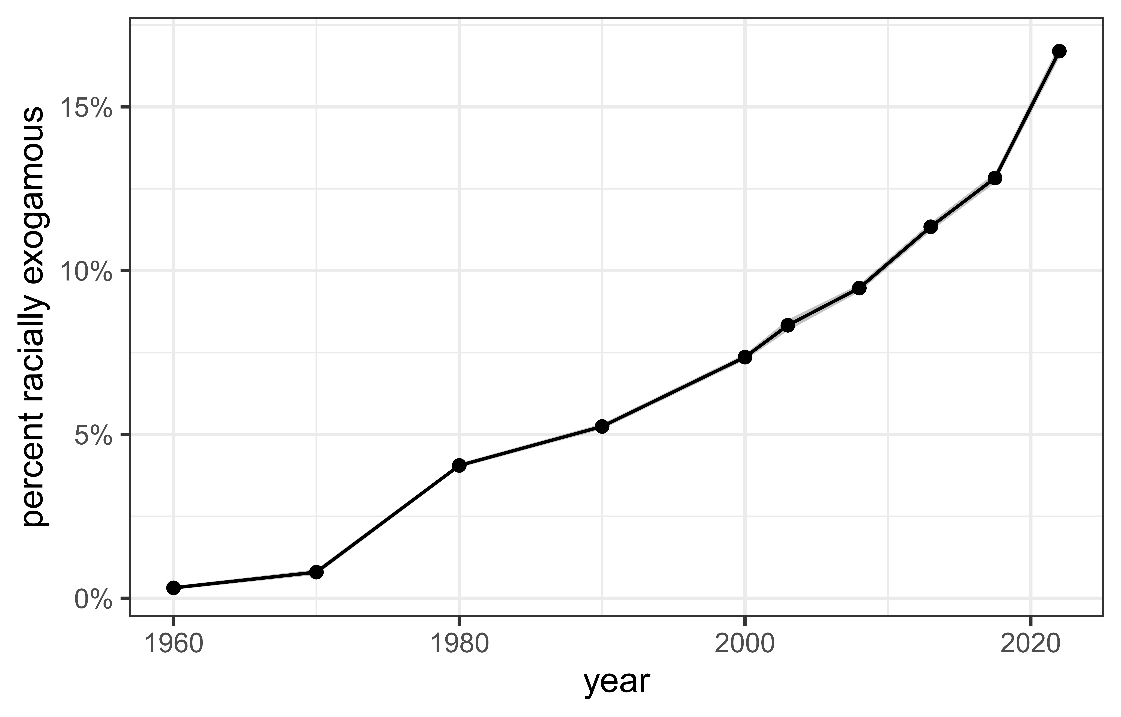
Figure 1: The trend in the share of all marriages that are racially exogamous. Values in all years are weighted to reflect the joint age distribution of newlywed partners. 95% confidence band shown.

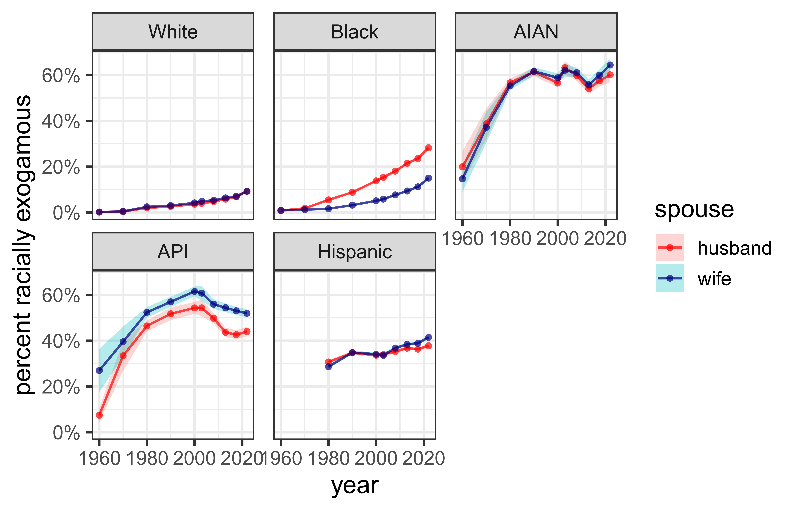
Figure 2: The trend in the share of spouses of a given race and gender that are in a racially exogamous marriage. Values in all years are weighted to reflect the joint age distribution of newlywed partners. 83% confidence bands shown.


Figure 3: Odds of racial exogamy across all single race pairings, separately by the focal race of spouse. Estimates are derived from log-linear models that control for state racial composition and are weighted to reflect the joint age distribution of spouses. 83% confidence bands shown.
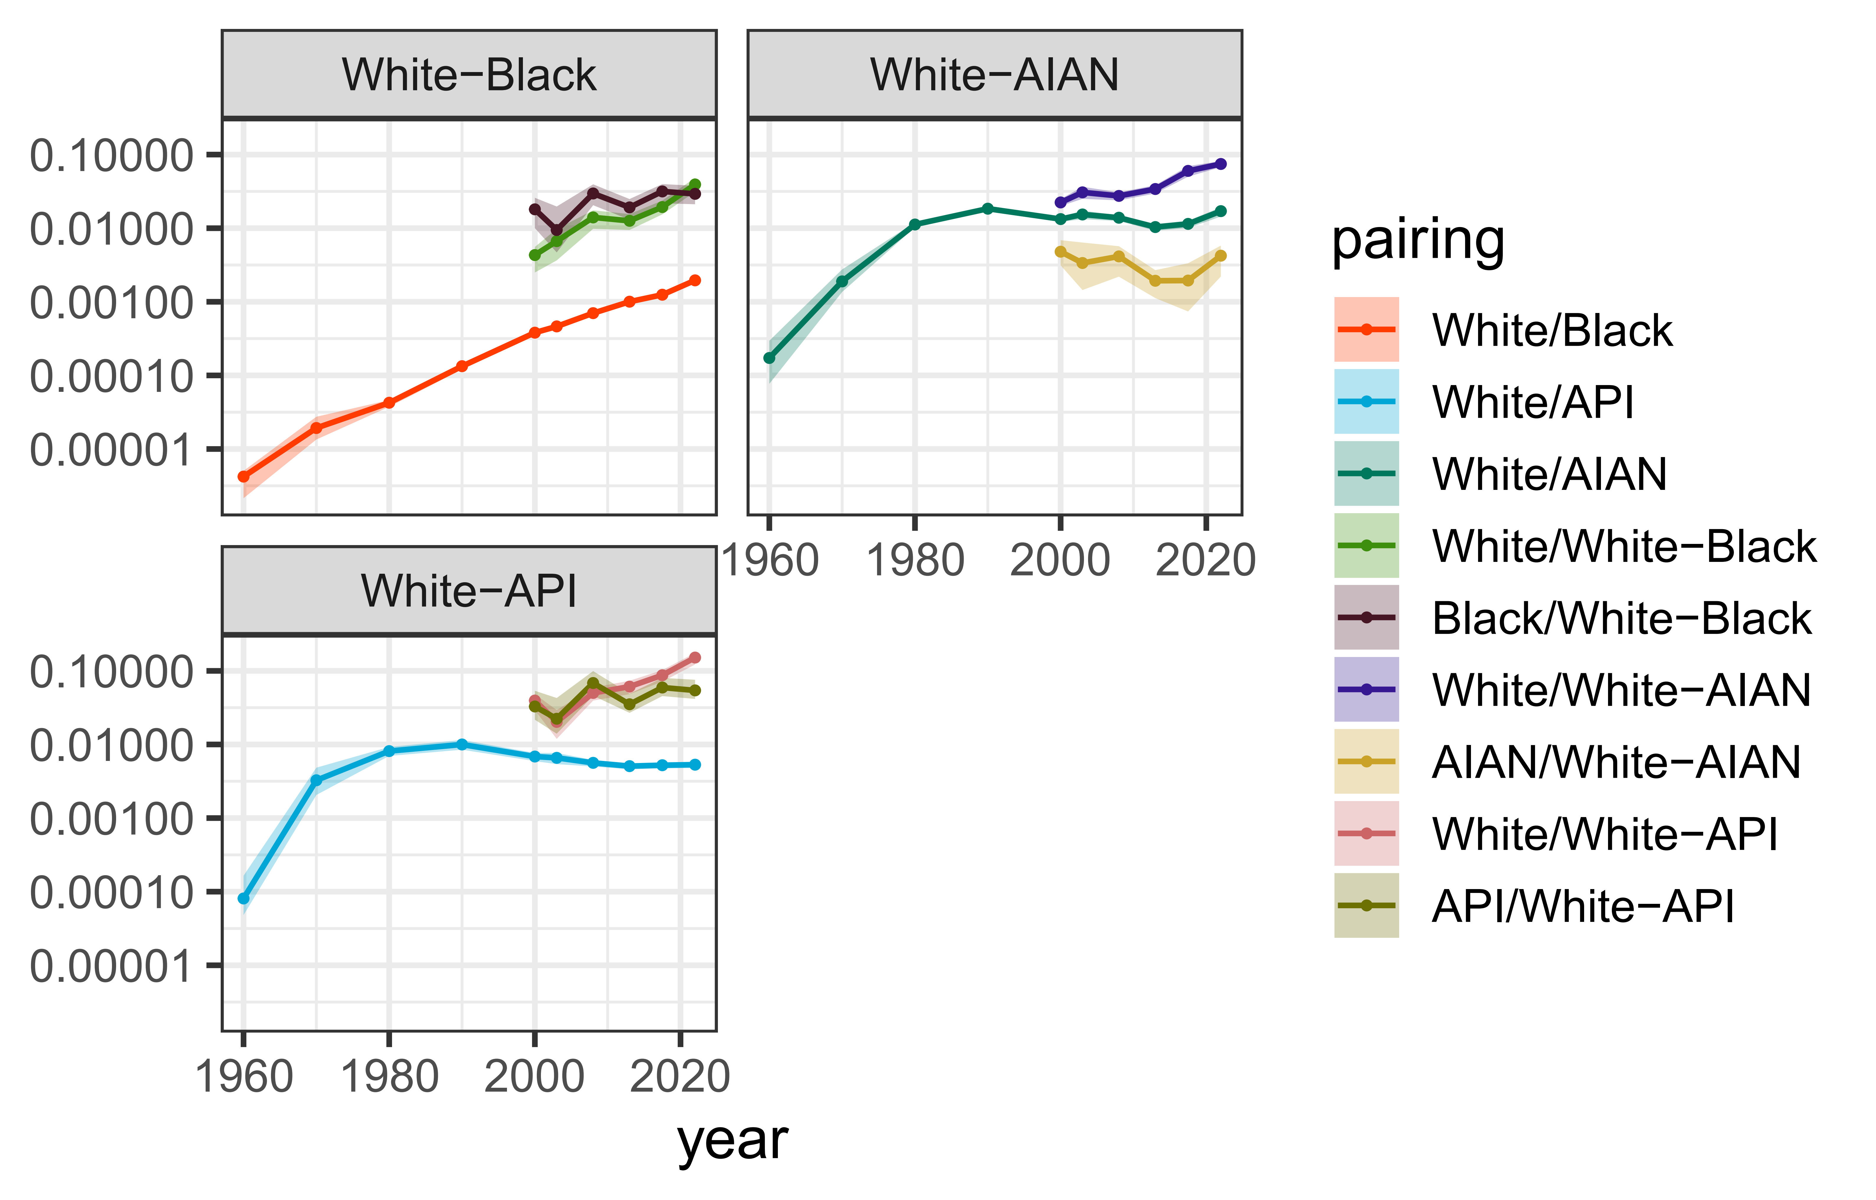
Figure 4: Odds of racial exogamy for biracial groups with component single race groups and in comparison to the odds of racial exogamy for the component single race groups. Estimates are derived from log-linear models that control for state racial composition and are weighted to reflect the joint age distribution of spouses. 83% confidence bands shown.

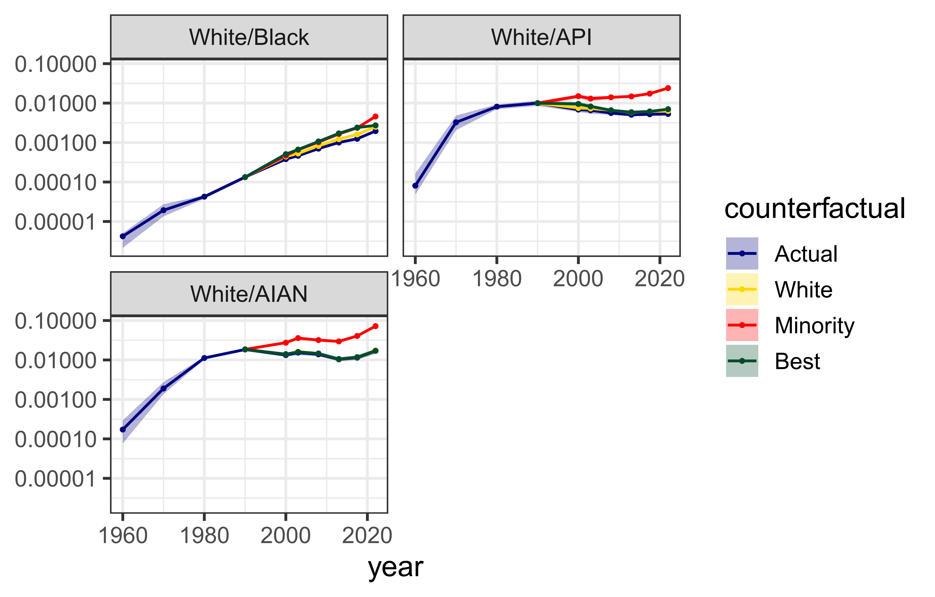
Figure 5: Comparison of odds of racial exogamy with different counterfactual assumptions about single race reporting among multiracial respondents. Estimates are derived from log-linear models that control for state racial composition and are weighted to reflect the joint age distribution of spouses. 83% confidence bands shown.

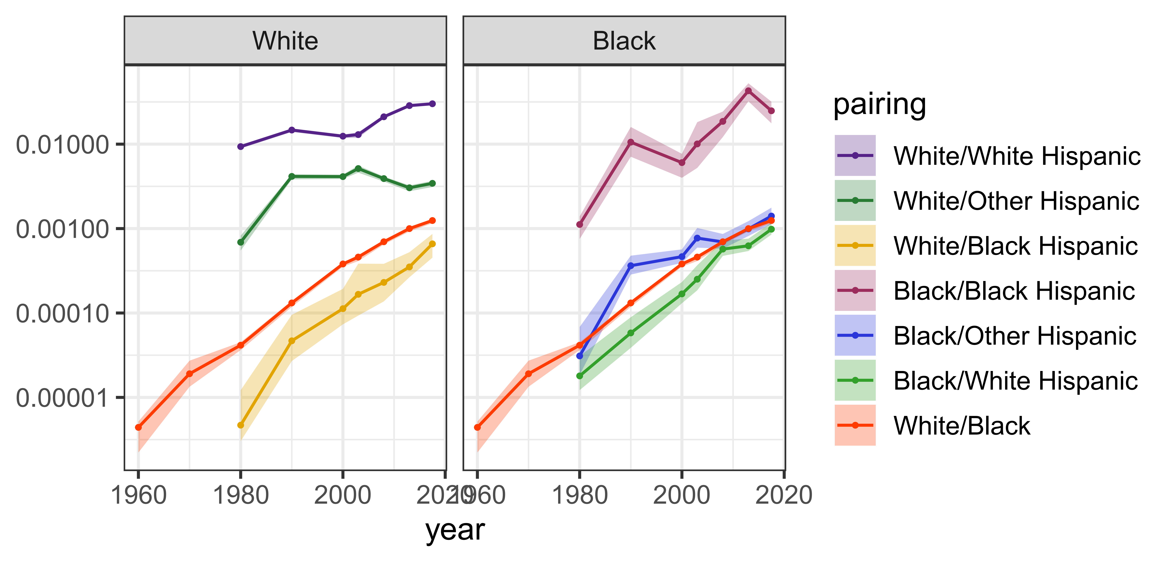
Figure 6: Odds of racial exogamy for Hispanic subgroups with non-Hispanic White and Black partners. White/Black exogamy odds are also shown for reference. Estimates are derived from log-linear models that control for state racial composition and are weighted to reflect the joint age distribution of spouses. 83% confidence bands shown.

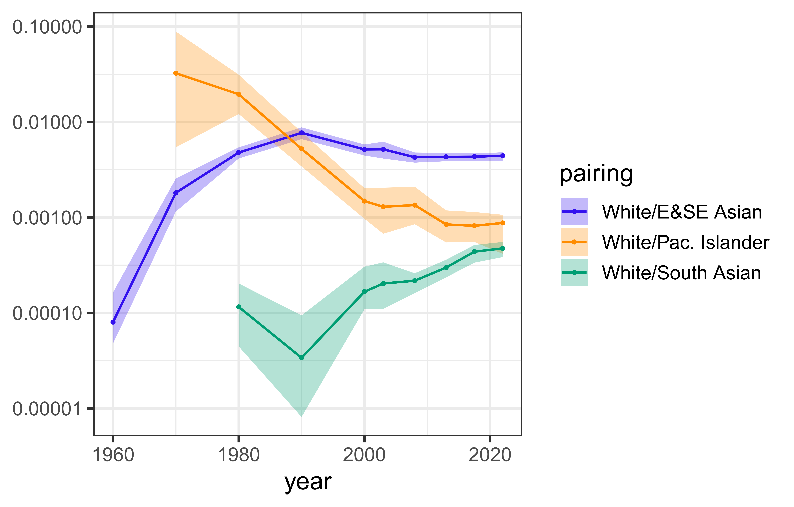
Figure 7: Odds of racial exogamy for Asian subgroups with White partners. Estimates are derived from log-linear models that control for state racial composition and are weighted to reflect the joint age distribution of spouses. 83% confidence bands shown.

Figure 8: Odds of racial exogamy across single race pairings involving a White partner, separately by opposite-sex marriage, opposite-sex cohabitation, and same-sex marriage. Estimates are derived from log-linear models that control for state racial composition and are weighted to reflect the joint age distribution of spouses. 83% confidence bands shown.

I use the term “interracial” here because I will focus on marriage between groups that are identified by a racialized boundary, but the logic could apply equally well to “intergroup” marriage where groups are defined by ethnicity, religion, etc.
While it is possible to identify same-sex cohabitations from 1990 onward, comparison across time is complicated by changes to coding practices and the possibility of response errors overwhelming the small number of same-sex cohabitations (Black et al. 2000, 2007). Therefore, I restrict my analysis to same-sex marriages since 2013.
Form 1 of the 1970 Census also included a Hispanicity question, but the results from this Hispanicity question have been found to be not comparable to the Hispanicity question asked since 1980 (US Census Bureau 1992, B–13).
The South Asian category is only identifiable from 1980 onward. Native Hawaiians are only identifiable from 1970 onward and other specific Pacific Islander groups (e.g. Tongan, Chamorro) are only identifiable from 1990 onward. The 1980 Census includes a category of “Other Asian and Pacific Islander” that makes it impossible to fully distinguish these groups in that year. I treat this issue as a missing data problem. Individuals in this category in 1980 are assigned to an API sub-group category via predictive mean matching based on 1990 Census data.
Throughout the article, I use a slash (“/”) to distinguish a union across two groups (e.g. White/Black for marriage between a White and Black spouse) and a dash (“-”) to indicate a multiracial individual with ancestry from two groups (e.g. White-Black to indicate an individual that identified as both White and Black).
The same-sex marriage sample cannot be cross-tabulated by gender. Because this sample only includes heads of households and their partners, I instead cross-tabulate same-sex marriages by head of household status instead of gender.
Zero counts in the cells forming the odds ratio in Equation 2 prevent estimation of the $β$ parameter for that group comparison. Such zero counts are more likely when sample size for one or both groups is small and when the underlying likelihood of interracial marriage is small. The degree of subgroup analysis that could be sustained without being affected by this issue was determined by investigation of cell frequencies. For the main results, the log-odds ratio is not reported for the AIAN/API pairing in 1960 due to zero cell counts.
Because the unit of observation is a couple, I use the mean of both partner’s person weight to derive the couple weight. All sample weights are divided by the mean sample weight for each year.
The replication package included with this article contains all model estimates in a machine readable format.

