Trends and Heterogeneity in Interracial Marriage in the United States, 1960-2023

Abstract
While scholars recognize that interracial marriage in the United States has grown exponentially since the 1960s, our understanding of this trend for specific racial pairings is piecemeal and thin, owing to issues with data comparability and lack of information on marriage timing between 1980 and 2007. In this article, I use log-linear models of Census and American Community Survey data to analyze trends in interracial marriage from 1960 to 2023 across major single-race groups, as well as some important subgroups. Weights are applied to match the joint age distribution of currently married partners to the age distribution of newlyweds in the same time period. While the overall trend is one of exponential increase, important heterogeneity is visible when examining particular racial pairings or subgroups. Most notably, the likelihood of interracial marriage for East/Southeast Asian and American Indian/Alaska Native spouses plateaued by the end of the 20th century and has not continued to grow. On the other hand, the likelihood of interracial marriage for Black spouses, although far lower than any other group at the start of the period, has increased more rapidly than any other group. Overall, these results indicate an ongoing transformation of group boundaries.

Introduction
Since the 1960s, the frequency of marriage between spouses who identify with different racial groups has risen at an unprecedented pace in the United States (Gullickson 2006a; Rosenfeld 2008). Although interracial marriage remains rarer than other forms of heterogamy such as educational or religious intermarriage, the growth in interracial marriage has been more substantial than for other forms of heterogamy over this same time period (Rosenfeld 2008).
This trend over roughly the last half century has been one of the most important features of the changing racial demography of the United States. Interracial marriage is widely seen as the engine of the “biracial baby boom” in which an increasing number of people desire to identify with more than one race (Root 1992). It is a general presumption among the public that interracial marriage rates have grown exponentially and will continue to rise for the foreseeable future, signaling weakening social boundaries between racial groups. This belief in the inevitability of interracial marriage helps to inform conceptions of a “post-racial” America in which everyone is mixed to some degree or another.
Given its importance, our knowledge of trends in interracial marriage over this period remains surprisingly piecemeal and thin. We lack a systematic examination of the trend in interracial marriage between most specific racial groups over the entire time period. Qian and Lichter (2011), which is one of the most cited scholarly treatments of the subject, only examines two points in time, 1980 and 2008. Rosenfeld (2008) only measures endogamy rather than the likelihood of specific interracial combinations (e.g. Black/White, Black/Asian). Gullickson (2006a) only examines interracial marriage between White and Black partners. None of these studies examine data beyond 2008. The most comprehensive recent analysis comes from the Pew Research Center (Livingston and Brown 2017). This report again uses two points in time, 1980 and 2015, to draw conclusions and focuses on simple outmarriage rates that do not account for group size differences and cannot be used to measure the frequency of particular interracial pairings.
In this article, I develop a systematic examination of the trends in interracial marriage from 1960 to 2023, using data from the US Census and the American Community Survey. I address the primary methodological challenge in developing such measures - the lack of comparable information on marital duration for much of the time period - by the use of weights that make each sample representative of the joint distribution of newlyweds in the same time period. Additionally, I handle a variety of other methodological challenges arising from changes in measurement across the time period, including the switch to a multiple check-off response to the race question since 2000. The goals of this paper are largely descriptive. However, given the overall importance of these trends and the piecemeal nature of our existing body of knowledge, such a comprehensive descriptive analysis is long overdue.
Many of my findings echo and reinforce previous work. I find, for example, that the odds of interracial marriage between Black and non-Black spouses have been lower than for other types of interracial marriage, but these odds have also grown the fastest over time. However, importantly, I also find that the story of uninterrupted weakening of boundaries is inaccurate for some groups. The odds of exogamy for Asian/Pacific Islanders and for American Indian/Alaska Natives increased in the early period under observation, but plateaued by 1990 and have not increased since. Further analysis across a variety of subgroups reveals important heterogeneity in trends and levels of interracial marriage across groups.

Background
The significance of interracial marriage to social systems is twofold. First, the likelihood of interracial marriage is seen as a key indicator of the social distance between groups and the strength and rigidity of the boundary separating those groups (Gordon 1964). Interracial marriage provides a window into the assimilation and integration of groups within the most intimate sphere of social life. For example, the almost complete social (and often legal) prohibition on marriage between Black and White partners for much of US history is a testament to the stark impermeability of the White/Black boundary.
Second, an increase in the likelihood of interracial marriage is seen as a harbinger of intergenerational change because the children from such unions can plausibly claim possession of both group identifications (Root 1992). Such children then potentially represent another source by which group boundaries can be weakened, by invalidating the distinctiveness of group identity itself. This argument comes with important caveats. Marriage is not the only means by which to produce “mixed” children. For example, for most of US history, White/Black mixing predominantly occurred outside of marriage (Hodes 1997; Kennedy 2003). Furthermore, norms of classification such as the “one drop rule” can often effectively stunt any challenge to group boundaries arising from “mixed” progeny (Johnston 1970; Davis 1991). Nonetheless, the “biracial baby boom” resulting from rising interracial marriage in the post-Civil Rights period has played an important role in restructuring our understanding, and even measurement, of racial boundaries (Lee and Bean 2004).
Measuring the frequency of interracial marriage is complicated by differences in group size. These differences will play an important role in who marries whom, because they determine the racial distribution of potential partners. Whether or not group size is accounted for in a measure of interracial marriage can lead to dramatic differences in our assessment of its frequency. A popular measure of interracial marriage is the outmarriage rate, or ratio. Typically, this measures the percent of individuals from a given group that are married to someone belonging to a different group, although it can also be measured across the population at large or for a specific pairing (e.g. what percent of black spouses are married to white spouses?). The measure is intuitive and easy to understand. However, it is also largely determined by relative group size above and beyond other factors.
A toy example easily demonstrates why this is so. Imagine a population divided by two groups A and B, where A constitutes 85% of the population and B constitutes the remaining 15%. Among B members looking for a romantic partner, 85% of the possible partners they can choose will belong the other group, while for A members only 15% of possible partners will belong to the other group. The two groups have very different opportunities for intergroup partnership. If both groups were to prefer an outgroup marriage to an ingroup marriage, we would expect a 100% outmarriage rate for group B, whose members can easily find a partner among the larger group A, but only a 15% outmarriage rate for group A. This difference in outmarriage rates tells us nothing useful except that the groups differ in size.
For this reason, most analysis of intergroup marriage uses an odds ratio to measure the likelihood of group exogamy and endogamy. The odds ratio implicitly controls for the marginal distribution of groups and thus provides a measure that is independent of group size differences. For this reason, the odds ratio is generally considered a better measure of actual social distance than outmarriage rates, although outmarriage rates might provide a more accurate measurement of the felt experience of intergroup marriage across different populations. Furthermore, odds ratios fit neatly into a log-linear model approach making this measure extensible to more complex model-based estimation.
Scholars also differ in whether they measure the likelihood of group endogamy/exogamy or the likelihood of specific pairings of racial groups. Rosenfeld (2008) and Livingston and Brown (2017), for example, only measure general patterns of endogamy/exogamy for each focal racial group. These general patterns are easier to estimate because they pool the specific racial outgroups together, but they also make it impossible to detect different trends for specific pairings of groups, such as White/Black or Black/Asian interracial marriage. Qian and Lichter (2011) provide estimates of exogamy for specific pairings of racial groups in their log-linear models, but only report results for pairings involving a White partner, meaning we know little about trends or even levels of interracial marriage for dual minority pairings.
Despite different measurement approaches and the piecemeal nature of prior work, some potential results have been identified across studies. First, the racial exogamy of Black partners is historically lower than for other groups, but exogamy has increased faster and more consistently for Black partners than for other groups, suggesting some convergence (Rosenfeld 2008; Qian and Lichter 2011; Gullickson 2022). Second, the increase in exogamy for Asian/Pacific Islander and American Indian/Alaska Native populations may have slowed down or stalled in more recent years, although the magnitude of this slowdown is unclear (Qian and Lichter 2011; Livingston and Brown 2017). Livingston and Brown (2017) actually find a decline in the outmarriage rate for Asian spouses from 1980 to 2015 and no change for Latino spouses as well. However, these results are somewhat difficult to interpret due to the use of outmarriage rates that do not adjust for group size and the inclusion of foreign-born individuals into the sample (an issue I discuss more below). Other work, using log-linear modeling, has shown Latino exogamy to be higher than for other groups, although the trend in Latino exogamy is less clear (Rosenfeld 2008; Qian and Lichter 2011).
Several other limitations are present in our existing body of knowledge. First, most of the prior work is limited in the years that are used. Qian and Lichter (2011), Livingston and Brown (2017), and Gullickson (2022) all use two time points starting from 1980, but two time points do not allow us to fully extrapolate a trend. The reason for this selectivity is the lack of information on marital duration in many data sources. Ideally, to measure trends in interracial marriage, researchers would use information on newlyweds. However, information on marital timing was removed after the 1980 Census and only re-introduced to the American Community Survey from 2008 onward. Furthermore, the 1980 data only provided marital duration for first marriages, making the comparison between 1980 and more recent years somewhat difficult. Researchers either have to decide on a slightly apples-to-oranges comparison between first marriages in 1980 and all marriages in more recent data, or they must restrict the analysis to first marriages throughout.
Second, while odds ratios adjust for group size, they only do so at the national level. Because racial groups are not equally distributed throughout the US, these national differences in group size may not reflect the actual distribution of groups in a person’s local marriage market (Harris and Ono 2005). These differences will tend to make interracial marriage appear less common than it is in practice. Furthermore, shifts in the geographic distribution of racial groups over time could be misinterpreted as trends in interracial marriage.
Third, existing work has largely focused on large single race groups, for reasons of sample size. However, we know relatively little about how these trends might change by analyzing subgroups within these larger aggregates, nor do we have much knowledge of trends or tendencies in interracial marriage for multiracial groups. Gullickson (2022) analyzes patterns of interracial marriage for Asian and Latino ethnonational groups and finds substantial differences in the patterns and trends for East/Southeast Asians and South Asians, but this analysis only uses two points in time (1980 and 2014-2018). Littlejohn (2019) and Gullickson and Bratter (2025) both examine the marriage choices of multiracial individuals, but only at one point in time.
In what follows, I attempt to resolve many of these shortcomings to produce an analysis of trends in interracial marriage over time from 1960 to 2023. By using weights to adjust extant marriages to the joint age distribution of newlywed partners, I am able to produce accurate results for the entire time period, and leverage larger sample sizes to examine interracial marriages across a wider variety of groups.

Data and Methods
Data for this analysis are derived from the microdata Census samples for Census 1960, 1970, 1980, 1990, and 2000, and American Community Survey (ACS) data from 2001 to 2023, with the exception of 2020. All data were extracted via the Integrated Public Use Microdata Sample system (Ruggles et al. 2025). ACS data from 2020 is removed due to issues with data collection during the COVID pandemic. To improve statistical power for the smaller ACS samples, single year samples are combined into intervals from 2001-2005, 2006-2010, 2011-2015, 2016-2019, and 2021-2023. The midpoint of the interval is used for analyzing trends.
The data include all extant heterosexual married couples in each sample. I also include a secondary sample of heterosexual cohabiting couples beginning in 1990 at which point “unmarried partner” is provided as a choice for relationship to head of household. Data are limited to heterosexual couples because data on same-sex couples (in marriage or cohabitation) is unavailable for most of the time period.
For most of the analysis, I also restrict the sample to couples in which both partners are native born. Foreign-born individuals may have been married prior to arrival in the US. Even in cases where foreign-born individuals arrived in the US unmarried, they will have substantial preferences for ethnonational endogamy that could easily be conflated with racial preferences, although this may be less true of individuals who arrived as children (i.e. the 1.5 generation). Figure S4 in the supplementary appendix shows how the results would change for single-race groups involving the Hispanic or Asian/Pacific Islander groups when including some or all of the foreign-born population. The results show that the overall odds of interracial marriage would decline substantially, but the trends are generally similar. The results are similar regardless of whether the entire foreign-born population or only the 1.5 generation is included.

Measuring Race
In order to measure the frequency of marriage across groups, I first need to establish what those groups will be. Ideally, group distinctions would capture meaningful and salient ideas within a given society of where group boundaries lie. However, over the substantial period of time analyzed here, the meaning, placement, salience, and measurement of boundaries can change. For these reasons, I confine most of the analysis to the large single race groups of White, Black, American Indian/Alaska Native (AIAN), Asian/Pacific Islander (API), and Hispanic, where conceptual and methodological changes are less likely to cause discrepancy over time.
Nonetheless, several changes in Census coding of race are noteworthy. First, Hispanic identification is not determined by a category on the race question but by a separate question on Hispanicity that precedes the race question. This question was not asked on all Census forms until 1980. Thus, I cannot measure Hispanic interracial marriage patterns prior to 1980 and Hispanics in the Census in 1960 and 1970 will instead appear in other racial categories. From 1980 onward, individuals who identified as Hispanic on the Hispanicity question are identified as Hispanic regardless of their response to the race question in most of the analysis. I do conduct a supplementary analysis that uses Hispanic subgroups identified by their response to the race question. For this supplementary analysis, I use the three largest categories of White, Black, and Other. While some scholars have treated this approach as synonymous with race or skin tone (Qian and Cobas 2004; Choi 2020), I do not assume that here as racial identification choices among Hispanics are complex, multi-faceted, and fluid (Rodriguez 2000). Nonetheless, these identification choices may reflect some role of both phenotype and cultural assimilation into the American racial schema (or lack thereof) and are therefore worth exploring, particularly in relation to marriage with non-Hispanic White and Black partners.
Second, combining all Asian and Pacific Islander respondents into a single category is less than ideal because of a great deal of heterogeneity within this panethnic group. Prior work has found that although South Asians are nominally categorized as “Asian,” their actual racial placement in the US is more ambiguous and they are less attached to Asian panethnic identity (Kibria 1996; Morning 2001; Schachter 2014). Pacific Islander populations were aggregated into the API category based on the now defunct 1977 Office of Management and Budget (OMB) standards, yet share a history of settler colonialism more similar to other indigenous groups (Sasa and Yellow Horse 2022). Although it is possible to identify more specific ethnonational identities (e.g. Chinese, Indian, Hawaiian) in the data, the categories included in a given year are not consistent across time. Furthermore, the sample size of specific ethnonational groups would preclude analysis for most groups. For most of the analysis, I therefore rely upon the Asian/Pacific Islander (API) aggregate. However, in supplementary analyses, I also explore trends where this group is broken into three subgroups of East/Southeast Asian, South Asian, and Pacific Islander.
Third, starting in 2000, individuals are allowed to check all categories that apply in response to the race question. This shift will likely affect trends in interracial marriage, but not in a manner that is easy to predict a priori, because we don’t know who is mostly likely to change their race response. For the main analysis, I separate multiracial respondents from monoracial respondents and I measure trends in interracial marriage for the largest multiracial groups of White-Black, White-AIAN, and White-API. In a supplementary analysis, I consider trends in interracial marriage among single race groups under different counterfactual scenarios where multiracial respondents are forced back into a single race option.
Finally, from 2020 onward, based on a format change to the race question on the Census and ACS, the Census Bureau changed its method of allocation of race responses in such a way that the number of multiracial respondents increased explosively (Starr and Pao 2024; Ventura and Flores 2025). This increase was most notable for individuals who identified as Hispanic and were placed in a multiracial category that included the “Other” category. Because I am identifying Hispanics by the Hispanicity question, this measurement issue should not lead to large discrepancies in the results presented here, but any substantial changes after 2020 may be affected somewhat by this issue.

Measuring Interracial Marriage
[Table 1 about here]
To help fix ideas, Table 1 provides a view of the frequency of interracial marriage for three abstract groups when marriages are cross-tabulated by the race of husband and wife. For reasons discussed above, the preferred measure of the strength of intermarriage across group combinations has long been the odds ratio or cross-product resulting from a cross-tabulation of husband’s race by wife’s race. From Table 1, I can estimate the odds ratio of interracial marriage between Group 1 and Group 2 as:
$$\text{odds ratio}=\frac{F_{12}F_{21}}{F_{11}F_{22}}\left(1\right)$$
This cross-product can be interpreted as the odds ratio of an individual from one of the groups having a partner from the other group relative to those same odds for an individual from the other group. If this cross-product is equal to one then group membership is not a factor in partner selection. Values lower than one indicate barriers to interracial marriage. Unlike the simpler outmarriage ratio, which measures the proportion of partners married to someone of a different group, the cross-product adjusts for group size.
Although this odds ratio and its standard error can be estimated directly from a cross-tabulation, I will instead use a model approach to estimate these values for the analysis. By using a model, I can condition the results on a variety of other factors, discussed below. To estimate the odds ratios, I use a log-linear model approach, where the outcome variable is the frequency count for a given cell in a cross-tabulation like Table 1. For a single year of the analysis, I estimate the following model:
$$log\left(F_{ij}\right)=λ+λ_{i}+λ_{j}+β_{ij}+α_{ij}\left(2\right)$$
Where $F_{ij}$ is the frequency count of marriages with a husband of race $i$ and a wife of race $j$. The model accounts for the marginal distributions of husband’s race ($λ_{i}$) and wife’s race ($λ_{j}$). The $β_{ij}$ and $α_{ij}$ parameters account for the saturated interaction between husband’s and wife’s race. The $β_{ij}$ parameters estimate the desired log odds ratios for each non-endogamous pairing of husband’s and wife’s race. The $α_{ij}$ parameters are residual parameters that must also be estimated to fully saturate the interaction between husband’s and wife’s race. For example, in a three-by-three table like Table 1, one can identify four non-redundant odds ratios, but only three intermarriage odds ratios ($β_{ij}$) can be estimated for the three pairwise group comparisons. The fourth unique odds ratio is estimated with $α_{ij}$.
To clarify this approach, Table 2, shows the parameter coding that would be used for a model in the three group case shown in Table 1. The three $β$ parameters are estimated by dummy coding the upper off-diagonal cell for each pairwise comparison. The single $α$ parameter is estimated via ANOVA style coding for one of the pairings. Using this modeling approach, the exponentiated $β$ parameters of the log-linear model will exactly correspond to the odds ratios estimated manually by the cross-product.
[Table 2 about here]
In most of the models used in the analysis to follow, I make two additional adjustments to the model outlined in Equation 2. First, I use a single model across time and allow all of the parameters from Equation 2 to vary by time. Second, I include state of residence to adjust for geographic variation in population distribution by race. This geographic adjustment is important although imperfect as states are usually too large to serve as a marriage market and I only have the state of residence at the time of data collection, not at the time of the marriage. Nonetheless, adjusting for state variation will likely address the lion’s share of geographic variation in population distribution by race.
The full model is thus given by:
$$log\left(F_{ijkt}\right)=λ+λ_{i}+λ_{j}+λ_{k}+λ_{t}+λ_{ik}+λ_{jk}+λ_{it}+λ_{jt}+λ_{ikt}+λ_{jkt}+β_{ijt}+α_{ijt}\left(3\right)$$
where $k$ is the state of residence and $t$ is the time period. All the two and three way tables between each partner’s race, time, and state are added to the model and the $β$ and $α$ parameters themselves vary by time.

Measuring Stocks vs. Flows
Ideally, I would use data on the “flow” of recent marriages rather than the “stock” of extant marriages. The stock of extant marriages includes marriages that were formed decades prior to the date of data collection and thus will indicate the conditions of that time period rather than the current time period. Furthermore, extant marriages reflect not only marriage patterns but also, implicitly, patterns of marriage dissolution through divorce or widowhood. Prior work has shown that interracial marriages have higher rates of divorce than same-race marriages (Bratter and King 2008). Both of these factors will contribution to underestimation of the tendency toward interracial marriage among recent marriage cohorts.
However, information on marital timing is not available for a substantial subset of the time period. From 1960 to 1980, the Census asked about the age of first marriage for all married respondents. Marital duration questions were removed from Census 1990. A question on the year of the current marriage was added to the ACS in 2007. Thus, between 1990 and 2006, I have no way to identify recent marriage cohorts and in the period before 1990, I can only identify timing of marriage for first marriages.
This issue has often been addressed by restricting the sample by the age of one or both partners (Qian 1997; Blackwell and Lichter 2000; Gullickson 2006b). By selecting younger partners, we can be assured that the marriage was relatively recently formed. However, this approach can also introduce a host of other biases as younger couples may differ in other ways from the full set of recent marriage cohorts. Furthermore, the age of marriage for both husbands and wives has increased substantially over this time period, meaning that any static restriction by age will lead to different kinds of couples across the time period.
Rather than subset by age, I take all extant marriages but apply weights to each couple to match the joint age distribution of newlywed partners for that time period. This approach generalizes the method of taking a restricted age group, but instead of arbitrarily deciding on an age group, I allow each age group (or joint age group) to be represented proportionally to its share of the most recent marriage cohort. Because these weights are derived from the joint age distribution within each time period, this approach also intrinsically adjusts for temporal changes in the timing of marriage for both spouses.
From 2007, I can estimate joint age distributions of recent marriage cohorts directly from the ACS data using couples married in the last year. Prior to 2007, I use publicly available tables on the joint distribution of the age of spouses from US vital statistics reports for 1960, 1970, 1980, and 1988 (National Center for Health Statistics 1960, 1970, 1980, 1988). After 1988, these reports were no longer produced for marriage. From 1990 to 2006, I use linear interpolation of the joint age distribution. The supplementary appendix provides a full discussion of the weighting procedure and interpolation.
In addition to the age weighting, I also apply sample weights to adjust for sample design in the Census and ACS results. Weights are applied by taking the sum of weights as frequency counts. Because of the use of weights as well as complex survey design, the analytical standard errors of model parameter estimates will be underestimated. No clear analytical solution exists for this issue, so I use a bootstrap technique to generate standard errors by resampling 1000 times from the individual level data within each year to re-generate parameter estimates.
This approach cannot eliminate every bias from the use of the stock of marriages, including bias arising from differential rates of union dissolution. Figure S3 in the supplementary appendix provides a comparison of the age weighted results to results based on newlyweds (married within the last year) in years where such comparison is possible. The results indicate that the age weighted results are quite close to the results for newlyweds both in magnitude and trend, although the odds ratios for newlyweds tend to be a little higher, as expected.
For analysis that includes cohabiting couples, I have no information on the duration of cohabitation. For comparative perspective with married couples, I apply the same age weighting to cohabiting couples as I do to married couples.

Results
All results are presented graphically as the trend in the outmarriage ratio/odds ratio over time. All figures involving odds ratios use logarithmic scaling of the y-axis to highlight differences over time and across groups, so an observed linear trend in these figures corresponds to exponential growth on the original scale. The colors used for each type of interracial marriage pairing are maintained across separate figures. All figures include 83% confidence bands unless otherwise stated. An 83% confidence band facilitates easier comparison between parameter estimates than a traditional 95% band because an overlap in these bands will be approximately equal to a statistically significant difference at $p<0.05$ (Knol, Pestman, and Grobbee 2011).

Trends in Outmarriage Ratios
[Figure 1 about here]
Figure 1 shows the overall outmarriage ratio across all married couples over time, weighted to match the joint age distribution of newlywed partners. The figure shows a consistent and relatively linear increase over time in the proportion of married couples who belong to different racial groups. In 1960, racially exogamous couples make up less than 1% of all couples. By the end of the time period, about 1 in 6 couples are in an interracial marriage. A larger than average increase in the final time period may reflect some changes to the measurement of race since 2020.
The simple trend shown in Figure 1 suggests rapidly diminishing racial boundaries. However, when we look at the outmarriage ratio separately by racial group, the picture becomes more complicated. Figure 2 shows outmarriage ratios for each single race group over time, and separately by the sex of the spouse. As before, all results are weighted to reflect the joint age distribution of newlyweds.
[Figure 2 about here]
For both the AIAN and API groups, outmarriage ratios largely stopped increasing (after 1990 for AIAN and after 2000 for API) and have remained flat, or have slightly declined since. In contrast, the outmarriage ratios for White, Black, and Hispanic partners have increased over the entire time period.
Consistent with prior work, Figure 2 also shows that the likelihood of racial exogamy varies by gender for Black and API spouses (Jacobs and Labov 2002; Gullickson 2006a). Black men are much more likely to marry a non-Black partner than Black women and that gap has increased over the time period, although the likelihood has been growing exponentially for both Black men and women. In contrast, the likelihood of racial exogamy is higher for API women than for API men. This difference has remained largely consistent across time and both API women and men experienced the same peak in the likelihood of racial exogamy in 2000, followed by a moderate decline.
Figure 2 provides important information on the experience of interracial partnering for different groups, but the results are highly reflective of group size differences. For example, as I will show below, once we adjust for group size, it is actually the Hispanic population which tends to have the highest likelihood of racial exogamy. This pattern is not apparent in Figure 2, because relative size of groups is not taken into account. I now turn to an analysis of the odds of racial exogamy, which can better track trends in the likelihood of interracial marriage net of group size differences.

Overall Trends in Odds Ratios
Figure 3 shows the odds of racial exogamy over time across all possible pairings of single race groups. Results are estimated from log-linear models and weighted by the joint age distribution of newlyweds at each time point. Each panel shows the results of each possible interracial pairing for a particular focal racial group. Thus, each interracial pairing is shown twice across all of the panels.
[Figure 3 about here]
The trends in Figure 3 are consistent with the plateau of outmarriage rates observed in Figure 2 for AIAN and API partners. Across all possible combinations, racial exogamy involving an API partner had either plateaued by the late 20th century or has shown no evidence of a rise at all over the time period. The results for AIAN partners are somewhat similar, except for some evidence of a moderate rise in the odds of marriage to Hispanic and Black partners in the later time period.
In contrast, in all cases involving combinations of White, Black, and Hispanic partners, the odds of interracial marriage consistently increase throughout the time period. In the early part of the time period, the odds of interracial marriage with a Black spouse are clearly the lowest of all possible exogamous pairings for each non-Black group. However, in many cases, these odds ratios grow the fastest throughout the time period. By the end of the time period, partnership with a Black spouse is only definitively the least likely form of interracial marriage for White partners. Even in this case, the odds of White/Black partnering are increasing much more rapidly than other pairings involving a White partner. If the trends observed here continue, White/Black interracial marriage will soon become more likely than White/API interracial marriage.
Interracial marriages involving an Hispanic partner are generally among the most likely for all groups. White/Hispanic partnering is the most likely form of interracial marriage throughout the time period in which Hispanics can be identified in the data. Interracial marriage with Hispanic partners is also the most likely form of partnering for Black spouses throughout the time period and the second most likely form of partnering for AIAN and API spouses after marriage with White partners for most of the time period.

Including Multiracial Groups
To this point, I have only examined the interracial marriage patterns between single race groups. The option to check more than one box on the race question since 2000 allows me to analyze trends in interracial marriage for some large multiracial groups for part of the time period. Figure 4 shows those trends for the three largest multiracial groups of White-Black, White-AIAN, and White-API. I examine the tendency of each of these groups to marry a member from each of their two constituent groups, in comparison to the odds of a “first generation” marriage between those constituent groups. For example, for the White-Black case, I compare the odds of a White-Black/White or a White-Black/Black marriage to a White/Black marriage.
[Figure 4 about here]
For both the White-Black and the White-API case, I observe a similar pattern. Multiracial individuals are considerably more likely to marry a partner from either constituent group than members of the constituent groups are to marry one another. This finding suggests that White-Black and White-API individuals face lower boundaries to interracial marriage with these groups because they are in some sense partially endogamous with both groups (Gullickson and Bratter 2025).
For the White-Black group, one might expect that, due to the one-drop rule, White-Black individuals would be more likely to marry Black rather than White partners. The odds of partnering with a Black spouse are slightly higher than the odds of partnering with a White spouse in the early period, but this slight difference has gone away by the end of the time period. Thus, the results here suggest a very weak role of the one-drop rule in the marriage selection choices of White-Black individuals. For White-API individuals, The odds of marriage with White and API partners are very similar. By the end of the period, the odds of a White-API individual partnering with a White spouse appear to be growing faster than the odds of partnering with an API spouse, but this finding should be considered tentative.
For White-AIAN individuals, we observe a very different pattern. Partnering with White spouses is more common than “first generation” White/AIAN interracial marriage and the odds of this form of intermarriage are growing over time. In contrast, the odds of partnership with AIAN spouses are less likely than those odds for “first generation” White/AIAN interracial marriage and do not appear to be increasing over time. These results are consistent with a norm of hyperdescent in which individuals of White-AIAN ancestry are more likely to be seen and treated as White than AIAN (Gullickson and Morning 2011; Iverson et al. 2022).
The change in 2000 to multiracial reporting may also affect the trends for single race groups, depending on which individuals were more likely to reclassify themselves as multiracial. While we can never know precisely the effect of this shift in reporting, I develop three counterfactual scenarios to better understand how the trends in interracial marriage might have looked if multiracial respondents had remained in single race categories. For sample size reasons, I focus on the three categories of White/Black, White/API, and White/AIAN interracial marriage. In each case, I consider three scenarios for reclassification of part-White multiracial respondents. In the first scenario, all these respondents are re-classified as White. In the second scenario, all these respondents are classified by their minority race. In the third scenario, I use the “best race” variable created by the Minnesota Population Center. This variable is based on multinomial logit models of data from the National Health Interview Survey, which asks multiracial respondents for their preferred single race.
[Figure 5 about here]
Figure 5 presents the trends resulting from these different scenarios. For White/Black respondents, the overall trend is quite similar across all scenarios, although all three scenarios would have slightly increased the odds of White/Black marriage over that actually observed after 2000.
For both White/API and White/AIAN interracial marriage, the scenario which differs from the other cases is when multiracial part-White respondents are identified by their single-race minority group. In this scenario, the odds of interracial marriage are substantially higher than the other two scenarios and the actual observed trend. The other two scenarios produce results that are statistically indistinguishable from the actual trend. The results here suggest that many part-White multiracial individuals have White spouses and thus reclassifying these individuals into single race minority groups would increase the observed odds of interracial marriage with White spouses. However, this assumption is likely unrealistic for individuals of part API and AIAN ancestry, both of which have been shown not to follow the logic of the one-drop rule (Gullickson and Morning 2011).

Trends Among Hispanic Subgroups
I now turn to results that divide the Hispanic group into three separate subgroups, identified by racial identification as “White”, “Black”, and “Other.” Figure 6 shows trends in the odds ratio of marriage between these three subgroups and non-Hispanic White and Black partners. For reference, the trend in White/Black interracial marriage is also shown.
[Figure 6 about here]
In terms of interracial marriage with White spouses, the ordering of the three subgroups is as expected. Hispanic individuals who identify as White by race are the most likely to marry non-Hispanic White spouses. The odds of marriage to White spouses are somewhat lower for Hispanic individuals who identify as Other by race. For comparison, both of these odds ratios are substantially higher than the odds of White/Black marriage. The odds of marriage to a White spouse are much lower for Hispanic individuals who identify as Black by race and are slightly lower than the odds of White/Black marriage.
Although the odds are lowest for Black Hispanics, the trend suggests a much faster increase in this odds ratio over time, on par, with the increase in the odds of White/Black marriage. Thus, while there is a clear stratification of the odds of marriage with White partners by Hispanic racial self-identification, these differences have been getting smaller over time.
As one might expect, the ordering of Hispanic groups by the odds of partnership with a non-Hispanic Black spouse are inverted relative to those for a non-Hispanic White spouse. Interracial marriage between non-Hispanic Black spouses and Hispanics who identify racially as either Other or White are both similar to the odds of White/Black interracial marriage over time. The odds of interracial marriage between non-Hispanic Black spouses and Hispanics who identify as Black, on the other hand, are much higher and are comparable to the odds of White/White Hispanic interracial marriage. All three odds ratios are growing at a similar exponential rate over time.

Trends Among API Subgroups
Figure 7 shows the odds of partnership with White spouses across three subgroups of the API category. I divide the API group into Pacific Islanders, South Asians, and East/Southeast Asians. The results show that the plateau trend seen for the API group overall is only the trend for the East/Southeast Asian group. This group experienced a rapid increase in the odds of partnership with White spouses until 1990, when those odds leveled off. Since 1990, the odds have declined slightly, but have largely remained stationary.
[Figure 7 about here]
In contrast, the results for South Asians suggest increasing odds of marriage with White spouses throughout the time period, although sparsity of data from before 1980 limits the full range of the time period. Point estimates suggest a decline from 1980 to 1990, but the wide error margins on these estimates make such a decline questionable at best. Since 1990, there has been steady growth in the odds of South Asian/White partnering. However, those odds begin and remain substantially lower than those same odds for South/Southeast Asian partners, even as they are converging across time.
The results for Pacific Islanders show a decline in the odds of marriage with White partners throughout the time period. The decline is particularly concentrated in the period before 2000. Although this group is small, this trend before 2000 is not simply a result of wide error margins. After 2000, the decline is slight and may simply be a result of measurement error.
The decline for Pacific Islanders is notable as the only trend examined here to show a substantial decline across the time period, which is otherwise characterized by substantial increases in the odds of interracial marriage for at least the early part of the time period. Notably, the starting odds of White/Pacific Islander marriage are relatively very high. Given that Pacific Islander identification has been unstable over the time period (Liebler et al. 2017), it is possible that this trend might reflect changing self-identification practices.

Including Cohabitation
Figure 8 compares the odds of an interracial union across the ten single race combinations, separately for marriage and cohabitation. The results for cohabitation are only available since 1990. As expected, the odds of interracial cohabitation are generally higher than the odds of interracial marriage. The White/AIAN case, where the odds are extremely similar across the time period, is the only case to deviate from this pattern. Furthermore, the overall trend in cohabitation matches the trend for interracial marriage for each combination. Therefore, it is unlikely that trends in interracial marriage are driven by changes in the frequency of cohabitation over the time period.
[Figure 8 about here]
For most of the cases, there is also some convergence over time in the odds of interracial cohabitation and marriage, although the odds of interracial marriage are still lower at the end of the time period in all cases except for White/AIAN marriage. Thus, although the barriers of entry into interracial cohabitation are lower than the barriers of entry into interracial marriage, the difference in those barriers is weakening over time, possibly reflecting a deterioration in meaning between cohabitation and marriage.

Conclusions
In general, the likelihood that a marriage will cross racial lines has gone up substantially between 1960 and 2023, regardless of whether one measures that likelihood by outmarriage ratios or odds ratios. However, that general trend masks a great deal of heterogeneity that emerges when examining this trend separately by groups and pairings of groups. This heterogeneity reveals information about the changes in group boundaries over time.
The most notable deviation from the general trend is for marriages involving an AIAN or API partner. For these cases, the increase in the likelihood of interracial marriage reached a peak by the end of the 20th century for some or all possible pairings. This finding is most consistent for API partners, where I observe either a moderately declining or stationary likelihood of partnership with all other single-race groups since 1990. Subgroup analysis indicates that the White/API trend is largely driven by the experiences of East and Southeast Asian partners. South Asian partners experienced an increase in the likelihood of interracial marriage with White spouses throughout the period, while Pacific Islander partners experienced a decline.
The plateau pattern is only visible for AIAN partners with regard to their marriage with White and API partners. The likelihood of interracial marriage with Hispanic and Black partners has increased consistently throughout the time period.
On the other hand, I observe a consistent exponential increase in the likelihood of interracial marriage for pairings that involve some combination of White, Black, and Latino partners. Notably, the greatest increase in the likelihood of interracial marriage is for marriages involving a Black partner. In 1960, the likelihood of marrying a Black partner was by far the lowest among all possible pairings for every other racial group. While this hierarchy still persists in many cases, there has been substantial convergence in these likelihoods over time, suggesting that the Black/non-Black boundary has diminished over time.
At the other end of the spectrum, interracial marriage with an Hispanic partner often ranks as one of the most likely forms of interracial marriage. White/Hispanic interracial marriage has the highest likelihood among all possible single-race pairings throughout the time period. Yet, that pattern is also structured by the self-identified race of the Hispanic partner. Hispanics who identify as White are most likely to marry White partners and least likely to marry Black partners. Hispanics who identify as Black are most likely to marry a Black partner, and least likely to marry a White partner. Hispanics who identify as Other are somewhere in-between in their likelihood to marry a White partner, and similar to White Hispanics in terms of their likelihood of marrying a Black partner. In this way, the interracial marriage patterns of Hispanics tend to reinforce an existing White/Black divide.
Multiracial groups also tend to have a higher likelihood of interracial marriage with single-race constituent groups than single-race groups have with one another, although I only analyze patterns for the three largest multiracial groups. The White/AIAN group is the exception to this rule. White/AIAN partners are much more likely to marry a White partner than an AIAN partner, consistent with a pattern of hyperdescent. In contrast, I observe only a small weak effect of hypodescent for White/Black partners.
These results are robust to a variety of specification tests including how multiracial responses are recorded, the exclusion of the foreign-born population, or direct use of newlyweds rather than age-weighted data. Although these factors can change the levels observed somewhat, they do not substantially alter the findings with regard to trends. Furthermore, an analysis of cohabitation shows that while interracial cohabitation tends to be somewhat more likely than marriage, the overall trends in interracial cohabitation are similar.
Ironically, historically high rates of interracial marriage for API and AIAN individuals combined with more freedom of identification for part-API and part-AIAN individuals may have contributed to the plateau in rates of interracial marriage for these groups. If the biracial children of such unions were identified solely as members of these groups, the observed plateau in interracial marriage rates would be less severe.
Importantly, the odds ratios used for much of the analysis help to factor out group size, which is critical when using interracial marriage as a benchmark to establish the strength of group boundaries. However, the experiences of groups and the children of such unions may be better reflected by the outmarriage ratios. For example, while the odds of interracial marriage involving API partners remain low, roughly 40-50% of API partners are married to someone of a different race. Group size does matter for the overall distribution of multiracial children produced by interracial unions. Nonetheless, the outmarriage ratios show the same general plateau effect for AIAN and API partners.
Overall, these results do not consistently point to a pattern of dissolving barriers even though many groups do continue to experience rapid exponential increase in the likelihood of interracial marriage. Rather they point to the ways that pre-existing norms around group boundaries are being challenged, transformed, and re-interpreted. In all cases, the likelihood of interracial marriage remains well below what one would expect if race was not a factor in partner selection at all.

References
Blackwell, Debra, and Daniel T Lichter. 2000. “Mate Selection Among Married and Cohabiting Couples.” Journal of Family Issues 21 (3): 275–302.
Bratter, Jenifer L., and Rosalind B. King. 2008. “‘But Will It Last?’: Marital Instability Among Interracial and Same-Race Couples.” Family Relations 57 (2): 160–71.
Choi, Kate H. 2020. “Racial Diversity in the Marital Assimilation of Hispanics.” Journal of Marriage and Family 82 (2): 675–90.
Davis, F. James. 1991. Who Is Black?: One Nation’s Definition. University Park, PA: Pennsylvania State University Press.
Gordon, Milton M. 1964. Assimilation in American Life. New York: Oxford University Press.
Gullickson, Aaron. 2006a. “Black/White Interracial Marriage Trends, 1850-2000.” Journal of Family History 31 (3): 289–312.
———. 2006b. “Education and Black-White Interracial Marriage.” Demography 43 (4): 673–89.
———. 2022. “Patterns of Panethnic Intermarriage in the United States, 1980–2018.” Demography, September, 10218826.
Gullickson, Aaron, and Jenifter Bratter. 2025. “Blurring the Marriage Market? Contemporary Patterns of Multiracial Marriage.” Presented at the Population Association of America, Washington DC, April 11.
Gullickson, Aaron, and Ann Morning. 2011. “Choosing Race: Multiracial Ancestry and Identification.” Social Science Research 40 (2): 498–512.
Harris, David R., and Hiromi Ono. 2005. “How Many Interracial Marriages Would There Be If All Groups Were of Equal Size in All Places? A New Look at National Estimates of Interracial Marriage.” Social Science Research 34 (1): 236–51.
Hodes, Martha. 1997. White Women, Black Men: Illicit Sex in the Nineteenth-Century South. New Haven: Yale University Press.
Iverson, Sarah, Ann Morning, Aliya Saperstein, and Janet Xu. 2022. “Regimes Beyond the One-Drop Rule: New Models of Multiracial Identity.” Genealogy 6 (2): 57.
Jacobs, Jerry A., and Teresa G. Labov. 2002. “Gender Differentials in Intermarriage Among Sixteen Race and Ethnic Groups.” Sociological Forum 17 (4): 621–46.
Johnston, James Hugo. 1970. Race Relations in Virginia and Miscegenation in the South, 1776-1860. Amherst: The University of Massachusetts Press.
Kennedy, Randall. 2003. Interracial Intimacies: Sex, Marriage, Identity, and Adoption. New York: Pantheon Books.
Kibria, Nazli. 1996. “Not Asian, Black or White? Reflections on South Asian American Racial Identity.” Amerasia Journal 22 (2): 77–86.
Knol, Mirjam J., Wiebe R. Pestman, and Diederick E. Grobbee. 2011. “The (Mis)use of Overlap of Confidence Intervals to Assess Effect Modification.” European Journal of Epidemiology 26 (4): 253–54.
Lee, Jennifer, and Frank D. Bean. 2004. “America’s Changing Color Lines: Immigration, Race/Ethnicity, and Multiracial Identification.” Annual Review of Sociology 30 (1): 221–42.
Liebler, Carolyn A., Sonya R. Porter, Leticia E. Fernandez, James M. Noon, and Sharon R. Ennis. 2017. “America’s Churning Races: Race and Ethnicity Response Changes Between Census 2000 and the 2010 Census.” Demography 54 (1): 259–84.
Littlejohn, Krystale E. 2019. “Race and Social Boundaries: How Multiracial Identification Matters for Intimate Relationships.” Social Currents 6 (2): 177–94. https://doi.org/10.1177/2329496518804553.
Livingston, Gretchen, and Anna Brown. 2017. “Intermarriage in the U.S. 50 Years After Loving v. Virginia.” Washington DC: Pew Research Center.
Morning, Ann. 2001. “The Racial Self-Identification of South Asians in the United States.” Journal of Ethnic and Migration Studies 27 (1): 61–79.
National Center for Health Statistics. 1960. “Vital Statistics of the United States, 1960: Volume III, Marriage and Divorce.” Washington DC: U.S. Department of Health, Education, and Welfare.
———. 1970. “Vital Statistics of the United States, 1970: Volume III, Marriage and Divorce.” Washington DC: U.S. Department of Health, Education, and Welfare.
———. 1980. “Vital Statistics of the United States, 1980: Volume III, Marriage and Divorce.” Washington DC: Department of Health and Human Services.
———. 1988. “Vital Statistics of the United States, 1988: Volume III, Marriage and Divorce.” Washington DC: Department of Health and Human Services.
Qian, Zhenchao. 1997. “Breaking the Racial Barriers: Variations in Interracial Marriage Between 1980 and 1990.” Demography 34 (2): 263–76.
Qian, Zhenchao, and José A. Cobas. 2004. “Latinos’ Mate Selection: National Origin, Racial, and Nativity Differences.” Social Science Research 33 (2): 225–47.
Qian, Zhenchao, and Daniel T. Lichter. 2011. “Changing Patterns of Interracial Marriage in a Multiracial Society.” Journal of Marriage and Family 73 (5): 1065–84.
Rodriguez, Clara. 2000. Changing Race: Latinos, the Census and the History of Ethnicity in the United States. New York: NYU Press.
Root, Maria P. P., ed. 1992. Racially Mixed People in America. 1st edition. Newbury Park, Calif: SAGE Publications, Inc.
Rosenfeld, Michael J. 2008. “Racial, Educational, and Religious Endogamy in the United States: A Comparative Historical Perspective.” Social Forces 87 (1): 1–32.
Ruggles, Steven, Sarah Flood, Matthew Sobek, Daniel Backman, Grace Cooper, Julia A. Rivera Drew, Stephanie Richards, Renae Rodgers, Jonathan Schroeder, and Kari Williams. 2025. “IPUMS USA: Version 16.0.” Minneapolis, MN: IPUMS.
Sasa, Steven M., and Aggie J. Yellow Horse. 2022. “Just Data Representation for Native Hawaiians and Pacific Islanders: A Critical Review of Systemic Indigenous Erasure in Census and Recommendations for Psychologists.” American Journal of Community Psychology 69 (3–4): 343–54.
Schachter, A. 2014. “Finding Common Ground? Indian Immigrants and Asian American Panethnicity.” Social Forces 92 (4): 1487–1512.
Starr, Paul, and Christina Pao. 2024. “The Multiracial Complication: The 2020 Census and the Fictitious Multiracial Boom.” Sociological Science 11 (December): 1107–23.
US Census Bureau. 1992. “1990 Census of Population and Housing: Public Use Microdata Sample (PUMS) Technical Documentation.” Washington, DC: U.S. Department of Commerce, Bureau of the Census.
Ventura, Ilana M., and René D. Flores. 2025. “The ‘Rise’ of Multiracials? Examining the Growth in Multiracial Identification in the 2020 U.S. Census.” RSF: The Russell Sage Foundation Journal of the Social Sciences 11 (1): 44–64.

Tables and Figures
Table 1: Abstract table of the frequency of interracial marriage across three groups, cross-tabulated by husband’s race and wife’s race.
 | Wife
Husband | Group 1 | Group 2 | Group 3
Group 1 | $$F_{11}$$ | $$F_{12}$$ | $$F_{13}$$
Group 2 | $$F_{21}$$ | $$F_{22}$$ | $$F_{23}$$
Group 3 | $$F_{31}$$ | $$F_{32}$$ | $$F_{33}$$

Table 2: Log-linear model parameters applied to a cross-tabulation of husband’s race and wife’s race for three groups.
 | Wife
Husband | Group 1 | Group 2 | Group 3
Group 1 | 0 | $$β_{12}$$ | $$β_{13}$$
Group 2 | 0 | 0 | $$β_{23}+α_{23}$$
Group 3 | 0 | $$-α_{23}$$ | 0
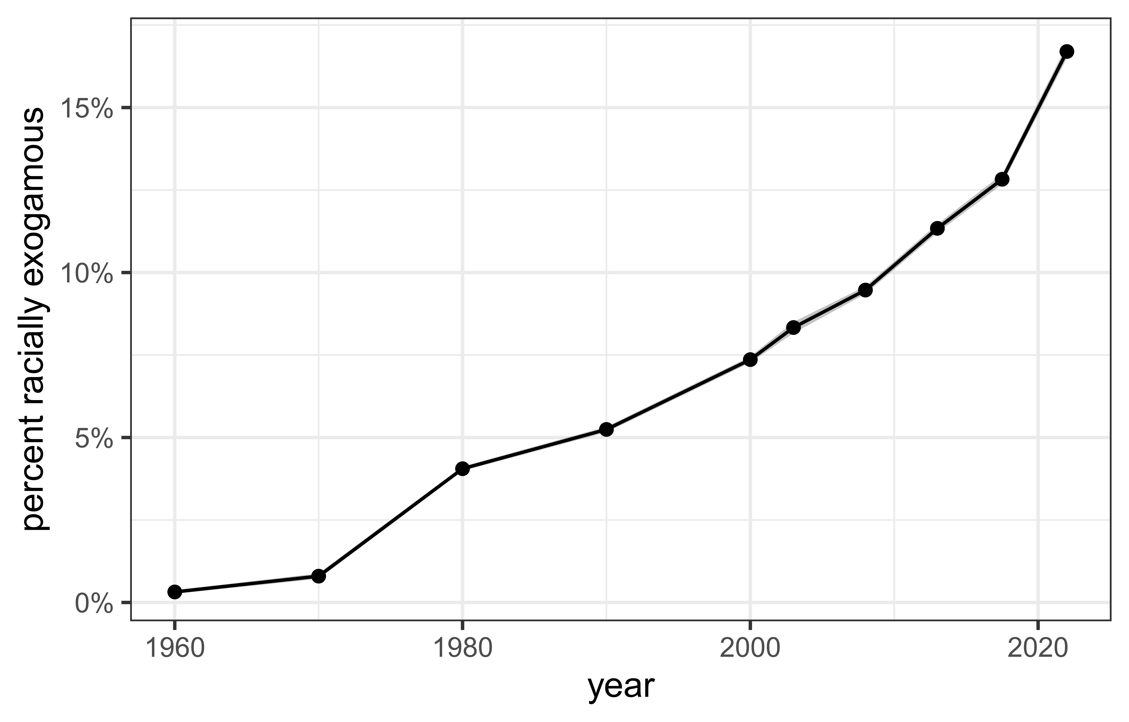
Figure 1: The trend in the share of all marriages that are racially exogamous. Values in all years are weighted to reflect the joint age distribution of newlywed partners. 95% confidence band shown.

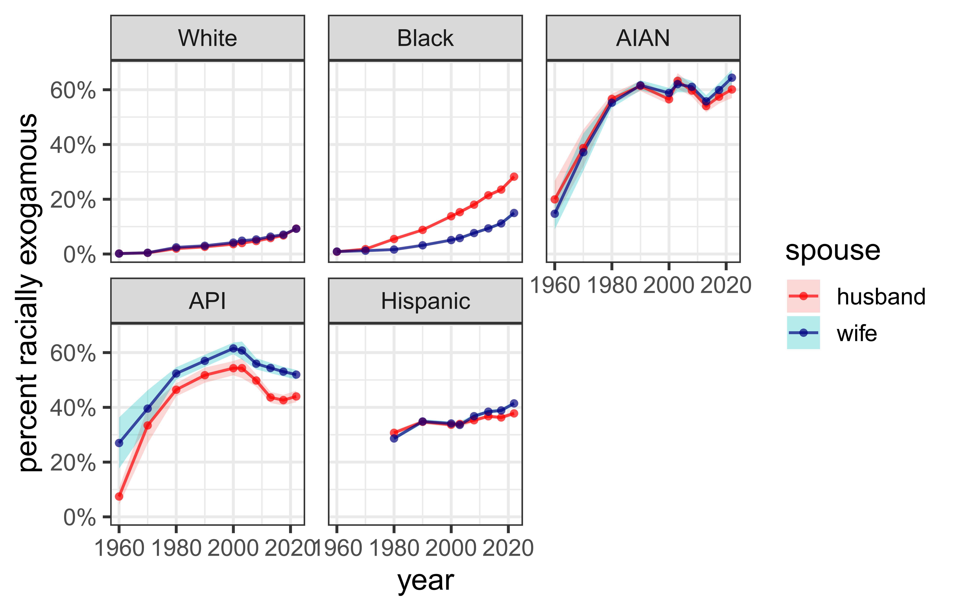
Figure 2: The trend in the share of spouses of a given race and gender that are in a racially exogamous marriage. Values in all years are weighted to reflect the joint age distribution of newlywed partners. 83% confidence bands shown.


Figure 3: Odds of racial exogamy across all single race pairings, separately by the focal race of spouse. Estimates are derived from log-linear models that control for state racial composition and are weighted to reflect the joint age distribution of spouses. 83% confidence bands shown.
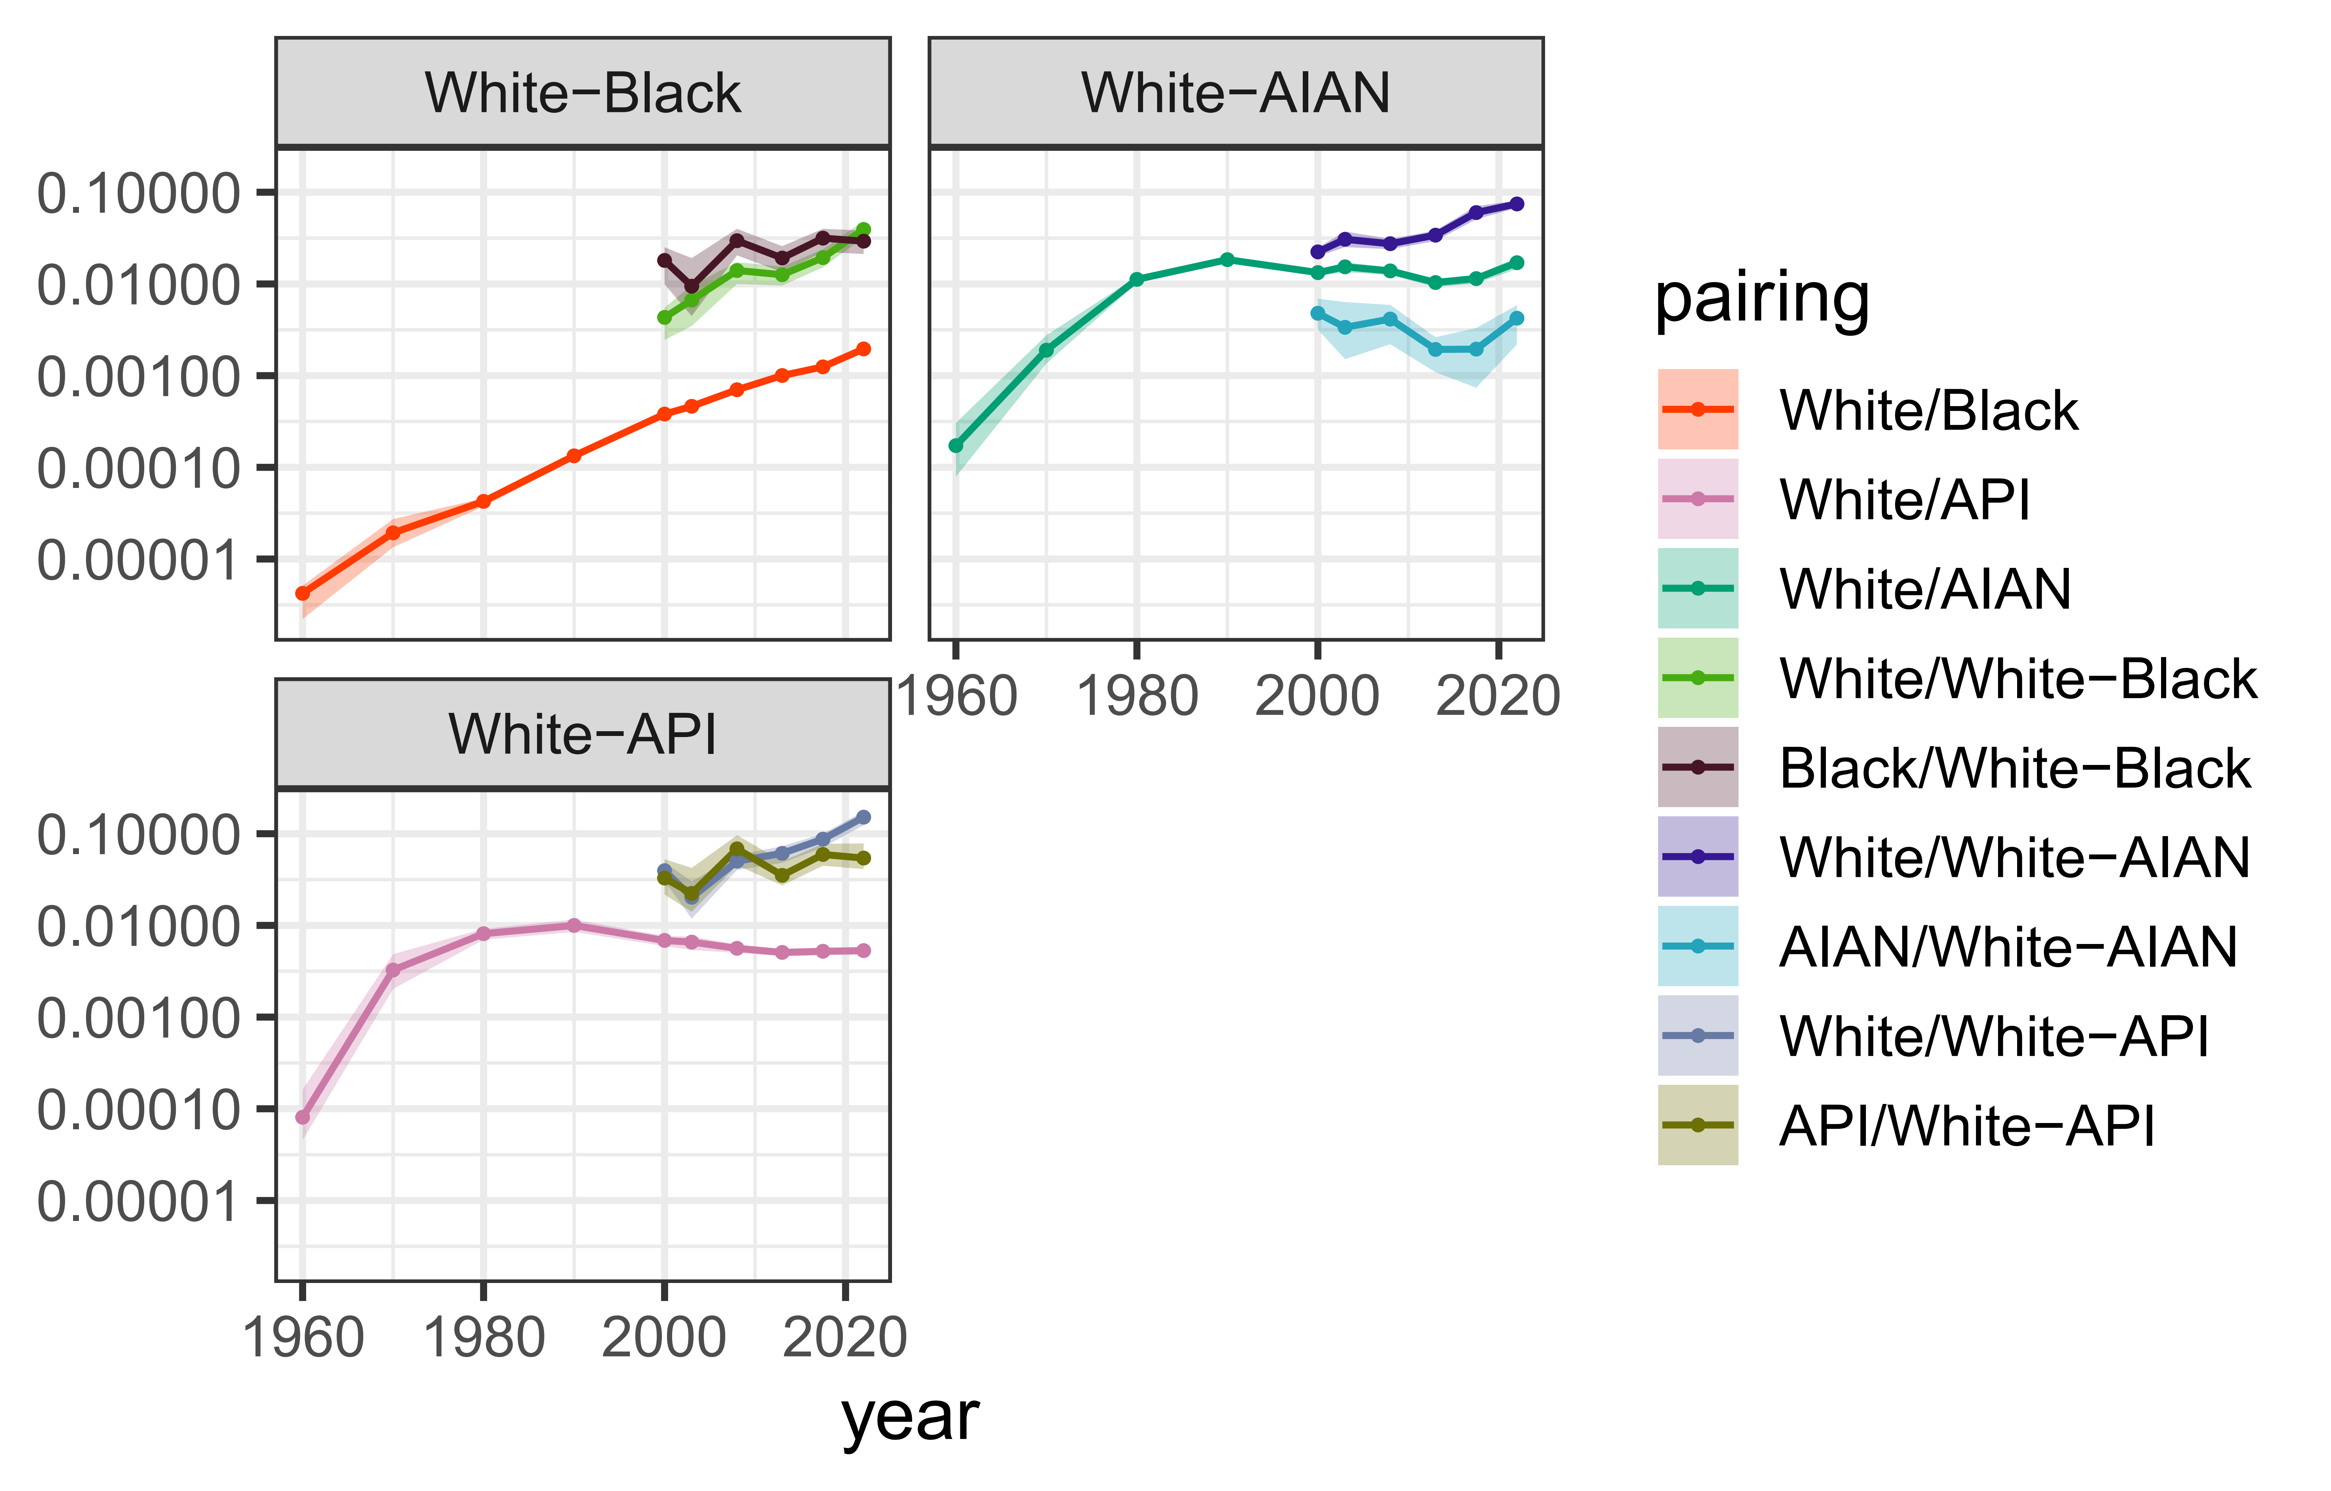
Figure 4: Odds of racial exogamy for biracial groups with component single race groups and in comparison to the odds of racial exogamy for the component single race groups. Estimates are derived from log-linear models that control for state racial composition and are weighted to reflect the joint age distribution of spouses. 83% confidence bands shown.
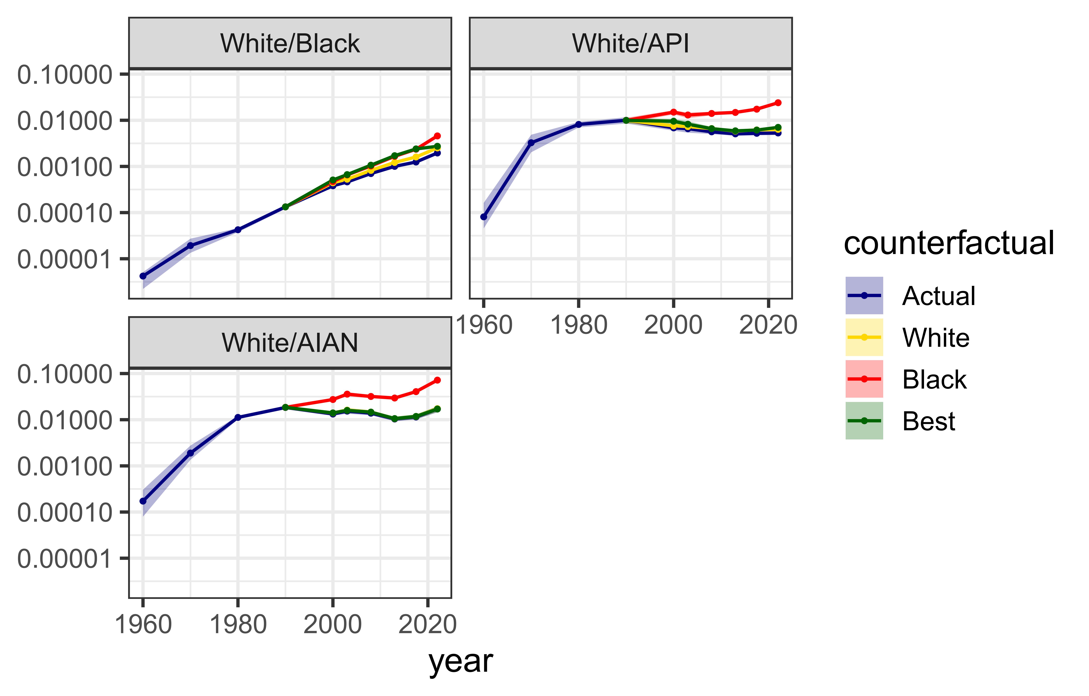
Figure 5: Comparison of odds of racial exogamy with different counterfactual assumptions about single race reporting among multiracial respondents. Estimates are derived from log-linear models that control for state racial composition and are weighted to reflect the joint age distribution of spouses. 83% confidence bands shown.
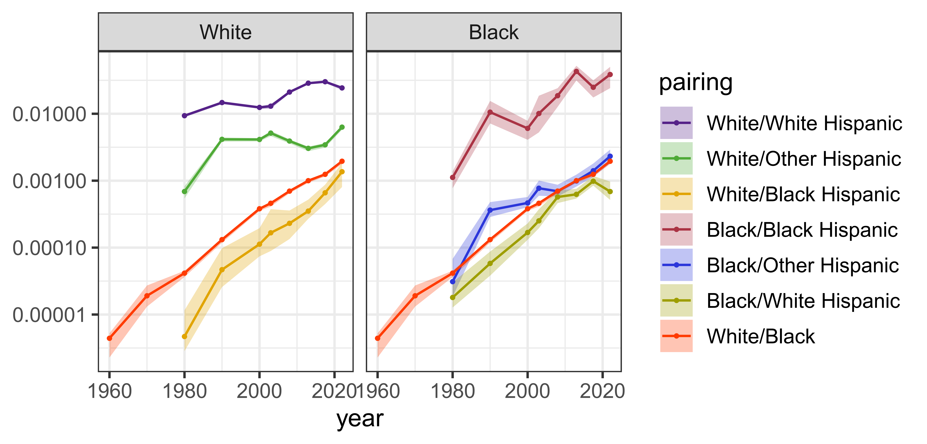
Figure 6: Odds of racial exogamy for Hispanic subgroups with non-Hispanic White and Black partners. White/Black exogamy odds are also shown for reference. Estimates are derived from log-linear models that control for state racial composition and are weighted to reflect the joint age distribution of spouses. 83% confidence bands shown.
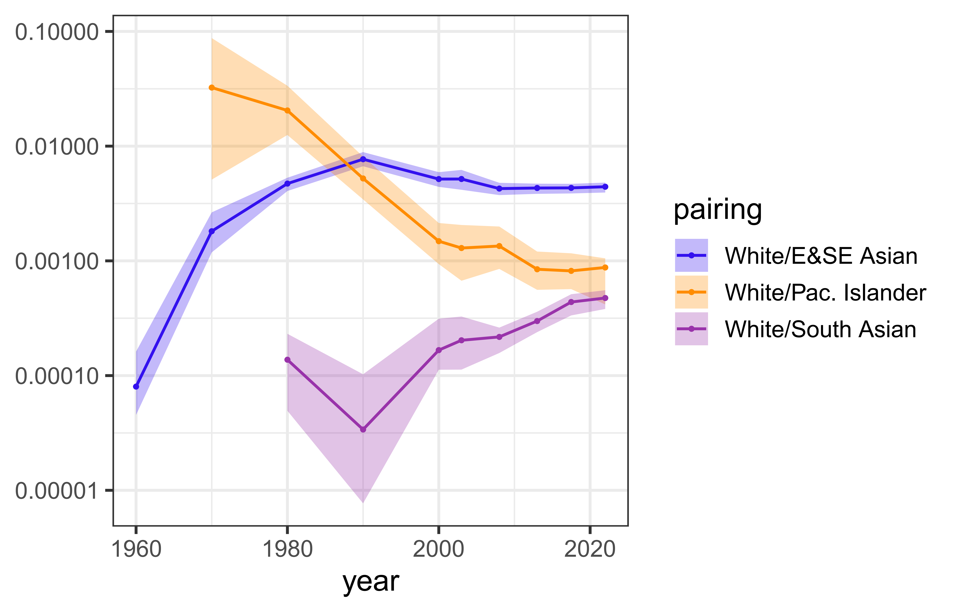
Figure 7: Odds of racial exogamy for Asian subgroups with White partners. Estimates are derived from log-linear models that control for state racial composition and are weighted to reflect the joint age distribution of spouses. 83% confidence bands shown.
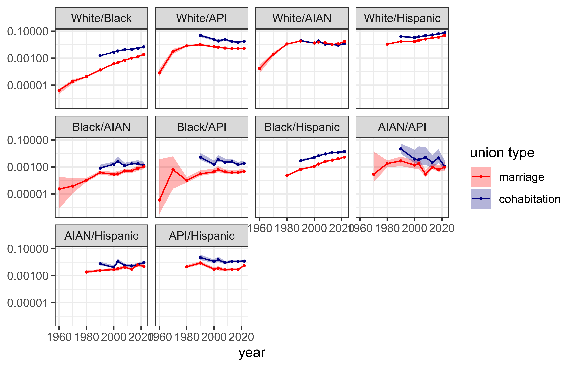
Figure 8: Odds of racial exogamy across all single race pairings, separately by cohabitation and marriage. Estimates are derived from log-linear models that control for state racial composition and are weighted to reflect the joint age distribution of spouses. 83% confidence bands shown.

I use the term “interracial” here because I will focus on marriage between groups that are identified by a racialized boundary, but the logic could apply equally well to “intergroup” marriage where groups are defined by ethnicity, religion, etc.
Form 1 of the 1970 Census also included a Hispanicity question, but the results from this Hispanicity question have been found to be not comparable to the Hispanicity question asked in 1980 onward (US Census Bureau 1992, B–13).
The 1980 Census includes a category of “Other Asian and Pacific Islander” that makes it impossible to fully distinguish these groups in that year. I treat this issue as a missing data problem. Individuals in this category in 1980 are assigned to an API sub-group category via predictive mean matching based on 1990 Census data.
Throughout the article, I use a slash (“/”) to distinguish a union across two groups (e.g. White/Black for marriage between a White and Black spouse) and a dash (“-”) to indicate a multiracial individual with ancestry from two groups (e.g. White-Black to indicate an individual that identified as both White and Black).
Because the unit of observation is a couple, I use the mean of both partner’s person weight to derive the couple weight.

