

Lab 2

[Click here to Register Attendance](https://goo.gl/forms/J9WP2kj83JC1mKYU2)

|  |  |
| --- | --- |
| Name |  |
| Date |  |
| Student No |  |
| Student Email |  |

### **Brainstorming**

**Preparation**:

Personal Reflection - personality traits, introversion/extroversion, personality tests, personal values

Building Group Trust - sharing some of your personal reflection

Collaborative brainstorming:

* Brainstorm for 2 minutes - go wild!
* Go around the circle and have everyone explain their brainstormed ideas
* Screenshot your ideas for further refinement

### **GitHub Revision**

1. Go to <http://github.com>
2. Create a new Repository called **thirdrepo** using the Add Repository button below your profile picture.
3. Use the Add File button to add a new file to your repository, give your new file a name, type some text and save the file.
4. On your Laptop/Desktop, install GitHub Desktop from here: <https://desktop.github.com/>
5. Using GitHub Desktop, Clone a repository from your GitHub account to your laptop/computer. Paste a screenshot here of your cloned **thirdrepo**.
6. On your Laptop/Desktop, create a repository called **fourthrepo**
7. In your fourthrepo folder add the Arduino Button sketch, and save it, then **commit** the change and **push** it to your GitHub account
8. Paste a screenshot here of your pushed **fourthrepo** repository on GitHub.com

### **Arduino Coding Digital & Analog Examples**

1. Open the Arduino Create Integrated Development Environment (IDE), create an account and login <https://create.arduino.cc/editor>

**OR**   
Download the Arduino IDE to your own computer <https://www.arduino.cc/en/software>

1. Click Examples -> Built-in -> **Digital** and choose the Button sketch

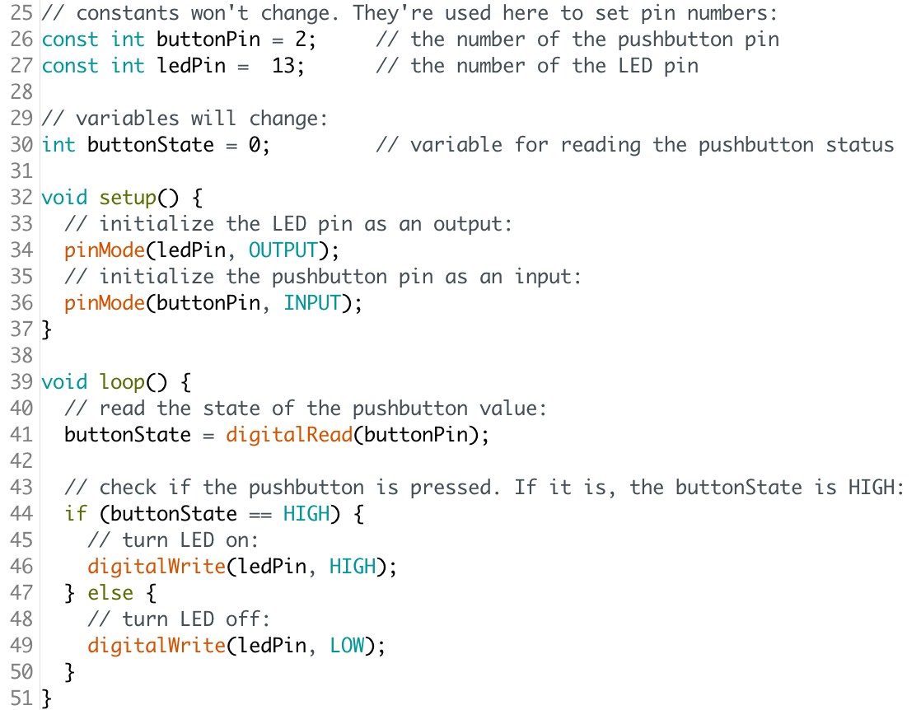

1. Compile the Button sketch and confirm it compiles correctly
2. Edit the Button sketch so, it \***blinks\*** the LED when the button is pushed and upload your code to your Github **fourthrepo** repository
3. Click Examples -> Built-in -> **Basics** and choose the AnalogReadSerial sketch  
   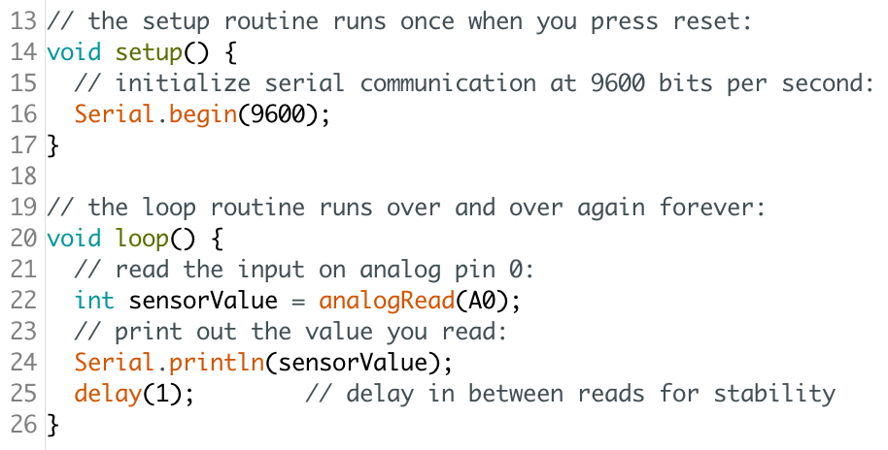
4. Edit the AnalogReadSerial sketch, so it blinks an LED in Digital Pin 3 if the value reading in Pin A0 goes above 500. Hint: reuse elements of the Button sketch to achieve this and in the comments, attribute the original authors of the Button sketch
5. Save your edited file as *AnalogBlinkAboveValue.ino* and Upload your revised code to your Github **fourthrepo** repository

**GitHub Collaboration**

1. Add me (marloftitsligo) and at least one classmate as a **Collaborator** on your **fourthrepo** repository
2. **Fork** this repository to your local machine using Github Desktop: <https://github.com/marloftitsligo/firstrep1>
3. Add a new Branch to this forked repository and add a file, commit and push to your Github
4. Add a pull request to marloftitsligo and ask to merge your branch changes to the original repo
5. Paste a screenshot of your pull request on Github.com
6. Fork a repository from a classmate and add a Branch for your changes
7. Make a pull request to your classmate asking them to merge the changes
8. Process any pull requests you have received and paste a screenshot of your completed request from Github.com