Implementation Plan

Our smart light was still designed with the target audience of students and those who work at home for many hours. We keep our clock feature the same as it worked perfectly and it helps keep the product more attractive to our target audiences.

Most people have messy desks and with our older version we added to that clutter with a lamp, So with our newer design we focused on a lightbulb rather than a lamp.

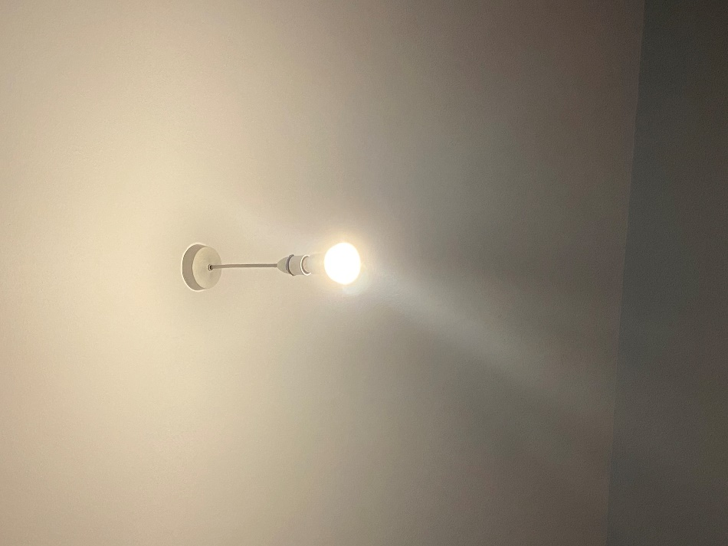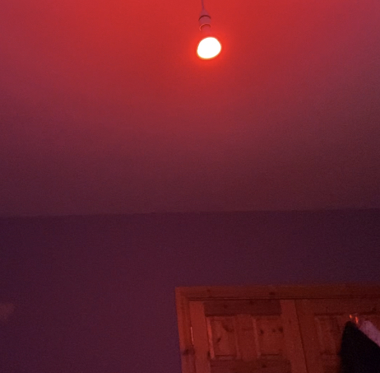

The great thing about our updated design is that it still does not require many parts to function

Parts List:

* Laptop / Desktop PC
* Arduino Yun
* Light Sensor
* LCD Screen
* Internet Access
* Philips Hue Light Bulb

No additional equipment was needed other than the “Grove Kit” + The Smart Bulb

We are using an API called If this then that which allowed us to connect the lightbulb to it and setup a webhook that can be triggered by the Arduino and get the light bulb to do the specific functions we have told it to do.

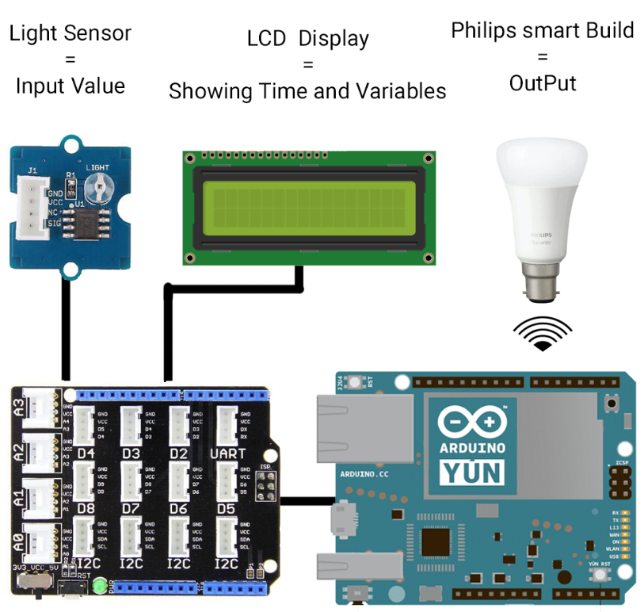

Code Samples

This is a sample of our code which runs a loop that will turn the light on and off every 5 sections, This was make sure the base code was working before it was added upon and also to test the light bulb triggers to make sure they were working as attended

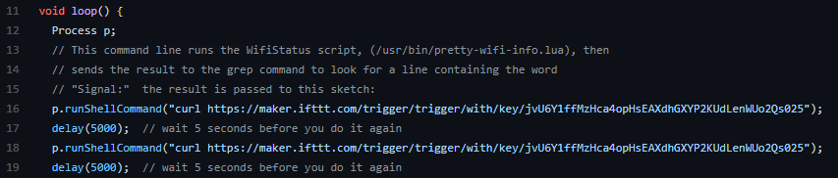

This section triggers each webhook allowing the light to change colour or turn on/off:

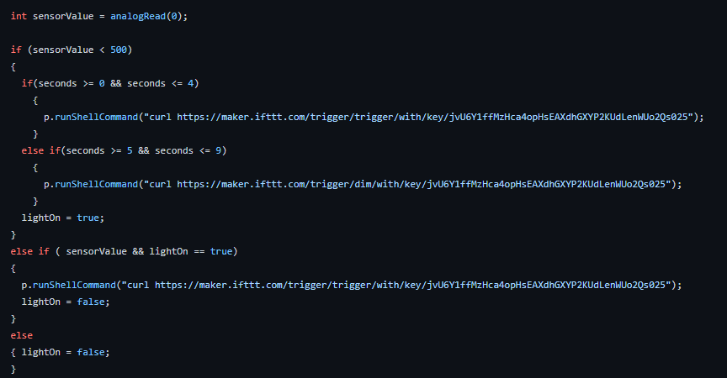

This is what tells the Arduino the time so it can display it on the LCD Screen:

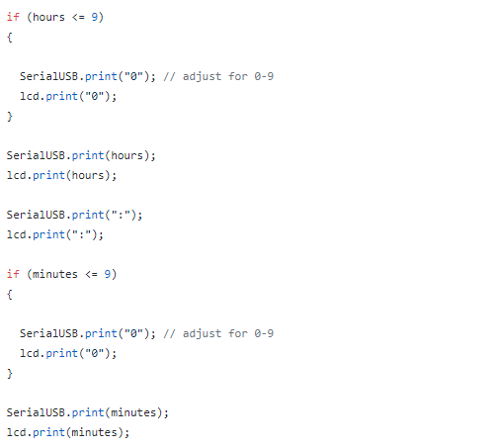

Script For PowerPoint – Leave out of Final Report

Our smart light was still designed with the target audience of students and those who work at home for many hours. We keep our clock feature the same as it worked perfectly and it helps keep the product more attractive to our target audiences. Most people have messy desks and with our older version we added to that clutter with a lamp, So with our newer design we focused on a lightbulb rather than a lamp.

We are using an API called “If this then that” which allowed us to connect the lightbulb to it and setup a webhook that can be triggered by the Arduino and get the light bulb to do the specific functions we have told it to do.

This is our updated parts list of everything needed to reproduce our product \*\*READ LIST\*\*

This is a sample of our code which runs a loop that will turn the light on and off every 5 sections, This was make sure the base code was working before it was added upon and also to test the light bulb triggers to make sure they were working as attended