Aaron Ho Tim Fat

Assignment 1

Flutter Exercise 1:

import 'package:flutter/material.dart';  
  
void main() {  
 runApp(MyApp());  
}  
  
class MyApp extends StatelessWidget {  
 const MyApp({super.key});  
  
 @override  
 Widget build(BuildContext context) {  
 return MaterialApp(  
 home: CartApp(),  
 debugShowCheckedModeBanner: false,  
 );  
 }  
}  
  
class CartApp extends StatefulWidget {  
 const CartApp({super.key});  
  
 @override  
 State<CartApp> createState() => _CartAppState();  
}  
  
class _CartAppState extends State<CartApp> {  
 int orangeAmount = 0;  
 int berryAmount = 0;  
 int grapeAmount = 0;  
 int carrotAmount = 0;  
 int totalItems = 0;  
 int subTotal = 0;  
 int taxes = 0;  
 int cartTotal = 0;  
  
 void addSubTotal(int amount) {  
 setState(() {  
 subTotal += amount;  
 calcTax(subTotal);  
 calcCartTotal();  
 calcTotalItems();  
 });  
 }  
  
 void removeSubTotal(int amount) {  
 setState(() {  
 subTotal -= amount;  
 calcTax(subTotal);  
 calcCartTotal();  
 calcTotalItems();  
 });  
 }  
  
 void calcTotalItems() {  
 totalItems = orangeAmount + berryAmount + grapeAmount + carrotAmount;  
 }  
  
 void calcTax(int amount) {  
 setState(() {  
 taxes = (amount * 0.15) as int;  
 });  
 }  
  
 void calcCartTotal() {  
 setState(() {  
 cartTotal = subTotal + taxes;  
 });  
 }  
  
 @override  
 Widget build(BuildContext context) {  
 return Scaffold(  
 appBar: AppBar(  
 title: Text('My Cart', style: TextStyle(color: Colors.*red*),),  
 centerTitle: true,  
 ),  
 body: Container(  
 padding: EdgeInsets.all(32),  
 child: Column(  
 children: [  
 Row(  
 children: [  
 ClipRRect(  
 borderRadius: BorderRadius.only(  
 topRight: Radius.circular(30),  
 topLeft: Radius.circular(8),  
 bottomLeft: Radius.circular(30),  
 bottomRight: Radius.circular(8)  
 ),  
 child: Image(image: AssetImage('assets/orange.jpg'), fit: BoxFit.cover, height: 100, width: 100,),  
 ),  
 SizedBox(width: 15,),  
 Column(  
 children: [  
 Text('Orange - XX Traders', style: TextStyle(color: Colors.*red*, fontSize: 20),),  
 Text('Rs.300/2KG', style: TextStyle(color: Colors.*grey*, fontSize: 12),),  
 SizedBox(height: 20,),  
 Row(  
 children: [  
 ElevatedButton(onPressed: () {  
 if (orangeAmount > 0) {  
 orangeAmount--;  
 removeSubTotal(900);  
 }  
 }, child: Text('-', style: TextStyle(color: Colors.*red*, fontSize: 25)), style:   
 ButtonStyle(  
 shape: WidgetStatePropertyAll(CircleBorder()),  
 side: WidgetStatePropertyAll(BorderSide(color: Colors.*red*, width: 3))  
 ),),  
 SizedBox(width: 10,),  
 Text(orangeAmount.toString(), style: TextStyle(color: Colors.*red*),),  
 SizedBox(width: 10,),  
 ElevatedButton(onPressed: () {  
 orangeAmount++;  
 addSubTotal(900);  
 }, child: Icon(Icons.*add*, color: Colors.*red*,),style:  
 ButtonStyle(  
 shape: WidgetStatePropertyAll(CircleBorder()),  
 side: WidgetStatePropertyAll(BorderSide(color: Colors.*red*, width: 3))  
 ),),  
 ],  
 )  
 ],  
 )  
 ],  
 ),  
 SizedBox(height: 30,),  
 Row(  
 children: [  
 ClipRRect(  
 borderRadius: BorderRadius.only(  
 topRight: Radius.circular(30),  
 topLeft: Radius.circular(8),  
 bottomLeft: Radius.circular(30),  
 bottomRight: Radius.circular(8)  
 ),  
 child: Image(image: AssetImage('assets/berry.jpg'), fit: BoxFit.cover, height: 100, width: 100,),  
 ),  
 SizedBox(width: 15,),  
 Column(  
 children: [  
 Text('Berry - WXY Traders', style: TextStyle(color: Colors.*red*, fontSize: 20),),  
 Text('Rs.300/2KG', style: TextStyle(color: Colors.*grey*, fontSize: 12),),  
 SizedBox(height: 20,),  
 Row(  
 children: [  
 ElevatedButton(onPressed: () {  
 if (berryAmount > 0) {  
 berryAmount--;  
 removeSubTotal(900);  
 }  
 }, child: Text('-', style: TextStyle(color: Colors.*red*, fontSize: 25)),style:  
 ButtonStyle(  
 shape: WidgetStatePropertyAll(CircleBorder()),  
 side: WidgetStatePropertyAll(BorderSide(color: Colors.*red*, width: 3))  
 ),),  
 SizedBox(width: 10,),  
 Text(berryAmount.toString(), style: TextStyle(color: Colors.*red*),),  
 SizedBox(width: 10,),  
 ElevatedButton(onPressed: () {  
 berryAmount++;  
 addSubTotal(900);  
 }, child: Icon(Icons.*add*, color: Colors.*red*,),style:  
 ButtonStyle(  
 shape: WidgetStatePropertyAll(CircleBorder()),  
 side: WidgetStatePropertyAll(BorderSide(color: Colors.*red*, width: 3))  
 ),),  
 ],  
 )  
 ],  
 )  
 ],  
 ),  
 SizedBox(height: 30,),  
 Row(  
 children: [  
 ClipRRect(  
 borderRadius: BorderRadius.only(  
 topRight: Radius.circular(30),  
 topLeft: Radius.circular(8),  
 bottomLeft: Radius.circular(30),  
 bottomRight: Radius.circular(8)  
 ),  
 child: Image(image: AssetImage('assets/grape.jpg'), fit: BoxFit.cover, height: 100, width: 100,),  
 ),  
 SizedBox(width: 15,),  
 Column(  
 children: [  
 Text('Grapes - AGR Traders', style: TextStyle(color: Colors.*red*, fontSize: 20),),  
 Text('Rs.50/2KG', style: TextStyle(color: Colors.*grey*, fontSize: 12),),  
 SizedBox(height: 20,),  
 Row(  
 children: [  
 ElevatedButton(onPressed: () {  
 if (grapeAmount > 0) {  
 grapeAmount--;  
 removeSubTotal(100);  
 }  
 }, child: Text('-', style: TextStyle(color: Colors.*red*, fontSize: 25)),style:  
 ButtonStyle(  
 shape: WidgetStatePropertyAll(CircleBorder()),  
 side: WidgetStatePropertyAll(BorderSide(color: Colors.*red*, width: 3))  
 ),),  
 SizedBox(width: 10,),  
 Text(grapeAmount.toString(), style: TextStyle(color: Colors.*red*),),  
 SizedBox(width: 10,),  
 ElevatedButton(onPressed: () {  
 grapeAmount++;  
 addSubTotal(100);  
 }, child: Icon(Icons.*add*, color: Colors.*red*,),style:  
 ButtonStyle(  
 shape: WidgetStatePropertyAll(CircleBorder()),  
 side: WidgetStatePropertyAll(BorderSide(color: Colors.*red*, width: 3))  
 ),),  
 ],  
 )  
 ],  
 )  
 ],  
 ),  
 SizedBox(height: 30,),  
 Row(  
 children: [  
 ClipRRect(  
 borderRadius: BorderRadius.only(  
 topRight: Radius.circular(30),  
 topLeft: Radius.circular(8),  
 bottomLeft: Radius.circular(30),  
 bottomRight: Radius.circular(8)  
 ),  
 child: Image(image: AssetImage('assets/carrot.jpg'), fit: BoxFit.cover, height: 100, width: 100,),  
 ),  
 SizedBox(width: 15,),  
 Column(  
 children: [  
 Text('Carrot - GAD Traders', style: TextStyle(color: Colors.*red*, fontSize: 20),),  
 Text('Rs.250/2KG', style: TextStyle(color: Colors.*grey*, fontSize: 12),),  
 SizedBox(height: 20,),  
 Row(  
 children: [  
 ElevatedButton(onPressed: () {  
 if (carrotAmount > 0) {  
 carrotAmount--;  
 removeSubTotal(500);  
 }  
 }, child: Text('-', style: TextStyle(color: Colors.*red*, fontSize: 25)),style:  
 ButtonStyle(  
 shape: WidgetStatePropertyAll(CircleBorder()),  
 side: WidgetStatePropertyAll(BorderSide(color: Colors.*red*, width: 3))  
 ),),  
 SizedBox(width: 10,),  
 Text(carrotAmount.toString(), style: TextStyle(color: Colors.*red*),),  
 SizedBox(width: 10,),  
 ElevatedButton(onPressed: () {  
 carrotAmount++;  
 addSubTotal(500);  
 }, child: Icon(Icons.*add*, color: Colors.*red*,),style:  
 ButtonStyle(  
 shape: WidgetStatePropertyAll(CircleBorder()),  
 side: WidgetStatePropertyAll(BorderSide(color: Colors.*red*, width: 3))  
 ),),  
 ],  
 )  
 ],  
 )  
 ],  
 ),  
 SizedBox(height: 30,),  
 Row(  
 mainAxisAlignment: MainAxisAlignment.end,  
 children: [  
 Column(  
 crossAxisAlignment: CrossAxisAlignment.end,  
 children: [  
 Text('Subtotal(${totalItems} Items)', style: TextStyle(color: Colors.*grey*, fontSize: 25),),  
 SizedBox(height: 25,),  
 Text('Tax', style: TextStyle(color: Colors.*grey*, fontSize: 25),),  
 SizedBox(height: 25,),  
 Text('Cart Total', style: TextStyle(color: Colors.*red*, fontSize: 25),),  
 ],  
 ),  
 SizedBox(width: 30,),  
 Column(  
 crossAxisAlignment: CrossAxisAlignment.end,  
 children: [  
 Text('RS.${subTotal}', style: TextStyle(color: Colors.*grey*, fontSize: 25),),  
 SizedBox(height: 25,),  
 Text('RS.${taxes}', style: TextStyle(color: Colors.*grey*, fontSize: 25),),  
 SizedBox(height: 25,),  
 Text('RS.${cartTotal}', style: TextStyle(color: Colors.*red*, fontSize: 25),)  
 ],  
 )  
 ]  
 ),  
 SizedBox(height: 40,),  
 Row(  
 mainAxisAlignment: MainAxisAlignment.center,  
 children: [  
 ElevatedButton(onPressed: () {  
 ScaffoldMessenger.*of*(context).showSnackBar(SnackBar(content: Text('Your total is RS.${cartTotal}')));  
 }, child: Text('Secure Checkout', style: TextStyle(color: Colors.*white*),), style: ButtonStyle(  
 backgroundColor: WidgetStatePropertyAll(Colors.*red*),  
 shape: WidgetStatePropertyAll(RoundedRectangleBorder(borderRadius: BorderRadius.all(Radius.*zero*))),  
 ),),  
 ],  
 )  
 ],  
 ),  
 ),  
 );  
 }  
}

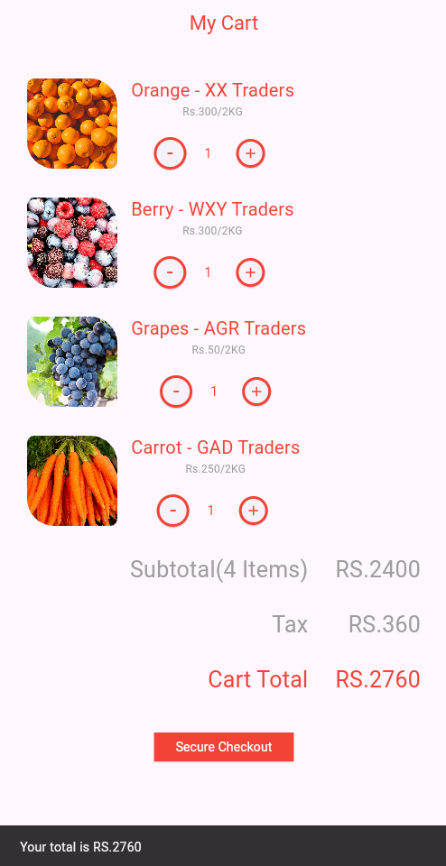

Flutter Exercise 2:

import 'package:flutter/material.dart';  
  
void main() {  
 runApp(MyApp());  
}  
  
class MyApp extends StatelessWidget {  
 const MyApp({super.key});  
  
 @override  
 Widget build(BuildContext context) {  
 return MaterialApp(  
 home: RentApp(),  
 theme: ThemeData(scaffoldBackgroundColor: Colors.*black*),  
 debugShowCheckedModeBanner: false,  
 );  
 }  
}  
  
class RentApp extends StatelessWidget {  
 const RentApp({super.key});  
  
 @override  
 Widget build(BuildContext context) {  
 return Scaffold(  
 body: SingleChildScrollView(  
 child: Center(  
 child: Container(  
 padding: EdgeInsets.all(32),  
 width: 400,  
 child: Column(  
 children: [  
 ClipRRect(  
 borderRadius: BorderRadius.all(Radius.circular(15)),  
 child: Image(image: AssetImage('assets/apartment.jpg'), fit: BoxFit.cover, height: 250, width: 400,),  
 ),  
 SizedBox(height: 10,),  
 Row(  
 mainAxisAlignment: MainAxisAlignment.spaceBetween,  
 children: [  
 Text('Chill Apartment', style: TextStyle(color: Colors.*white*, fontWeight: FontWeight.*bold*),),  
 Text('Katowice', style: TextStyle(color: Colors.*white*, fontWeight: FontWeight.*bold*),)  
 ],  
 ),  
 Divider(  
 color: Colors.*white*,  
 ),  
 Row(  
 mainAxisAlignment: MainAxisAlignment.spaceBetween,  
 children: [  
 Row(  
 children: [  
 Text('350 \$', style: TextStyle(color: Colors.*blue*),),  
 Text(' per night', style: TextStyle(color: Colors.*white*),)  
 ],  
 ),  
 Row(  
 children: [  
 Icon(Icons.*star*, color: Colors.*white*,),  
 Text('4.0/5', style: TextStyle(color: Colors.*white*),)  
 ],  
 )  
 ],  
 ),  
 SizedBox(height: 20,),  
 ClipRRect(  
 borderRadius: BorderRadius.all(Radius.circular(15)),  
 child: Image(image: AssetImage('assets/hotel.jpg'), fit: BoxFit.cover, height: 250, width: 400,),  
 ),  
 SizedBox(height: 10,),  
 Row(  
 mainAxisAlignment: MainAxisAlignment.spaceBetween,  
 children: [  
 Text('Luxury Katowice Hotel', style: TextStyle(color: Colors.*white*, fontWeight: FontWeight.*bold*),),  
 Text('Katowice', style: TextStyle(color: Colors.*white*, fontWeight: FontWeight.*bold*),)  
 ],  
 ),  
 Divider(  
 color: Colors.*white*,  
 ),  
 Row(  
 mainAxisAlignment: MainAxisAlignment.spaceBetween,  
 children: [  
 Row(  
 children: [  
 Text('500 \$', style: TextStyle(color: Colors.*blue*),),  
 Text(' per night', style: TextStyle(color: Colors.*white*),)  
 ],  
 ),  
 Row(  
 children: [  
 Icon(Icons.*star*, color: Colors.*white*,),  
 Text('4.2/5', style: TextStyle(color: Colors.*white*),)  
 ],  
 )  
 ],  
 )  
 ],  
 ),  
 ),  
 )  
 ),  
 );  
 }  
}

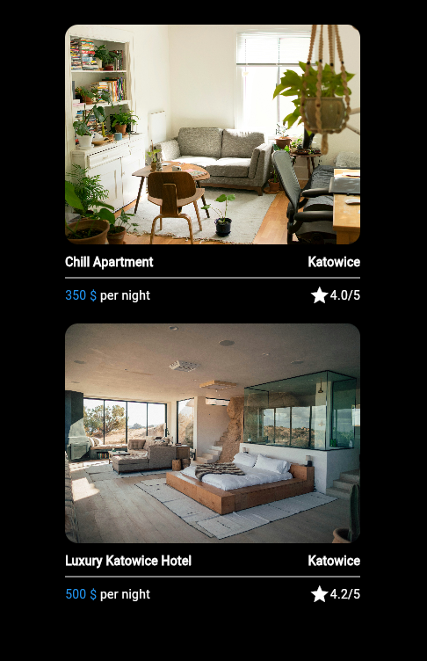

Dart Exercise 1:

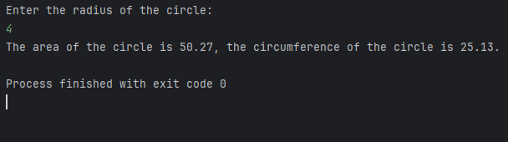

Dart Exercise 2:

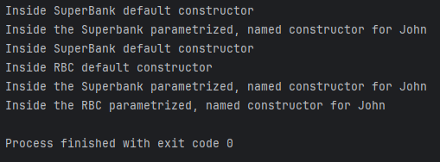

Dart Exercise 3:

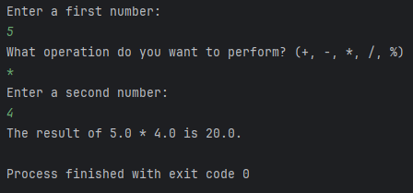

Dart Exercise 4:

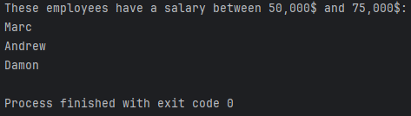

Dart Exercise 5:

