**Introduction to SkyKart:**

This project aims to make an online shopping store. Tools used for development are PHP, HTML5, CSS, JAVA script, PHPMYADMIN etc. SkyKart enables users to create their own account, login into their account, Search products, View product description and reviews, add products to cart, Payment transaction, see trending and new products etc.

An online shopping store enables users to buy products with a mouse click over internet. The basic functionality of an online retail store is to display various products and make them available for buying. Including that there are other functionalities like personalization for user, user accounts, transaction processing, search suggestions, recommended products, trending products, different categories, adding to cart options etc.

**Requirements:**

A user or customer can sign up, create his own account with his details and logs into his account with a password. He/she searches for products by typing in the search bar or they can go through the list of categories of products available and search on the product.

They can add products to their cart and the respective price is collected at the end of the shopping session. If the payment is successful, the product will be delivered to the customer.

The system will be able to manage customers’ data, data about products in store and transaction made by the customers. Management will be able to add, edit and view the products in the store, also administrator of the system can view transaction made edit and even remove the transaction from the e-commerce management system. Customers’ information will be kept confidential by system and online administrator can view them.

Cart access restricted when user not logged in. Support for payment transactions and automatic balance updates and checks. Products with description and reviews. A user can give a review for the product which he has already bought. Customer can add products to cart and increase the quantity of product required. The total amount will be dynamically updated.

After successful payment the quantity of the product in the database reduces and a row is added in the checkout History.

Report Overview:

1. Database Description
2. ER Diagram
3. Relational Schema
4. Procedures and queries
5. Backend development
6. Future works
7. Conclusion

Database description:

Database consists of 6 tables. We have achieved BCNF form of normalization where in every functional dependency one attribute is a primary key of the table.

Reviews, Checkouthistory, Cart tables come from the relations between Users and products entities.

All the entities are strong relations and there are no identifying relationships.

Entity users and products are related by 3 relations Reviews, Checkouthistory, Cart   
 and nowhere total participation is expected.

Users and Transaction entities are in 1:N cardinality where participation from transaction is a must. Total participation is reuired from transaction.

Hence while designing the relational schema we have taken all the simple attributes in entity types and for users to transaction 1:N relationship primary key of users is added as a foreign key to transaction table.

For M:N relationships Reviews, Checkouthistory, Cart tables are created and the primary key attributes of participating entities are added to the relations and a composite primary key is formed along with the attributes of relationships.

**ER Diagram**

Entities:

* Users
* Products
* Transactions

Relationships:

* Checkout history : M:N
* Cart: M:N
* Makes : 1:N
* Reviews: M:N

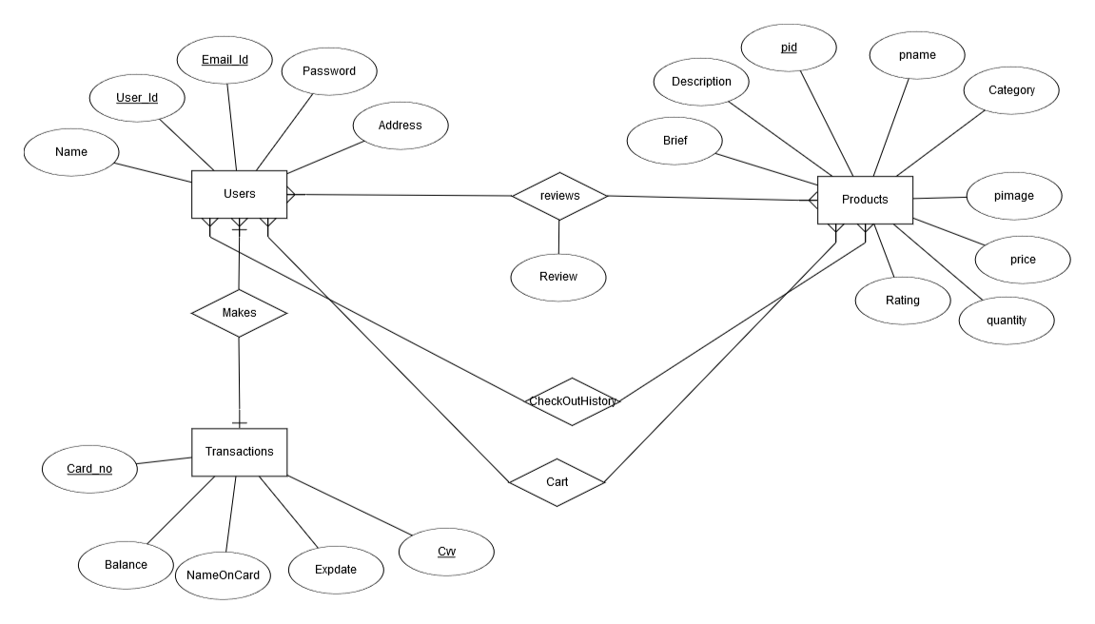

**Relational Schema:**

Tables:

Users

Products

Transaction

Reviews

CheckoutHistory

Cart

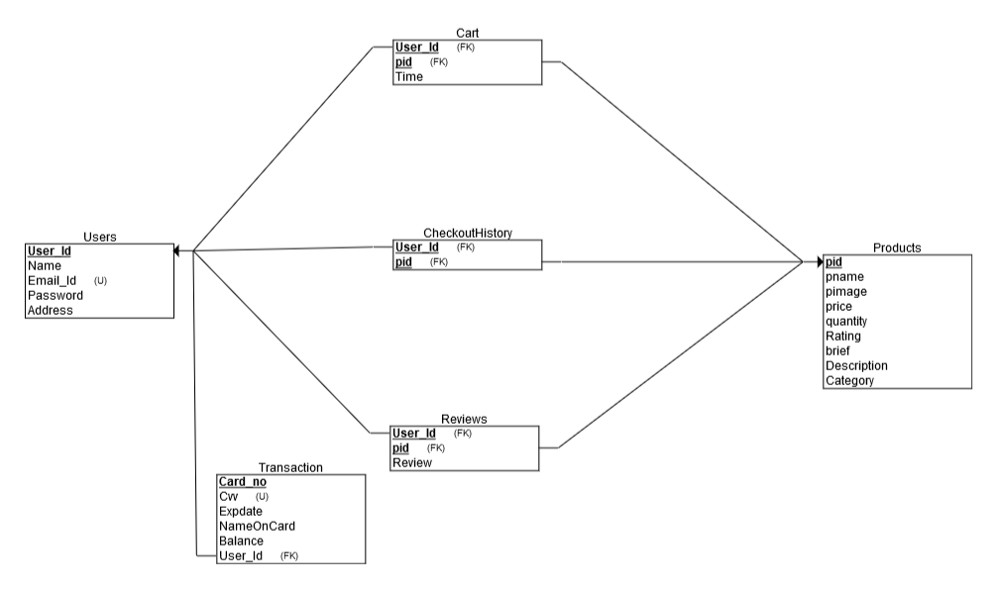

**Procedures and SQL queries**:

Backend Development:

Backend is developed using PHP and JAVA script.

Future Works:

Products can be specialized based up on the Categories. Then ne tables will be added

Conclusion: