Starting with the robot facing as shown below, with the sonar facing to the front:
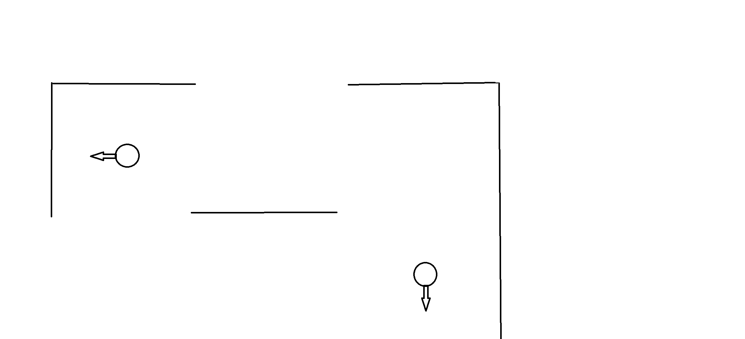

Take a sonar reading to localize yourself, then turn right to face the upper wall, take another reading.
Next, turn right again, to face the corridor, and rotate the sonar to the left of the robot, facing upwards.
Then do wall-following.
As the top wall disappears, try these two things:
a) keep moving forward until the next wall is in range
and b) rotate sonar to the opposite side and read while moving forward
Next, as the closest particle is getting close to the right (east), stop the robot, move the sonar to the center position and take a reading. Keep adjusting the robots position so that it is roughly in the center of the rightmost tile (up to, say 5-10 cm)
Then start wall-following down.

