Robot Manipulator Management System

A Web-Based System for Monitoring, Reservation and Maintenance of Laboratory Robotic Manipulators
Software Engineering — Project Report
Aaron Joshua
Registration No: 24BRS1393
Vellore Institute of Technology (VIT), Chennai

Table of Contents
Right-click and choose “Update Field” to build the Table of Contents.

1. Introduction

1.1 Background and Motivation
Modern engineering and research laboratories increasingly host a fleet of robotic manipulators —
articulated arms, collaborative robots (cobots), SCARA, delta and Cartesian systems — that are shared
among many students, researchers and technicians. These machines are expensive capital assets with
finite service life: their joints, harmonic drives and actuators wear with cumulative operating hours
and must be serviced at defined intervals.
In practice, labs often track this information informally — a whiteboard showing which arm is "busy",
a spreadsheet of maintenance dates, or simply tribal knowledge. This leads to double-booking,
under-utilised equipment, missed preventive maintenance, and no single source of truth for the
condition of each robot. As the number of machines grows, the problem becomes unmanageable.
This motivated the development of the Robot Manipulator Management System (RMMS): a lightweight,
web-based platform that gives a lab a single dashboard to see every connected robot, its real-time
availability (free / in use), its wear condition, and its complete technical and maintenance history.

1.2 Problem Statement
*Laboratories that operate multiple robotic manipulators lack a centralised system to monitor
availability, track equipment wear, coordinate reservations, and manage maintenance. The absence
of such a system results in scheduling conflicts, poor asset utilisation and unplanned downtime.*
RMMS addresses this by providing role-based access (users and administrators), a live status
dashboard, a reservation (check-out/check-in) workflow that automatically accrues operating hours and
recomputes wear, and administrative tools for fleet and maintenance management.

1.3 Objectives
- Provide a centralised dashboard summarising fleet status, utilisation and wear at a glance.
- Maintain a catalogue of robots with full specifications and search/filter capability.
- Implement a reservation workflow so users can check robots out and back in, preventing conflicts.
- Model and track wear automatically from accumulated operating hours against a service interval.
- Enable administrators to manage the fleet (CRUD) and log maintenance, resetting wear on service.
- Enforce role-based access control with secure authentication (hashed passwords, signed sessions).
- Deliver a responsive, usable interface suitable for desktop and tablet use in a lab.

1.4 Scope and Limitations
In scope
- User registration/login and admin/user roles.
- Robot catalogue, dashboard analytics, reservation lifecycle, maintenance logging, user management.
- A relational database with referential integrity and a documented REST API.
- Automated test suite covering the core logic and API.
Out of scope / Limitations
- No direct hardware integration. RMMS is a *management* layer; operating hours are logged on
check-in rather than read live from a robot controller (e.g. ROS, PROFINET). A hardware telemetry
adapter is proposed as future work.
- Single-server deployment with an embedded SQLite database (appropriate for a lab; not a
multi-tenant cloud product).
- Scheduling is immediate check-out/check-in rather than calendar-based future booking.
- Notifications (email/SMS) and analytics export are not implemented in this version.

2. Literature Survey / Existing System

2.1 Review of Existing Systems
System / Category | Primary purpose | Relevance & limitation for a robot lab
CMMS (e.g. Fiix, UpKeep, eMaintenance) | Computerised Maintenance Management for industrial assets | Strong on work orders & maintenance, but heavyweight, licensed, and not oriented to self-service *reservation* of shared lab equipment.
Lab equipment booking tools (e.g. Clustermarket, Bookkit, NEMO) | Calendar reservation of instruments | Good for scheduling, but treat equipment as opaque "resources" with no concept of mechanical wear or robot-specific specifications.
MES / fleet dashboards (vendor tools: ABB RobotStudio, FANUC ZDT, KUKA Connect) | Vendor-specific robot telemetry & monitoring | Powerful condition monitoring, but single-vendor, expensive, and cannot present a *mixed-brand* lab fleet (KUKA + ABB + UR + …) in one place.
Spreadsheets / whiteboards | Ad-hoc tracking | Zero cost and familiar, but no concurrency control, no access roles, error-prone, and no analytics.

2.2 Gaps Identified and Proposed Solution
Gaps
- No single tool combines availability/reservation *and* wear/maintenance tracking for a
multi-vendor fleet of manipulators.
- Vendor monitoring tools are siloed; general booking tools ignore equipment health.
- Low-cost options (spreadsheets) lack access control, integrity and a real-time view.
Proposed solution (RMMS) — a vendor-neutral, open, lightweight web application that unifies:
*fleet dashboard + specifications catalogue + reservation lifecycle + wear model + maintenance log +
role-based administration*, deployable on a single modest server with no licensing cost.

3. Software Process Model and Project Planning

3.1 SDLC Model Chosen — Agile (Scrum-lite) with Iterative Increments
An Agile, iteration-based model was chosen over Waterfall because:
- Requirements for the dashboard and wear model were expected to evolve as early prototypes were seen.
- The project naturally decomposes into independently demonstrable increments (auth → catalogue →
reservations → maintenance → analytics), each producing working software.
- A single developer benefits from short feedback loops and continuous integration of tested code
rather than a single big-bang integration at the end.
Work was organised into four short sprints, each ending with a runnable, tested increment.

3.2 Project Schedule (Sprint Plan)
Sprint | Duration | Goals / Increment | Key deliverables
Sprint 0 — Setup | Week 1 | Project skeleton, DB schema, auth | Express app, SQLite schema, login/register
Sprint 1 — Catalogue | Week 2 | Robot model, listing, search/filter, detail | /api/robots, robot grid & detail UI
Sprint 2 — Reservations | Week 3 | Reserve/release, wear model, dashboard | Reservation lifecycle, stats, charts
Sprint 3 — Admin & QA | Week 4 | Fleet CRUD, maintenance, user mgmt, tests, docs | Admin tools, test suite, report & diagrams

Gantt (sprint timeline):

3.3 Risk Analysis
# | Risk | Likelihood | Impact | Mitigation
R1 | Scope creep (live hardware telemetry) | Medium | High | Fixed scope to a management layer; telemetry deferred to future work
R2 | Data integrity (orphaned reservations/logs) | Medium | High | Foreign keys + ON DELETE CASCADE; transactions around reserve/release
R3 | Concurrency — two users reserve the same robot | Low | Medium | Server-side status check inside a transaction; status flips atomically
R4 | Security — password/credential leakage | Low | High | scrypt hashing + per-user salt; signed, expiring tokens; no secrets in client
R5 | Environment/setup friction for evaluation | Medium | Medium | Single dependency, built-in SQLite, auto-seed on first run, documented steps
R6 | Single-developer time constraints | Medium | Medium | Agile increments; each sprint ships a usable subset

3.4 Cost / Effort Estimation (Optional)
A simplified estimate using effort = size × productivity:
- Approx. source size: ~1,600 LOC (≈ 0.0016 KLOC… i.e. 1.6 KLOC).
- Using a small-project heuristic of ~1 person-week per ~400 LOC of full-stack code → ~4 person-weeks,
matching the 4-sprint plan.
- Tooling cost: ₹0 — all tools used (Node.js, Express, SQLite, VS Code, Git, Mermaid) are free/open-source.

4. Requirements Analysis

4.1 Functional Requirements
ID | Requirement
FR1 | A visitor can register a user account and log in; invalid credentials are rejected.
FR2 | The system distinguishes two roles — *user* and *administrator* — and restricts features accordingly.
FR3 | An authenticated user can view the dashboard: counts by status, average wear, utilisation, charts.
FR4 | A user can browse, search and filter robots by status, category and free-text.
FR5 | A user can view full details of a robot including specifications, wear and maintenance history.
FR6 | A user can reserve a *free* robot; the robot becomes *in use* and a reservation record is created.
FR7 | A user (or admin) can release a robot, logging the hours used; the system updates operating hours and recomputes wear.
FR8 | A user can view their own reservations; an admin can view all reservations.
FR9 | An admin can create, edit and delete robots.
FR10 | An admin can log maintenance against a robot and optionally reset its wear clock.
FR11 | An admin can list users, change roles and delete users (but not demote/delete their own account).
FR12 | The system prevents reserving a robot that is not free (returns a conflict).

4.2 Non-Functional Requirements
ID | Category | Requirement
NFR1 | Security | Passwords stored only as scrypt hashes with per-user salts; sessions use signed, expiring tokens.
NFR2 | Performance | Dashboard and list endpoints respond in < 200 ms for a lab-scale fleet (tens–hundreds of robots).
NFR3 | Usability | Responsive dark UI; primary tasks reachable in ≤ 3 clicks; clear status colour-coding.
NFR4 | Reliability | Referential integrity enforced; reserve/release/maintenance run in transactions.
NFR5 | Portability | Runs on any OS with Node.js ≥ 22.5; no native build steps; embedded database.
NFR6 | Maintainability | Modular routes, shared helpers, documented REST API, automated tests.
NFR7 | Scalability | Stateless auth tokens allow horizontal scaling of the API tier.

4.3 Software Requirements Specification (SRS) Summary
- Purpose: centralise monitoring, reservation and maintenance of shared lab robotic manipulators.
- Users: *Lab Users* (browse, reserve, release, view own history) and *Administrators* (all of the
above plus fleet CRUD, maintenance logging, user management).
- Interfaces: a browser-based single-page UI and a JSON REST API over HTTP.
- Data: four entities — users, robots, reservations, maintenance_logs (see §5.5).
- Constraints: single-server deployment; wear derived from logged hours (no live telemetry).
- Assumptions: one active reservation per robot at a time; operating hours logged honestly on check-in.

4.4 Hardware and Software Requirements
Software
Item | Requirement
Runtime | Node.js ≥ 22.5 (built-in SQLite)
Dependency | Express.js ^4.19
Browser | Any modern browser (Chrome/Edge/Firefox)
OS | Windows / macOS / Linux

Hardware (minimum, for server)
Item | Requirement
CPU | Dual-core 1.5 GHz+
RAM | 512 MB+ (1 GB recommended)
Disk | ~100 MB (app + database)
Network | LAN/HTTP access for clients

5. System Design

5.1 System Architecture
RMMS follows a classic three-tier architecture: a browser-based presentation tier, a Node.js/Express
application tier exposing a stateless REST API, and a SQLite data tier. The tiers communicate over
HTTP/JSON; the client holds a signed session token and sends it as a Bearer header.
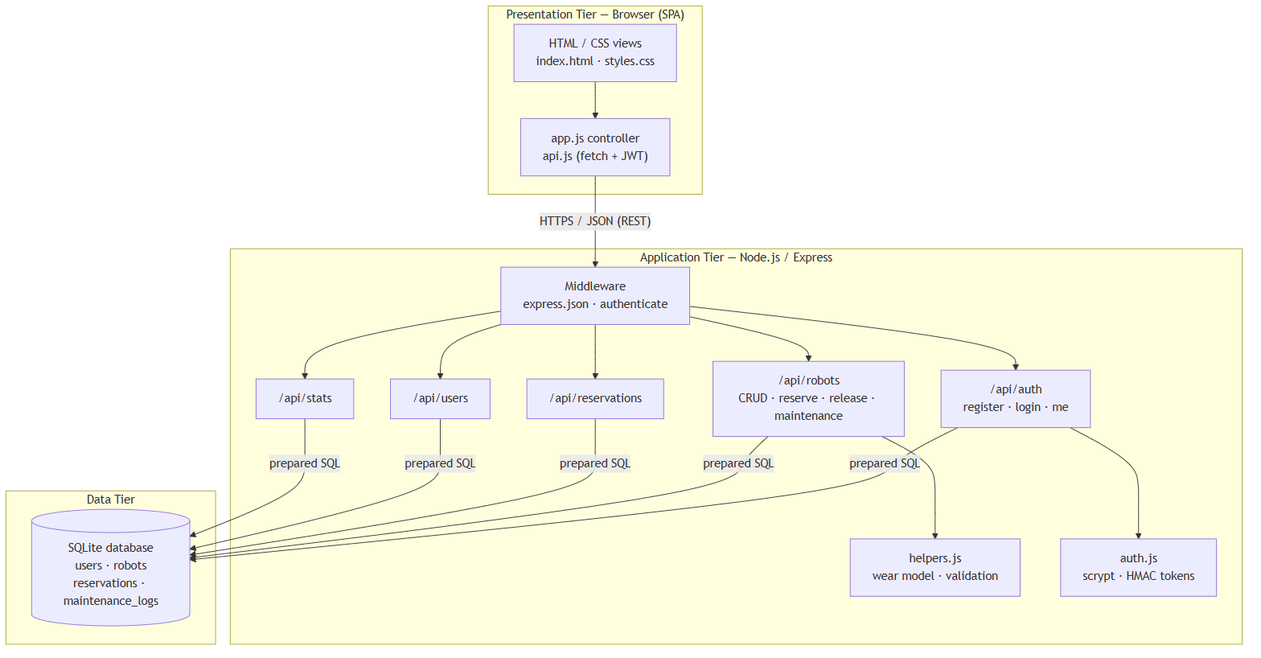

5.2 Use Case Diagram
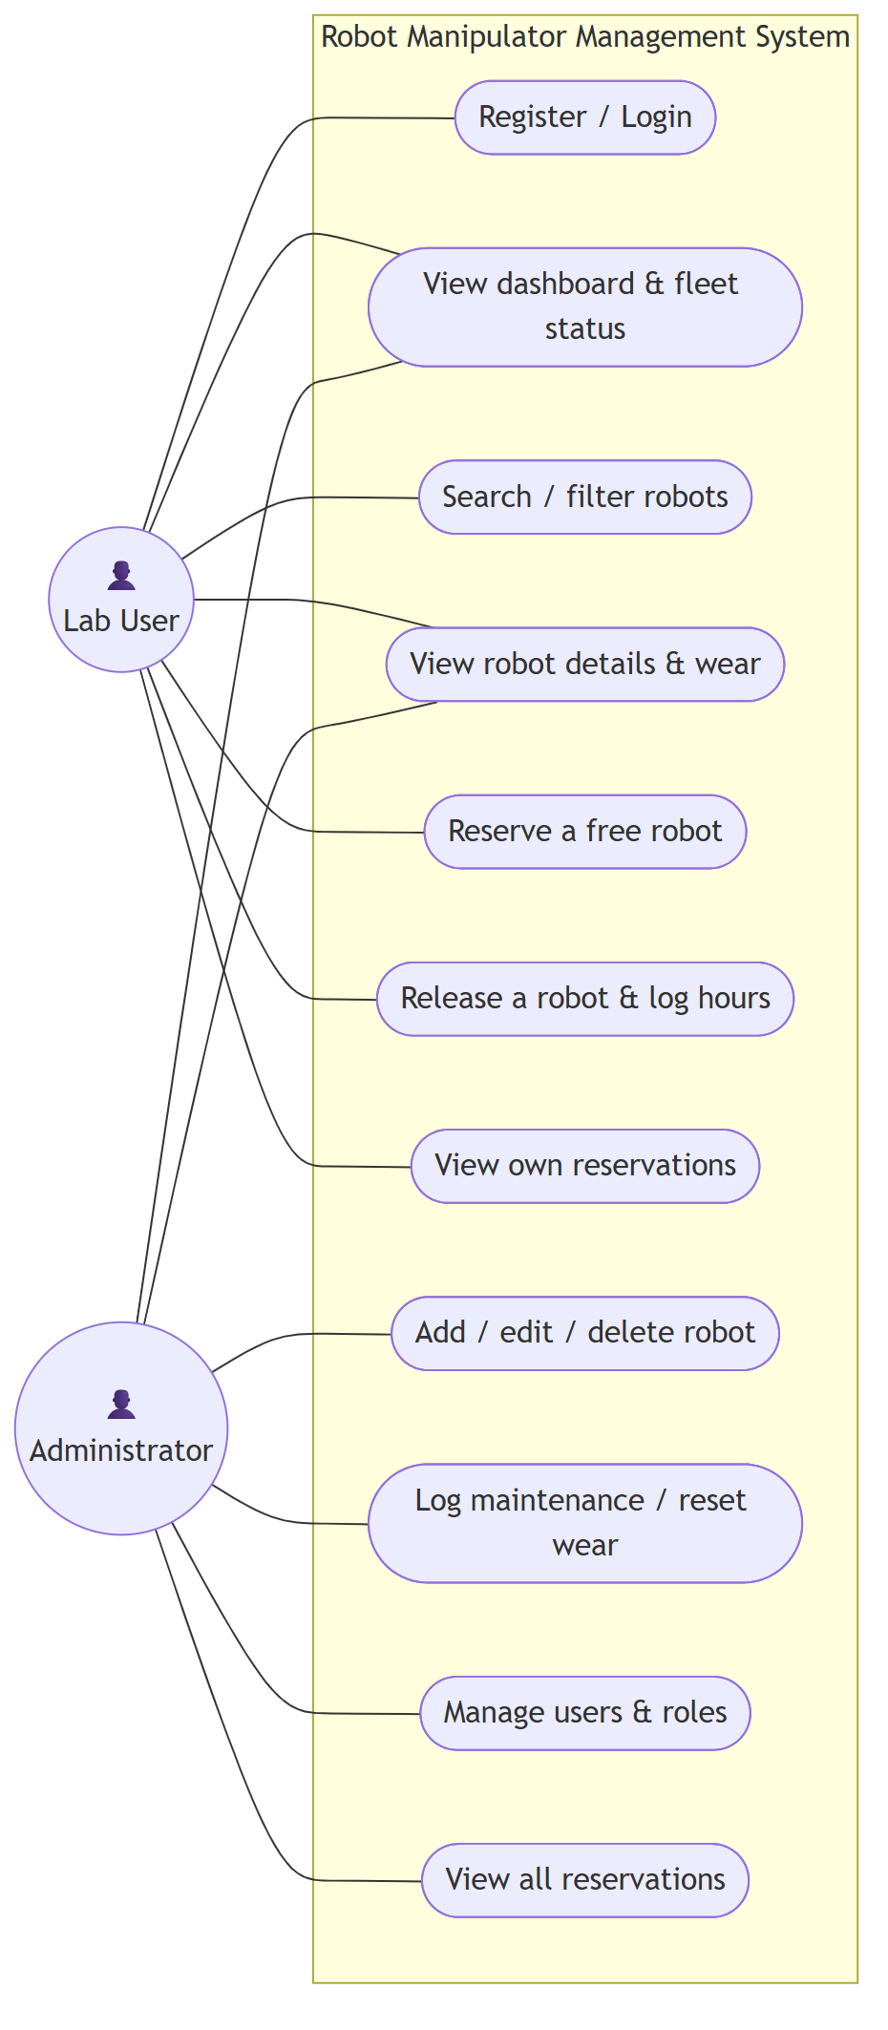
Primary actors: *Lab User* and *Administrator* (an administrator can perform all user actions plus
administrative ones).

5.3 Class Diagram
The domain is modelled as four core entities. Behaviour such as computeWear(), reserve() and
release() is implemented in the corresponding route/service modules operating on these records.
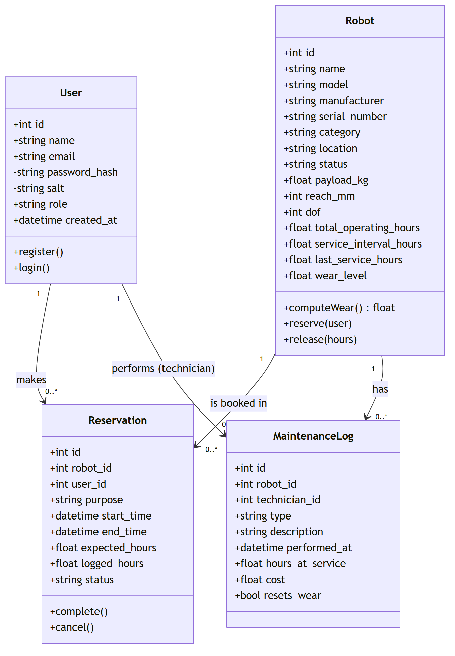

5.4 Sequence and Activity Diagrams
Sequence — "Reserve a free robot":
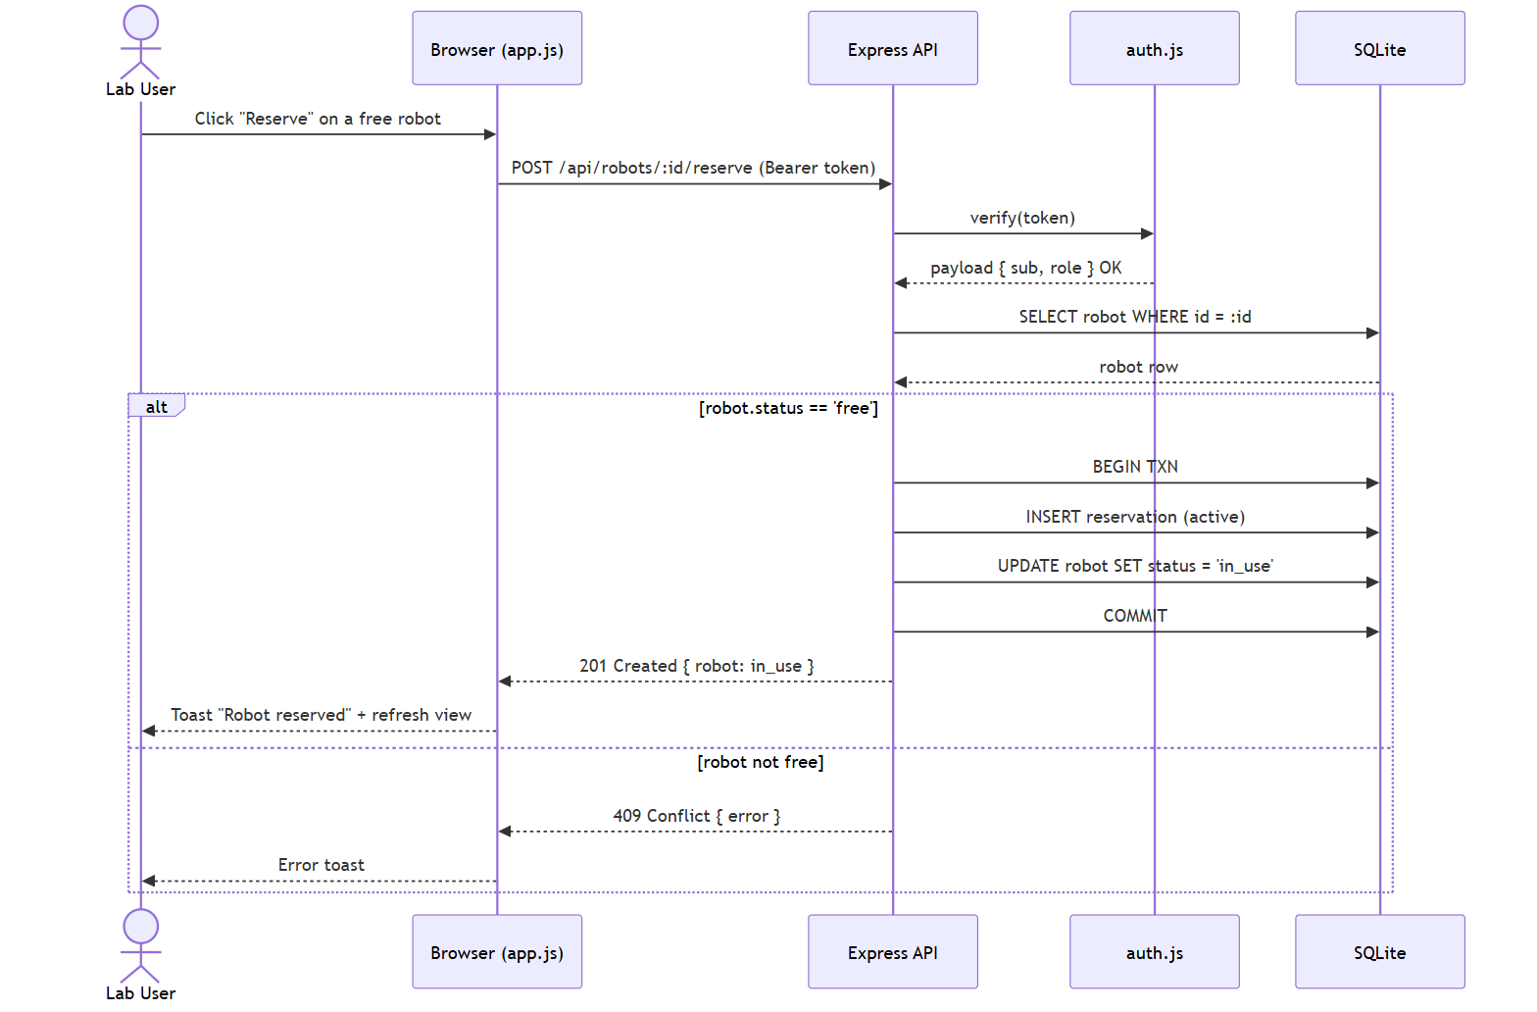
Activity — robot usage & maintenance lifecycle:
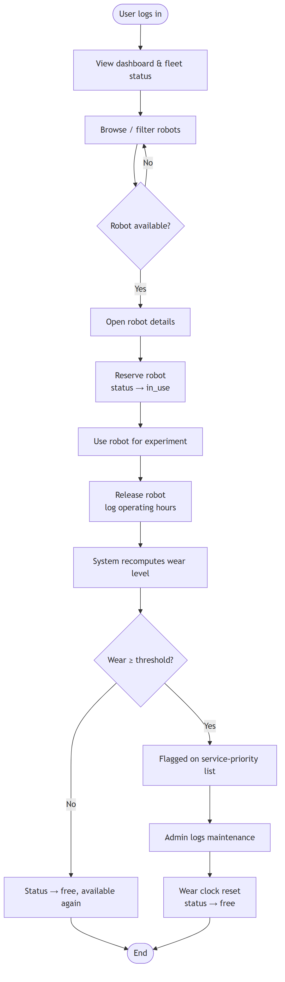

5.5 ER Diagram / Database Design
Four tables with enforced foreign keys. reservations and maintenance_logs reference both robots
and users; deleting a robot cascades to its reservations and logs.
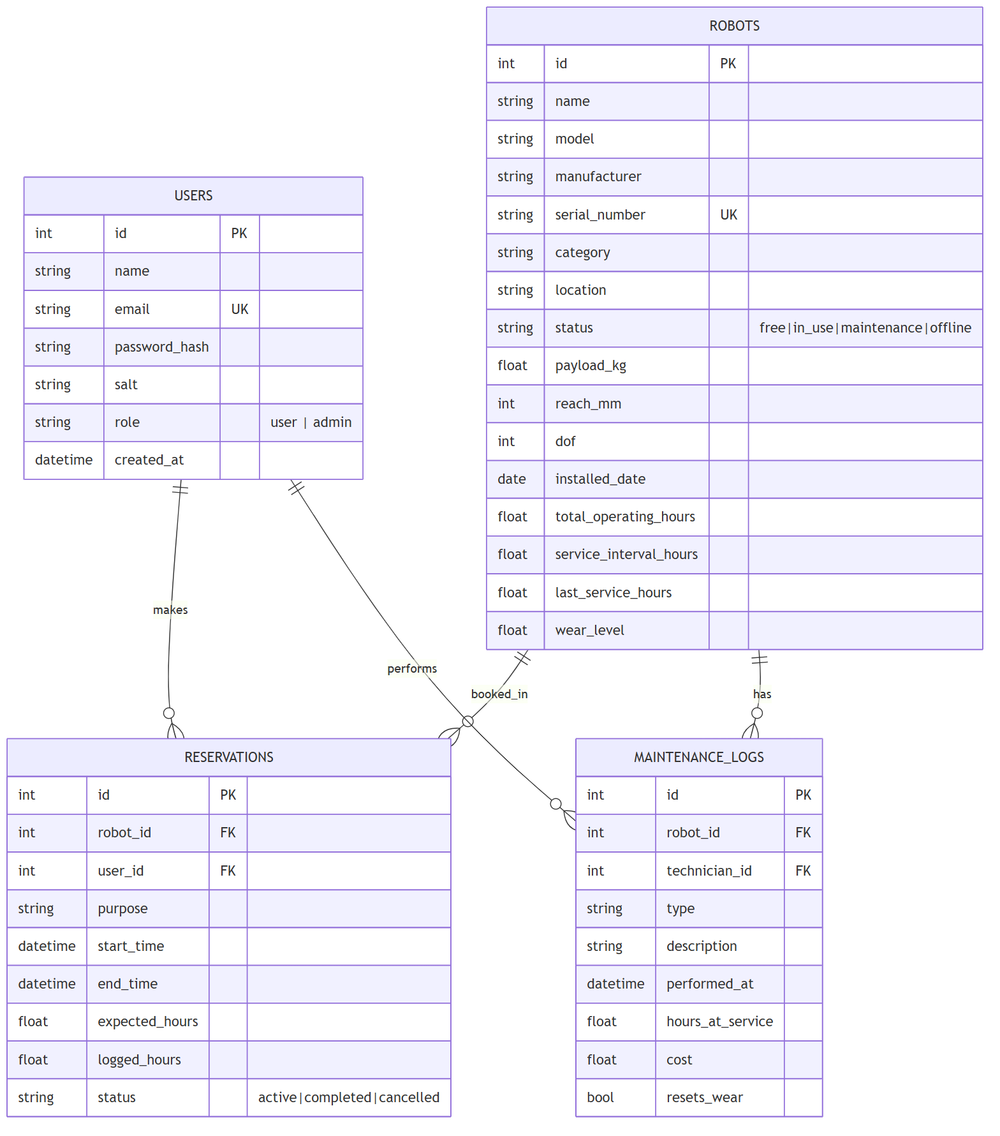
Key design points
- robots.status ∈ {free, in_use, maintenance, offline} and reservations.status ∈ {active, completed, cancelled}
are enforced with CHECK constraints.
- Wear is stored (wear_level) for fast dashboard queries but always derived from
total_operating_hours, last_service_hours and service_interval_hours, so it can be recomputed.
- Unique constraints on users.email and robots.serial_number prevent duplicates.

5.6 UI Design / Wireframes
The interface uses a persistent left sidebar for navigation, a top bar with the signed-in user and
role, and a content area that swaps between views. Status is colour-coded consistently
(green = free, amber = in use, red = maintenance, grey = offline); wear bars shade green→amber→red.
The realised screens are shown in §9.

6. Implementation

6.1 Technology Stack
Layer | Technology | Why
Frontend | HTML5, CSS3, vanilla JS (SPA) | No build step; fast to load; full control of the UI
Backend | Node.js + Express.js | Lightweight, ubiquitous, excellent for JSON REST APIs
Database | SQLite via built-in node:sqlite | Zero-config, serverless, relational, integrity constraints
Security | crypto scrypt + HMAC-SHA256 tokens | Strong hashing & stateless sessions with no extra dependency
Testing | node:test + fetch | Built-in unit + HTTP integration tests

6.2 Module Description
Module | Responsibility
server/index.js | App entry: middleware, route mounting, static hosting, server start
server/config.js | Centralised configuration (port, DB path, secret, wear thresholds)
server/db.js | Opens SQLite, enables foreign keys, creates schema
server/auth.js | Password hashing, token sign/verify, requireAuth/requireAdmin middleware
server/helpers.js | Pure wear model, health banding, input validation
server/seed.js | Representative sample fleet, users, reservations and maintenance history
server/routes/auth.js | Register, login, current-user
server/routes/robots.js | Robot CRUD, reserve, release, maintenance
server/routes/reservations.js | Own/all reservation listing
server/routes/users.js | User administration
server/routes/stats.js | Dashboard aggregates
public/js/app.js | SPA controller: routing, rendering, actions
public/js/api.js | Fetch wrapper + token storage

6.3 Key Code Snippets
(Full source is on GitHub — see Appendix A.)
The wear model (server/helpers.js):
function computeWear(totalHours, lastServiceHours, serviceIntervalHours) {
if (!serviceIntervalHours || serviceIntervalHours <= 0) return 0;
const used = totalHours - lastServiceHours;
const pct = (used / serviceIntervalHours) * 100;
return Math.max(0, Math.min(100, Math.round(pct * 10) / 10));
}
Atomic reserve (server/routes/robots.js) — the status check and update run in one transaction so
two users cannot reserve the same robot:
if (robot.status !== 'free')
return res.status(409).json({ error: `Robot is not available (current status: ${robot.status})` });
db.prepare('BEGIN').run();
db.prepare(`INSERT INTO reservations (robot_id, user_id, purpose, expected_hours, status)
VALUES (?, ?, ?, ?, 'active')`).run(robot.id, req.user.sub, purpose, expectedHours);
db.prepare("UPDATE robots SET status = 'in_use' WHERE id = ?").run(robot.id);
db.prepare('COMMIT').run();
Password hashing (server/auth.js):
function hashPassword(password) {
const salt = crypto.randomBytes(16).toString('hex');
const hash = crypto.scryptSync(password, salt, 64).toString('hex');
return { salt, hash };
}

7. Software Tools Used
This section documents the tools used across the SDLC. Replace the *[INSERT SCREENSHOT]* placeholders
with your own captures as noted; the diagrams and application outputs shown elsewhere in this report
were produced with the tools below.

7.1 Tool 1 — Visual Studio Code (IDE)
- Purpose: primary code editor / IDE.
- Usage in this project: authored all backend and frontend source, used the integrated terminal to
run npm start and npm test, and the debugger/Problems panel to catch issues.
[INSERT SCREENSHOT 7.1] — VS Code open on the robot-manipulator-management-system folder
showing the file tree and an open source file (e.g. server/routes/robots.js).
*Caption: Fig 7.1 — Project developed in Visual Studio Code.*

7.2 Tool 2 — Git & GitHub (Version Control)
- Purpose: source-code version control and hosting.
- Usage in this project: tracked changes across sprints and published the repository with a README
and setup instructions (Appendix A).
[INSERT SCREENSHOT 7.2] — the GitHub repository page showing the file list and README.
*Caption: Fig 7.2 — Source code hosted on GitHub.*

7.3 Tool 3 — Node.js & npm (Runtime / Build)
- Purpose: JavaScript runtime and package manager; also runs the test suite.
- Usage in this project: npm install, npm start, npm test, npm run seed.
*The actual npm test console output is shown in §8.3 (Fig 8.1).*
[OPTIONAL SCREENSHOT 7.3] — your terminal showing npm start printing the running URL.
*Caption: Fig 7.3 — Application started with Node.js.*

7.4 Tool 4 — Mermaid / draw.io (UML & ER Diagramming)
- Purpose: authoring the architecture, use case, class, sequence, activity and ER diagrams.
- Usage in this project: all diagrams in §5 were produced as Mermaid definitions and rendered to
images (equivalent diagrams can be drawn in draw.io/StarUML).
The rendered diagrams appear throughout §5 (Figs 5.1–5.6).

7.5 Tool 5 — Chrome DevTools / Postman (API Testing & Debugging)
- Purpose: inspecting network requests and manually testing REST endpoints.
- Usage in this project: verified status codes and JSON payloads for login, robot listing and the
reserve/release flow during development.
[INSERT SCREENSHOT 7.5] — Postman (or the DevTools Network tab) showing a POST /api/auth/login
request returning 200 with a token, or GET /api/stats returning the dashboard JSON.
*Caption: Fig 7.5 — REST API tested with Postman / DevTools.*

7.6 Summary Table
Tool | Purpose | Phase of SDLC | Usage in project
Visual Studio Code | Code editor / IDE | Implementation | Writing & debugging all source
Git & GitHub | Version control & hosting | All phases | Change tracking, repository hosting
Node.js & npm | Runtime, build, test runner | Implementation, Testing | Running the server & test suite
Mermaid / draw.io | UML & ER diagramming | Design | Architecture, UML, ER diagrams
Chrome DevTools / Postman | API testing & debugging | Testing | Verifying endpoints & payloads

8. Testing

8.1 Test Plan and Strategy
Testing combined unit testing of pure logic (wear model, validation, password hashing, token
signing) with integration testing of the live REST API over HTTP on an ephemeral port, using
Node's built-in node:test runner. The strategy targets:
- correctness of the wear computation and its boundaries (0% and 100% caps);
- authentication correctness (valid login, wrong password, tampered token);
- authorisation (unauthenticated and non-admin requests are blocked);
- the reservation lifecycle (reserve → in_use → release → hours & wear updated);
- business rules (cannot reserve a non-free robot).
Run with npm test.

8.2 Test Cases
ID | Test case | Input | Expected output | Actual output | Status
TC1 | Wear at mid-interval | 1000 h used of 2000 h | 50% | 50% | Pass
TC2 | Wear caps / floors | 9000/2000 and 0/2000 | 100% and 0% | 100% and 0% | Pass
TC3 | Wear band thresholds | 10, 75, 95 | healthy, warning, critical | healthy, warning, critical | Pass
TC4 | Robot validation | empty body | ≥ 6 field errors | 6 errors | Pass
TC5 | Password hash round-trip | correct & wrong password | true / false | true / false | Pass
TC6 | Token sign/verify + tamper | valid & tampered token | role=admin / null | role=admin / null | Pass
TC7 | Login valid admin | admin@rmms.io / admin123 | 200 + token, role=admin | 200 + token | Pass
TC8 | Login wrong password | admin@rmms.io / nope | 401 | 401 | Pass
TC9 | Unauthenticated list | GET /api/robots (no token) | 401 | 401 | Pass
TC10 | Authenticated list | GET /api/robots (token) | 200 + robot array | 200 + 12 robots | Pass
TC11 | Stats consistency | GET /api/stats | status counts sum to total | sum = total | Pass
TC12 | Reserve then release | reserve + release 2 h | in_use → free, +2 h | in_use → free, +2 h | Pass
TC13 | Reserve non-free robot | reserve a maintenance robot | 409 Conflict | 409 | Pass
TC14 | Non-admin creates robot | user POST /api/robots | 403 Forbidden | 403 | Pass

8.3 Test Results and Bug Log
Result: 14 / 14 tests pass. Console output:
✔ computeWear: midway through interval
✔ computeWear: caps at 100 and never negative
✔ wearBand: thresholds map to bands
✔ validateRobotPayload: flags missing required fields
✔ password hashing round-trips and rejects wrong password
✔ token sign/verify works and rejects tampering
✔ login with valid admin credentials returns a token
✔ login with wrong password is rejected (401)
✔ unauthenticated request to /api/robots is blocked (401)
✔ authenticated user can list robots
✔ dashboard stats add up to the fleet size
✔ reserve then release a free robot updates status and operating hours
✔ reserving a robot that is not free is rejected (409)
✔ non-admin cannot create a robot (403)
ℹ tests 14 ℹ pass 14 ℹ fail 0
Fig 8.1 — `npm test` results.
Bug log (defects found and fixed during development)
Bug ID | Description | Severity | Resolution | Status
BUG1 | Deleting a robot left orphaned reservation/maintenance rows | High | Enabled PRAGMA foreign_keys = ON and added ON DELETE CASCADE | Fixed
BUG2 | Wear could exceed 100% for very high hours | Medium | Clamped computeWear() to the range 0–100 | Fixed
BUG3 | A non-owner saw an enabled "Release" button | Low | Server enforces owner/admin on release (403); button is advisory only | Fixed
BUG4 | /api/* unknown routes returned the SPA HTML instead of JSON | Low | Added a JSON 404 handler scoped to /api before the static fallback | Fixed

9. Results and Discussion

9.1 Output Screenshots of the Working System
Login screen — role-based authentication with demo accounts.
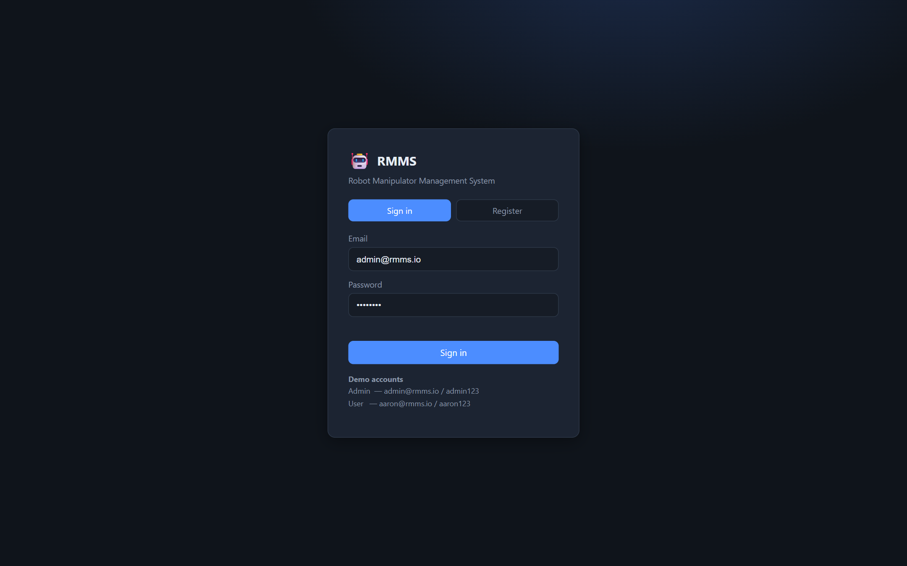
Fig 9.1 — Login / registration screen.
Administrator dashboard — fleet counts, utilisation, wear distribution, category breakdown and a
service-priority list of the highest-wear robots.
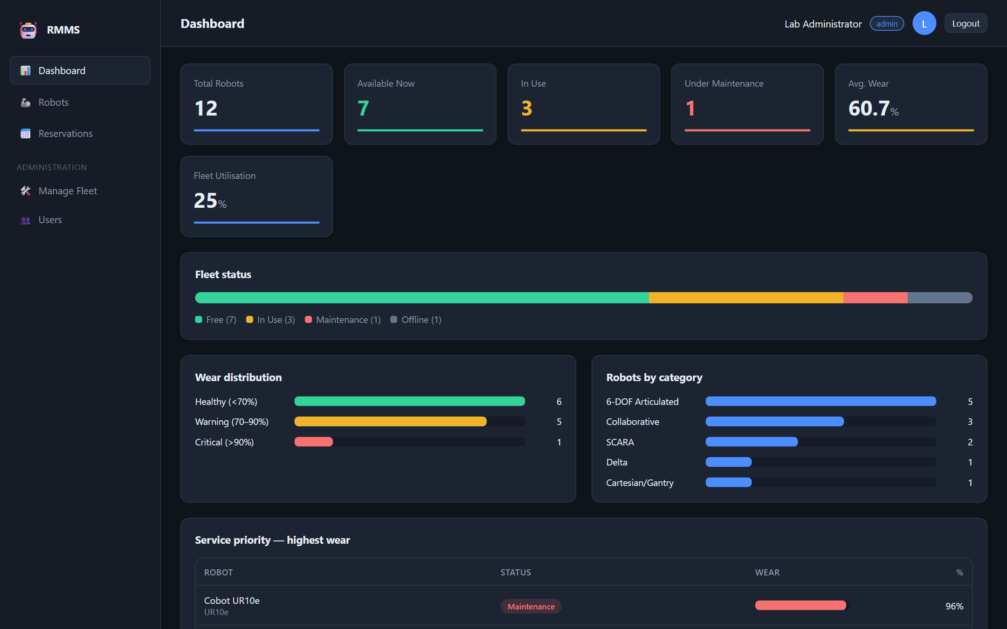
Fig 9.2 — Dashboard with live fleet analytics.
Robot fleet — searchable, filterable grid with status pills and wear bars.
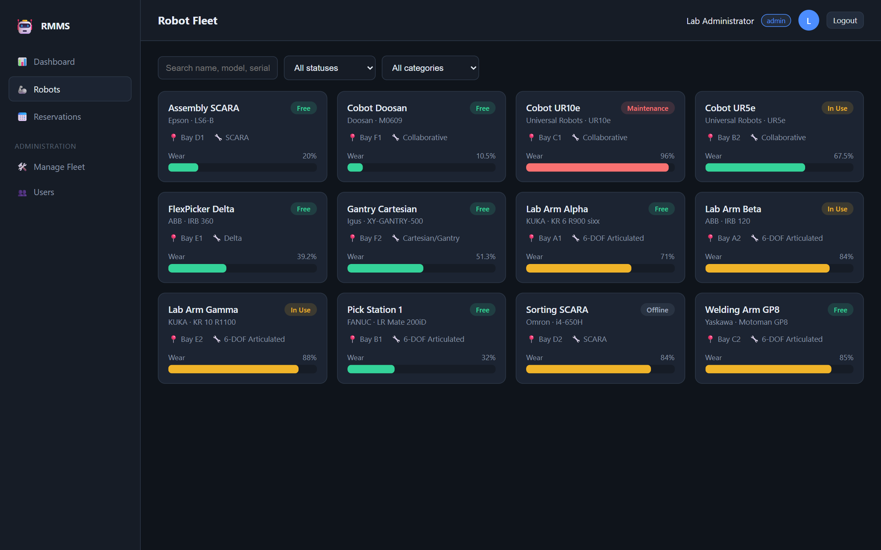
Fig 9.3 — Robot fleet browser.
Robot details — full specifications, wear level and maintenance history, with contextual actions.
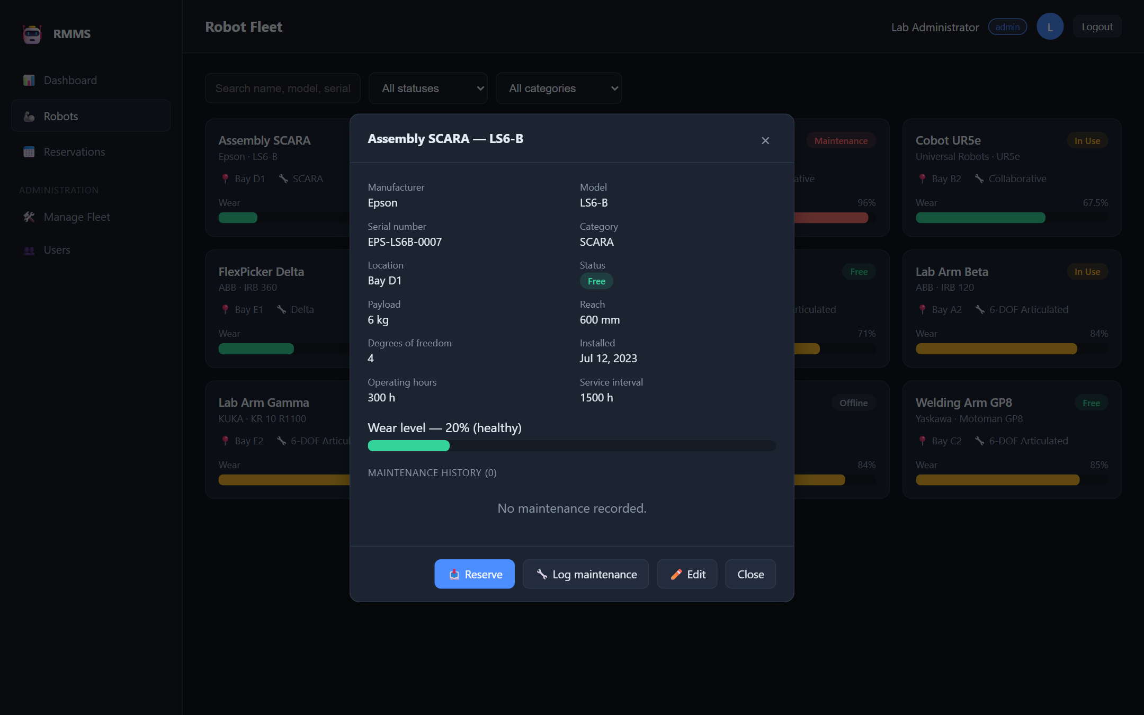
Fig 9.4 — Robot detail with actions.
Reserve dialog — checking a free robot out for a stated purpose and expected hours.
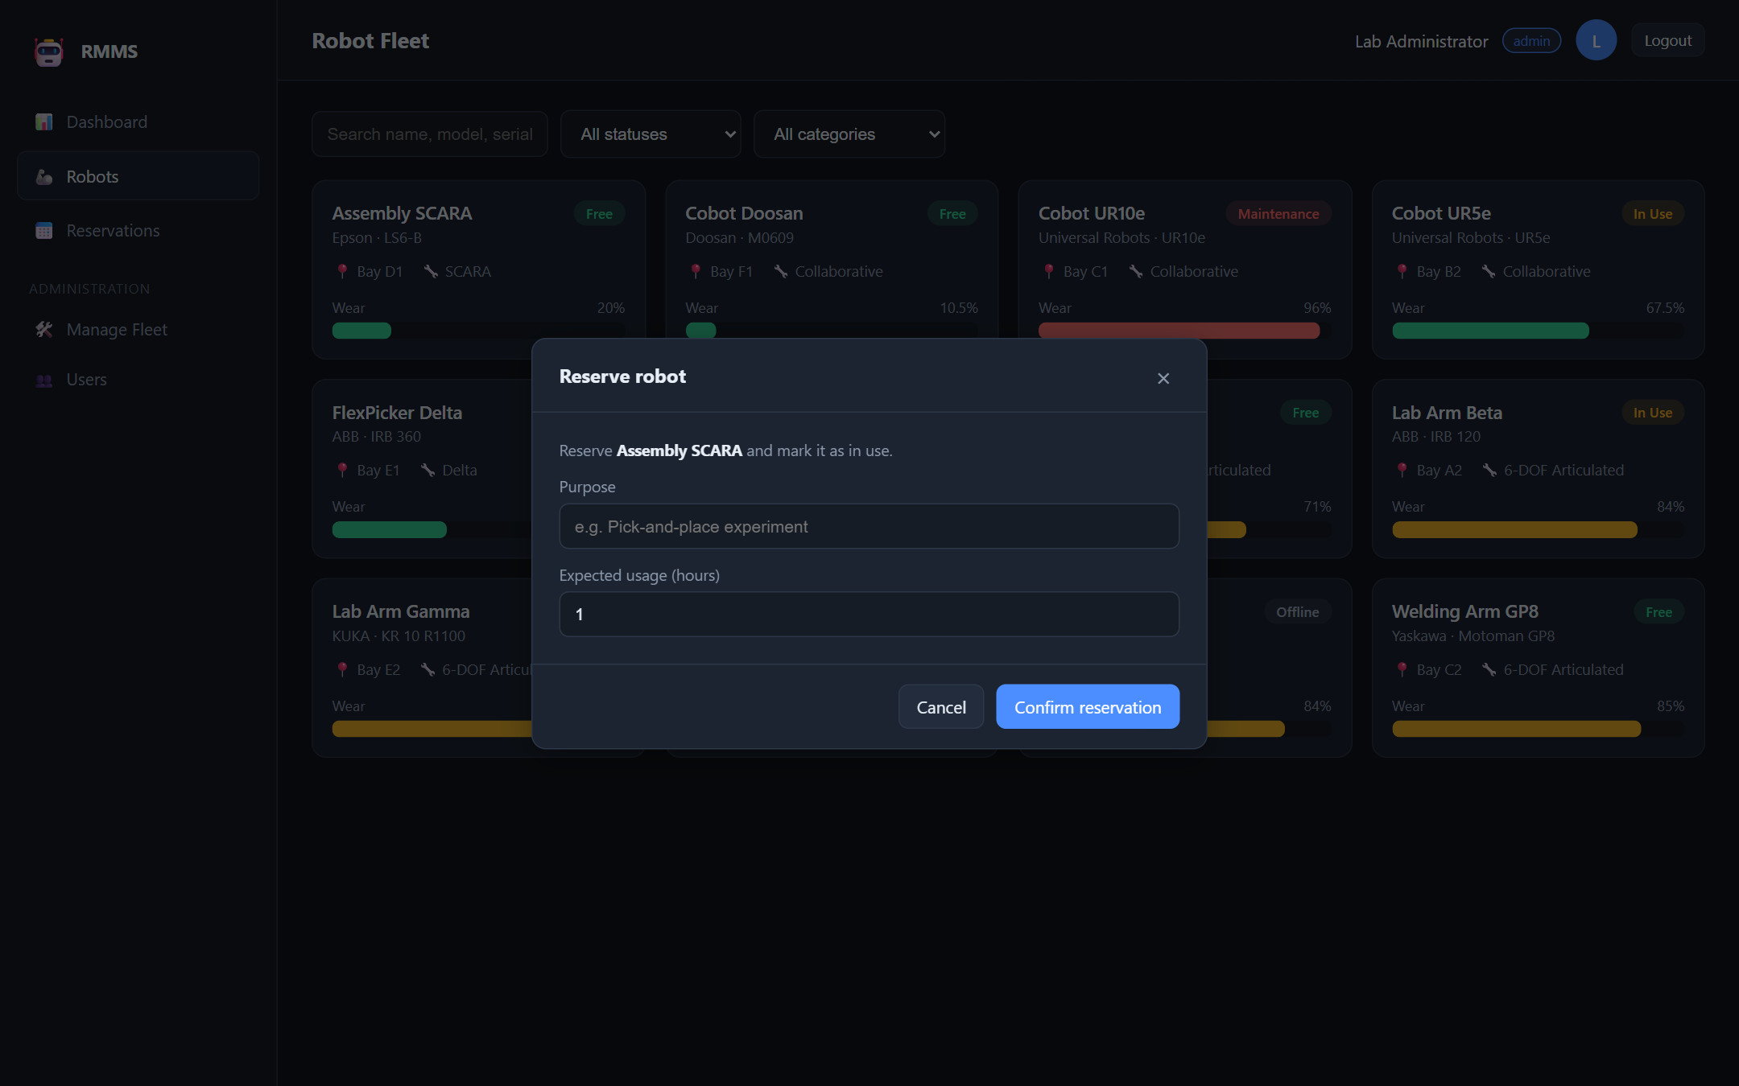
Fig 9.5 — Reservation dialog.
Reservations — the signed-in user's reservation history (admins can view all).
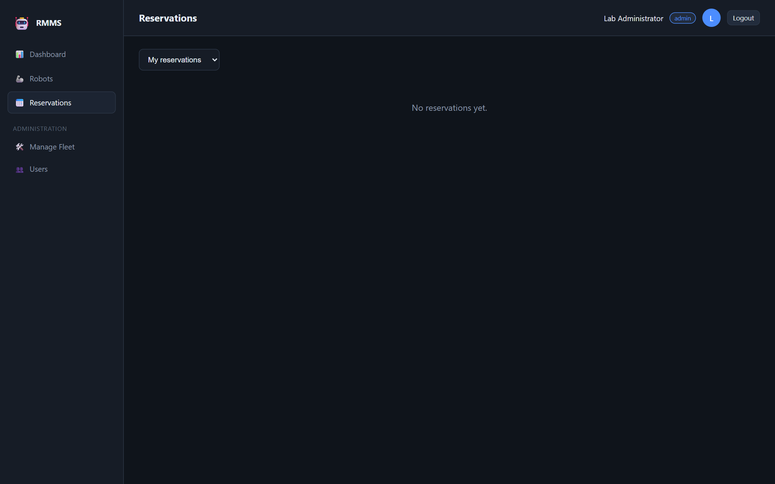
Fig 9.6 — Reservations view.
Manage fleet (admin) — table view with add / edit / delete.
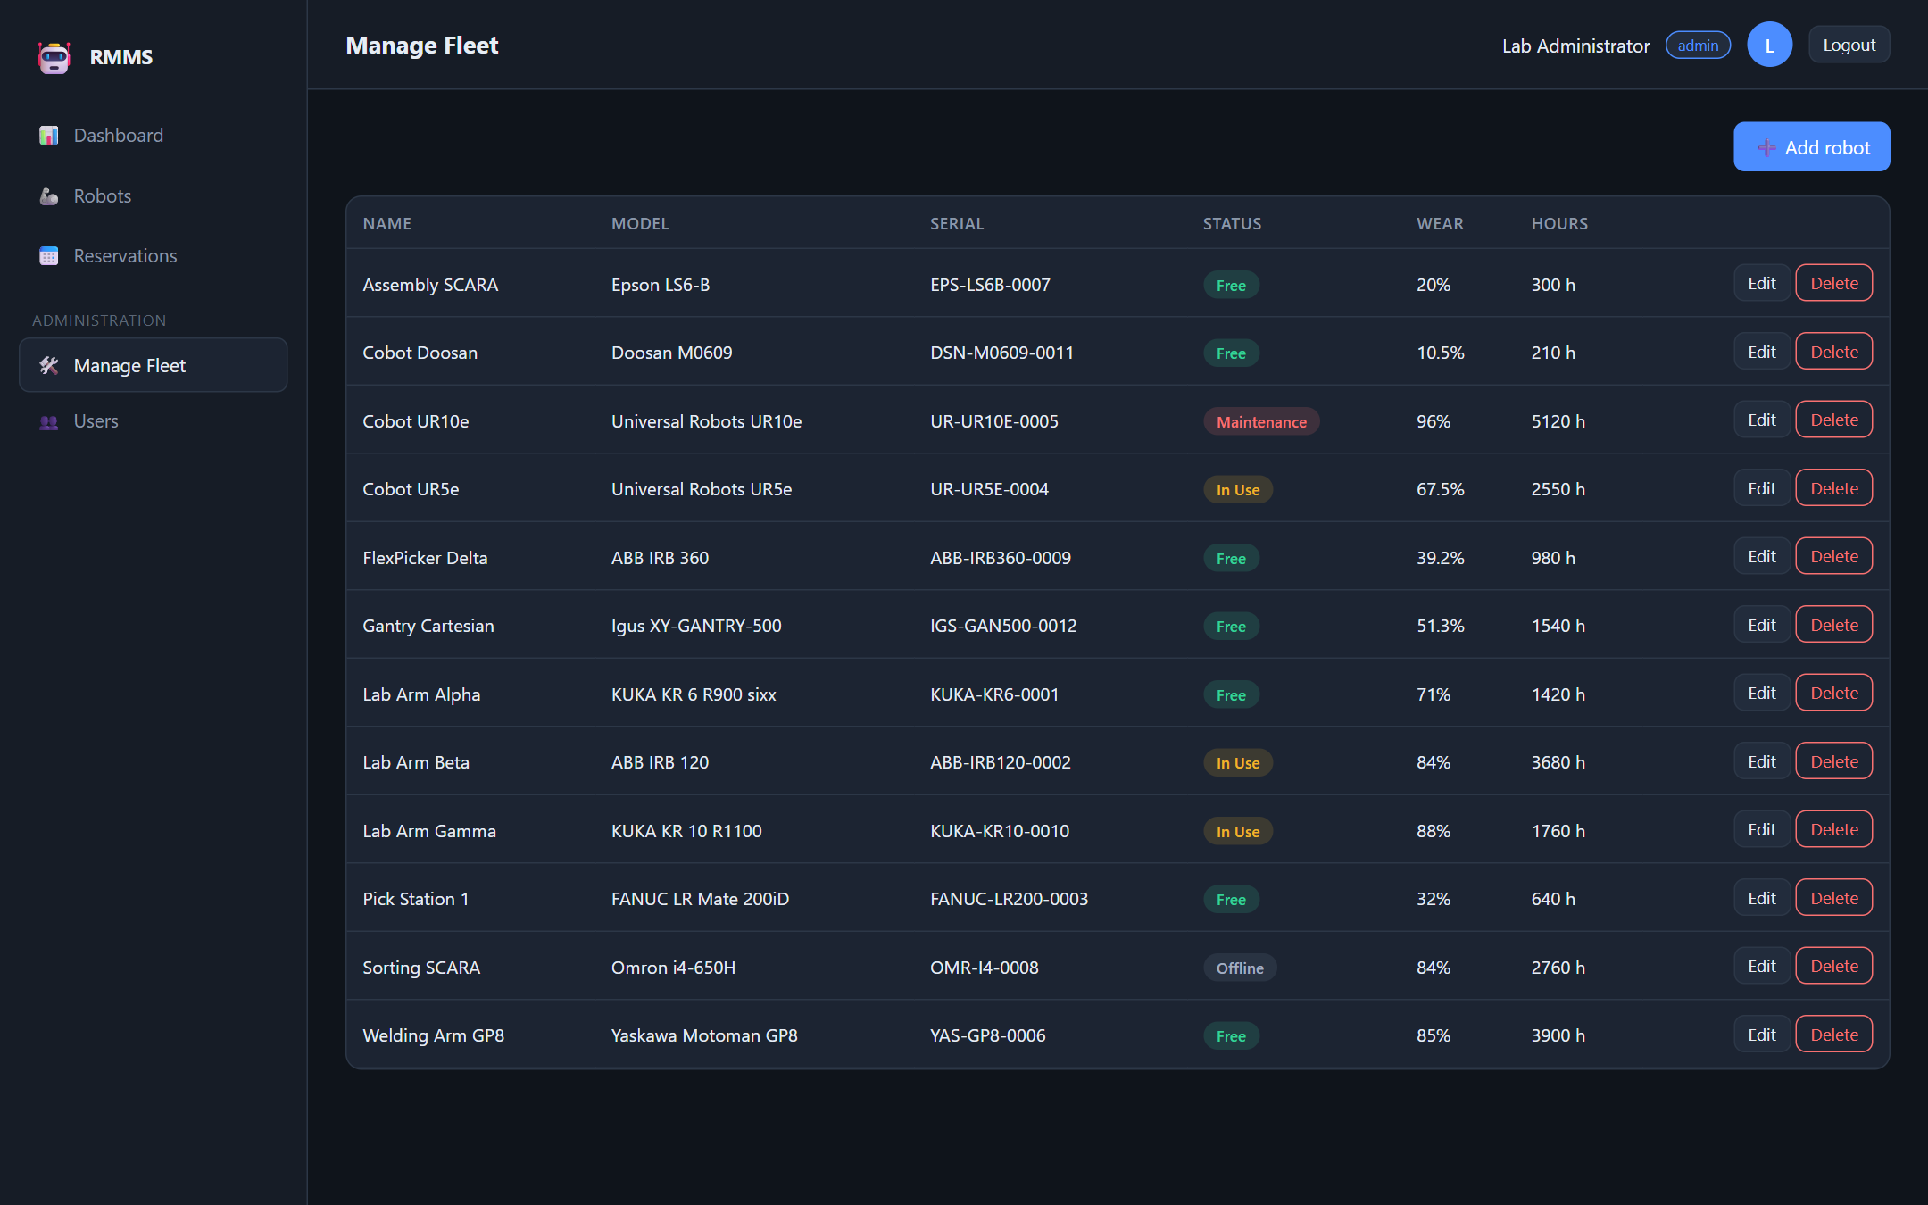
Fig 9.7 — Administrative fleet management.
Add / edit robot (admin) — full specification form with validation.
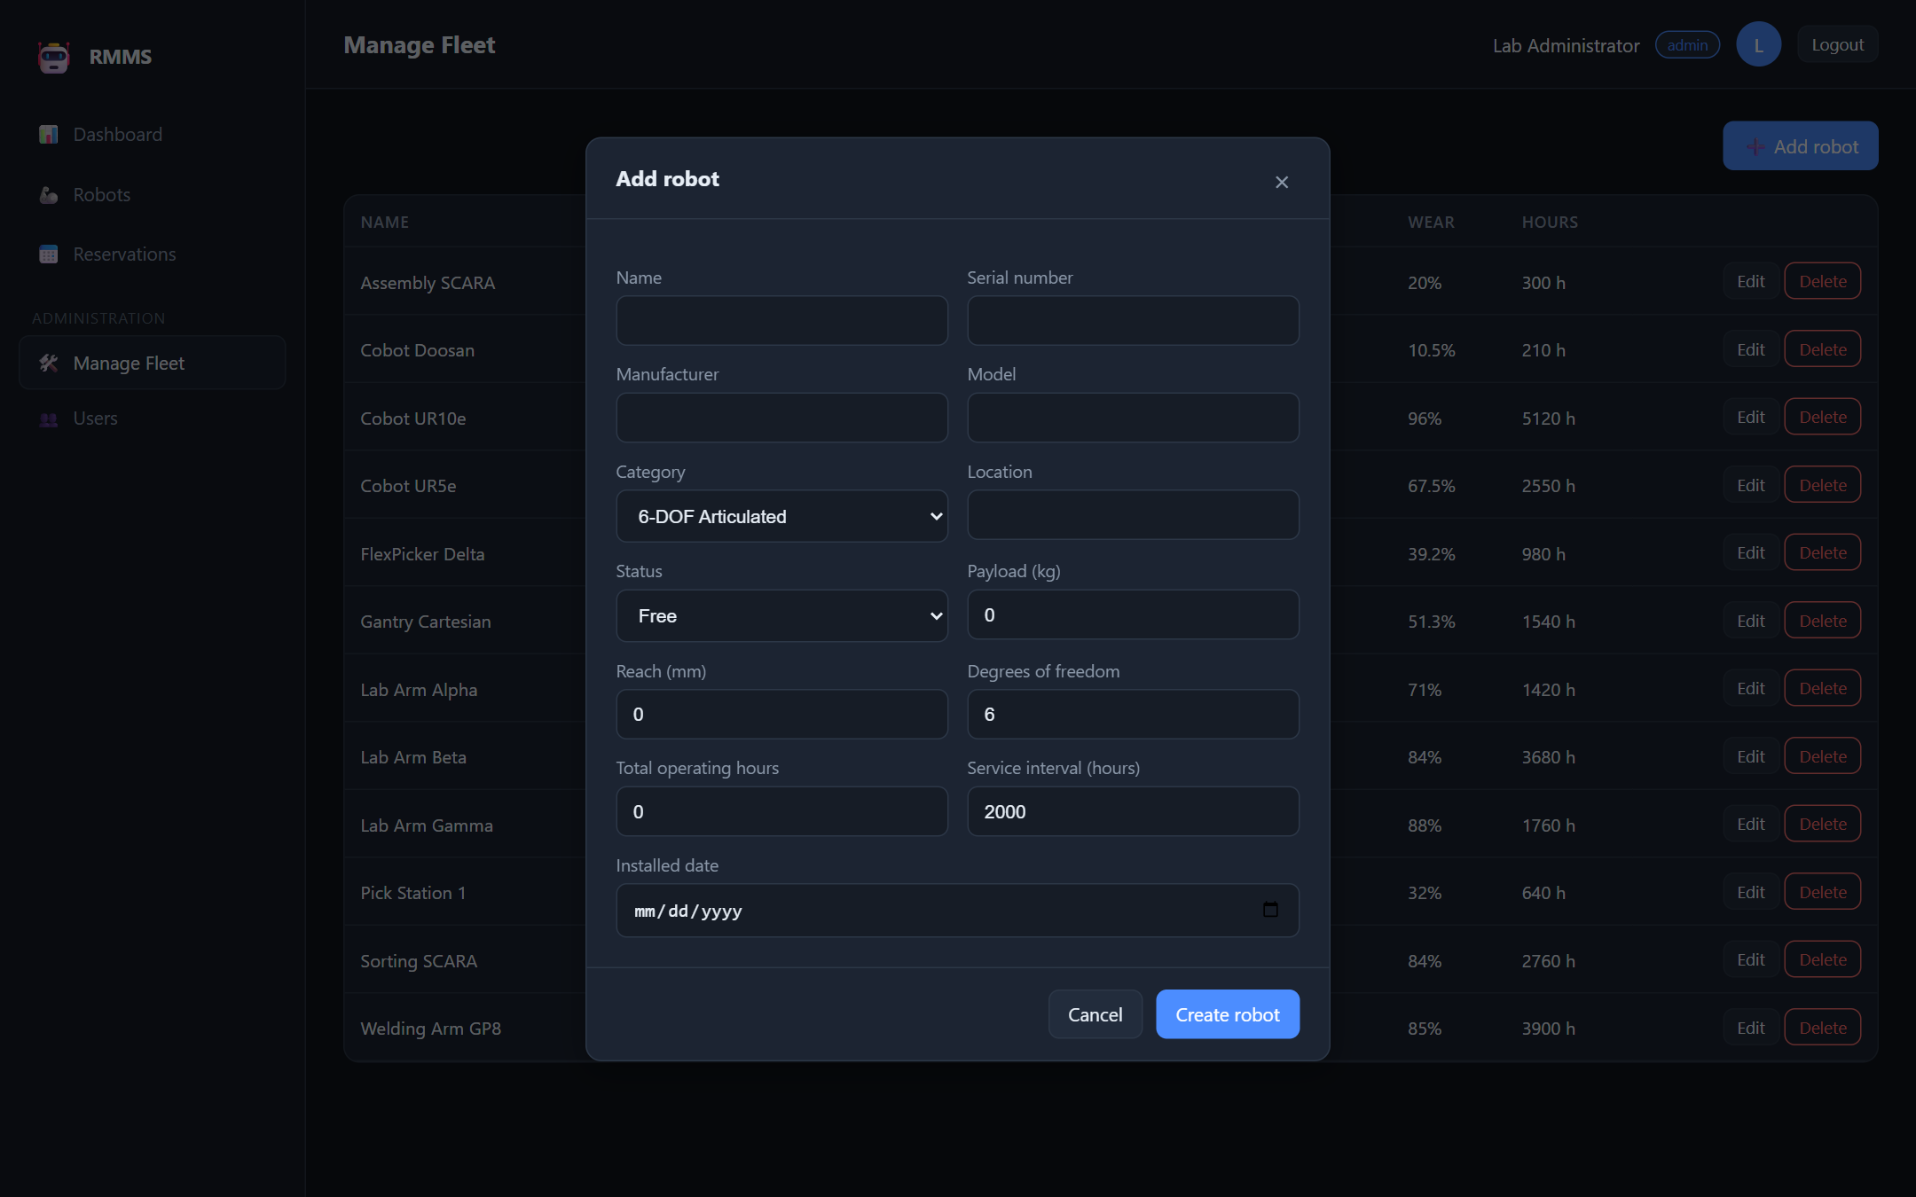
Fig 9.8 — Add/edit robot form.
User management (admin) — promote/demote and remove users.
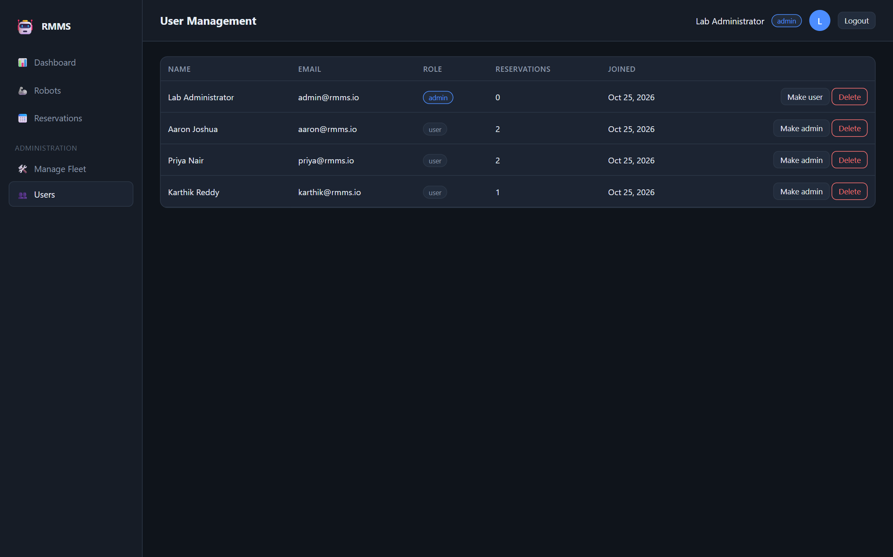
Fig 9.9 — User management.
Standard-user view — the same dashboard with administrative navigation hidden (RBAC).
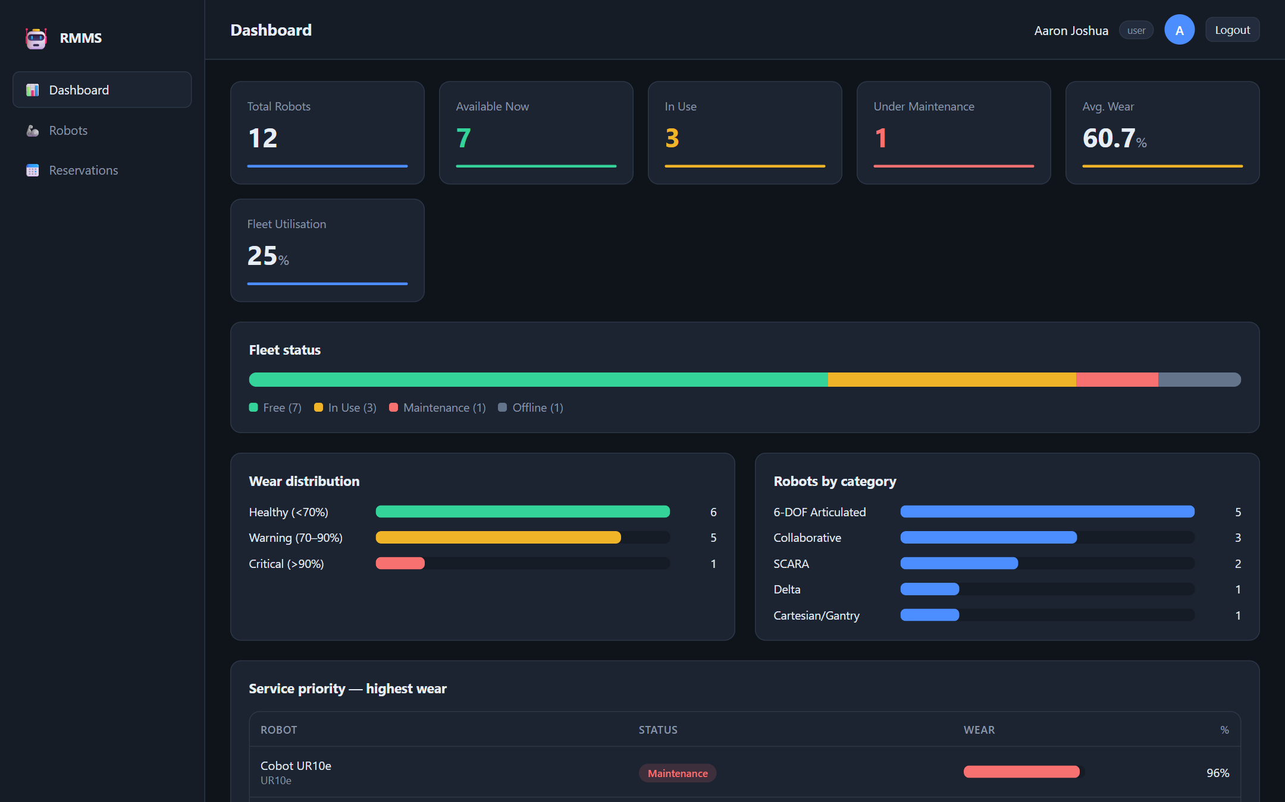
Fig 9.10 — User role sees no admin tools.

9.2 Analysis Against Objectives
Objective | Outcome
Centralised dashboard | Delivered — counts, utilisation, wear & category charts, service-priority list
Robot catalogue with search/filter | Delivered — grid with status/category/text filters and detail view
Reservation workflow | Delivered — atomic reserve/release with conflict prevention
Automatic wear modelling | Delivered — hours accrue on release; wear recomputed and banded
Admin fleet & maintenance management | Delivered — CRUD + maintenance logging with wear reset
Role-based access control | Delivered — user/admin separation enforced on client and server
Responsive, usable UI | Delivered — dark responsive SPA, consistent colour-coding

All seven objectives were met. The automated test suite (14/14 passing) gives confidence in the core
logic, and the live screenshots demonstrate each feature end-to-end. The main limitation remains the
absence of live hardware telemetry, addressed below.

10. Conclusion and Future Enhancements

Conclusion
RMMS successfully delivers a vendor-neutral, web-based platform that unifies availability/reservation
and wear/maintenance tracking for a mixed fleet of robotic manipulators — a combination the existing
tools surveyed in §2 do not provide together. Built with a clean three-tier architecture, a documented
REST API, enforced data integrity and an automated test suite, it meets all stated objectives and is
simple to deploy in a laboratory.

Future Enhancements
- Live hardware telemetry — integrate with robot controllers (ROS 2 / OPC-UA / vendor SDKs) to read
operating hours and fault codes automatically instead of logging them manually.
- Calendar-based booking — reserve future time slots with conflict detection and a calendar view.
- Predictive maintenance — use historical wear/fault data to forecast failures (condition-based).
- Notifications — email/push alerts when a robot crosses the warning/critical wear threshold.
- Analytics & export — utilisation reports and CSV/PDF export for lab administrators.
- Audit trail & 2FA — full action logging and two-factor authentication for administrators.
- Containerised deployment — Docker image and migration to PostgreSQL for larger, multi-lab use.

11. References
[1] I. Sommerville, *Software Engineering*, 10th ed. Harlow, U.K.: Pearson, 2016.
[2] R. S. Pressman and B. R. Maxim, *Software Engineering: A Practitioner's Approach*, 8th ed. New York, NY, USA: McGraw-Hill, 2015.
[3] K. Schwaber and J. Sutherland, "The Scrum Guide," Scrum.org, 2020. [Online]. Available: https://scrumguides.org
[4] OpenJS Foundation, "Node.js Documentation — SQLite (node:sqlite)," 2025. [Online]. Available: https://nodejs.org/api/sqlite.html
[5] OpenJS Foundation, "Express.js — Fast, unopinionated, minimalist web framework for Node.js," 2024. [Online]. Available: https://expressjs.com
[6] SQLite Consortium, "SQLite — Foreign Key Support," 2024. [Online]. Available: https://www.sqlite.org/foreignkeys.html
[7] International Organization for Standardization, *ISO 8373:2021 — Robotics — Vocabulary*, Geneva, Switzerland, 2021.
[8] Object Management Group, *Unified Modeling Language (UML) Specification, v2.5.1*, 2017. [Online]. Available: https://www.omg.org/spec/UML

12. Appendices

Appendix A: Project Links
- GitHub repository: https://github.com/<your-username>/robot-manipulator-management-system
(replace with your actual URL; the repo is public and includes a README with setup steps).
- Demo video (Google Drive): https://drive.google.com/file/d/<your-file-id>/view?usp=sharing
(set sharing to "Anyone with the link can view"; verify it opens in an incognito window).

Appendix B: Sample Code Listings (Optional)
Database schema (server/db.js, abridged):
CREATE TABLE robots (
id INTEGER PRIMARY KEY AUTOINCREMENT,
name TEXT NOT NULL, model TEXT NOT NULL, manufacturer TEXT NOT NULL,
serial_number TEXT NOT NULL UNIQUE,
category TEXT NOT NULL, location TEXT NOT NULL,
status TEXT NOT NULL DEFAULT 'free'
CHECK (status IN ('free','in_use','maintenance','offline')),
payload_kg REAL, reach_mm INTEGER, dof INTEGER,
total_operating_hours REAL NOT NULL DEFAULT 0,
service_interval_hours REAL NOT NULL DEFAULT 2000,
last_service_hours REAL NOT NULL DEFAULT 0,
wear_level REAL NOT NULL DEFAULT 0
);
CREATE TABLE reservations (
id INTEGER PRIMARY KEY AUTOINCREMENT,
robot_id INTEGER NOT NULL REFERENCES robots(id) ON DELETE CASCADE,
user_id INTEGER NOT NULL REFERENCES users(id) ON DELETE CASCADE,
purpose TEXT, start_time TEXT, end_time TEXT,
expected_hours REAL, logged_hours REAL,
status TEXT NOT NULL DEFAULT 'active'
CHECK (status IN ('active','completed','cancelled'))
);
Release endpoint with wear recomputation (server/routes/robots.js, abridged):
const loggedHours = Number(req.body.logged_hours) || reservation.expected_hours || 1;
const newTotal = robot.total_operating_hours + loggedHours;
const newWear = computeWear(newTotal, robot.last_service_hours, robot.service_interval_hours);
// ...inside a transaction:
db.prepare("UPDATE reservations SET status='completed', end_time=datetime('now'), logged_hours=? WHERE id=?")
.run(loggedHours, reservation.id);
db.prepare("UPDATE robots SET status='free', total_operating_hours=?, wear_level=? WHERE id=?")
.run(newTotal, newWear, robot.id);
Robot Manipulator Management System — Software Engineering Project
Aaron Joshua · 24BRS1393 · VIT Chennai

