<https://www.joinquant.com/help/api/help#name:JQData>

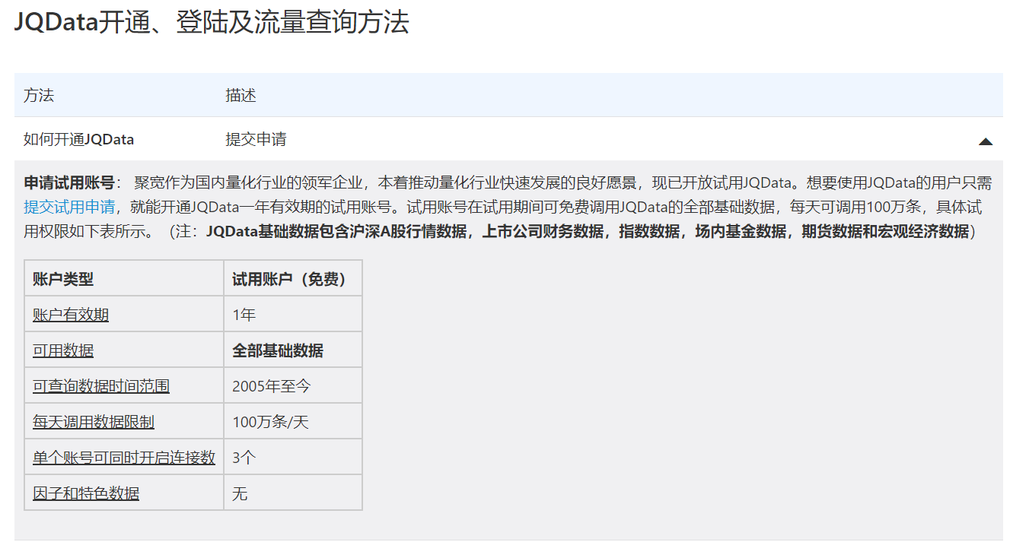

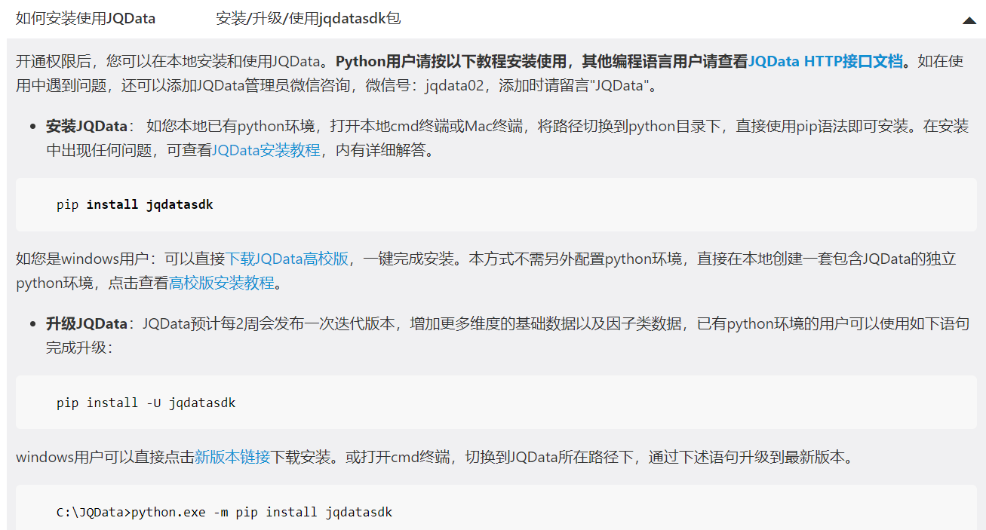

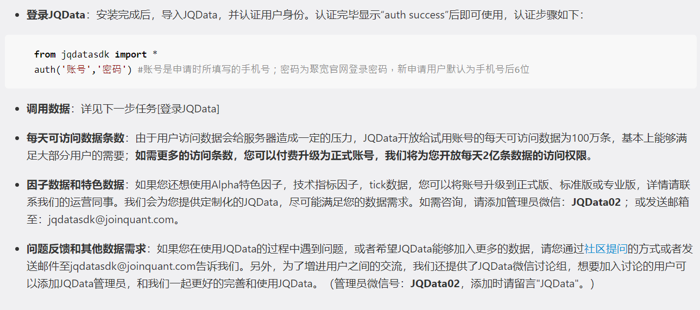

<https://www.joinquant.com/default/index/sdk>

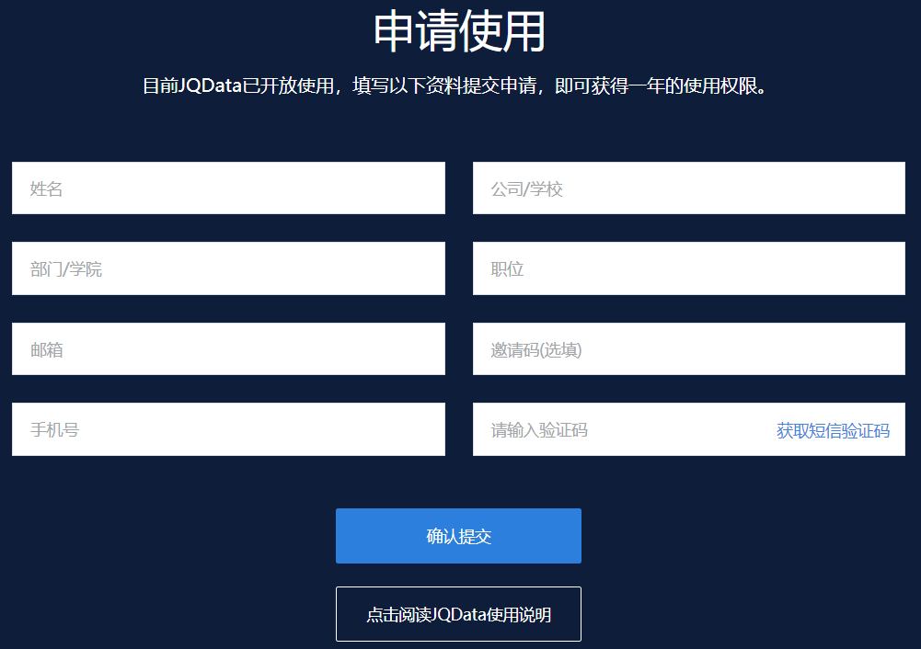

<https://www.joinquant.com/help/api/help#Future:%E8%8E%B7%E5%8F%96%E6%9C%9F%E8%B4%A7tick%E6%95%B0%E6%8D%AE>

