# CCISYSTEM2.1使用教程

Introduces the new index.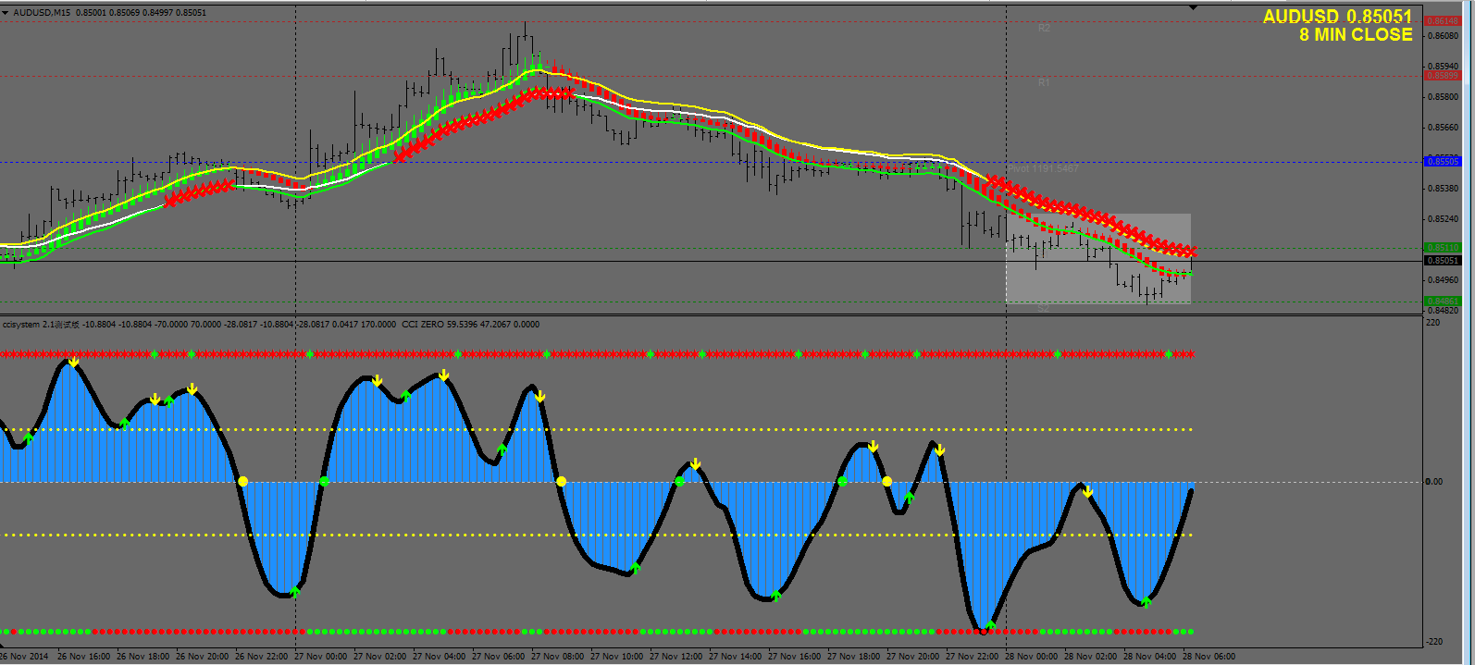

Main map contains several sections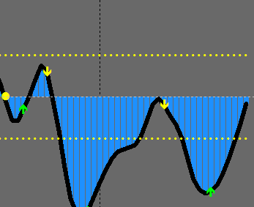

CCI Core indicators, use the same, you can use the draw method, arrow of hair, as well as 0 Axis methods operate.

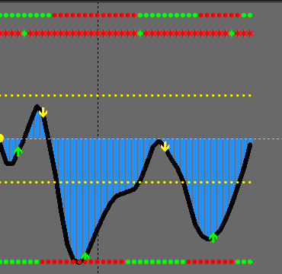

And increased 2 Trend analysis

Origin of the above And below the origin of the

Analytical methods are as follows

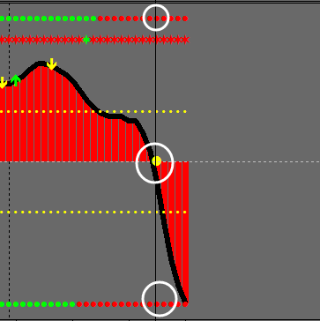

0 Shaft break a method, which applies when the market is in shock, and without too much volatility.

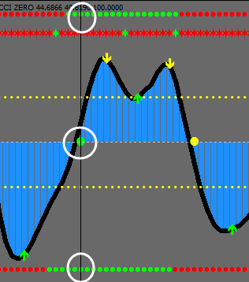

0 Shaft break a method, which applies when the market is in shock, and without too much volatility.

For Example

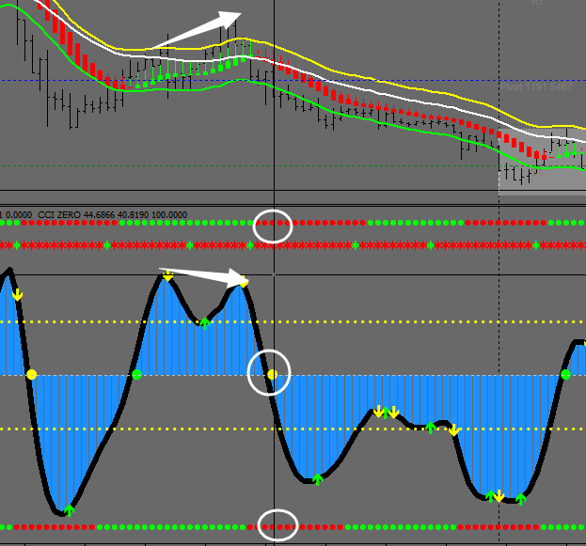

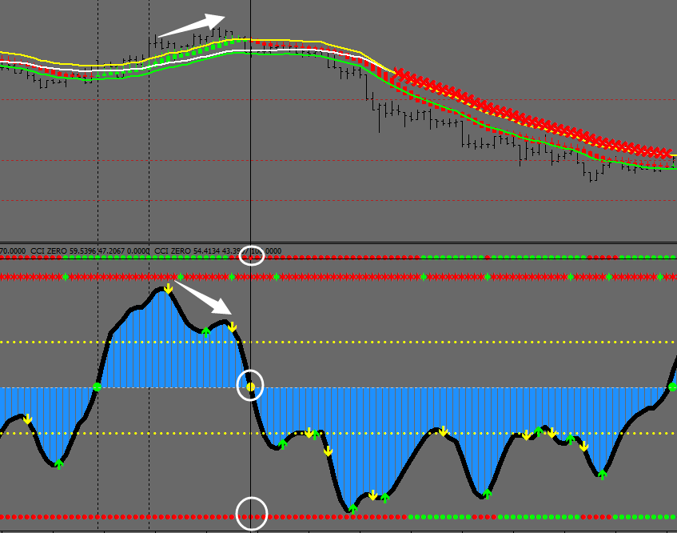

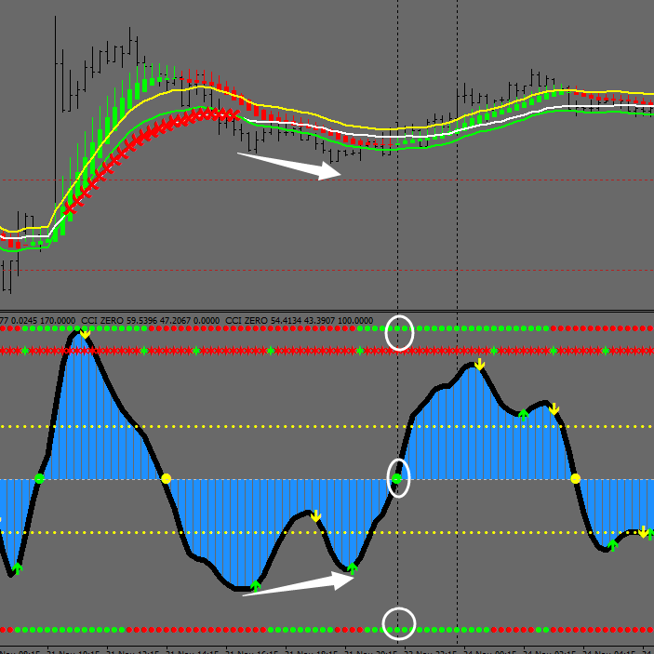

This figure has a characteristic was departure from, you can directly reference N Form of breakthrough.

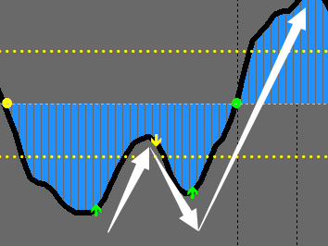

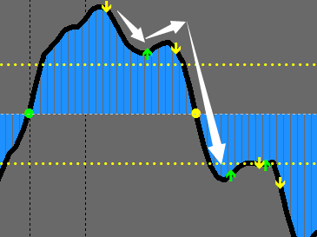

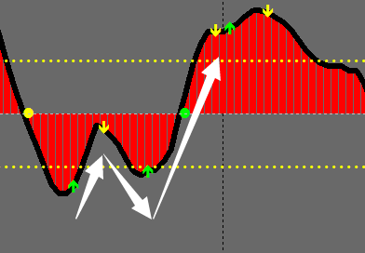

Observe, clear and is not too much to say here

Method

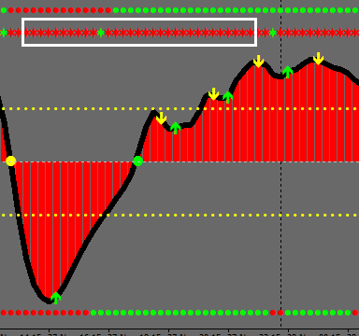

This is a new set of indicators

Combination is used to determine the top and bottom of the current market CCI To use very well.

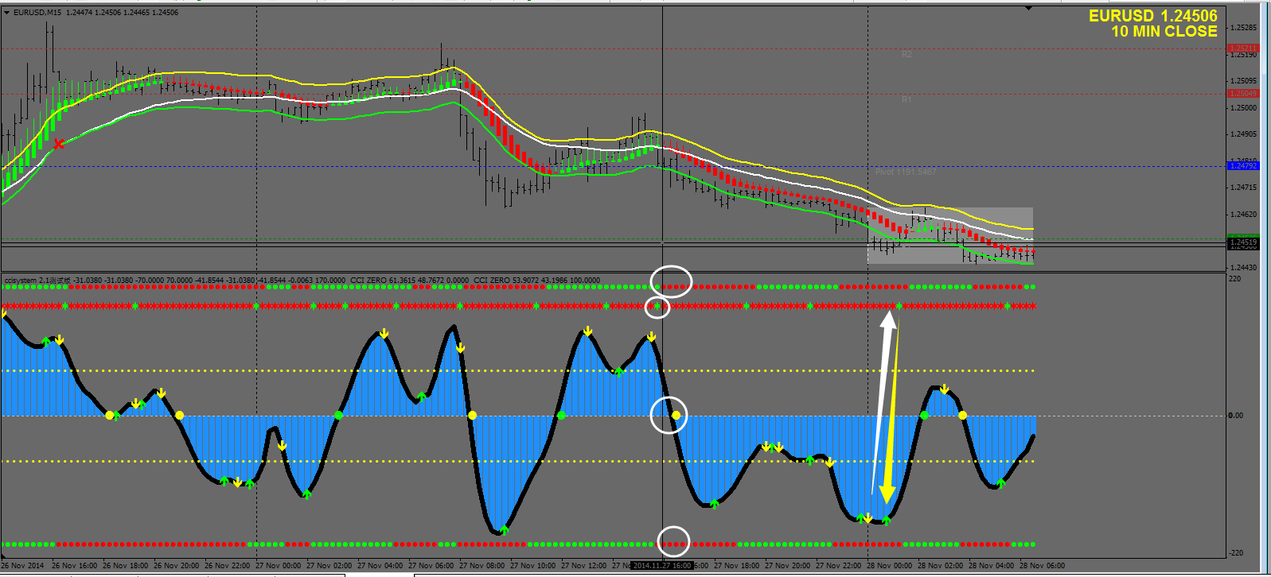

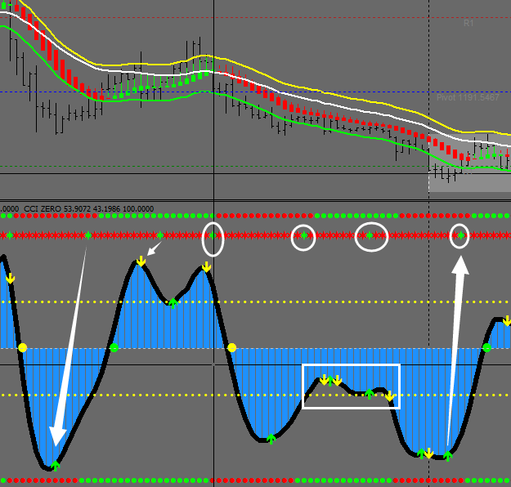

Analysis process

1, Determine whether the asterisk appears, if there is, represents the current market near the top and bottom.

2, After the confirmation signal appears, look for the nearest CCI Arrow direction.

3, As shown in the figure, confirm the arrows as well as top-end conditions, start, may be appropriate to add here other analytical tools.

4, After the square, shock, but how do you filter out the shocks observed above asterisk, asterisk quotes

Top and bottom, such as occurred after the asterisk, below the graphics do not meet N Forms, as well as single shape at the bottom, give the signal.

If the above appears after the asterisk, observation forms below the arrow, such as morphologically consistent with, confirmed recently the direction of the arrow away from the field, held before a single out of the field.

If the morphologically consistent with requirements, can continue to do.

# 2.12额外添加

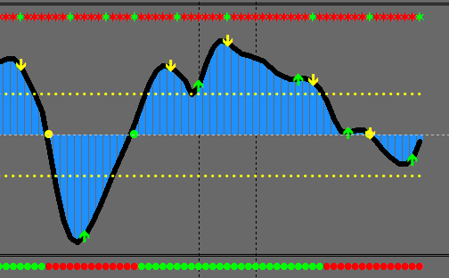

Simplifies the judgments of trends, optimize interfaces.

Asterisk as above the top end of judgment, combined CCI The direction of the arrow and single model to do.

Below the trend appear more than once used to determine the direction of the arrow, daily not as a reference.

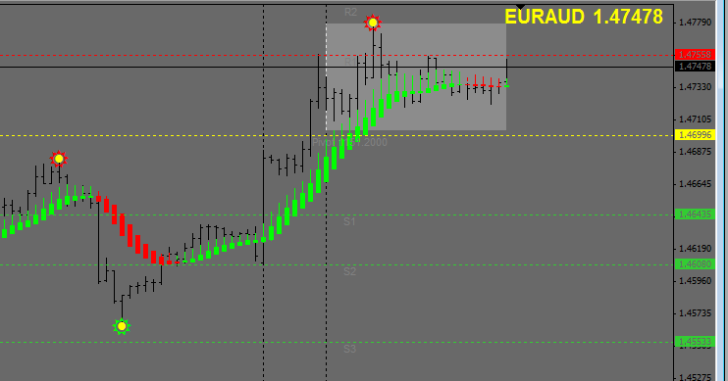

Photos added 3 Indexes, eliminating the previous departure indicators,

Resistance line, used to set stop loss and profit target, profit lower than the line, or higher, is not.

Added a function in the future indicators, profits as a follow-up reference only, must not as a single signal.

Add a K Trend lines for viewing K Line and shock.

Single sequence is as follows.

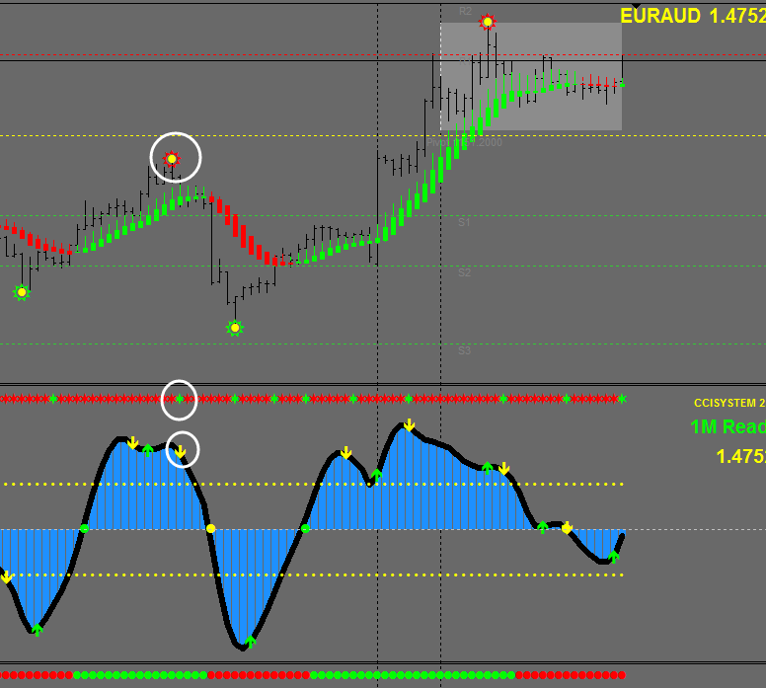

First, identifying top and bottom signal appears，

And then confirm that the below CCI Arrows appear, or model. 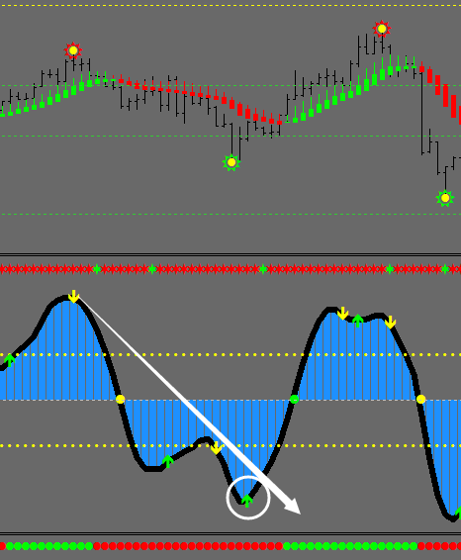

Final observation, master Sun, before the lowest point, if there is a description for the time being for the ascent stage, combined with the CCI Breakthrough single.

Departure to

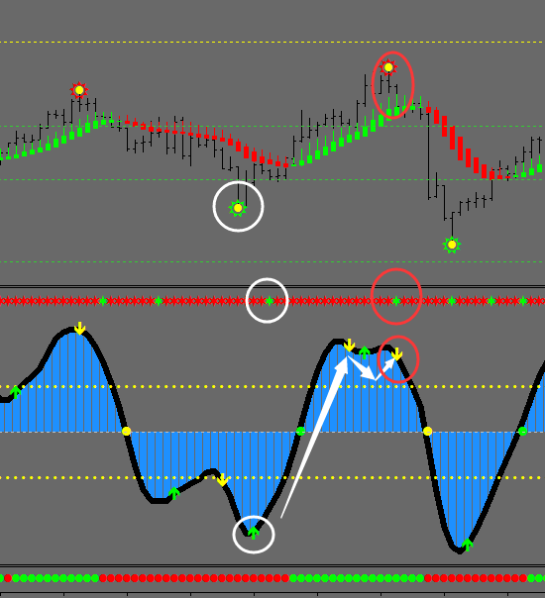

Then returned and the top end of the signal, and CCI Down arrow that appears, and Sun.

Single field.

In addition, you can consider the air admission, and the next signal and back again at the end of the arrow appeared out of the field.

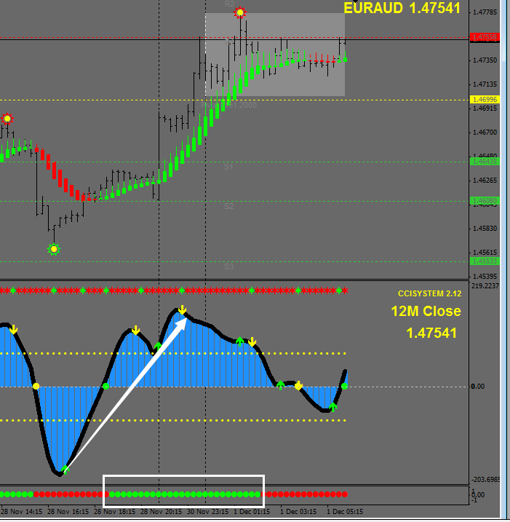

Do single note, such as the market rose after the down arrow many times, observe the trend of color at the bottom.

As for green, indicating market continue to rise, consider only the green arrow, but must be combined with graphics to do so.

Otherwise empty.

As shown in the figure, the current blank arrow, but with a model drawing, this angle is too tricky, give the signal, waiting for the next short occurs.

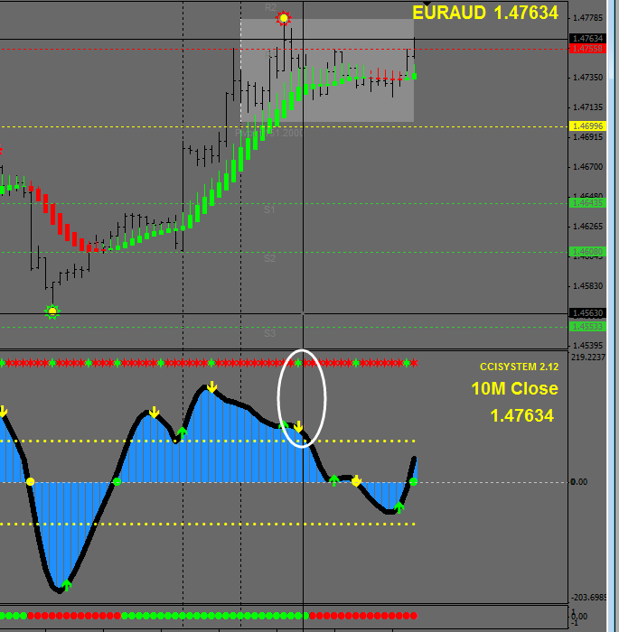

Here below continue to be green, as a graphic, and appears again at the end of the asterisk, the region may be at the top, combined with the direction of the arrow air admission and, in some, possible reversal signal appears, hold the attention cycle.

And try not to make a big news 1-2 Quotes of the day.