Here is an example of a trade I made last week so hopefully it clarifies what I just said. Looking at the daily chart on Cable I noticed the daily candle bounced off resistance area so my bias for the next day was on the short side. Although the price didn’t exactly reach the resistance level I still found it to be valid based on daily candle formation appearing on a major pair. I don’t pay too much attention to candle formation on non major pairs since there is not much liquidity on those pairs and market makers can easily manipulate the price and take out the stops.
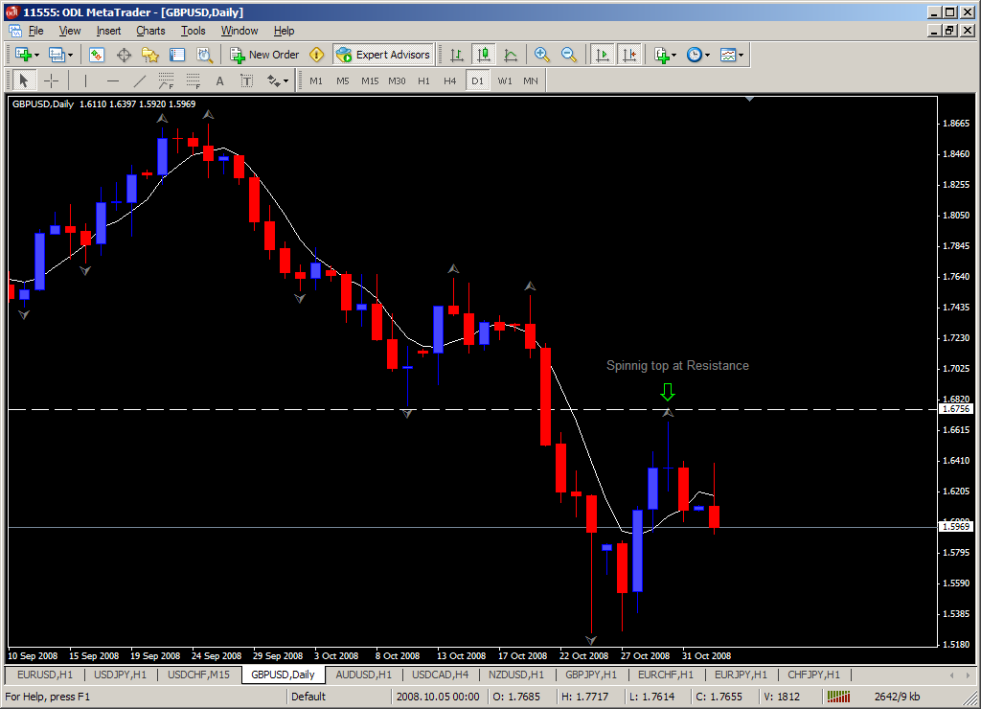

Dropping down to 1HR chart I look for other areas of S/R. 1.6749 area was resistance at one point then was broken. Once price dropped below that same level it turned into resistance again.
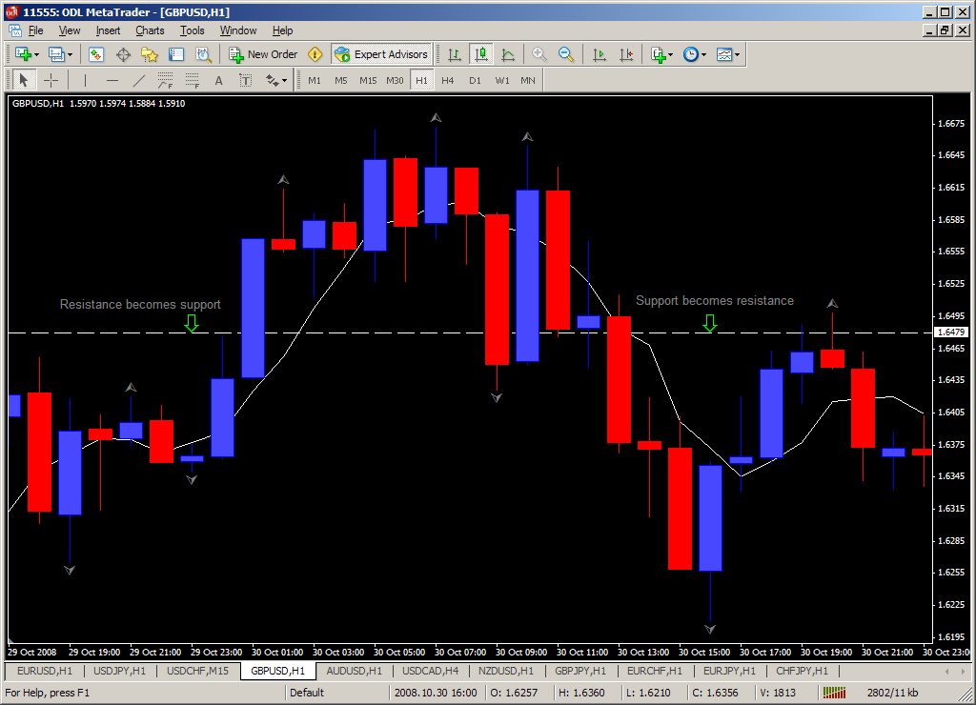

Finally on 15Min chart I look for setup possibilities. The resistance area on 1HR chart (white line) overlaps with 61.8 level of the move down. Nice bearish reversal candle and stochastic crossing at the same time. Although I have to admit I didn’t wait for stochastic to cross so I got filled at a better price. I scaled out of my trade as it moved down.
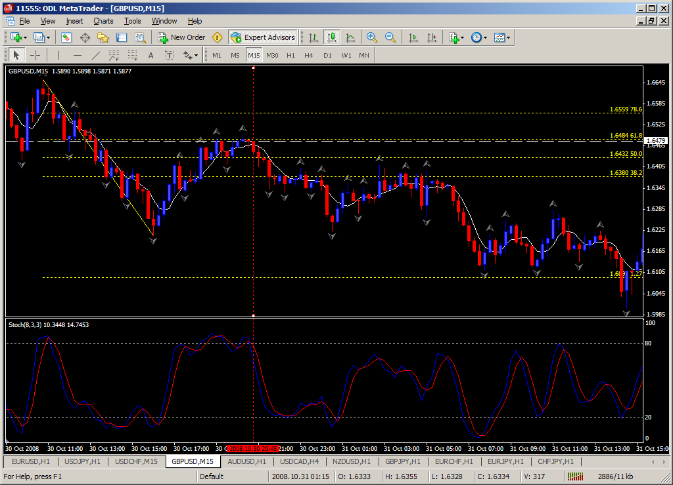

As you can see there is nothing special about the way I look for these setups. I try to be as close as possible to areas of S/R on higher timeframe. If this is too basic then that’s what I intended it to be. This is my comfort zone. I’m more comfortable trading when I simplify my trading setups.

