“5!”
Forex trading system

First of all, I want to tell every one that there is no perfect system for trading on FOREX market. Everyone is trader for himself... I found myself as complicated trader – Scalpingpositionswingdaily trader!
WOOOOOOOOW !
So you must found out what trader you are, and find a system that suits you the best!
In my case my system do 85% of a trade, other is techical analyses, experience and the last but not least important – feeleng. Sense of security in your trade! You have to be 100% confident in that what you are doing. This is the only way that leads to succses!
This system came up from Thv system, I don't care about the time in FOREX, I just care about PRICE MOVEMENT and this is the hart of my system. I just aplied Thv system on renko bars. I tried with 2 pips box, 3 pips, 4 pips..... And found out that best results came with 5 pips box size and 13 pips box size. Of course that you can try with all sizes and maybe found better results with different sizes but, 5 pips and 13 pips fits me the best!

Let’s go with the system!

After you download and install al indicators you have to see something like this:
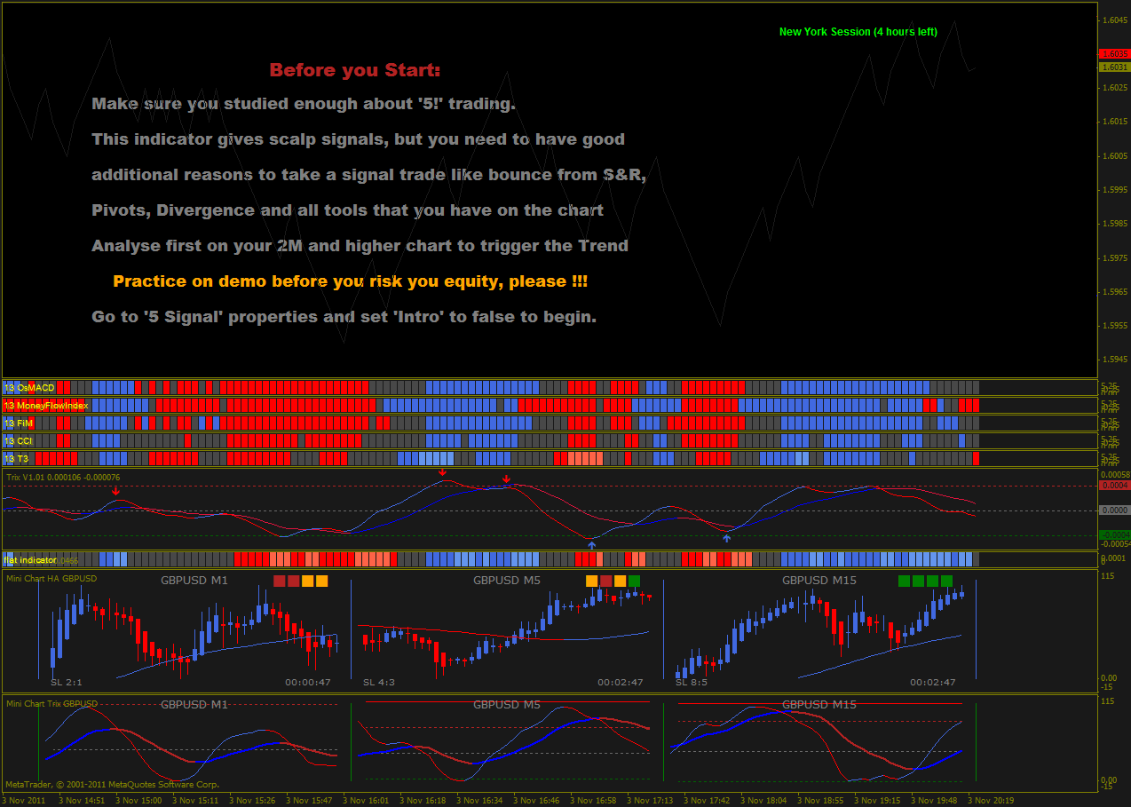

After you reed all that is on your screen, go to „5 signal“ properties and set intro to false. After that your screen sould look like this:
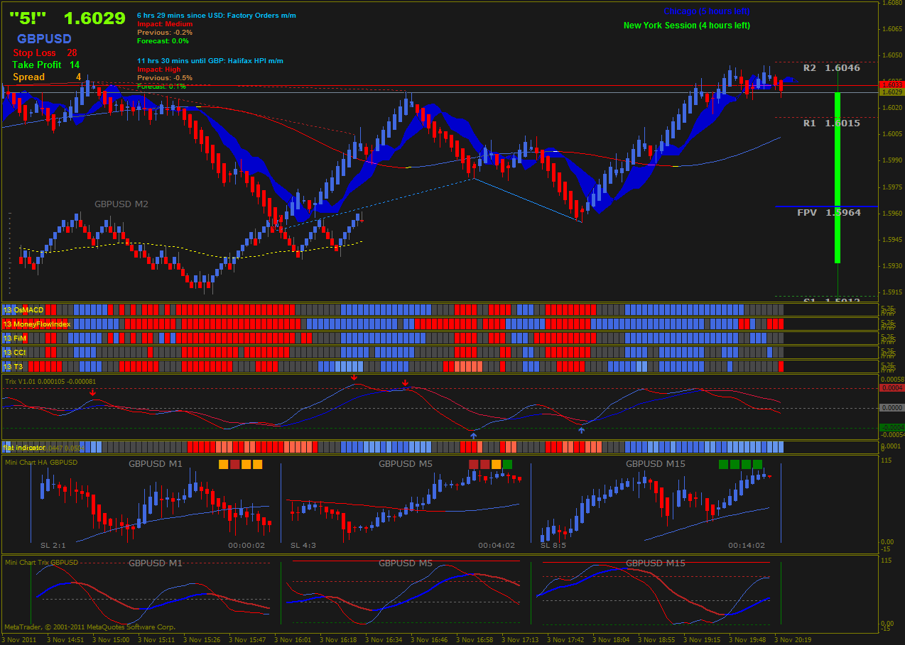

Or like this:
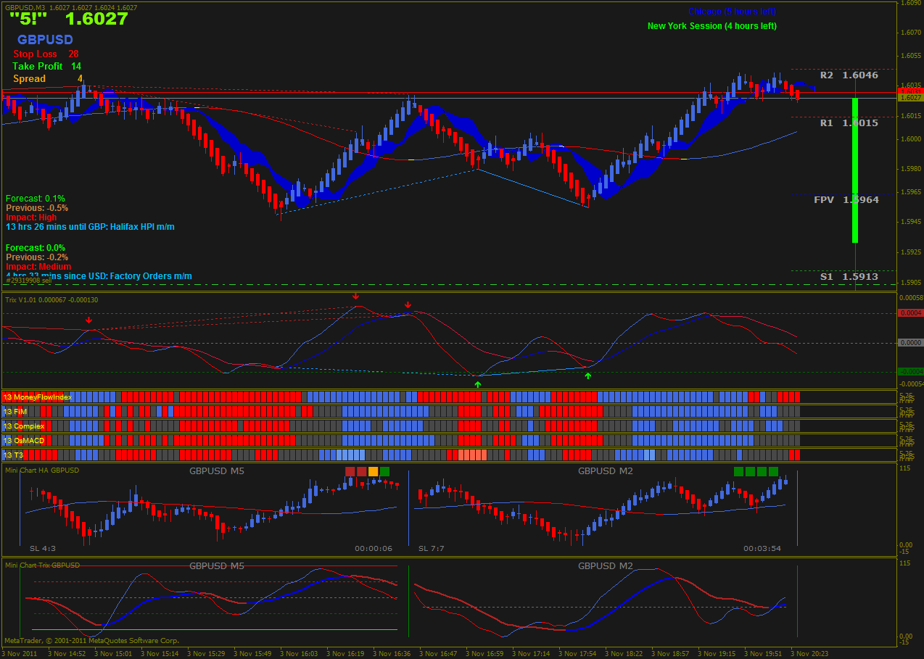

Depends on what template do you use.
In the case of template RenkopThv template, in the main window, you will find Renko candles with Heiken Ashi. I use HA to see easyly in what direction goes PA.
You will also find Ichimoku cloud and Coral 55.
In the upper left corner you will find big price, the name of the pair with spread and recomended TP and SL.
On the right side of that info is info with news. This is very important info because I DONT TRADE 15 mins BEFORE and 15 mins AFTER NEWS.
On the right upper side you will find market hours. When you open the properties of this indie you will find settings for time zone. Just change number to your distance from GMT and you dont need to change market times – it will be adjusted automaticly.
On the right side you will find pivot lines. Also you can set time zone and everythig will be automatic adjusted.
In the left down corner you wil find a graf with the name of the par and renko candles. This is graf of the 13 pips box with coral 55. This graf use to determine trend of the pair.
Next few windows are 13 OsMACD, 13 Money flow index, 13 FIM, 13 CCI and13 T3.
13 OsMACD is Osma and MACD in one use properties to change parameters if you like.
13 FiM is Force index and momentum in one.
13 T3 is indicator that show us when the fast trix line crossed the zero line.
Next indicator window is TRIX.
Next one is flat indicator. It is MA indicator shows us when market is flat.
Next two windows are minicharts with Thv rules. It helps me to be more confident in my descision.

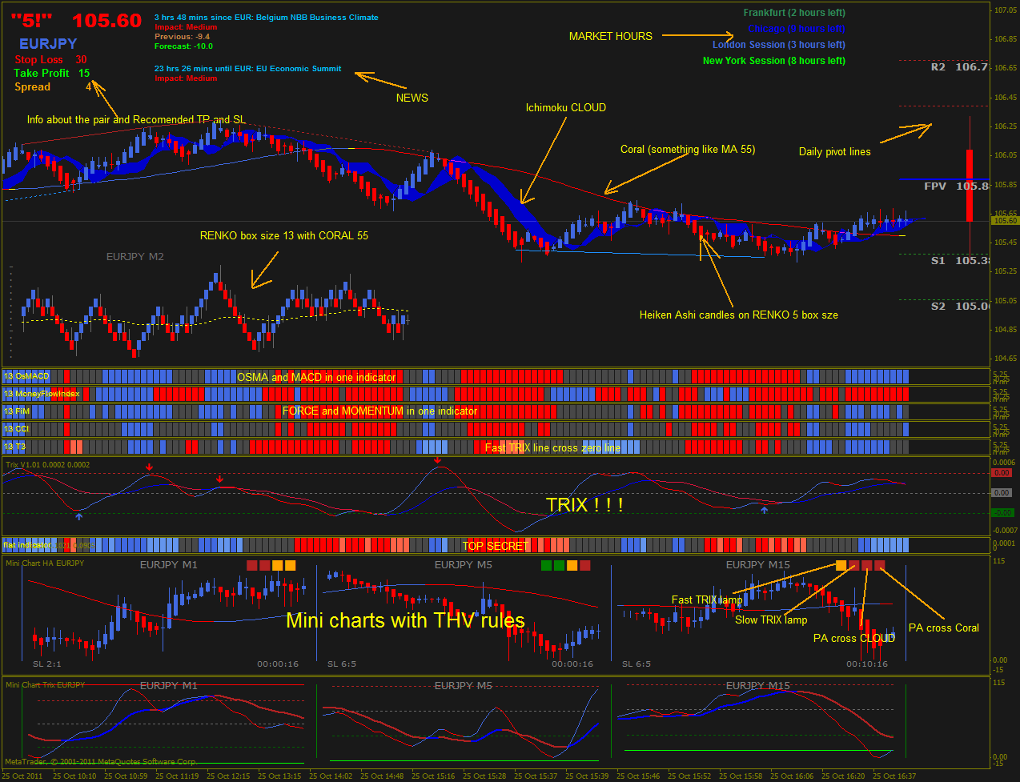
Renko Thv template

In the case of 5! Template, everything is the same but diferently organised. You can use it whatever you like. What fits you the best!

TRADING RULES

Trading rules are very simple:
Long
- Chart goes BLUE
- PA is above Coral
- PA is above Cloud
- All block indicators are BLUE for first time
- PA on M2 chart is above Coral and directon is UP
- PA is NOT close to any important S & R line
- NO news in next 15 minutes at least.

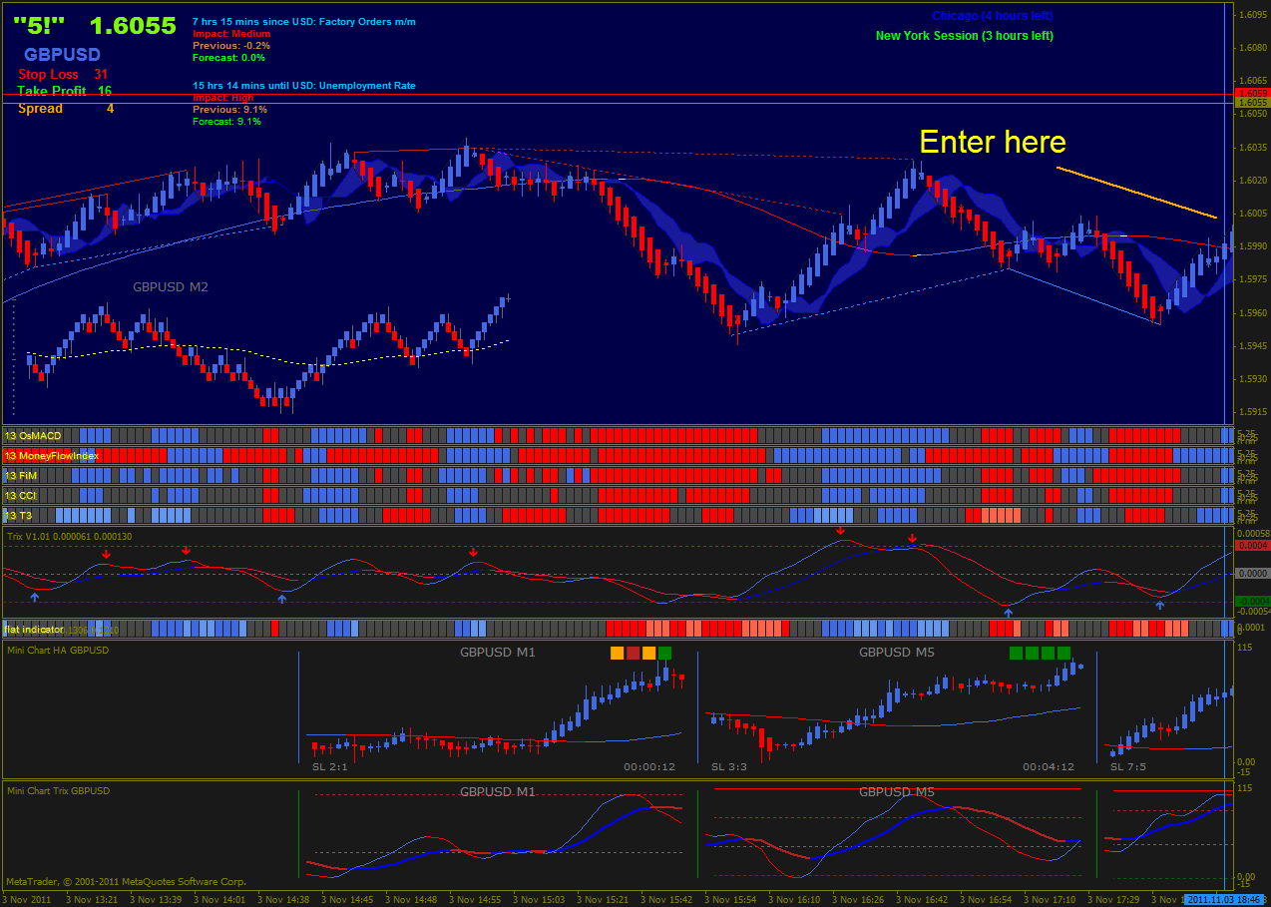
Short
- Chart goes RED
- PA is below Coral
- PA is below Cloud
- All block indicators are RED for first time
- PA on M2 chart is below Coral and direction is DOWN
- PA is NOT close to any important S & R line
- NO news in next 15 minutes at least.
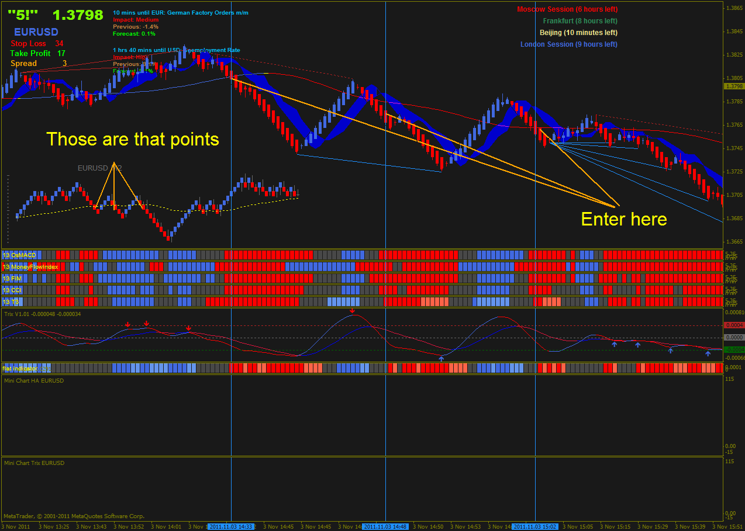

It is very easy to determine an entering point, hardest thing is to know when to get out from a trade…

I’m using TP from 15 to 20 pips. Sometimes if I have some kind of sense, I use 50 and more pips.
SL is between 35 and 50 pips according to MM that you use.

Good Luck to All!

