TMAtrue vs TMA Centered.
My understanding is the following:
At the time we look at a live graphic, TMA centered and TMAtrue are exactly the same at that exact moment. So this is the picture of EUR/USD on Dec 7 at around 12:00 using TMA Centered. At that time, I wouldn’t have taken the trade because it doesn’t correspond to NB’s rules.
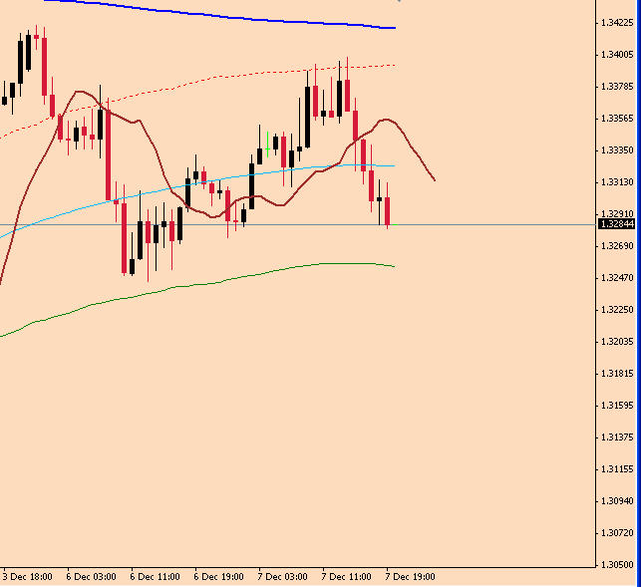

However, when I look at it today (Jan 2nd), it seems like it was a good trade. This is a picture of EUR/USD as of today, with TMA Centered (again). If this is the picture I would have seen on Dec 7th, I would have initiated a trade for sure.

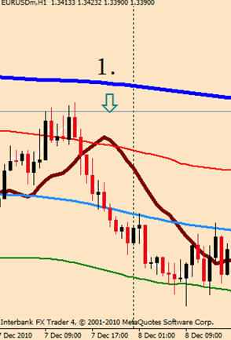

Using the TMAtrue, even today (Jan 2nd), reflects the same image as it was on Dec 7 at around 12:00. So even today, I can tell that it was not an option when it happened. This is a picture of EUR/USD as of today, with TMAtrue.

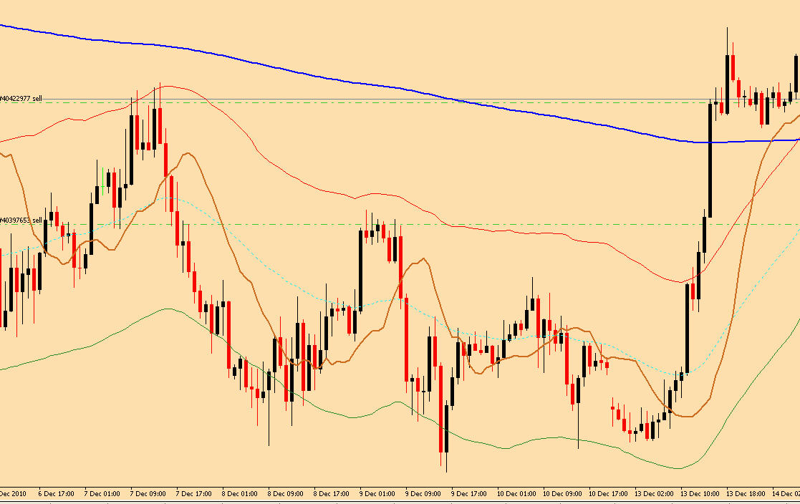

I am understanding this correctly ?

