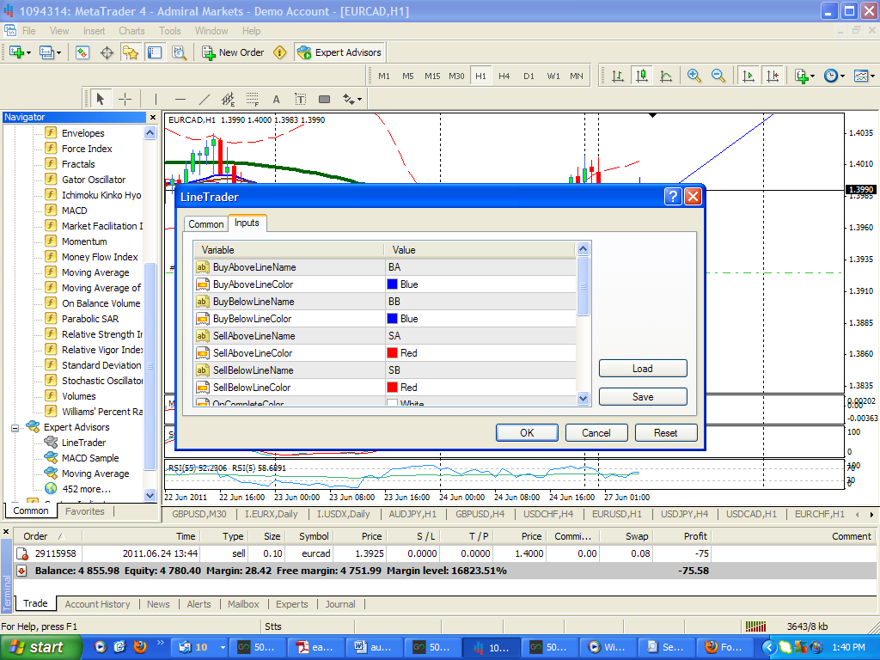
Above is screendump of the inputs for line trader. BA stands for buy above, BB stands for buy below. SA is for sell above, SB is for sell below. Those boxes have colors. Take note. There is one other parameter that has provision for a color. It is on complete. Depending on the color of your chart this would be white or black.
So, you want to place a trade on the price breaking below a trend line. So obviously this is a sell.
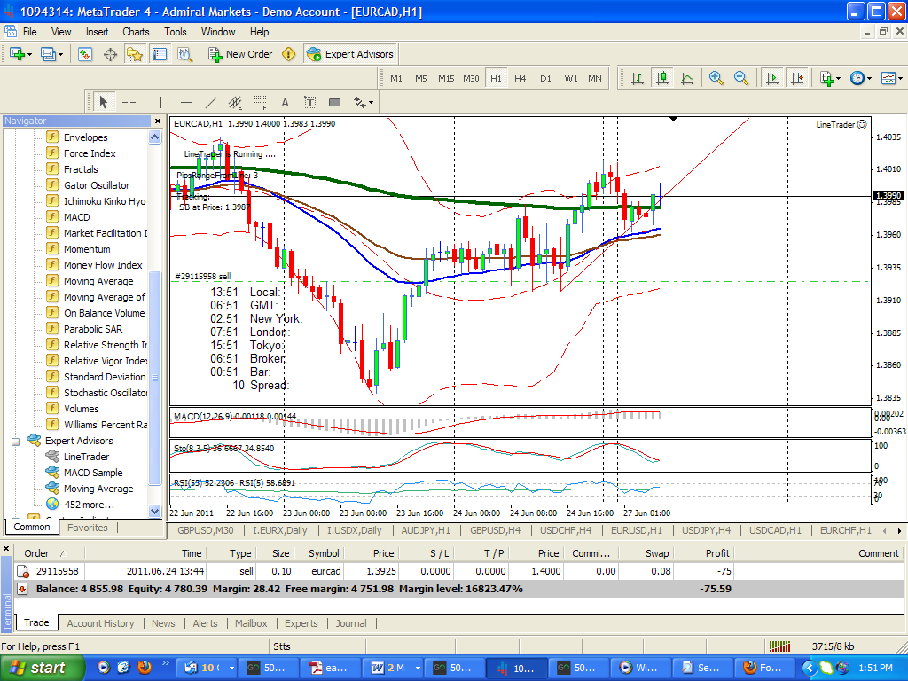

Once you have drawn your trendline, go to properties and rename the trendline SB and change it to the same color red as in input box. Now set your lot size, take profit and stoploss. When the price gets to this level, it will pull the trigger. Once this is done the line will change color to the color you selected in input box, white or black. It will also give an alert box saying work completed, or something like that. Note when you change the properties of the trendline or support line, you will have to make sure you change the name, the description and color to what you need the ea to do
This is the best I can describe it. Hope you understand it. Hope I can post something this large. If not I will get you to give me an email addy.
TOKO

