My vertical line and arrow represent the entry candle AFTER the signal.

These are the 2 that I think were valid entries per your chart. I would have had to suffer 15 minutes of invasion on both.
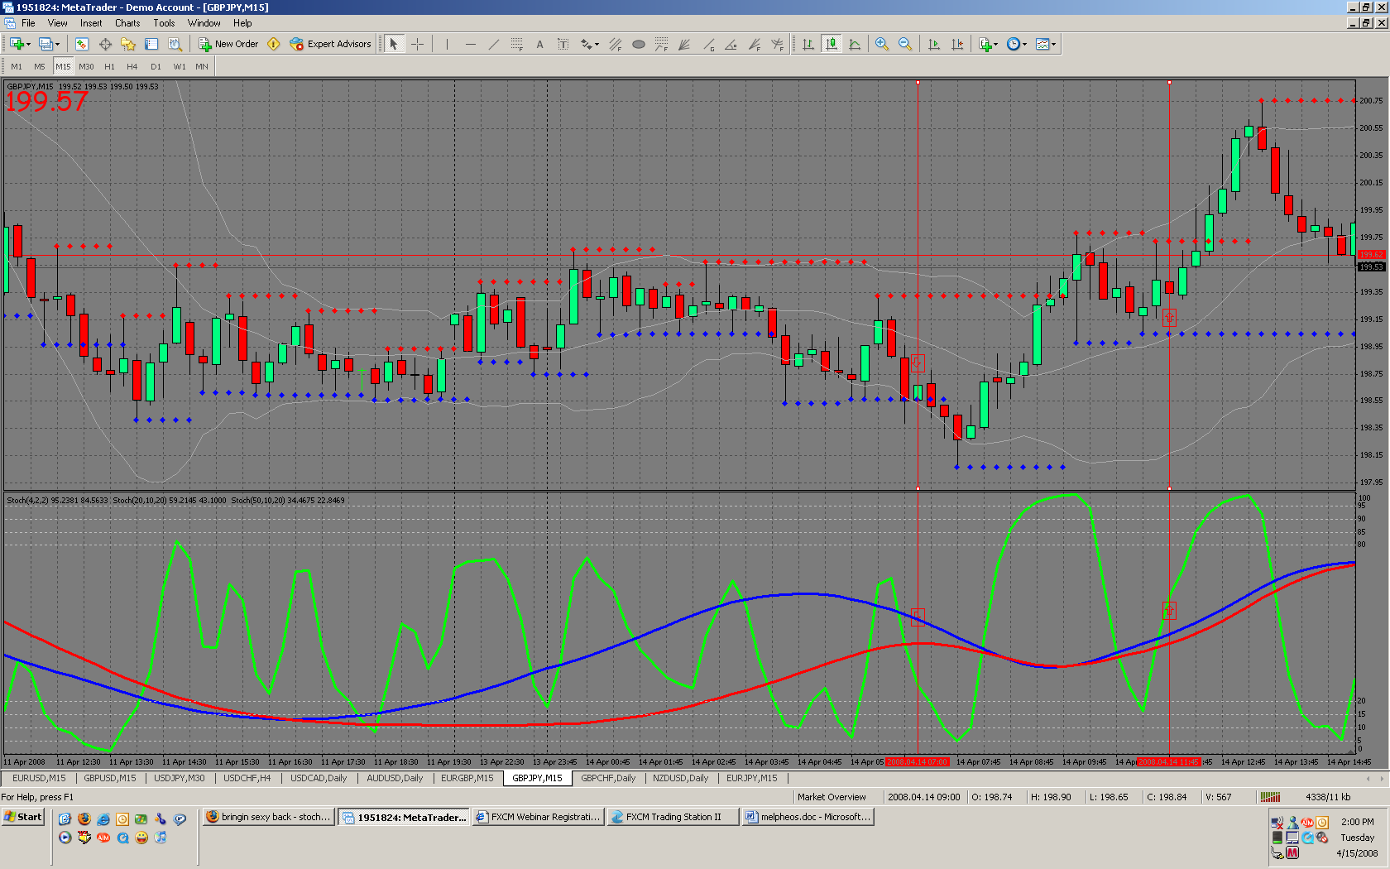

I see 6 entries on this chart, all but last one would have paid out.
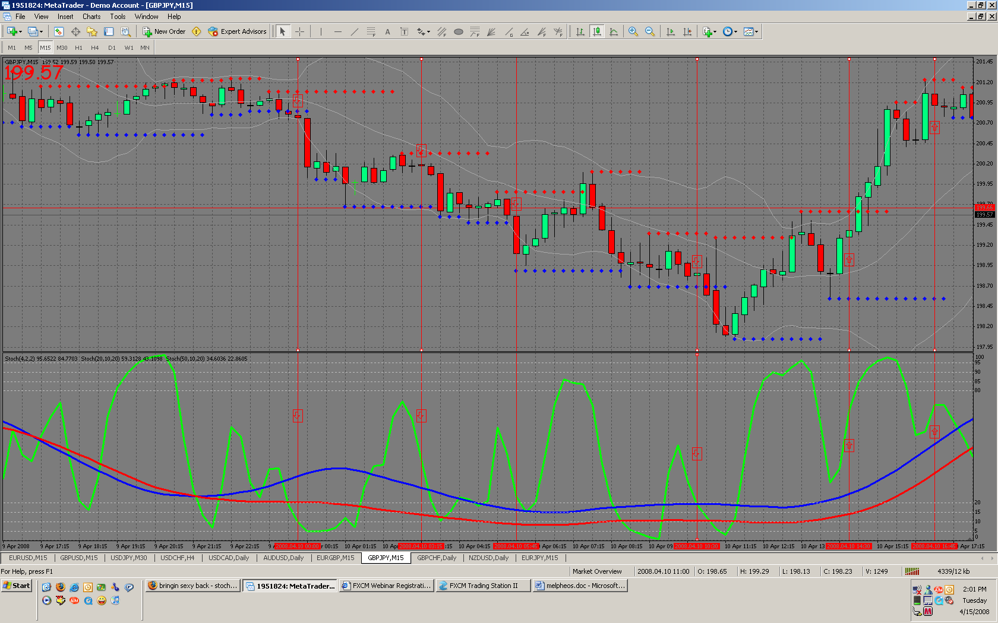

This is what I came up with for this one. Again, my vertical line that I am marking would be where I would be entering the market at the beginning of that time period/candle.
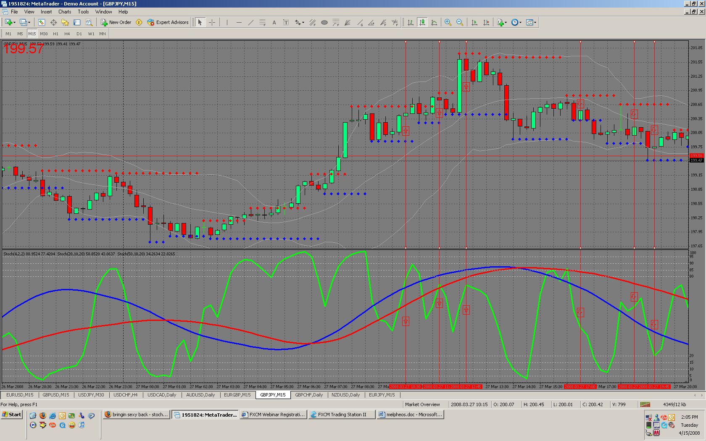

These are my possible trades on this one.
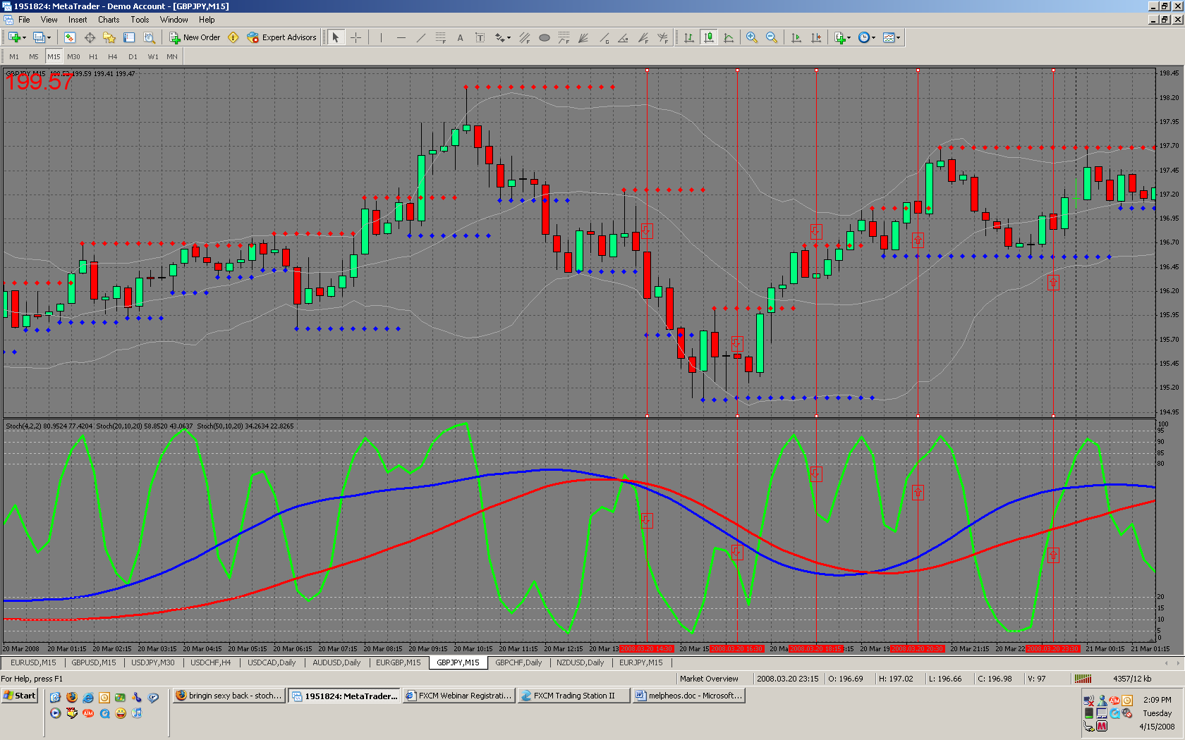

Tried to trade these objectively not knowing what would be coming and as you can see I lost a few. I am anxious for your feedback.
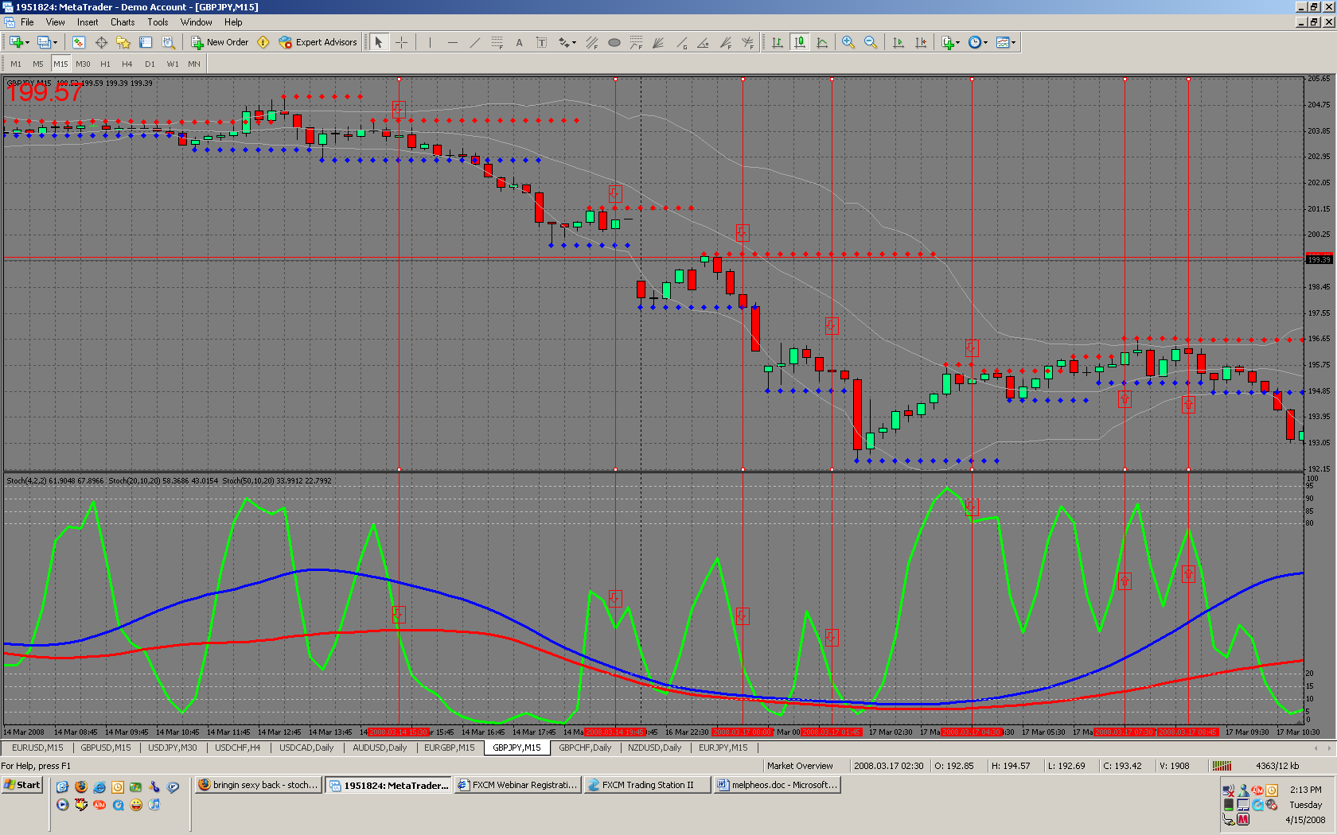

I think you should be able to see the directions of my arrows clear enough. Regardless, I never trade against the 20… EVER!

