Supdfyre MTF Stochastic Basic Rules

All the following 4 trade types use the 4H stochastic as the key signal for entry. It is easier to see that signal with all the time frames on one chart. Either the 4H stochastic is high (above 76.4) or low (below 23.6).
The 4H stochastic will be leading the entry quite a few hours ahead because the 4H will not update as fast as the rest of the smaller time frame stochastics. We are always basing our indications on candle closes.
We are either trading "to" the 4H stochastic or "away" from the 4H stochastic based on the location of all the stochastics.
Our four basic trade types then are:
1. Long: Climbing To the 4H stochastic
2. Long: Climbing Away from the 4H stochastic
3. Short: Diving To the 4H stochastic
4. Short: Diving Away from the 4H stochastic

Long: Climbing To
Example of a long trade where the 15M,30M and 1H stochastics cross the 23.6 level and climb to the 4H stochastic line.
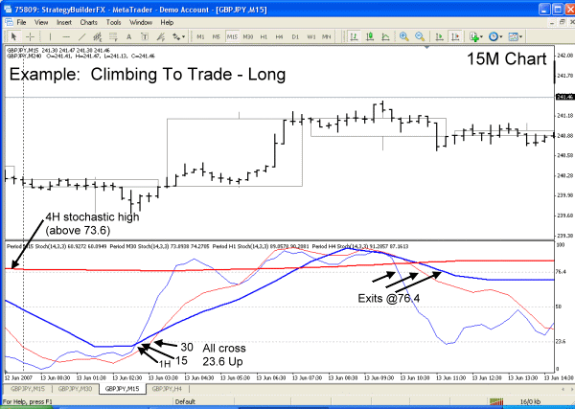
Long: Climbing Away Trade
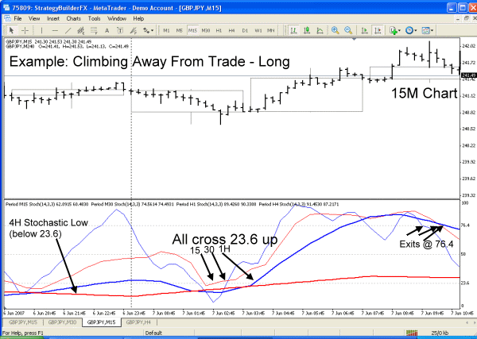
Diving To Trade 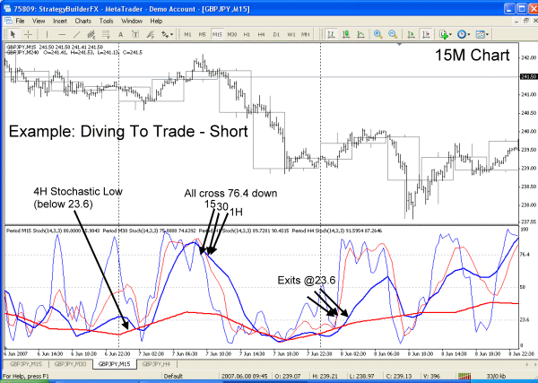

Diving Away Trade
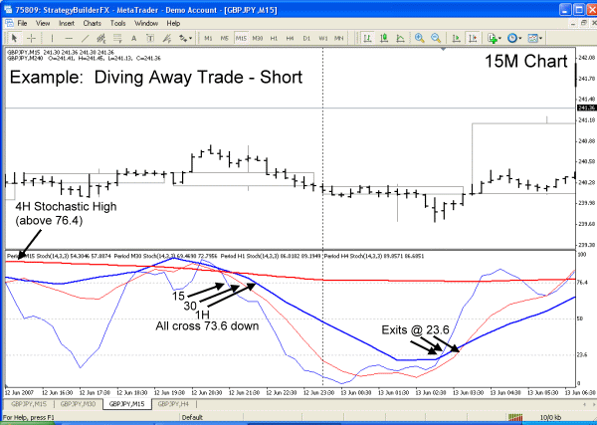
You'll notice from the 4 basic trade types that most of the exits lead into the opposite trade type...so it can be very cyclical if the 4H stochastic remains high or low.
That leads into what to do when the 4H stochastic moves and crosses the 76.4 down or 23.6 up. Follow the same rules as the 4 basic trades but trade with the direction of the 4H stochastic.
In other words, if the 4H stochastic starts to climb and crosses 23.6 up...trade long trades only.....unless the 15/30/1H zip to the top and can dive back down on the 4H stochastic. Vice versa for the 4H stochastic moving down. (This is basically momentum trading).
Stick to these basic 4 trades and use the 4H stochastic as your guide and you should be winning a whole lot more than losing.

