White Marubozu  Bullish | Doji  Neutral | Spinning Top  Neutral
Hanging Man  Bearish | Hammer  Bullish | Black Marubozu  Bearish
Bullish Engulfing  Bullish | Shooting Star  Bearish | Inverted Hammer  Bullish
Tweezer Bottoms  Bullish | Tweezer Tops  Bearish | Bearish Engulfing  Bearish
Three White Soldiers  Bullish | Evening Star  Bearish | Morning Star  Bullish
Three Inside Down  Bearish | Three Inside Up  Bullish | Three Black Crows  Bearish

Created by BernhardA (Forexfactory.com) – Source: babypips.com
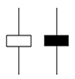 | 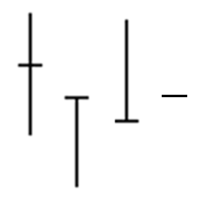 | 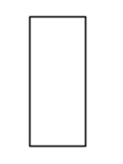
 | 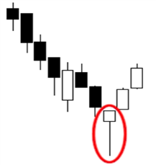 | 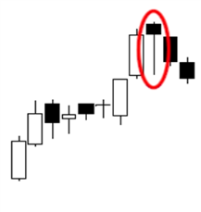
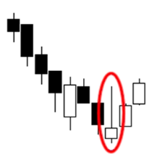 | 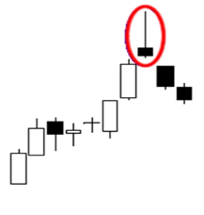 | 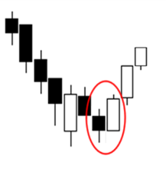
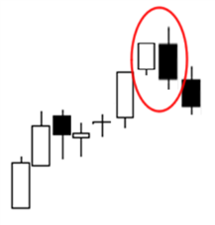 | 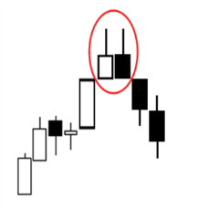 | 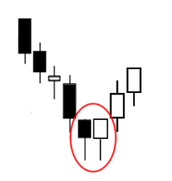
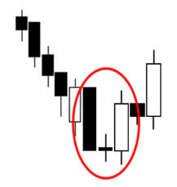 | 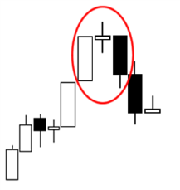 | 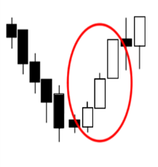
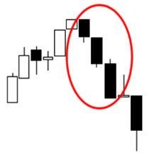 | 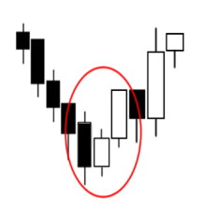 | 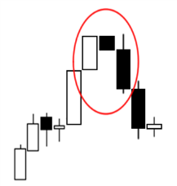

Created by BernhardA (Forexfactory.com) – Source: babypips.com

