01.
If we see a signal and want to trade long then click LMT button on EA.
The EA will set limit order on half body of current Heiken Ashi, put the stoploss on low of previous Heiken Ashi and takeprofit equals sl*2. Bid must be higher then center of body of current Heiken Ashi.

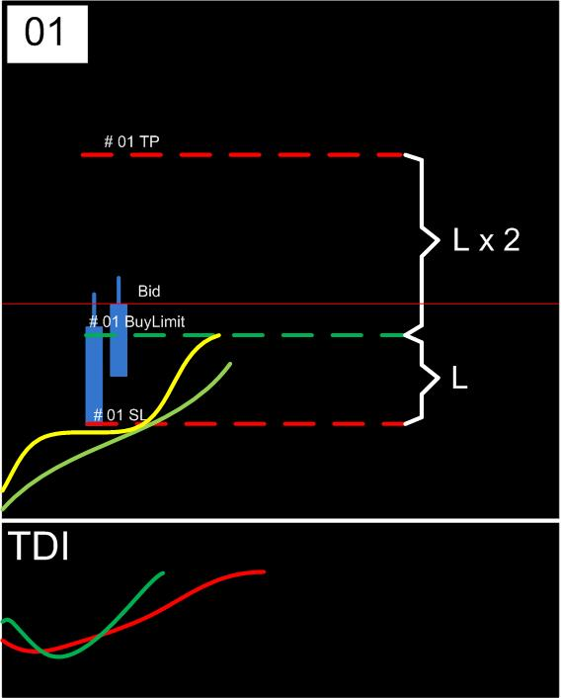

02.
When the candle is growing then EA tralls limit order to new center of body of current Heiken Ashi. Therefore distance to takeprofit too changes.
When the candle is reduced, limit and tp no changes.
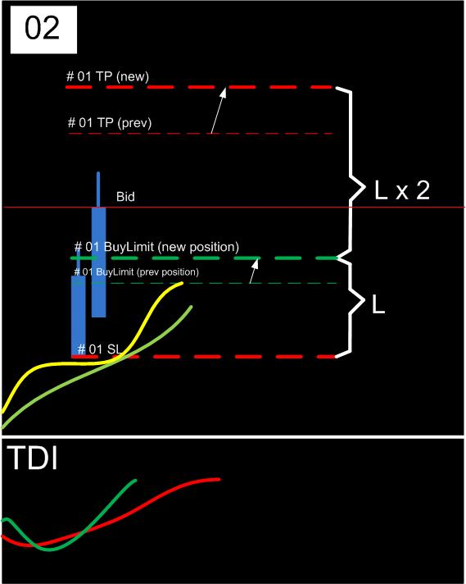

03 a.
If the price is not hooked order, and formed a new candle, then limit order jump to new candle and sl/tp updates.

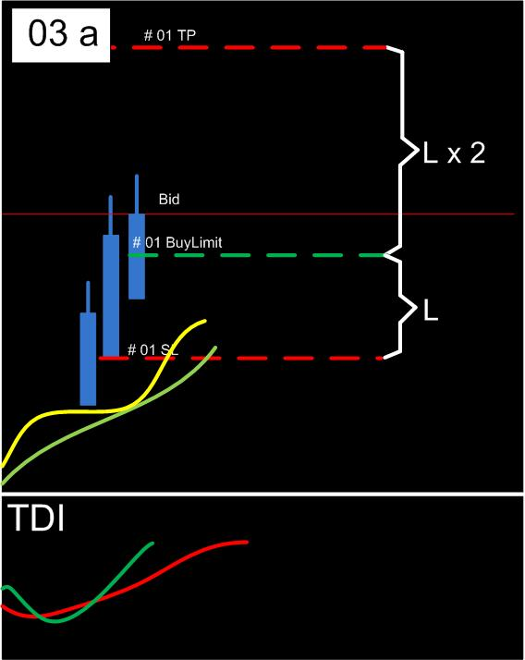

03 b.
If the price is hooked order, and formed a new candle, then stoploss jumps to next low of Heiken Ashi.

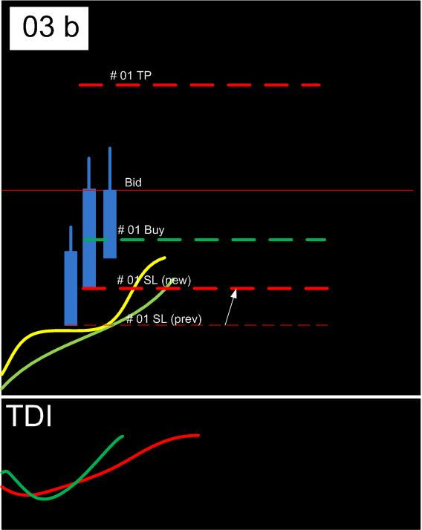

Added new parameter “Destination HA candle” in percents of current HA candle. Limit order tralled when candle is growing. Same action as in origin EA, but added tweak of limit order level. Example: if set 100, then buy limit order will be placed on low of current HAcandle; if set 0, then will be placed market trade.
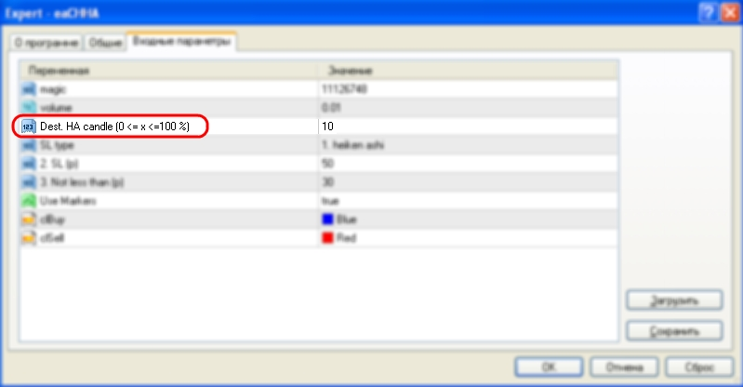

SL-type mode 0: you can use you own stops. tral turned off;
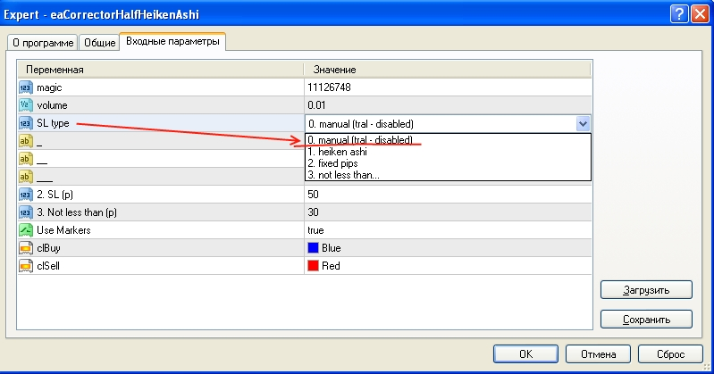

SL-type mode 1: EA uses SL on minimum formed Heiken Ashi candle. tral enabled;
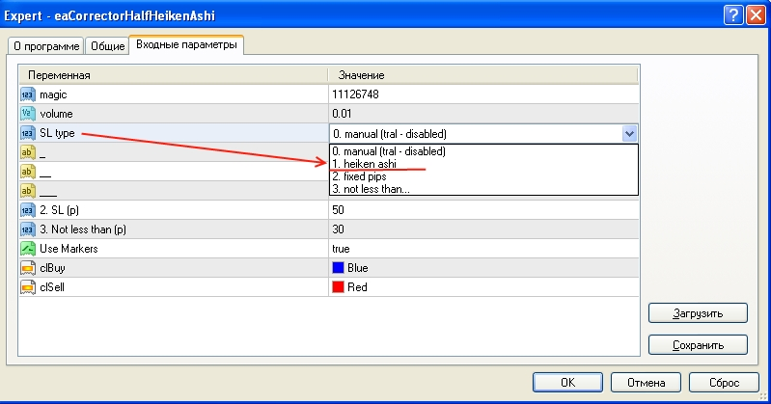

SL-type mode 2: You can use fixed SL, which will be tralled by EA on same distance;
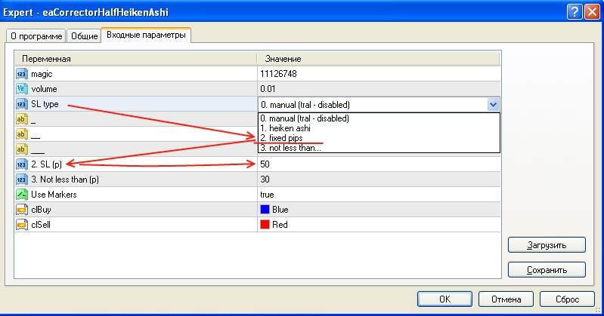

SL-type mode 3: EA uses SL not less than specified in parameters. If SL bigger than “3.Not less than (p)” parameter, it equals extremum of formed HA candle. Same action EA uses for tral.
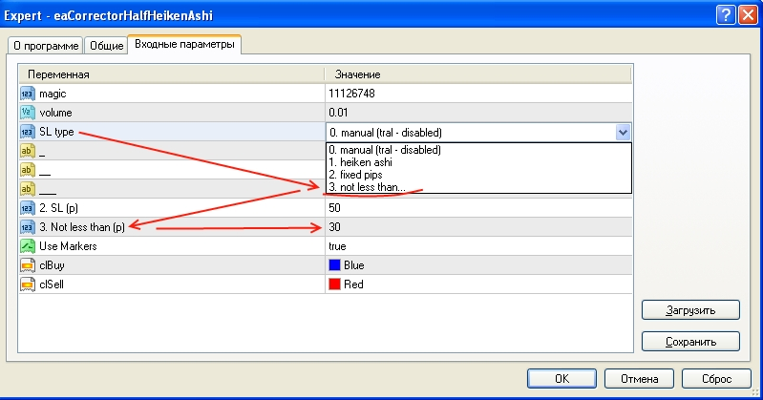

PS: Sorry for my French

