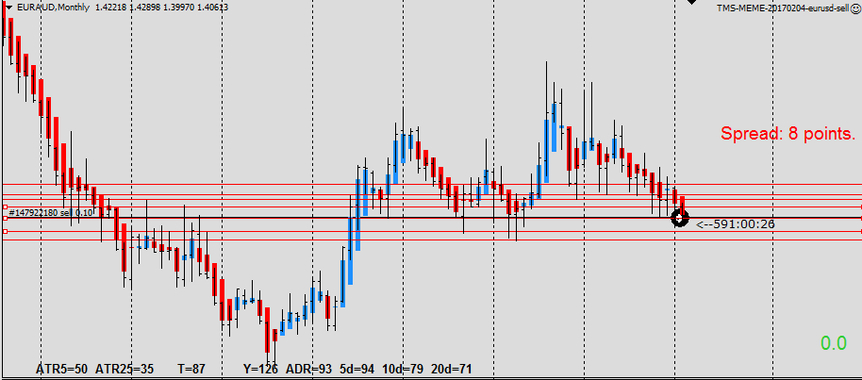

Down ward trend and possiblely approach botton of range bound market. Expect the price will down further to next resistance line If it break inside bar. Otherewise it will stay on range bound area.

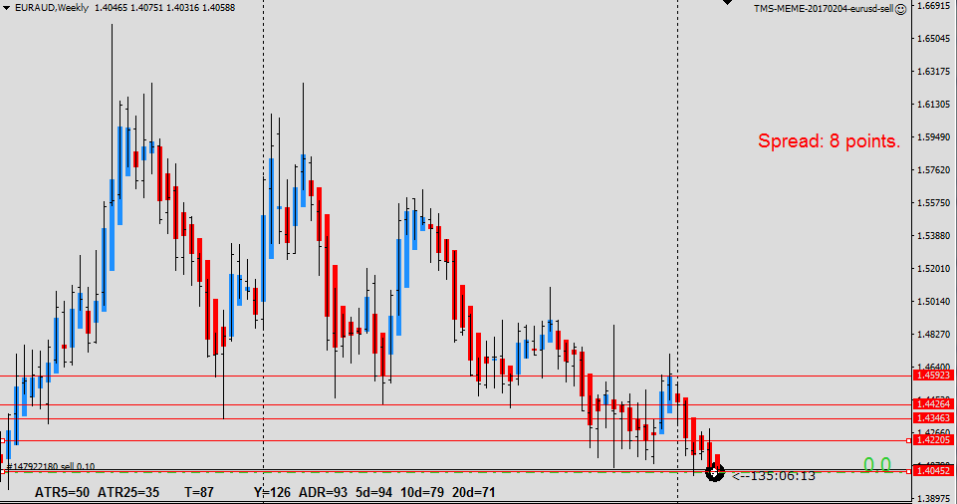

Strong down trend but near resistance line. If it break Big WRB, will be down to next structure.

