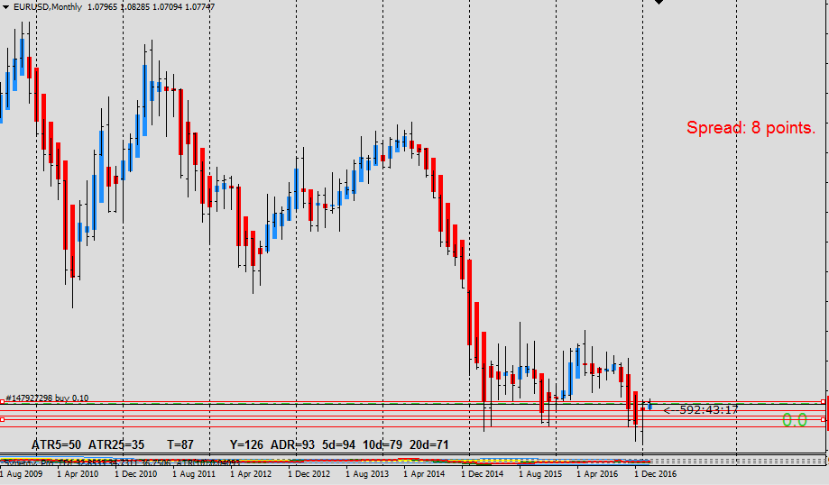

There is triple bottom with double low high bar up to last month. Open with same as last month’s close high and blue color bar. So expecting bull side will be in charge if it break last month’s closing price. Yet we have to find out. Market is forming side way at the bottom of down trend.

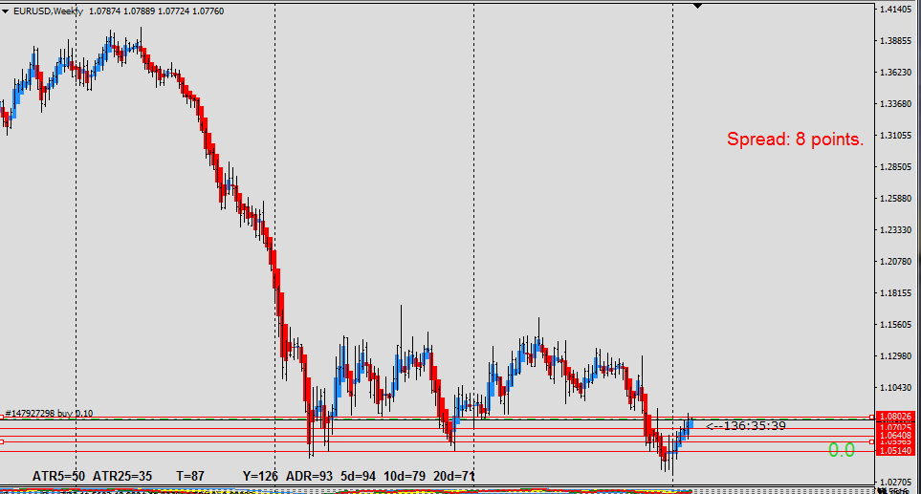

Same pattern here in W1 chart with side way market. It had been up ward direction with room to grow.
I can see the resistance at current price. If we cross this, there is about 5000 pips to hit next resistance.

