Some rules I collected from the TMS thread and currently trying to put into my brain!
Many thanks to all contributors!

→blue: what I am currently focusing on as a beginner & back tester.
MY trading rules:
- I am looking at 9 Major pairs: GBP/USD, EUR/USD, USD/CHF, USD/JPY, AUD/USD, USD/CAD, NZD/USD, EUR/GBP, EUR/CHF
- I am watching only 4h charts
- I am not trading during high impact news
- I look at the bigger picture to avoid consolidation areas and trading against the trend.
- I am using the method TMS from Big E based on the TDI indicator.
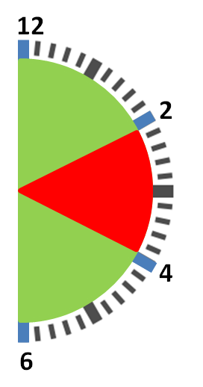
- I don’t risk more than 2% of my account
- I am taking trades with an R:R of minimum 1:1
- Direction of trade: TDI... Is it going up (long) or coming down (short).
- Re-enter after a bounce is allowed.
My entry:
- TDI Green cross Red; 12-2, 4-6, angle \/ & /\ bounce
- APB/HA change color entry candle #1 or #2
- Price action: >APB agrees with TDI
  - Check recent swing High / Low, distance from current price
  - Do not chase after long candle. Wait for price pull back
  - PA candle strength/size? Avoid candles with long wicks
- Lookout for confluence of Supp/Res
  - PA confirms reversal at Supp/Res confluence
  - Higher TF confirms Primary trend
- Stoch (8,3,3) confirms
  - Is there TDI or Stoch Divergence?
Stopploss:
- The last hi or low a couple of candles back
My exit
- when the green TDI line goes flat, starts to hook over or makes a check mark reversal.
- when APB smaller candles/change color

