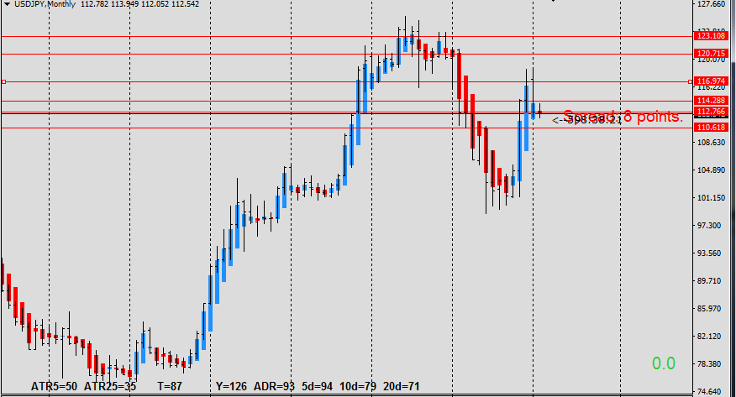

After downward thrust bar, February MN bar look like small undecided doji . If it break from last MN candle, possibly will travel down to the bottom of big WRB candle. Overall, looks like it’s going to side way market.

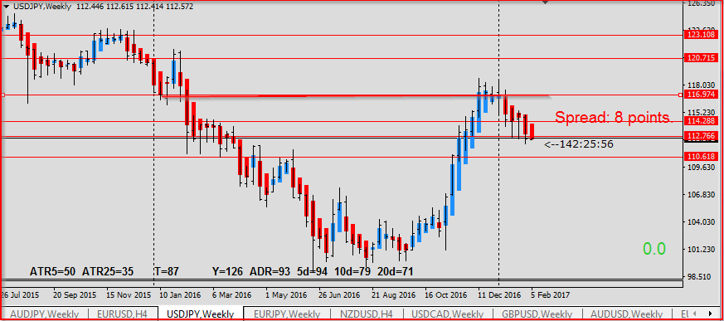

With strong rejection on resistance area, the trend is downside. If it break inside bar, it’s seems like there is empty space until next structure level.

