

Technical Safety Concept Lane Assistance

**Document Version: [V1.1]**



# Document history

**[Instructions: Fill in the date, version and description fields. You can fill out the Editor field with your name if you want to do so. Keep track of your editing as if this were a real world project.**

**For example, if this were your first draft or first submission, you might say version 1.0. If this is a second submission attempt, then you'd add a second line with a new date and version 2.0]**

|  |  |  |  |
| --- | --- | --- | --- |
| Date | Version | Editor | Description |
| 24-01-2019 | V1.1 | Liping S | First version with all required content |
|  |  |  |  |
|  |  |  |  |
|  |  |  |  |
|  |  |  |  |

# 

# Table of Contents

**[Instructions: We have provided a table of contents. If the table of contents is not showing up correctly in your word processor of choice, please update it. The table of contents should show each section of the document and page numbers or links. Most word processors can do this for you. In** [**Google Docs**](https://support.google.com/docs/answer/116338?co=GENIE.Platform%3DDesktop&hl=en)**, you can use headings for each section and then go to Insert > Table of Contents.** [**Microsoft Word**](https://support.microsoft.com/en-us/help/285059/how-to-create-a-table-of-contents-by-marking-text-in-word) **has similar capabilities]**

Document history

Table of Contents

Purpose of the Technical Safety Concept

Inputs to the Technical Safety Concept

Functional Safety Requirements

Refined System Architecture from Functional Safety Concept

Functional overview of architecture elements

Technical Safety Concept

Technical Safety Requirements

Refinement of the System Architecture

Allocation of Technical Safety Requirements to Architecture Elements

Warning and Degradation Concept

# Purpose of the Technical Safety Concept

**[Instructions: Answer what is the purpose of a technical safety concept?]**

ISO 26262 places the technical safety concept as part of the product development phase.

Before developing hardware or software, the technical safety requirements need to be determined for each of these systems.

The technical safety concept involves:

* Turning functional safety requirements into technical safety requirements
* Allocating technical safety requirements to the system architecture

This will set us up for drilling down into software and hardware implementation in the next step.

# Inputs to the Technical Safety Concept

## Functional Safety Requirements

**[Instructions: Provide the functional safety requirements derived in the functional safety concept ]**

|  |  |  |  |  |
| --- | --- | --- | --- | --- |
| **ID** | **Functional Safety Requirement** | **ASIL** | **Fault Tolerant Time Interval** | **Safe State** |
| Functional  Safety  Requirement  01-01 | ﻿The lane keeping item shall  ensure that the lane departure  oscillating torque amplitude  is below Max_Torque_Amplitude | C | 50ms | ﻿Function is  deactivated |
| Functional  Safety  Requirement  01-02 | ﻿The lane keeping item shall  ensure that the lane departure  oscillating torque frequency  is below Max_Torque_Frequency | C | 50ms | ﻿Function is  deactivated |
| Functional  Safety  Requirement  02-01 | ﻿The steering ECU shall ensure  that the wheel steering torque  only be applied in the Max_Duration | B | 500ms | ﻿Lane​ ​Keeping  Assistance  torque​ ​is​ ​zero. |

## Refined System Architecture from Functional Safety Concept

**[Instructions: Provide the refined system architecture from the functional safety concept]**

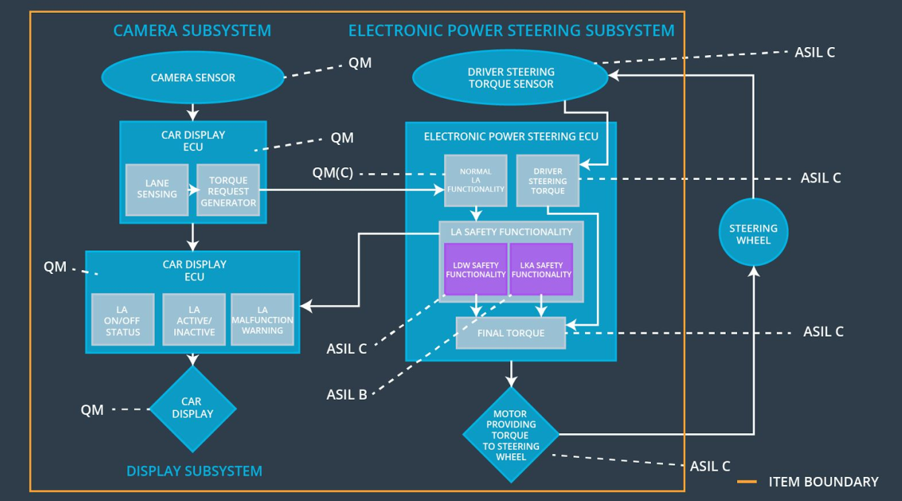

### 

### Functional overview of architecture elements

**[Instructions: Provide a description for each functional safety element; what is each element's purpose in the lane assistance item? ]**

|  |  |
| --- | --- |
| **Element** | **Description** |
| Camera Sensor | ﻿Provide visual signal to camera sensor ECU |
| Camera Sensor ECU - Lane Sensing | ﻿Detect lane line |
| Camera Sensor ECU - Torque request generator | ﻿​Calculate​ ​the​ ​torque​ ​to​ ​be​ ​requested​ ​to​ ​the​ ​Electronic​ ​Power Steering​ ​ECU. |
| Car Display | ﻿ Provide user interface to the driver and show the info of the system |
| Car Display ECU - Lane Assistance On/Off Status | ﻿Indicate​ ​the​ ​status​ ​of​ ​the​ ​Lane​ ​Assistance  functionality​ ​(On/Off.) |
| Car Display ECU - Lane Assistant Active/Inactive | ﻿Indicate​ ​if​ ​the​ ​Lane​ ​Assistance​ ​functionality​ ​is  properly​ ​functioning​ ​(Active/Inactive.) |
| Car Display ECU - Lane Assistance malfunction warning | ﻿Indicate​ ​a​ ​malfunction​ ​on​ ​the​ ​Lane​ ​Assistance  functionality |
| Driver Steering Torque Sensor | ﻿Measure​ ​the​ ​torque​ ​applied​ ​to​ ​the​ ​steering  wheel​ |
| Electronic Power Steering (EPS) ECU - Driver Steering Torque | Receive driver torque request from the steering wheel |
| EPS ECU - Normal Lane Assistance Functionality | Receive Camera ECU torques request |
| EPS ECU - Lane Departure Warning Safety Functionality | ﻿Ensure​ ​the​ ​torque​ ​is​ ​below​ ​Max_Torque_Amplitude and Max_Torque_Frequency. |
| EPS ECU - Lane Keeping Assistant Safety Functionality | ﻿​Ensure​ ​the​ ​Lane​ ​Keeping Assistance​ ​functionality​ ​ ​ ​is​ ​not activated​ ​more​ ​than​ ​Max_duration |
| EPS ECU - Final Torque | ﻿​Receive and process torque​ ​request​ ​from​ ​the​ ​Lane Keeping​ ​and​ ​Lane​ ​Departure​ ​Warning​ ​and​ ​send​ ​the final torque decision​ ​to​ ​the​ ​Motor |
| Motor | ﻿Apply​ ​the​ ​required​ ​torque​ ​to​ ​the​ ​steering  wheel |

# Technical Safety Concept

## Technical Safety Requirements

**[Instructions: Fill in the technical safety requirements for the lane departure warning first functional safety requirement. We have provided the associated functional safety requirement in the first table below. Hint: The technical safety requirements were discussed in the lesson videos. The architecture allocation column should contain element names such as LDW Safety block, Data Transmission Integrity Check, etc. Allocating the technical safety requirements to the "EPS ECU" does not provide enough detail for a technical safety concept.]**

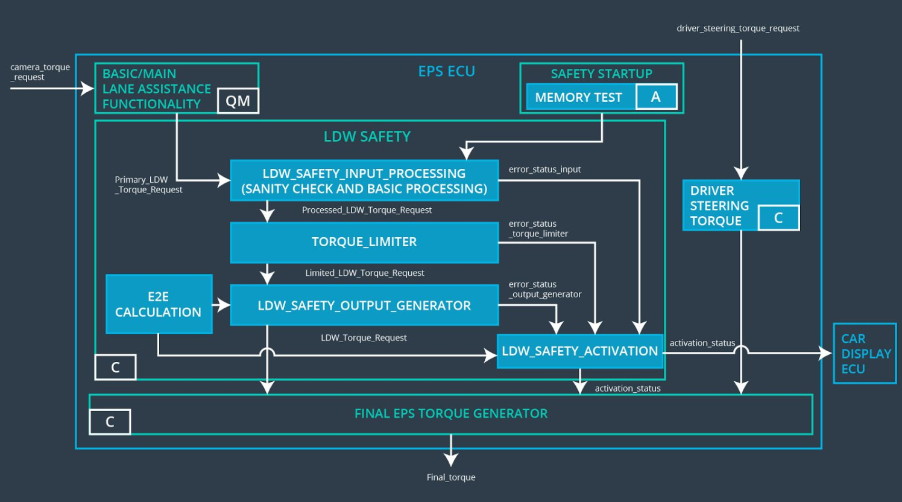

**Lane Departure Warning (LDW) Requirements:**

Functional Safety Requirement 01-01 with its associated system elements

(derived in the functional safety concept)

|  |  |  |  |  |
| --- | --- | --- | --- | --- |
| **ID** | **Functional Safety Requirement** | **Electronic Power Steering ECU** | **Camera ECU** | **Car Display ECU** |
| Functional  Safety  Requirement  01-01 | The lane keeping item shall ensure that the lane departure oscillating torque amplitude is below Max_Torque_Amplitude | X |  |  |

Technical Safety Requirements related to Functional Safety Requirement 01-01 are:

|  |  |  |  |  |  |
| --- | --- | --- | --- | --- | --- |
| **ID** | **Technical Safety Requirement** | **ASIL** | **Fault Tolerant Time Interval** | **Architecture Allocation** | **Safe State** |
| Technical  Safety  Requirement  01 | The LDW safety component shall ensure that amplitude of  ‘LDW_Torque_Request’ sent to the ‘Final electronic power steering torque’ is below ‘Max_Torque_Amplitude’ | C | 50ms | LDW Safety | LDW activation status to zero |
| Technical  Safety  Requirement  02 | The LDW safety component shall send warning signal to Car Display ECU for display when LDW is deactivated. | C | 50ms | LDW Safety | LDW activation status to zero |
| Technical  Safety  Requirement  03 | When a failure is detected by the LDW, it shall deactivate the LDW and set ‘LDW_Torque_Request’ to zero. | C | 50ms | LDW Safety | LDW activation status to zero |
| Technical  Safety  Requirement  04 | ﻿The​ ​validity​ ​and​ ​integrity  of​ ​the​ ​data​ ​transmission  for  ‘LDW_Torque_Request’ shall be ensured | C | 50ms | Data transmission integrity check | N/A |
| Technical  Safety  Requirement  05 | Memory test shall be conducted at start up of the EPS ECU to check for any memory problems | A | Ignition cycle | Memory Test | LDW activation status to zero |

**[Instructions: Fill in the technical safety requirements for the lane departure warning second functional safety requirement. We have provided the associated functional safety requirement in the table below. Hint:. Most of the technical safety requirements will be the same. At least one technical safety requirement will have to be slightly modified because we are talking about frequency instead of amplitude. These requirements were not given in the lessons]**

Functional Safety Requirement 01-2 with its associated system elements

(derived in the functional safety concept)

|  |  |  |  |  |
| --- | --- | --- | --- | --- |
| **ID** | **Functional Safety Requirement** | **Electronic Power Steering ECU** | **Camera ECU** | **Car Display ECU** |
| Functional  Safety  Requirement  01-02 | The lane keeping item shall ensure that the lane departure oscillating torque frequency is below Max_Torque_Frequency | X |  |  |

Technical Safety Requirements related to Functional Safety Requirement 01-02 are:

|  |  |  |  |  |  |
| --- | --- | --- | --- | --- | --- |
| **ID** | **Technical Safety Requirement** | **ASIL** | **Fault Tolerant Time Interval** | **Architecture Allocation** | **Safe State** |
| Technical  Safety  Requirement  01 | The LDW safety component shall ensure that frequency of  ‘LDW_Torque_Request’ sent to the ‘Final electronic power steering torque’ is below ‘Max_Torque_Frequency | C | 50ms | LDW Safety | LDW activation status to zero |
| Technical  Safety  Requirement  02 | The LDW safety component shall send warning signal to Car Display ECU for display when LDW is deactivated. | C | 50ms | LDW Safety | LDW activation status to zero |
| Technical  Safety  Requirement  03 | When a failure is detected by the LDW, it shall deactivate the LDW and set ‘LDW_Torque_Request’ to zero. | C | 50ms | LDW Safety | LDW activation status to zero |
| Technical  Safety  Requirement  04 | The​ ​validity​ ​and​ ​integrity  of​ ​the​ ​data​ ​transmission  for  ‘LDW_Torque_Request’ shall be ensured | C | 50ms | Data transmission integrity check | N/A |
| Technical  Safety  Requirement  05 | Memory test shall be conducted at start up of the EPS ECU to check for any memory problems | A | Ignition cycle | Memory Test | LDW activation status to zero |

**Lane Departure Warning (LDW) Verification and Validation Acceptance Criteria:**

**[OPTIONAL: For each technical safety requirement, identify both the verification and validation acceptance criteria. “Validation” asks whether or not you chose the appropriate parameters. “Verification” involves testing to make sure the vehicle behaves as expected when the parameter value is crossed. There is not necessarily one right answer. Look at your verification and validation acceptance criteria from the functional safety concept for inspiration.]**

**Lane Keeping Assistance (LKA) Requirements:**

**[Instructions: Fill in the technical safety requirements for the lane keeping assistance functional safety requirement 02-01. We have provided the associated functional safety requirement in the table below. Hint:. You can reuse the technical safety requirements from functional safety requirement 01-01. But you need to change the language because we are now looking at a different system. The ASIL and Fault Tolerant Time Interval are different as well.]**

Functional Safety Requirement 02-1 with its associated system elements

(derived in the functional safety concept)

|  |  |  |  |  |
| --- | --- | --- | --- | --- |
| **ID** | **Functional Safety Requirement** | **Electronic Power Steering ECU** | **Camera ECU** | **Car Display ECU** |
| Functional  Safety  Requirement  02-01 | The lane keeping item shall ensure that the lane keeping assistance torque is applied for only Max_Duration | X |  |  |

Technical Safety Requirements related to Functional Safety Requirement 02-01 are:

|  |  |  |  |  |  |
| --- | --- | --- | --- | --- | --- |
| **ID** | **Technical Safety Requirement** | **ASIL** | **Fault Tolerant Time Interval** | **Allocation to Architecture** | **Safe State** |
| Technical  Safety  Requirement  01 | The LKA safety component shall ensure that ‘LKA_Torque_Request’ is sent to ‘Final electronic power steering torque’ in limited period of time(Max_Duration) | B | 500ms | LKA Safety | LKA activation status to zero |
| Technical  Safety  Requirement  02 | The LKA safety component shall send warning signal to Car Display ECU for display when LKA is deactivated. | B | 500ms | LKA Safety | LKA activation status to zero |
| Technical  Safety  Requirement  03 | When a failure is detected by the LKA, it shall deactivate the LKA and set ‘LKA_Torque_Request’ to zero. | B | 500ms | LKA Safety | LKA activation status to zero |
| Technical  Safety  Requirement  04 | The​ ​validity​ ​and​ ​integrity  of​ ​the​ ​data​ ​transmission  for  ‘LKA_Torque_Request’ shall be ensured | B | 500ms | Data transmission integrity check | N/A |
| Technical  Safety  Requirement  05 | Memory test shall be conducted at start up of the EPS ECU to check for any memory problems | A | Ignition cycle | Memory test | LKA activation status to zero |

**Lane Keeping Assistance (LKA) Verification and Validation Acceptance Criteria:**

**[OPTIONAL: For each technical safety requirement, identify both the verification and validation acceptance criteria. “Validation” asks whether or not you chose the appropriate parameters. “Verification” involves testing to make sure the vehicle behaves as expected when the parameter value is crossed. There is not necessarily one right answer. Look at your verification and validation acceptance criteria from the functional safety concept for inspiration.]**

## Refinement of the System Architecture

**[Instructions: Include the refined system architecture. Hint: The refined system architecture should include the system architecture from the end of the technical safety lesson, including all of the ASIL labels.]**

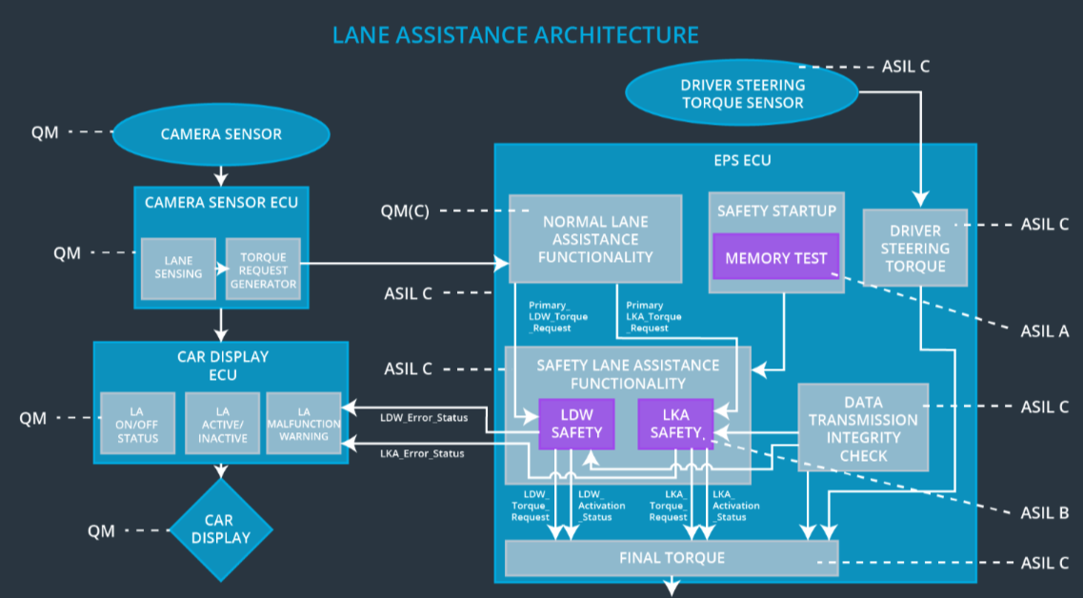

## Allocation of Technical Safety Requirements to Architecture Elements

**[Instructions: We already included the allocation as part of the technical requirement tables. Here you can state that for this particular item, all technical safety requirements are allocated to the Electronic Power Steering ECU]**

For Lane Assistance item, all technical safety requirements were allocated to the Electronic Power Steering ECU.

## Warning and Degradation Concept

**[Instructions: We've already identified that for any system malfunction, the lane assistance functions will be turned off and the driver will receive a warning light indication. The technical safety requirements have not changed how functionality will be degraded or what the warning will be.**

**So in this case, the warning and degradation concept is the same for the technical safety requirements as for the functional safety requirements. You can copy the functional safety warning and degradation concept here.**

**Oftentimes, a technical safety analysis will lead to a more detailed warning and degradation concept. ]**

|  |  |  |  |  |
| --- | --- | --- | --- | --- |
| **ID** | **Degradation Mode** | **Trigger for Degradation Mode** | **Safe State invoked?** | **Driver Warning** |
| WDC-01 | ﻿Turn off Lane  Assistant  functionality | ﻿Malfunction_01 | Yes | Lane assistance malfunction warning on car display |
| WDC-02 | ﻿Turn off Lane  Assistant  functionality | ﻿Malfunction_02 | Yes | Lane assistance malfunction warning on car display |
| WDC-03 | ﻿Turn off Lane  Assistant  functionality | ﻿Malfunction_03 | Yes | Lane assistance malfunction warning on car display |