Methylisothiazolinone Inhibits the Development of Neurites in Differentiating PC-12 Cells
Aaron Miller, Precious Velarde, Casey Massah, Jeff Bailey, and Thomas Weimbs

Abstract

Methylisothiazolinone, an antimicrobial agent commonly used in hygiene and cosmetic products, has been shown to cause cell death in cultured rat cortical neurons. There is insufficient data on neurotoxicity in humans at concentrations that result from household product exposure, although methylisothiazolinone exposure has been linked to dermatitis and allergic reactions. In this study, we examine its effects on PC-12 cells both alone and in combination with nerve growth factor (NGF), including its effects on the number of neurites that develop when exposed to conditions that favor differentiation. For controls, we counted neurites in cells treated with NGF, epidermal growth factor (EGF), dbcAMP (a cyclic AMP analog that can cross the plasma membrane) and combinations thereof. In addition, we measured the amount of tubulin and actin produced in the presence and absence of NGF. Our results show that differentiating PC-12 cells produce fewer neurites per cell when exposed to MIT and NGF together than when exposed to NGF alone.

Introduction

Methylisothiazolinone (MIT) is a small hydrophilic molecule with antimicrobial properties at relatively low concentrations; it is used for this purpose in many hygiene and cosmetics products. It has been shown that MIT exhibits neurotoxic effects in vitro, but no clinical evidence has been published for patient CNS or nerve damage, although this cannot be ruled out, considering the lack of research. However, the tendency of MIT to cause dermatitis and allergic reactions in some individuals has been documented (García-Gavín et al., 2010).

In this study, we examine the effects of MIT on PC-12 cells. PC-12 cells are derived from a rat adrenal medulla tumor, and can differentiate to become very similar to sympathetic neurons: neurites and other neuron-like processes are extended from the cell body and synapses are formed. The secondary messenger cAMP is known to promote this neurite growth alone and in combination with NGF (Richter-Landsberg, Jastorff, 1986), but the polarity of cAMP makes it difficult to cross the plasma membrane, so we use a less polar analog, dbcAMP (dibutyryl cAMP). Earlier experiments by collaborators in our lab grew PC-12 cells in a single type of medium containing fetal bovine serum both after splitting and to initiate differentiation, but it was found that different types of media (containing mixtures of fetal calf serum and horse serum in different proportions) for these two stages produced better results.

Previous work has revealed the mechanism by which methylisothiazolinone causes the death of cultured rat cortical neurons: certain soluble zinc-binding proteins rely on thiol groups for their function, and so the cytosolic Zn²⁺ concentration increases when these thiol groups are oxidized by MIT. The high concentration of Zn²⁺ leads to a signal transduction cascade ultimately resulting in cell death (Du, et al., 2002).

G-actin and tubulin are monomers of cytoskeletal components that (among other functions) allow neurites to be extended and provide their structural integrity. In this study, we use a Western blot to compare the amounts of actin and tubulin produced in the presence and absence of NGF.

Materials and Methods

Neurite outgrowth under varying chemical conditions. PC-12 cells were grown under seven different conditions: unsupplemented differentiation media (1x penicillin/ streptomycin/ fungizone (P/S/F) and 2% horse serum in DMEM), and differentiation media supplemented with 20ng/mL EGF, 200ng/mL NGF, 2mM dbcAMP, 200ng/mL NGF + 2mM dbcAMP, 1uM MIT, or 200ng/mL NGF + 1uM MIT. Cells were supplemented only after growing for one day in normal media (1x P/S/F, 5% fetal calf serum, and 10% horse serum in DMEM) to provide time to adhere, except for the MIT cells, which were grown in normal media for three days before treatment. Cells were observed and neurites were counted after 3 and 5 days of growth.

Cells for Western blot. In parallel with the aforementioned experiment, two plates of PC-12 cells were grown: one treated with 100ng/mL NGF, and one without treatment. After 7 days, the number of cells with neurites were counted. After 9 days, the confluence fractions for each plate were measured and cells were lysed with the corresponding proportion of lysis buffer (300uL for 60% confluent cells). Proteins were separated from cell debris by centrifugation at 10,000 rpm for 10 min., and protein content was assayed using a NanoDrop instrument.

SDS-PAGE. The above two protein solutions were diluted with lysis buffer to equalize volume and protein concentration, and 240 ug protein in 1X loading buffer solution (total volume 40uL) were loaded in each well of a polyacrylamide stacking+resolving gel contained in a Mini-Protean II electrophoresis cell (Bio-Rad Laboratories, Hercules, CA); both -NGF and +NGF were performed in duplicate to permit both Coomassie Blue staining and Western blot. Gel was run at 200V for 40 min.

Western blot. The above gel was packaged with a nitrocellulose membrane into a gel box, allowed to equilibrate for 5 min. in the transfer buffer, and then run at 100V for 1 hour. Nitrocellulose membrane was soaked protein side down in blocking buffer (5% milk in PBS-Tween) for two days. A western blot was performed; primary antibodies were mouse anti-beta-tubulin and rabbit anti-actin; secondary antibodies were goat anti-mouse IgG-800nm conjugate and goat anti-rabbit IgG-680nm conjugate. The resulting nitrocellulose membrane was imaged in the infrared using a LICOR instrument.

Results

Effects of MIT, NGF, EGF, and dbcAMP on neurite outgrowth. It was discovered that cells did not adhere well enough in the chambered slide we were using. Fortunately, J. Bailey was performing this experiment with plates instead of a chambered slide, and so his data will be analyzed here (Figures 1 and 2; Table 1).

The standard deviation of the dbcAMP cell groups is much larger than those of the other treatment conditions, suggesting that this maximum neurite count is not significant data (Table 1).

Figure 1: PC-12 cells after one day of treatment: (A) dbcAMP + NGF; (B) NGF; (C) NGF+MIT; (D) MIT; (E) dbcAMP; (F) EGF; (G) differentiation medium only; and (H) normal medium only.
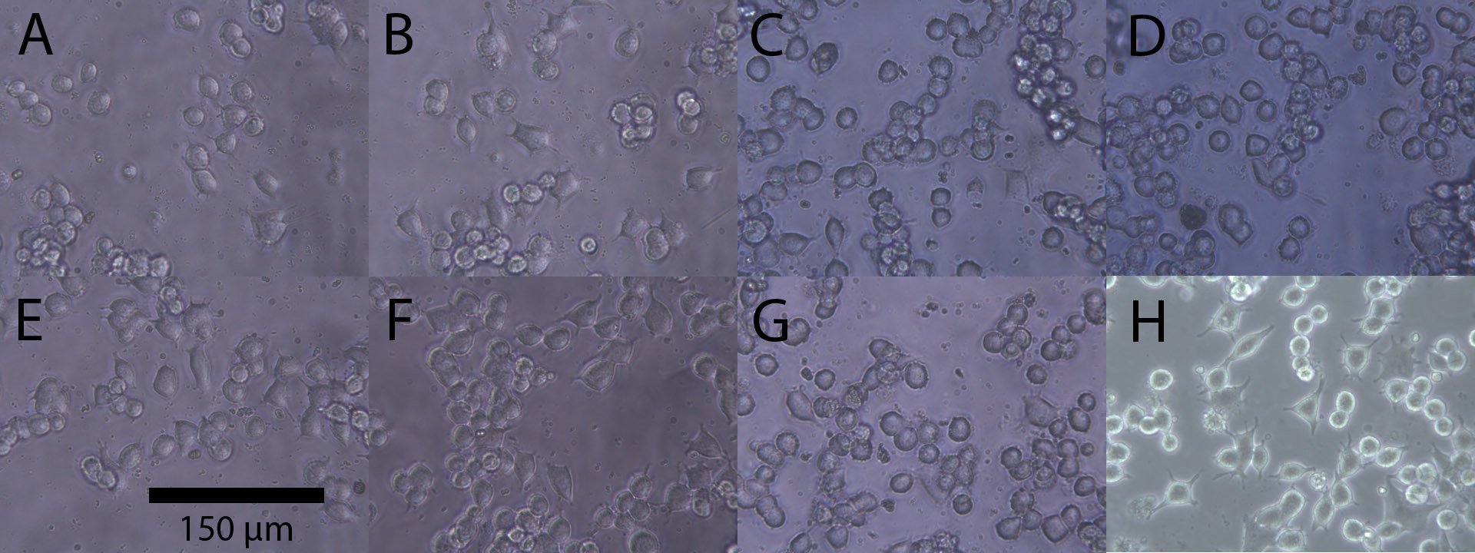
Figure 2: PC-12 cells after three days of treatment: (A) dbcAMP + NGF; (B) NGF; (C) NGF+MIT; (D) MIT; (E) dbcAMP; (F) EGF; and (G) differentiation medium only.
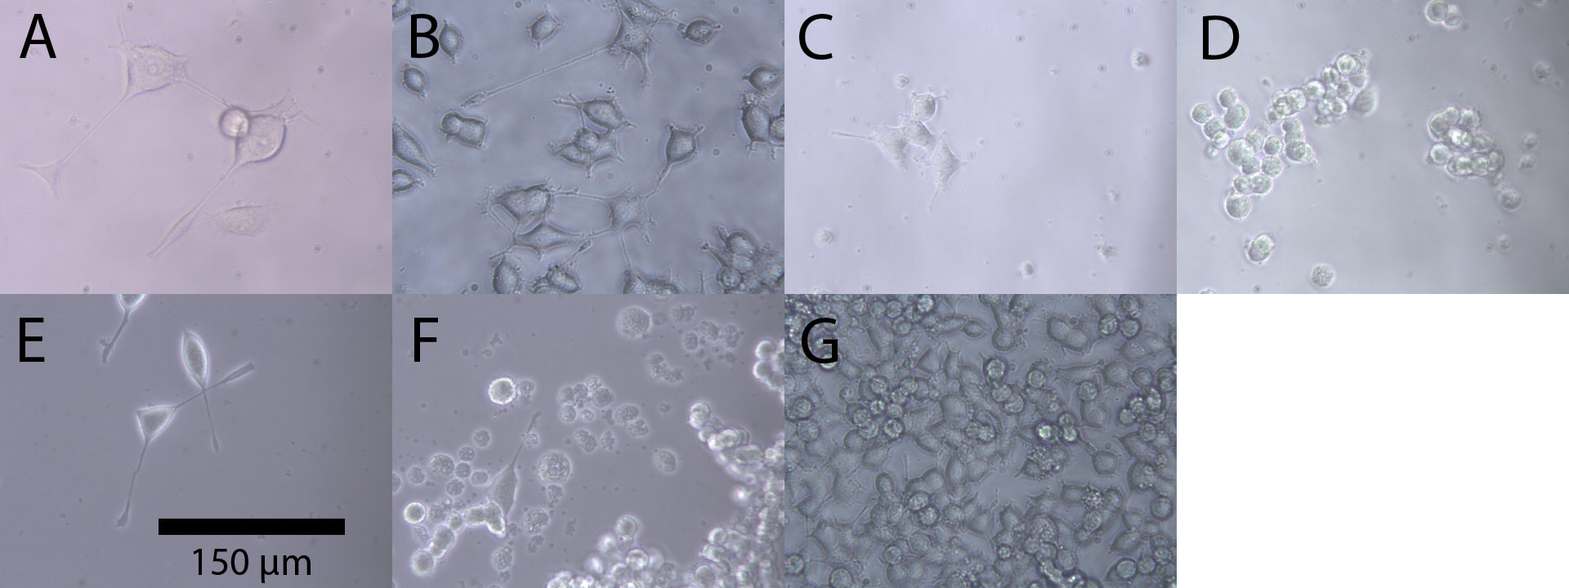
Table 1: data for neurite counts at the end of growth period, according to each treatment; N is the number of groups of cells assayed; for each group, the number of cells with neurites is divided by the total number of cells in the group.
Treatment | Mean | Std. Dev. | N
Diff. Medium | 0.0111 | 0.0192 | 3
NGF | 0.2444 | 0.1018 | 3
EGF | 0.0444 | 0.0770 | 3
dbcAMP | 0.4111 | 0.2502 | 3
dbcAMP + NGF | 0.2333 | 0.0577 | 3
MIT | 0.0333 | 0.0333 | 3
NGF + MIT | 0.0667 | 0.0577 | 3
Total | 0.1492 | 0.1702 | 21

Table 2: NanoDrop A280 protein assay of cell lysates for SDS-PAGE and Western blot.
+/- NGF | Protein conc. | OD₂₆₀/OD₂₈₀
- | 10.889 mg/mL | 1.54
+ | 8.037 mg/mL | 1.62

Figure 3: LICOR imaging of Western blot. The secondary antibody for tubulin (conjugated to 800nm fluorophore) is visualized in green and the secondary antibody for actin (conjugated to 680nm fluorophore) is visualized in red. Actin band is not visible for unknown reasons.
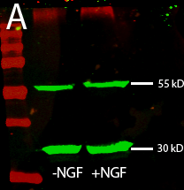

Table 3: Tubulin content as measured by infrared imaging of Western blot. Actin content could not be measured, possibly because of a problem with the primary antibody to actin.
Band Measured | -NGF Lane | +NGF Lane
~55 kD | 1.18 | 1.80
~30 kD | 3.02 | 3.18

Discussion

Actin bands were not seen in the Western blot (Figure 3), however there is signal from the secondary antibody for actin at the top of the gel. This suggests that either the primary or secondary actin antibodies are binding to high molecular weight proteins, and so too little free antibody is available to bind to G-actin and produce a visible band.

We have demonstrated that methylisothiazolinone (MIT) exhibits neurotoxicity in rat PC-12 cells. To establish the risk of this compound to humans who use MIT-containing hygiene and cosmetic products, further experiments are needed. In particular, the ability of MIT to penetrate the epidermis needs to be assessed (previous studies have determined that MIT can cause contact dermatitis and allergic reactions, but no correlation has yet been found between central nervous system (CNS) damage or peripheral nerve damage and MIT). It would also be helpful to measure the concentration of MIT and its metabolites in the blood of mammals exposed to topical MIT; this would give a better indication of the risks to the CNS.

References

Du S, McLaughlin B, Pal S, Aizenman E. (2002) In Vitro Neurotoxicity of Methylisothiazolinone, a Commonly Used Industrial and Household Biocide, Proceeds via a Zinc and Extracellular Signal-Regulated Kinase Mitogen-Activated Protein Kinase-Dependent Pathway. Journal of Neurosci., 1 September 2002, 22(17): 7408-7416.

García-Gavín J, Vansina S, Kerre S, Naert A, Goossens A. (2010) Methylisothiazolinone, an emerging allergen in cosmetics?. Contact Dermatitis, 63: 96–101. doi: 10.1111/j.1600-0536.2010.01754.x

Richter-Landsberg C, Jastorff B. (1986) The Role of cAMP in Nerve Growth Factor-Promoted Neurite Outgrowth in PC12 Cells. J Cell Bio, 102(3): 821-829. doi: 10.1083/jcb.102.3.821

