Isolation of GFP Ensconsin from Bacterial Plasmid and Expression in Cos-7 Cells
Aaron Miller, Shivani Suklikar, and Jeff Bailey

Results

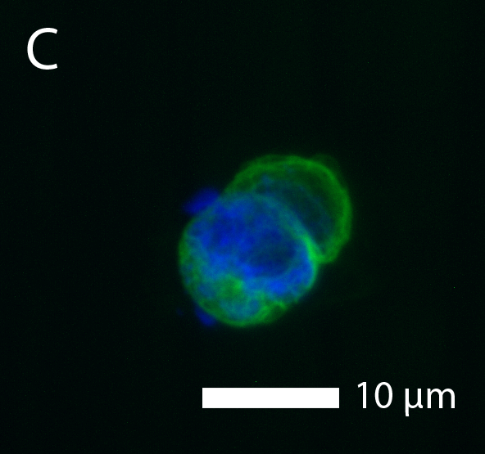

Materials and Methods

Materials. Liquid culture of E. coli containing EMTB-3XGFP plasmid. L-broth ampicillin plate. Qiagen plasmid isolation kit from Qiagen (Venlo, Netherlands). 10x reaction buffer C. EcoRI and XhoI restriction enzymes. 1% agarose electrophoresis gel with 1μg/mL ethidium bromide. COS-7 cell media consisting of DMEM (Gibco #121600) with 10% fetal bovine serum (Gibco #10438-026) and 1x penicillin-streptomycin- fungizone mixture (Gibco #15240-062), all from Life Technologies (Carlsbad, CA). COS-7 cells (ATCC number: CRL-1651). Trypsin-EDTA. Fugene, Prolong Gold, and DAPI.

Producing colonies of plasmid-containing bacteria. The liquid culture of E. coli containing the EMTB-3XGFP plasmid was streaked onto an LB-Amp plate. Plate was incubated at 37°C for roughly 24 hours.

Isolation of EMTB-3XGFP plasmid DNA. A single colony was used to inoculate 6mL of LB-Amp media and grown for roughly 24 hours. 1.5mL of this liquid culture was micro-centrifuged at 10,000g for 5 minutes; the supernatant was discarded. Another 1.5mL was micro-centrifuged in the same Eppendorf tube. The Qiagen Kit protocol for plasmid purification was followed (QIAprep Miniprep Handbook 12/2006, pg. 22-23).

Analysis of plasmid DNA. The OD₂₆₀ and OD₂₈₀ of the plasmid DNA were measured. Approximately 1μg of 150ng/μL plasmid DNA was put into each of three Eppendorf tubes labelled A, B, and C. Tube A was the negative control, containing only DNA in 1x reaction buffer C; tubes B and C additionally contained restriction enzymes (0.5μL EcoRI in the case of tube B and 0.5μL of both EcoRI and XhoI in the case of tube C). Four wells of an agarose electrophoresis gel were loaded as follows: 5μL ladder, 15μL from each of tubes A, B, and C. Gel was run for 47 minutes at 100 volts, and the result was photographed under UV illumination.

Splitting of COS-7 cells. 100mL of COS-7 cell media was prepared. A plate of COS-7 cells was washed with 10mL PBS and trypsinized for 5 minutes. It was verified that the cells were dislodged using an inverted microscope. Trypsin was inhibited with 5mL media, and the cells were collected to a pellet at 1500rpm for 3 minutes; the supernatant was aspirated. Cells were resuspended in media and counted with a hemacytometer. Cells were split to low and high cell count plates.

References

Weimbs, T. (2013). Cell Biology Laboratory Manual. MCDB department at University of California, Santa Barbara.

Qiagen Plasmid Purification Handbook. (2006). <http://www.lifesci.ucsb.edu/mcdb/labs/weimbs/classes/2013-MCDB_103L/additional/QIAprep_Miniprep_Handbook.pdf>.

