The Prospects for Life Elsewhere in the Solar System

Mark “Aaron” Miller

Writ 109ST – 12:30pm section

August 2, 2013

In the later years of the 20th century, it became common in the scientific community to assume that life does not exist in the Solar System; therefore, the exploration of the Solar System by humans or unmanned devices must have other objectives than the discovery of life. This pessimism is largely the result of the initial discoveries of the US and Soviet space programs, which revealed hostile environments such as Venus and Mars.

**Mars**

Mars is currently a very cold place with an extremely thin atmosphere; at first glance, it would appear to be an inhospitable environment for life. It has been compared to Antarctica, though this is an interesting comparison, because Antarctica has many forms of microbial life within its ice and rocks, even in its most inhospitable regions. Liquid water could not exist on the surface for longer than a few minutes at a time, but there is likely to be liquid water in rock pores and cracks several kilometers underground; this may be a habitat for life.

***Viking* biology experiments**

The *Viking* Mars landers were active on Mars from 1976-1980. They were equipped with biology experiments for analyzing Martian soil that, it was assumed, would definitively answer the question of life on Mars. An astonishing positive result was obtained with the Labeled Release (LR) experiment, but the GCMS experiment failed to detect any organic compounds in the Martian soil (Levin and Straat, 1988). A non-biological explanation was accepted for the positive result of the LR experiment; however, Levin notes that this was a change in attitudes among the scientists: “It was understood [before the *Viking* mission], then, that only one of the three experiments might return a positive response, were there truly life on Mars, and that such independent data would most probably be strong enough on its own merit to substantiate the detection of life” (Levin and Straat, 1988).

The LR experiment (Figure 1) used simple nutrients labeled with carbon-14 dissolved in water. To test the Martian soil, the nutrient broth was added to it, and then the radioactivity of any gas released would be measured―microbial life would presumably metabolize the nutrients and give off carbon dioxide containing carbon-14. To control for non-biological reactions that could cause this same effect, the same experiment was repeated after heating the samples to a temperature of 165⁰C, which would presumably sterilize the soil sample (Levin, 2010).

The results, which were very similar for both *Viking* 1 and 2 landers, indicated the presence of life: carbon-14 dioxide was produced from the soil upon addition of the nutrient broth, but with prior “sterilization,” no carbon-14 dioxide was given off. If a second addition of the nutrient broth was given to the non-sterilized soil after several days, no carbon-14 dioxide was given off. This last result was widely understood to be evidence *against* life, since microbes usually reproduce when given nutrients, so there would presumably be more microbes to produce carbon-14 dioxide when more of the nutrient broth is added. However, Antarctic soil samples containing microorganisms were found to exhibit the same behavior, because the microorganisms died before the second addition of nutrients (Levin, 2010).

The *Viking* Pyrolytic Release (PR) experiment was designed to measure synthesis of organic compounds using carbon dioxide from the air (this is essentially the reverse process of the LR experiment); in this experiment, a simulated Martian atmosphere containing carbon-14-labeled carbon dioxide and carbon monoxide were incubated with Martian soil for varying lengths of time and with or without simulated sunlight, then the labeled gas was purged and the soil was heated to 635⁰C to vaporize any carbon-containing compounds. This experiment gave positive results, since radioactive gases were detected (Plaxco and Gross, 2011:280). The PR experiment results cannot be interpreted as biological, however, since heating to 175⁰C does not entirely prevent the reaction, and heating to only 90⁰C does not inhibit the reaction at all; this is inconsistent with reactions mediated by biology (Klein 1978).

To explain the seemingly inconsistent results of the *Viking* biology experiments, it has been proposed that there are three oxidants in Martian soil: superoxides, hydrogen peroxide, and a third, unknown oxidant (Klein, 1978). However, Levin notes that all attempts to replicate the *Viking* results on Earth using various non-living conditions have failed (Levin 2010). Although the possibility cannot be eliminated that there is some non-biological reaction responsible for the *Viking* results that has simply not been tested by experts on Earth, the absence of a non-biological explanation lends credibility to the idea that the results are biological in nature.

The GCMS experiment failed to detect any organic compounds, but it did detect dichloromethane, an organic solvent that was used to clean the soil compartments prior to launch of the *Viking* probes. A logical conclusion was that the dichloromethane detected was left over from this cleaning. The negative GCMS results initially seemed to rule out organic matter in the Martian soil; because it is almost inconceivable that living organisms could exist without organic compounds, this implied that there were not any microorganisms in the Martian soil. The conclusion that there were no organic materials was brought into question in 2008, when the Phoenix lander detected the presence of perchlorate ions (ClO4-); this would destroy any organic material in the heating step that begins GCMS analysis, converting it to dichloromethane (Levin, 2010). McKay has determined that “if *Phoenix*-like levels of perchlorates were present in the *Viking* samples, the organic content of the Martian soil could have been as high as 0.1% and still would have produced the (false) negative result that the GCMS experiment returned” (Plaxco and Gross, 2011:285). In light of this new information, the best interpretation of the detected presence of dichloromethane is that organic compounds *were* present in the analyzed Martian soil.

The discovery of perchlorates is significant for two other reasons: perchlorate is not stable on the surface due to photochemical reactions, and perchlorate solutions can have a much lower freezing point than pure water, potentially allowing its use as an “anti-freeze” by extant Martian microorganisms (Enecrenaz et al., 2012). The *Viking* Gas Exchange (GEx) experiment detected a large release of oxygen upon addition of water to Martian soil; this has been difficult to explain using either biology or non-biological chemistry, but the decomposition of hydrogen peroxide would produce the same effect (Enecrenaz et al., 2012). Mixtures of hydrogen peroxide and water can have freezing points as low as -56⁰C, and so could have a similar biological function as perchlorates in allowing microorganisms to have liquid cytoplasms at very low temperatures (Enecrenaz et al., 2012). In addition, the perchlorate-rich hyperarid Atacama Desert has microbes living under the soil that use perchlorates to extract water from the air; Martian life may perchlorates for this purpose (Figure 3; Enecrenaz et al., 2012).

**Post-*Viking* exploration of Mars**

The European Space Agency's *Mars Express* orbiter, in orbit since late 2003, has detected methane in the Martian atmosphere in concentrations ranging from 0 to 30 parts per billion by volume (ppbv) (Formisano et al., 2004). Although non-biological explanations have been proposed, such as a slow release from underground methane reservoirs (originally present due to hydrothermal activity) or cometary impacts, a reasonable possibility is that organisms living in underground aquifers are metabolizing carbon monoxide and hydrogen gas from the atmosphere to form methane, which then leaks up into the atmosphere (Formisano et al., 2004). Considering methane's relatively short half life (on the order of hundreds of years) in the Martian atmosphere, the methane production or release must be relatively continuous, with an average rate of production or release of about 126 tons per year (Formisano et al., 2004). Another interesting characteristic of this detected methane is that it is not uniform over the surface, suggesting an active source, active sink, or both (Formisano et al., 2004).

**Martian meteorites**

The SNC class of meteorites have been identified as originating from Mars due to large impacts that caused Martian rock to escape the gravity of Mars and enter heliocentric orbit; to date, at least two of them have been reported to show evidence of biological exposure on Mars. One of these is ALH 84001 (Figure 2). In 1996, microscopic structures in the rock that appear to be fossils of microorganisms were identified (McKay et al, 1996). In addition, there are carbonate globules that must have formed in a wet environment at a temperature lower than 100⁰C, and are suggestive of biological activity (McKay et al, 1996). Magnetite crystals have been identified in the meteorite; a similar discovery in an ancient Earth rock would be taken as strong evidence for past magnetotactic bacteria (Plaxco and Gross, 2011:295). Unfortunately, it was later discovered by D.C. Golden et al. that similar magnetite crystals can be produced abiologically, by the heating of iron carbonates (Plaxco and Gross, 2011:295).

**Icy outer moons**

**Europa**

Europa, Jupiter's fourth largest moon, has much stronger evidence for liquid water than does Mars; surprisingly, it may have more liquid water than does the Earth. Unfortunately for astrobiologists, this water is below a thick (~10km) ice sheet, and so accessibility is a significant problem. The hypothesized ocean would be in direct contact with a geologically active rocky surface (Figure 4), which could have hydrothermal vents with microorganisms, or even multicellular and macroscopic life, analogous to that which exists around hydrothermal vents in Earth's oceans. At Europa's distance from the sun, a planet the size of Europa would not be able to sustain liquid water, but tidal heating from Europa's eccentricity is believed to liquid water and an active geology. One requirement for life to develop is stability of the environment over geological time spans. This appears to be the case for Europa's sub-surface ocean, though its chemical composition has likely evolved since its formation (Greeley et al., 2009). The chemical requirements for life, such as significant amounts of carbon, nitrogen, phosphorus, sulfur, and iron, are also believed to be met for Europa based on theories of its formation; chemical analysis of the ice surface would provide further evidence for this (Greeley et al., 2009).

**Titan**

Titan, Saturn's largest moon, is also thought to have a sub-surface ocean, albeit with large amounts of ammonia. However, the most promising place to look for life is on the surface, where methane and ethane play roles analogous to water on Earth, and could potentially be a solvent for a very different form of life. At the average surface temperatures on Titan of 95 K, methane and ethane are liquids, and solid water is essentially another type of rock (McKay and Smith, 2005). The European Space Agency's *Cassini-Huygen* spacecraft, which included a lander component that sent back photographs from the surface (Figure 5), has detected lakes of methane-ethane on the surface; this liquid could possibly be a habitat for life with a biochemistry very different from Earth life. Unfortunately, any life that exists would have a very slow reaction rate due to the low temperatures, and the lack of solubility of many organic substances (such as those produced by sunlight in the upper atmosphere) in liquid methane decreases the likelihood that liquid methane-based life could exist (McKay and Smith, 2005).

**Conclusion**

The evidence for life on Mars is still inconclusive, despite many attempts to determine this. The exploration of Mars has not been thorough enough to rule out life, however: there have been no sample return missions, no manned missions, and no drilling of the interior. The existing results, especially those from the Labeled Release experiment of the *Viking* landers, suggest that further exploration would be justified. In some ways, robotic exploration is no substitute for manned exploration, which can avoid the communications delay inherent in the remote operation of landers by controllers on Earth.

The exploration of Europa and Titan is still in its infancy, compared to the exploration of Mars, and so very little is known of the potential for life on these moons: Europa has only been observed up close by the *Voyager 2* and *Galileo* spacecraft, and Titan is the only icy moon to have had a lander mission (*Huygens*, which lasted only hours before its battery ran out). Additional lander missions will almost certainly be necessary to detect any life that may exist on these moons, and in the case of Europa, such a lander will probably need to include a radioactive melt-probe for direct observation of the sub-surface ocean.

The consequences of discovering life, even in microbial form, can be predicted in advance, at least in outline: if the microbial life has biochemistry suggesting a common origin with Earth life, this would validate the panspermia hypothesis; this would raise the question of whether this common origin was on Earth or some other location in the Solar System, and the fossil record of the planet or moon on which this life is detected could be studied to determine at what point the transfer occurred, and even shed light on abiogenesis, the initial appearance of life from non-life (in the case that Earth was inoculated with microbes from this other body). If, on the other hand, the microbial life has biochemistry indicating a different origin from Earth life, this would show that abiogenesis is *not* an exceedingly unlikely occurrence, and greatly increase the likelihood that there are other living worlds to be discovered beyond the Solar System; with the data available at present, it cannot be ruled out that life appeared only once in the history of the universe.

Figure 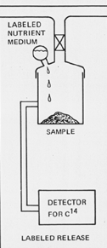1: Labeled Release (LR) experiment of Viking landers (artemis 2012).

Figure 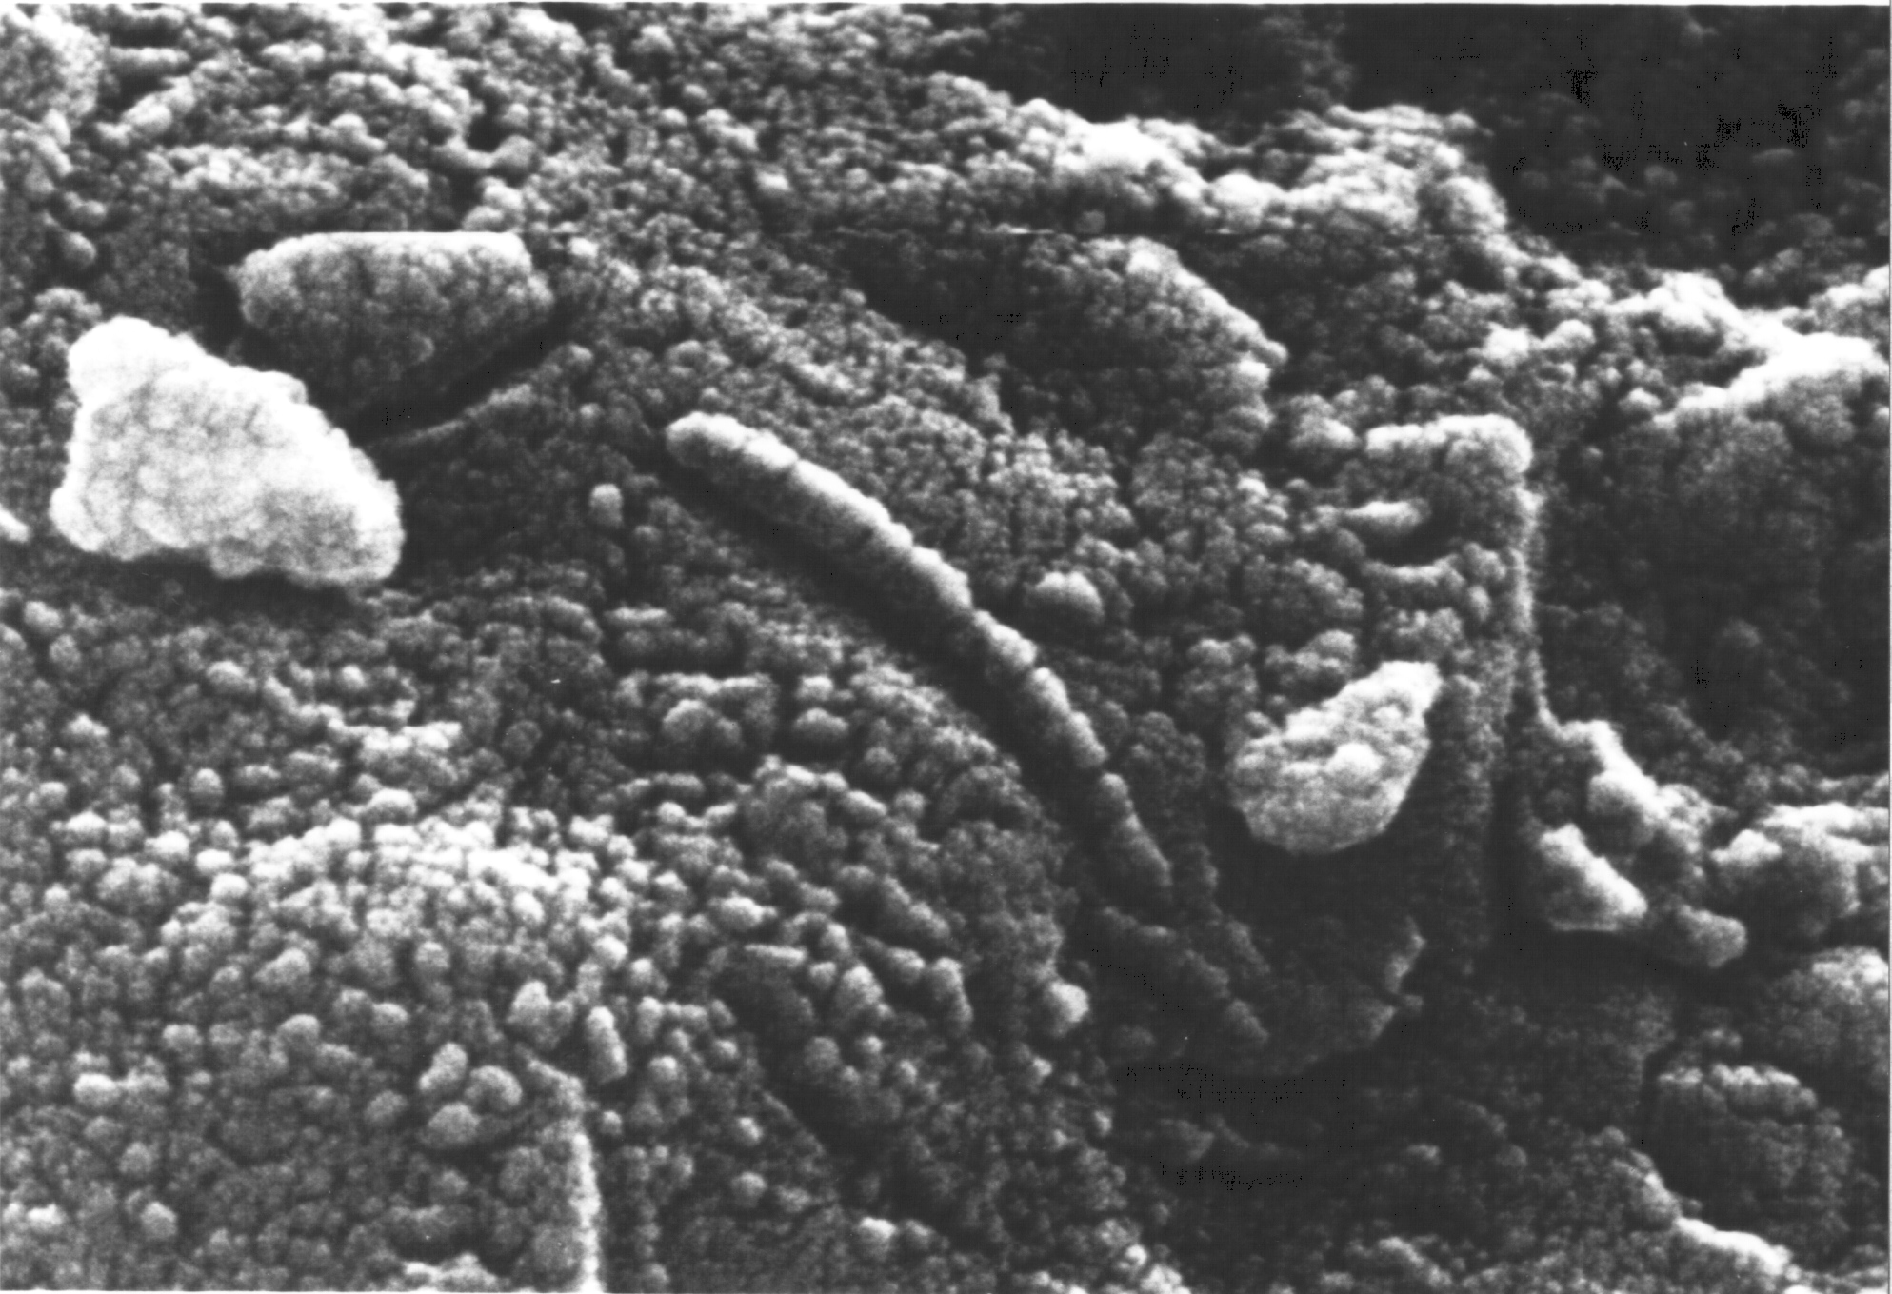2: Electron micrograph of a section from the ALH84001 meteorite. The putative fossil is approximately 200nm in diameter (NASA).

Figure 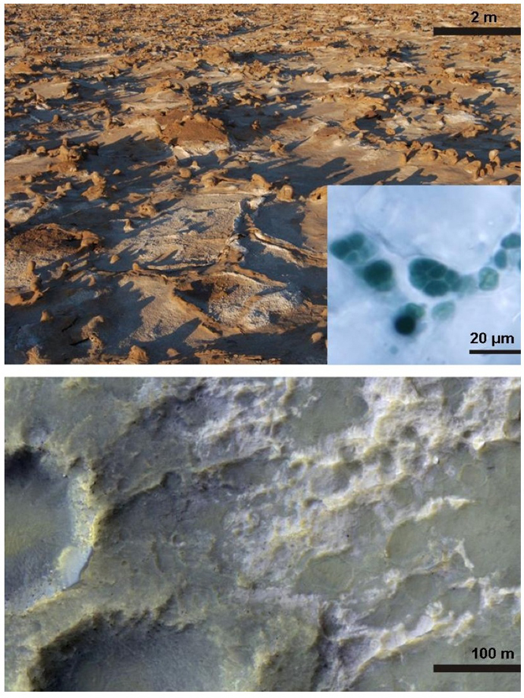3: Above: halite crusts in the Atacama Desert in Chile are habitats for cyanobacteria (inset), which absorb water from the air using perchlorates. Below: the bright regions of this section of the Martian surface are salt deposits which could serve as a similar habitat for Martian life (Enecrenaz et al., 2012).

Figure 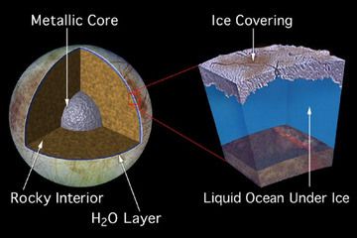4: Left: the proposed internal structure of Europa includes a metallic core, surrounded by a rocky interior in direct contact with a water layer. Right: based on studies of Europa's magnetic field, the water layer is believed to be liquid underneath (Source: NASA).

Figure 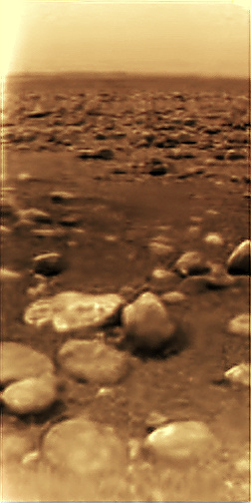5: the surface of Titan, as captured by the Huygens lander in 2005 (Source: ESA/NASA/JPL/University of Arizona).

Works Cited

artemis (2012, July 24). *MSL Picture of the Day: T-12 Days: Feet on Mars: Vikings*. Retrieved from http://www.exploremars.org/msl-picture-of-the-day-t-12-days-feet-on-mars-vikings.

Formisano, V., Atreya, S., Encrenaz, T., Ignatiev, N., & Giuranna, M. (2004). Detection of

methane in the atmosphere of Mars. *Science*, *306*(5702), 1758-1761.

Encrenaz, T., Greathouse, T. K., Lefèvre, F., & Atreya, S. K. (2012). Hydrogen peroxide on Mars: Observations, interpretation and future plans. *Planetary and Space Science*, *68*(1), 3-17.

Greeley, R., Pappalardo, R. T., Prockter, L. M., Hendrix, A. R., & Lock, R. E. (2009). Future exploration of Europa. *Europa, Edited by Robert T. Pappalardo, William B. McKinnon, Krishan K. Khurana; with the assistance of René Dotson with 85 collaborating authors. University of Arizona Press, Tucson, 2009. The University of Arizona space science series ISBN: 9780816528448, p. 655*, *1*, 655.

Klein, H. P. (1978). The Viking biological experiments on Mars. *Icarus*, *34*(3), 666-674.

Levin, G. V., & Straat, P. A. (1988). A reappraisal of life on Mars. In *The NASA Mars Conference* (Vol. 1, pp. 187-208).

Levin, G. V. (2010). Extant life on Mars: Resolving the issues. *Journal of Cosmology*, *5*, 920-929.

McKay, C. P., & Smith, H. D. (2005). Possibilities for methanogenic life in liquid methane on the

surface of Titan. Icarus, 178(1), 274-276.

McKay, D. S., Gibson, E. K., Thomas-Keprta, K. L., Vali, H., Romanek, C. S., Clemett, S. J., Chillier, X. D. F., Maechling, C.R., & Zare, R. N. (1996). Search for past life on Mars: Possible relic biogenic activity in Martian meteorite ALH84001. *Science*, *273*(5277), 924-930.

Plaxco, K. W., & Gross, M. (2011). *Astrobiology: a brief introduction*. JHU Press.