Page 1
[Error: Error code: 429 - {'error': {'message': 'You exceeded your current quota, please check your plan and billing details. For more information on this error, read the docs: https://platform.openai.com/docs/guides/error-codes/api-errors.', 'type': 'insufficient_quota', 'param': None, 'code': 'insufficient_quota'}}]
Page 1
[Error: Error code: 429 - {'error': {'message': 'You exceeded your current quota, please check your plan and billing details. For more information on this error, read the docs: https://platform.openai.com/docs/guides/error-codes/api-errors.', 'type': 'insufficient_quota', 'param': None, 'code': 'insufficient_quota'}}]
Page 1
[Error: Error code: 429 - {'error': {'message': 'You exceeded your current quota, please check your plan and billing details. For more information on this error, read the docs: https://platform.openai.com/docs/guides/error-codes/api-errors.', 'type': 'insufficient_quota', 'param': None, 'code': 'insufficient_quota'}}]
Page 1
[Error: Error code: 429 - {'error': {'message': 'You exceeded your current quota, please check your plan and billing details. For more information on this error, read the docs: https://platform.openai.com/docs/guides/error-codes/api-errors.', 'type': 'insufficient_quota', 'param': None, 'code': 'insufficient_quota'}}]
Page 1
[Error: Error code: 429 - {'error': {'message': 'You exceeded your current quota, please check your plan and billing details. For more information on this error, read the docs: https://platform.openai.com/docs/guides/error-codes/api-errors.', 'type': 'insufficient_quota', 'param': None, 'code': 'insufficient_quota'}}]
Page 1
[Error: Error code: 429 - {'error': {'message': 'You exceeded your current quota, please check your plan and billing details. For more information on this error, read the docs: https://platform.openai.com/docs/guides/error-codes/api-errors.', 'type': 'insufficient_quota', 'param': None, 'code': 'insufficient_quota'}}]
Page 1
[Error: Error code: 429 - {'error': {'message': 'You exceeded your current quota, please check your plan and billing details. For more information on this error, read the docs: https://platform.openai.com/docs/guides/error-codes/api-errors.', 'type': 'insufficient_quota', 'param': None, 'code': 'insufficient_quota'}}]
Page 1
[Error: Error code: 429 - {'error': {'message': 'You exceeded your current quota, please check your plan and billing details. For more information on this error, read the docs: https://platform.openai.com/docs/guides/error-codes/api-errors.', 'type': 'insufficient_quota', 'param': None, 'code': 'insufficient_quota'}}]
Page 1
[Error: Error code: 429 - {'error': {'message': 'You exceeded your current quota, please check your plan and billing details. For more information on this error, read the docs: https://platform.openai.com/docs/guides/error-codes/api-errors.', 'type': 'insufficient_quota', 'param': None, 'code': 'insufficient_quota'}}]
Page 2
[Error: Error code: 429 - {'error': {'message': 'You exceeded your current quota, please check your plan and billing details. For more information on this error, read the docs: https://platform.openai.com/docs/guides/error-codes/api-errors.', 'type': 'insufficient_quota', 'param': None, 'code': 'insufficient_quota'}}]
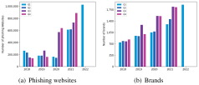
Page 2
[Error: Error code: 429 - {'error': {'message': 'You exceeded your current quota, please check your plan and billing details. For more information on this error, read the docs: https://platform.openai.com/docs/guides/error-codes/api-errors.', 'type': 'insufficient_quota', 'param': None, 'code': 'insufficient_quota'}}]
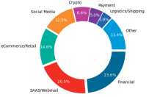
Page 2
[Error: Error code: 429 - {'error': {'message': 'You exceeded your current quota, please check your plan and billing details. For more information on this error, read the docs: https://platform.openai.com/docs/guides/error-codes/api-errors.', 'type': 'insufficient_quota', 'param': None, 'code': 'insufficient_quota'}}]
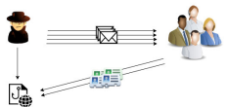
Page 2
[Error: Error code: 429 - {'error': {'message': 'You exceeded your current quota, please check your plan and billing details. For more information on this error, read the docs: https://platform.openai.com/docs/guides/error-codes/api-errors.', 'type': 'insufficient_quota', 'param': None, 'code': 'insufficient_quota'}}]
Page 3
[Error: Error code: 429 - {'error': {'message': 'You exceeded your current quota, please check your plan and billing details. For more information on this error, read the docs: https://platform.openai.com/docs/guides/error-codes/api-errors.', 'type': 'insufficient_quota', 'param': None, 'code': 'insufficient_quota'}}]
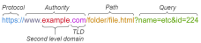
Page 3
[Error: Error code: 429 - {'error': {'message': 'You exceeded your current quota, please check your plan and billing details. For more information on this error, read the docs: https://platform.openai.com/docs/guides/error-codes/api-errors.', 'type': 'insufficient_quota', 'param': None, 'code': 'insufficient_quota'}}]
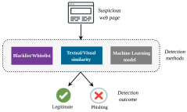
Page 3
[Error: Error code: 429 - {'error': {'message': 'You exceeded your current quota, please check your plan and billing details. For more information on this error, read the docs: https://platform.openai.com/docs/guides/error-codes/api-errors.', 'type': 'insufficient_quota', 'param': None, 'code': 'insufficient_quota'}}]
Page 4
[Error: Error code: 429 - {'error': {'message': 'You exceeded your current quota, please check your plan and billing details. For more information on this error, read the docs: https://platform.openai.com/docs/guides/error-codes/api-errors.', 'type': 'insufficient_quota', 'param': None, 'code': 'insufficient_quota'}}]
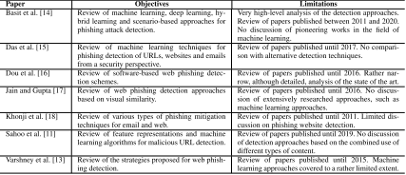
Page 4
[Error: Error code: 429 - {'error': {'message': 'You exceeded your current quota, please check your plan and billing details. For more information on this error, read the docs: https://platform.openai.com/docs/guides/error-codes/api-errors.', 'type': 'insufficient_quota', 'param': None, 'code': 'insufficient_quota'}}]
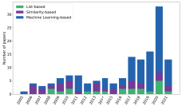
Page 4
[Error: Error code: 429 - {'error': {'message': 'You exceeded your current quota, please check your plan and billing details. For more information on this error, read the docs: https://platform.openai.com/docs/guides/error-codes/api-errors.', 'type': 'insufficient_quota', 'param': None, 'code': 'insufficient_quota'}}]
Page 5
[Error: Error code: 429 - {'error': {'message': 'You exceeded your current quota, please check your plan and billing details. For more information on this error, read the docs: https://platform.openai.com/docs/guides/error-codes/api-errors.', 'type': 'insufficient_quota', 'param': None, 'code': 'insufficient_quota'}}]
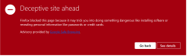
Page 5
[Error: Error code: 429 - {'error': {'message': 'You exceeded your current quota, please check your plan and billing details. For more information on this error, read the docs: https://platform.openai.com/docs/guides/error-codes/api-errors.', 'type': 'insufficient_quota', 'param': None, 'code': 'insufficient_quota'}}]
Page 6
[Error: Error code: 429 - {'error': {'message': 'You exceeded your current quota, please check your plan and billing details. For more information on this error, read the docs: https://platform.openai.com/docs/guides/error-codes/api-errors.', 'type': 'insufficient_quota', 'param': None, 'code': 'insufficient_quota'}}]
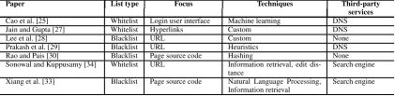
Page 6
[Error: Error code: 429 - {'error': {'message': 'You exceeded your current quota, please check your plan and billing details. For more information on this error, read the docs: https://platform.openai.com/docs/guides/error-codes/api-errors.', 'type': 'insufficient_quota', 'param': None, 'code': 'insufficient_quota'}}]
Page 7
[Error: Error code: 429 - {'error': {'message': 'You exceeded your current quota, please check your plan and billing details. For more information on this error, read the docs: https://platform.openai.com/docs/guides/error-codes/api-errors.', 'type': 'insufficient_quota', 'param': None, 'code': 'insufficient_quota'}}]
Page 8
[Error: Error code: 429 - {'error': {'message': 'You exceeded your current quota, please check your plan and billing details. For more information on this error, read the docs: https://platform.openai.com/docs/guides/error-codes/api-errors.', 'type': 'insufficient_quota', 'param': None, 'code': 'insufficient_quota'}}]
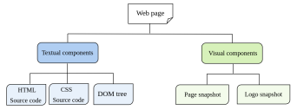
Page 8
[Error: Error code: 429 - {'error': {'message': 'You exceeded your current quota, please check your plan and billing details. For more information on this error, read the docs: https://platform.openai.com/docs/guides/error-codes/api-errors.', 'type': 'insufficient_quota', 'param': None, 'code': 'insufficient_quota'}}]
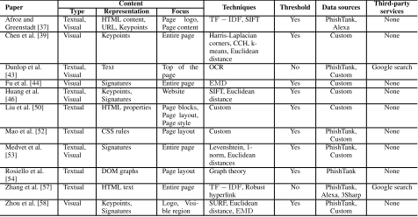
Page 8
[Error: Error code: 429 - {'error': {'message': 'You exceeded your current quota, please check your plan and billing details. For more information on this error, read the docs: https://platform.openai.com/docs/guides/error-codes/api-errors.', 'type': 'insufficient_quota', 'param': None, 'code': 'insufficient_quota'}}]
Page 9
[Error: Error code: 429 - {'error': {'message': 'You exceeded your current quota, please check your plan and billing details. For more information on this error, read the docs: https://platform.openai.com/docs/guides/error-codes/api-errors.', 'type': 'insufficient_quota', 'param': None, 'code': 'insufficient_quota'}}]
Page 10
[Error: Error code: 429 - {'error': {'message': 'You exceeded your current quota, please check your plan and billing details. For more information on this error, read the docs: https://platform.openai.com/docs/guides/error-codes/api-errors.', 'type': 'insufficient_quota', 'param': None, 'code': 'insufficient_quota'}}]
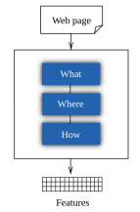
Page 10
[Error: Error code: 429 - {'error': {'message': 'You exceeded your current quota, please check your plan and billing details. For more information on this error, read the docs: https://platform.openai.com/docs/guides/error-codes/api-errors.', 'type': 'insufficient_quota', 'param': None, 'code': 'insufficient_quota'}}]
Page 11
[Error: Error code: 429 - {'error': {'message': 'You exceeded your current quota, please check your plan and billing details. For more information on this error, read the docs: https://platform.openai.com/docs/guides/error-codes/api-errors.', 'type': 'insufficient_quota', 'param': None, 'code': 'insufficient_quota'}}]
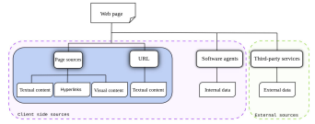
Page 11
[Error: Error code: 429 - {'error': {'message': 'You exceeded your current quota, please check your plan and billing details. For more information on this error, read the docs: https://platform.openai.com/docs/guides/error-codes/api-errors.', 'type': 'insufficient_quota', 'param': None, 'code': 'insufficient_quota'}}]
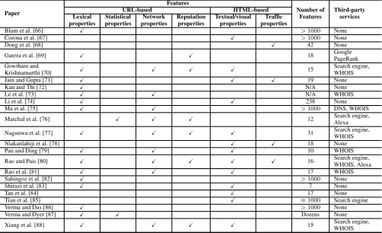
Page 11
[Error: Error code: 429 - {'error': {'message': 'You exceeded your current quota, please check your plan and billing details. For more information on this error, read the docs: https://platform.openai.com/docs/guides/error-codes/api-errors.', 'type': 'insufficient_quota', 'param': None, 'code': 'insufficient_quota'}}]
Page 12
[Error: Error code: 429 - {'error': {'message': 'You exceeded your current quota, please check your plan and billing details. For more information on this error, read the docs: https://platform.openai.com/docs/guides/error-codes/api-errors.', 'type': 'insufficient_quota', 'param': None, 'code': 'insufficient_quota'}}]
Page 13
[Error: Error code: 429 - {'error': {'message': 'You exceeded your current quota, please check your plan and billing details. For more information on this error, read the docs: https://platform.openai.com/docs/guides/error-codes/api-errors.', 'type': 'insufficient_quota', 'param': None, 'code': 'insufficient_quota'}}]
Page 14
[Error: Error code: 429 - {'error': {'message': 'You exceeded your current quota, please check your plan and billing details. For more information on this error, read the docs: https://platform.openai.com/docs/guides/error-codes/api-errors.', 'type': 'insufficient_quota', 'param': None, 'code': 'insufficient_quota'}}]
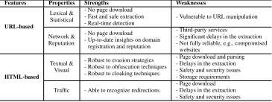
Page 14
[Error: Error code: 429 - {'error': {'message': 'You exceeded your current quota, please check your plan and billing details. For more information on this error, read the docs: https://platform.openai.com/docs/guides/error-codes/api-errors.', 'type': 'insufficient_quota', 'param': None, 'code': 'insufficient_quota'}}]
Page 15
[Error: Error code: 429 - {'error': {'message': 'You exceeded your current quota, please check your plan and billing details. For more information on this error, read the docs: https://platform.openai.com/docs/guides/error-codes/api-errors.', 'type': 'insufficient_quota', 'param': None, 'code': 'insufficient_quota'}}]
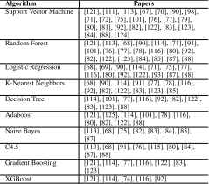
Page 15
[Error: Error code: 429 - {'error': {'message': 'You exceeded your current quota, please check your plan and billing details. For more information on this error, read the docs: https://platform.openai.com/docs/guides/error-codes/api-errors.', 'type': 'insufficient_quota', 'param': None, 'code': 'insufficient_quota'}}]
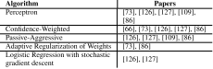
Page 15
[Error: Error code: 429 - {'error': {'message': 'You exceeded your current quota, please check your plan and billing details. For more information on this error, read the docs: https://platform.openai.com/docs/guides/error-codes/api-errors.', 'type': 'insufficient_quota', 'param': None, 'code': 'insufficient_quota'}}]
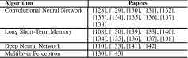
Page 15
[Error: Error code: 429 - {'error': {'message': 'You exceeded your current quota, please check your plan and billing details. For more information on this error, read the docs: https://platform.openai.com/docs/guides/error-codes/api-errors.', 'type': 'insufficient_quota', 'param': None, 'code': 'insufficient_quota'}}]
Page 16
[Error: Error code: 429 - {'error': {'message': 'You exceeded your current quota, please check your plan and billing details. For more information on this error, read the docs: https://platform.openai.com/docs/guides/error-codes/api-errors.', 'type': 'insufficient_quota', 'param': None, 'code': 'insufficient_quota'}}]
Page 17
[Error: Error code: 429 - {'error': {'message': 'You exceeded your current quota, please check your plan and billing details. For more information on this error, read the docs: https://platform.openai.com/docs/guides/error-codes/api-errors.', 'type': 'insufficient_quota', 'param': None, 'code': 'insufficient_quota'}}]
Page 18
[Error: Error code: 429 - {'error': {'message': 'You exceeded your current quota, please check your plan and billing details. For more information on this error, read the docs: https://platform.openai.com/docs/guides/error-codes/api-errors.', 'type': 'insufficient_quota', 'param': None, 'code': 'insufficient_quota'}}]
Page 19
[Error: Error code: 429 - {'error': {'message': 'You exceeded your current quota, please check your plan and billing details. For more information on this error, read the docs: https://platform.openai.com/docs/guides/error-codes/api-errors.', 'type': 'insufficient_quota', 'param': None, 'code': 'insufficient_quota'}}]
Page 20
[Error: Error code: 429 - {'error': {'message': 'You exceeded your current quota, please check your plan and billing details. For more information on this error, read the docs: https://platform.openai.com/docs/guides/error-codes/api-errors.', 'type': 'insufficient_quota', 'param': None, 'code': 'insufficient_quota'}}]
Page 21
[Error: Error code: 429 - {'error': {'message': 'You exceeded your current quota, please check your plan and billing details. For more information on this error, read the docs: https://platform.openai.com/docs/guides/error-codes/api-errors.', 'type': 'insufficient_quota', 'param': None, 'code': 'insufficient_quota'}}]

Page 21
[Error: Error code: 429 - {'error': {'message': 'You exceeded your current quota, please check your plan and billing details. For more information on this error, read the docs: https://platform.openai.com/docs/guides/error-codes/api-errors.', 'type': 'insufficient_quota', 'param': None, 'code': 'insufficient_quota'}}]

Page 21
[Error: Error code: 429 - {'error': {'message': 'You exceeded your current quota, please check your plan and billing details. For more information on this error, read the docs: https://platform.openai.com/docs/guides/error-codes/api-errors.', 'type': 'insufficient_quota', 'param': None, 'code': 'insufficient_quota'}}]

Page 21
[Error: Error code: 429 - {'error': {'message': 'You exceeded your current quota, please check your plan and billing details. For more information on this error, read the docs: https://platform.openai.com/docs/guides/error-codes/api-errors.', 'type': 'insufficient_quota', 'param': None, 'code': 'insufficient_quota'}}]

