**System Requirements Specification**

**COVID Tracking Ego Network App**

**CS-490 Fall 2020**

Team Name: COVID Tracking App

Team Members:

* Sultan Abdalla Salim Saif Alteneiji
* Justin Andrews
* Bryce Cole
* Jonah Corbin

Contents of this Document

Introduction

· System to be Produced

Product Overview

· Assumptions

· Stakeholders

· Event Table

· Use Case Diagram

· Use Case Descriptions

Specific Requirements

· Requirements

· Physical Environment Requirements

· Users and Human Factors Requirements

· Documentation Requirements

· Data Requirements

· Resource Requirements

· Security Requirements

· Quality Assurance Requirements

**Section 1: Introduction - Sultan**

It is said the forbidden fruit is the sweeter and it could be out or reactance, curiosity or rebound but as human beings, we often tend to do the exact opposite of what we are told to do. Think about the many times you were asked not to do something but you actually ended up doing it anyway. Psychologists have researched this occurrence and proved that as a result of reactance, rebound, or curiosity, a person will actually go for forbidden fruits. As a result, when you want to encourage a give behaviour, instead of giving the don’ts of the activity or behaviour in focus, it is encouraged that one focuses on the Dos and most importantly empowers the person receiving instruction with all the relevant information including the consequences of the behaviour and leaving it to them to make the decision. It's more like, giving them a sense of control over their decisions and actions. The Covid-19 pandemic has proven this in so many ways.

As the Covid-19 pandemic spread across the world from China in December 2019, countries put in place measures to fast of all prevent it from spreading to their borders and once that battle was lost, the concerned ten months down the line has been to contain its spread. Some of the measures included lockdowns and restriction of movement aimed at social distancing and containing the spread of the disease. However, in so many occasions, what I would like to call “the forbidden fruit syndrome” creped in and so many people have been violating the set restrictions. It could actually be the reason for our own undoing as a huge part of why the virus spread to uncontrollable high levels could be because people were not following the simple instructions, restrictions, and recommendations given. What if our approach, could be the reason why some people are finding it difficult to abide by the set guidelines?

This is where our Covid-19 application comes in. Instead of all the restrictions, the app will equip individuals all the knowledge and support they need to make sound and informed decisions that will not only empower them to protect themselves from contracting the Covid-19 virus but also help in containing the virus. Although the virus’s curve seems to have flattened in most countries, there is a threat of a second wave meaning that we need to be more and better prepared that we were last time.

**Section 2: Product Overview - Bryce**

Assumptions:

The mobile app should work mainly as a standalone application. Due to the privacy issues surrounding using lots of user data, all computation will be done locally on device. The user is expected to have a phone running either Android or iOS. The application is not resource intensive so the memory/processor configuration is irrelevant. If the device can run the operating system, it will be able to run the app. In order to make a good evaluation the application also needs data about the user. It will be assumed in version 1 that the user has an Instagram account that is used on a semi-frequent basis. This means following at least 100 people and liking 500 photos.

Stakeholders:

The main stakeholder is the customer, the information provided by the app will be important in staying safe during the national pandemic.

Another stakeholder are the people identified during the application process. While they will not be alerted about their relationship with the user, if their friend is being safer everyone becomes safer.

Event Table:

|  |  |  |  |
| --- | --- | --- | --- |
| Event Name | External Stimuli | External Responses | Internal data and state |
| Link Data Source | User clicks the link data source button. | The application guides the user through the process of downloading data to be used. | User must be on the manage data source page. |
| Remove Data Source | User clicks remove on a data source. | The application removes the data from the ego network decision. | User must be on the manage data source page. |
| Calculate Ego Network | User clicks the calculate ego network button. | The application generates an ego network based on downloaded data. |  |
| Show CDC Guidelines | User clicks on the guidelines button. | A page is displayed with verified information about COVID-19. |  |
| Share Ego Network Image | User clicks the share button. | An image is generated of the ego networked and is then shared using Android/iOS’s built in share feature. | An ego network must be calculated. |

Use Case Diagram

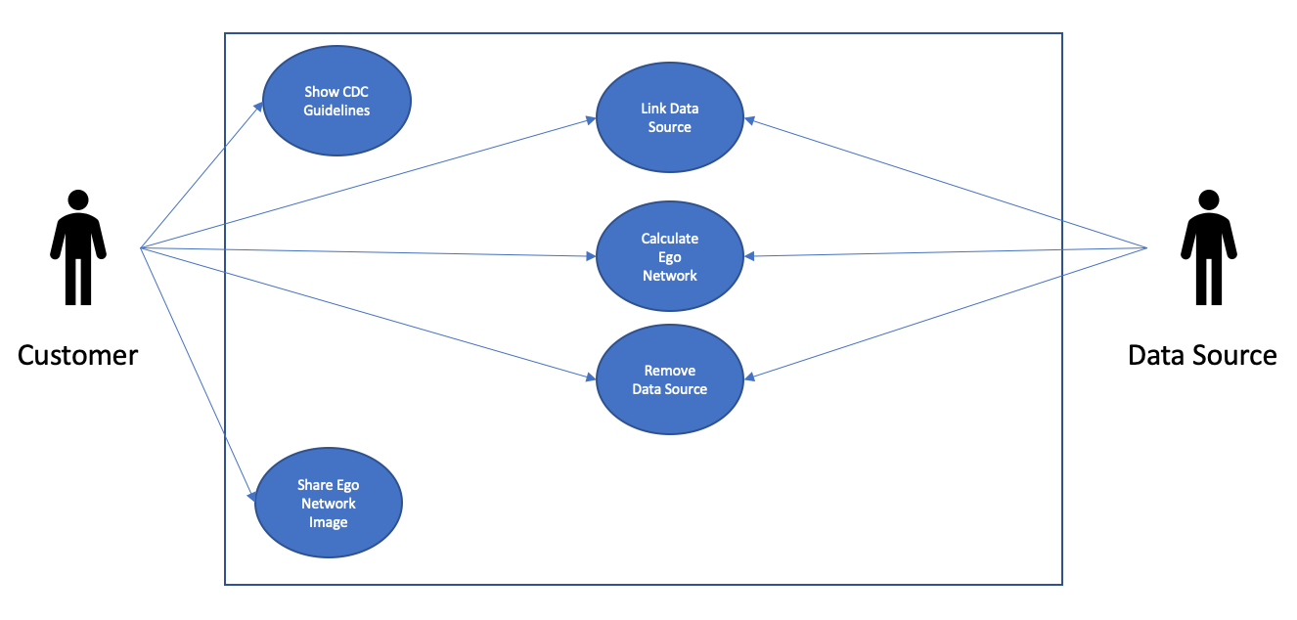

Mockup Guideline

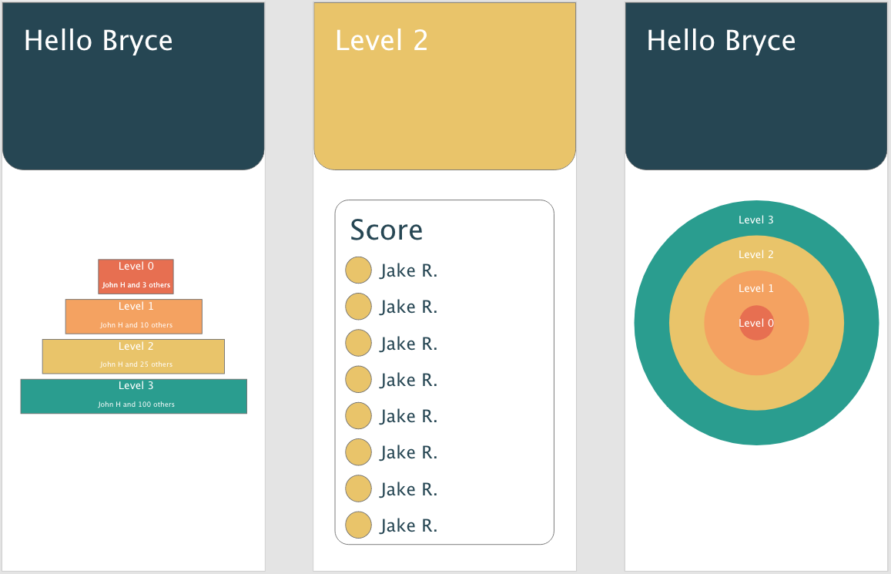

**Section 3: Specific Requirements - Bryce, Justin**

3.1 Functional Requirements - Bryce, Justin

* F-1: The app shall produce an ego network that informs the user of how close they are to different people they interact with based on the given data.
* F-2: The app shall use the user’s Instagram follower list as a parameter of the ego network algorithm.
* F-3: The app shall use the user’s Instagram likes data as a parameter of the ego network algorithm.
* F-4: The app shall use the user’s Instagram message history as a parameter of the ego network algorithm.
* F-5: The app shall use the user’s Instagram post location data as a parameter of the ego network algorithm to determine people they may have been close to.
* F-6: The app shall allow the user to delete all local data that is related to their instagram data or their ego network.
* F-7: The app shall display to the user who is in each level of closeness in their ego network.
* F-8: The app shall ask the user to upload their data to the app to be analyzed.
* F-9: The app shall inform the user of people in their ego network that they have been in close physical contact with recently.
* F-10: The app shall direct the user to reliable information about COVID-19 when prompted by clicking on the COVID-19 information tab.
* F-11: The app shall allow the user to generate an image representing the ego network and share it using the OS’s sharing api.

3.3 Physical Environment Requirements - Bryce

The system must run on either android or iOS. Due to the use of flutter, one codebase should operate on both platforms and provide the opportunity moving forward to port to the web. The system should operate on all modern versions of the proposed operating systems. Being a mobile application the location of the device should not matter, as long as it has an internet connection. Variables like temperature and humidity will be defined by the device manufacturer.

3.4 User and Human Factors Requirements - Bryce

The system will be aimed at all users over the age of 13. This is due to the age requirement of most social sites. The skill level of the app should be relatively low. Downloading your data from a company is a little difficult on purpose, so less technologically inclined users may need a little assistance.

Normally apps that handle large amounts of user data are ripe with misuse and a large target for hackers. Because of this we made a design decision to keep all data stored locally. This greatly reduces the opportunities for misuse.

3.5 Documentation Requirements - Bryce

The most important part of the documentation suite will be the SRS but an SDS and Test Plan will also be completed. Other than these formal documents more informal documents will exist as well. This includes well commented code and readme files. All documentation will be online not printed. The skill level assumed will vary depending on the documentation. Formal documents like the SRS will assume little to no skill, but code comments will be directed at people who are either modifying or writing code.

3.6 Data Requirements - Justin

* D-1: The app shall only accept data that is in the JSON format.
* D-2: The app shall convert the inputted JSON data from the user’s Instagram into a custom JSOM format specified in the GitHub repository in the file “data_standard.md”.
* D-3: The app shall not retain any of the JSON data that is imported into the app.
* D-4: The app shall retain who the user’s friends are and what level of their ego network they belong in.
* D-5: The app shall calculate the user’s ego network using a custom ego network algorithm that will be created specifically for this app.

3.7 Resource Requirements - Justin

* No resources shall be required by the app.

3.8 Security Requirements - Justin

* S-1: The app shall not store any communication data that the user imports for usage in creating their ego network.
* S-2: The app shall only store the names and friendship levels of the user’s friends.
* S-3: The app shall only store data locally on the user’s device.
* S-4: The app shall require a username and password for user accounts.
* S-5: The app shall hash and salt all passwords being stored.
* S-6: The user shall have to login to their account to view their saved ego network.

3.9 Quality Assurance Requirements - Justin

* QA-1: The app shall be required to be secure enough that a user can trust this app with their data.
* QA-2: The app shall demonstrate security to the user by not storing any of their data that they upload.
* QA-3: The app shall demonstrate security to the user by forcing the user to sign in to their account to view their saved ego network.
* QA-4: The app shall demonstrate security to the user by hashing and salting their password.