**System Design Document**

**For**

**COVID-19 Tracking App**

Team Members:

● Sultan Abdalla Salim Saif Alteneiji

● Justin Andrews

● Bryce Cole

● Jonah Corbin

|  |  |
| --- | --- |
| Version | Date |
| V1 | 10/01/2020 |
|  |  |
|  |  |
|  |  |

**Table of Contents**

**1 Introduction** **3**

1.1 Purpose and Scope 3

1.2 Project Executive Summary 3

1.2.1 System Overview 3

1.2.2 Design Constraints 4

1.2.3 Future Contingencies 4

1.3 Document Organization 4

1.4 Project References 4

1.5 Glossary 4

**2 System Architecture** **5**

2.1 System Hardware Architecture 5

2.2 System Software Architecture 5

2.3 Internal Communications Architecture 5

**3 Human-Machine Interface** **6**

3.1 Inputs 6

3.2 Outputs 6

**4 Detailed Design** **7**

4.1 Hardware Detailed Design 7

4.2 Software Detailed Design 7

4.3 Internal Communications Detailed Design 8

**5 External Interfaces** **8**

5.1 Interface Architecture 8

5.2 Interface Detailed Design 8

**6 System Integrity Controls** **8**

# 1 Introduction

## **1.1 Purpose and Scope**

This document will describe the system overview, system design, inputs, outputs, and interface of the COVID-19 Tracking App project.

## **1.2 Project Executive Summary**

Section 1.2 gives a high level overview and introduction to the system and its constraints.

### 1.2.1 System Overview

The diagram below (Figure 1) is a use case diagram that gives an overview of how the user and the software interact.

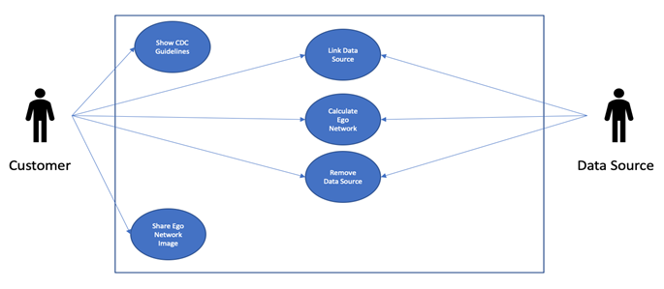

Figure 1: Use Case Diagram for COVID-19 Tracking App.

The figure below (Figure 2) gives a high level overview of the system process that calculates the ego network of the user. This figure includes inputs, like the user uploading their communication data, and outputs, such as displaying the user’s ego network that has been calculated.

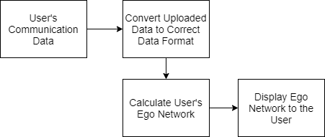

Figure 2: Overview of the process of the system

### 1.2.2 Design Constraints

### 1.2.3 Future Contingencies

## **1.3 Document Organization**

The purpose of this Software Design Document is to give an overview of the design of the system.

## **1.4 Project References**

## **1.5 Glossary**

# 2 System Architecture

## **2.1 System Hardware Architecture**

## **2.2 System Software Architecture**

The app has 3 major components: accepting the user’s uploaded data, calculating the user’s ego network, and displaying the ego network and its details to the user. The user uploads their communication data to the app which the app then cleans so that the data is in the format that the ego network algorithm can work with. The app can then use this data to calculate their ego network. Finally, the app displays the ego network to the user. The user can then select different levels of their ego network to get more information about that level, such as who of their friends falls within that level. This is shown below in Figure 3.

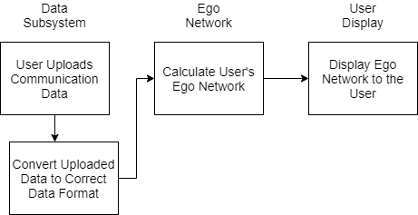

Figure 3: System Architecture Overview

## **2.3 Internal Communications Architecture**

# 3 Human-Machine Interface

## **3.1 Inputs**

To use this app the user must use their device’s file explorer to upload their communication data (as a JSON file) to the app for the ego network algorithm to analyze. After uploading their data the user must provide their consent for the app to look at and analyze this data by selecting that they wish to have their ego network calculated. This process is shown below in Figure 4.

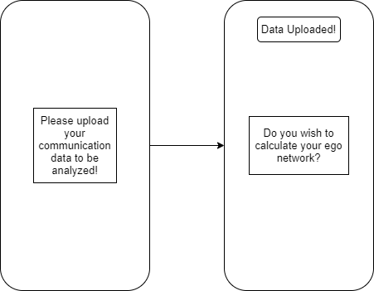

Figure 4: Input Display to the User

## **3.2 Outputs**

After the app has calculated the user’s ego network the app shall display the ego network to the user in an interactive way. The user shall be able to see how many people are in each level of their ego network but if they select a level they will be able to see a more detailed view of which of their friends are in that specific level of their ego network. This display is shown below in Figure 5. The left side of Figure 5 shows the user’s ego network as a whole. The right side of Figure 5 shows the view the user would see if they selected a level, in this case Level 2. It would show the people in that level and their friendship score.

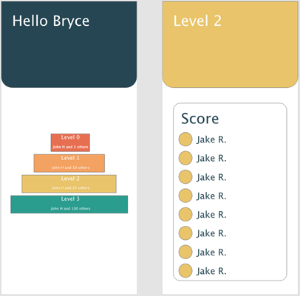

Figure 5: Output Displayed to the User

# 4 Detailed Design

## **4.1 Hardware Detailed Design**

## **4.2 Software Detailed Design**

This app has 3 main systems; the display subsystem, the data subsystem, and the ego network subsystem. The display subsystem is in charge of displaying the app to the user. This includes displaying the input and output to the user. Next is the data subsystem, the system deals with the user’s data once it is uploaded. This system will accept the data and then clean the data so that it is in an acceptable format to the ego network algorithm. Finally, the ego network algorithm system takes the data from the data system, calculates the user’s ego network, and then gives the ego network to the user display system to be displayed. An overview of these subsystems and how they communicate can be seen below in Figure 6.

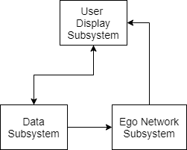

Figure 6: Software Architecture

## **4.3 Internal Communications Detailed Design**

# 5 External Interfaces

## 5.1 Interface Architecture

## 5.2 Interface Detailed Design

# 6 System Integrity Controls