**Review**

*The following will be considered during the implementation process, as opposed to forming another design as there are only minor changes to be made.*

**UI Design Feedback**

* Remove black borders
* The rounded corners on the search input look off
* Could place text above text inputs
* Home page background image is good
* Example search bar style ...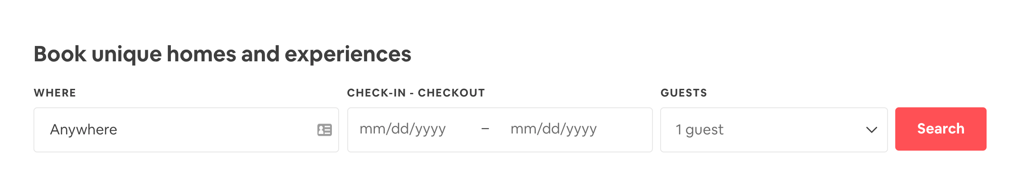
* Header about 100px high
* Header with an overlay type background `background: rgba(0,0,0,0.8)`
* Use time instead of ‘Breakfast, Lunch, Dinner’

**UI Design Usability Testing**

* **Learnability**
  + The website looks like it would be easy for a new customer to learn how to use. A simple homepage with a search bar and basic parameters, a pretty standard login and sign up page similar to most commonly used websites. The restaurant specific pages look good but could potentially make the reservation booking page a separate page accessed through a click instead of taking up as much space as it currently is.
* **Efficiency**
  + The website seems to be fairly efficient, perhaps a user could have the option to select favourite restaurants to their homepage to save them from needing to search for them every time.
* **Errors**
  + Login errors are mentioned in the data plan as displaying an error message. This error message is shown in the design. There could also be errors with the user inputting a search that returns no results, this isn’t discussed anywhere in the design (we will make sure to change this, creating an error message to be displayed in this case)