

Computer Games Development CW208

Technical Design Document

Year III

Aaron O’Dea

C00217820

[03-05-2020]

**Faculty of Department of Computing and Networking**

**Open-Book and Remote Assessment Cover Page**

**Student Name: Aaron O’Dea**

**Student Number: C00217820**

**Lecturer Name: Ross Palmer**

**Module: 4th-year project**

**Stage/Year: 4th Year**

**Date: 03-5-20**

**Declaration**

This examination/assessment will be submitted using Turnitin as the online submission tool. By submitting my examination/assessment to Turnitin, I am declaring that this examination/assessment is my own work. I understand that I may be required to orally defend any of my answers, to the lecturer, at a given time after the examination/assessment has been completed, as outlined in the student regulations.

**Contents**

**Architecture** **3**

System use Case 4

NPC use case 5

GUI use case 5

**UML** **5**

**Features** **7**

Feature 1: custom genetic algorithm 7

Feature 2: highest fitness genetic algorithm 7

Class Name: NPC 8

Class Name: System 8

Class Name: GUI 10

**References** **10**

# **Architecture**

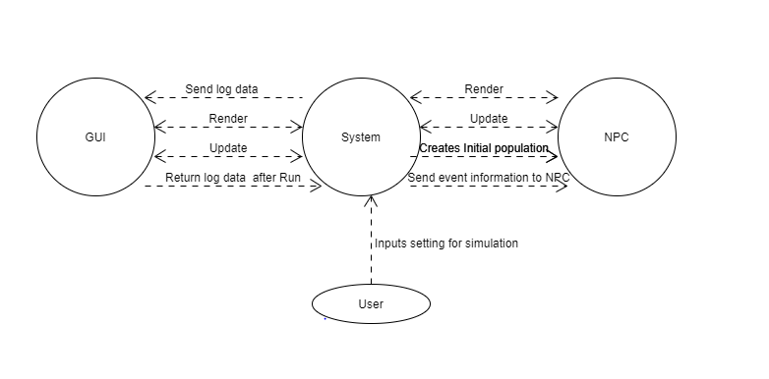

### **System use Case**

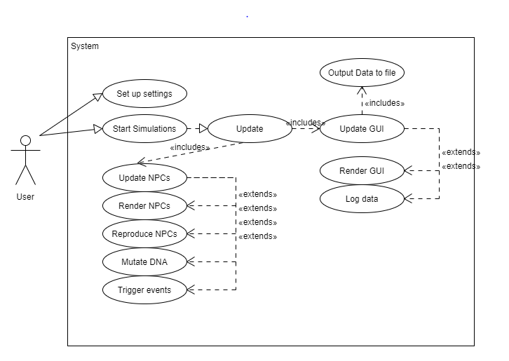

### **NPC use case**

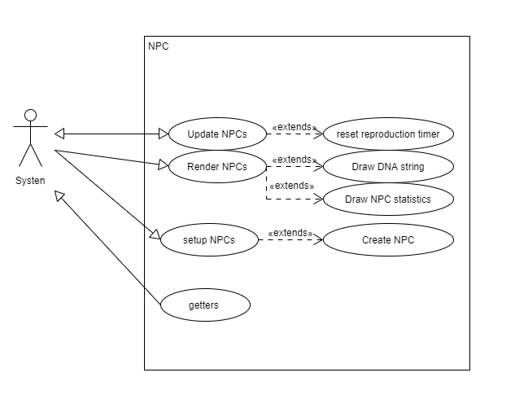

### **GUI use case**

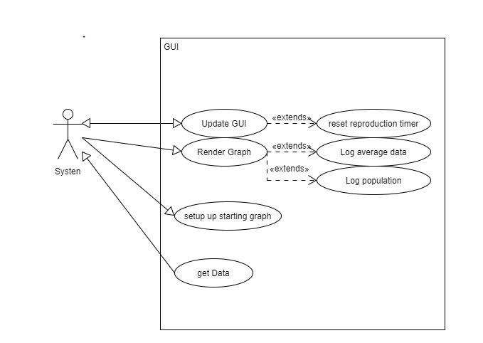

# **UML**

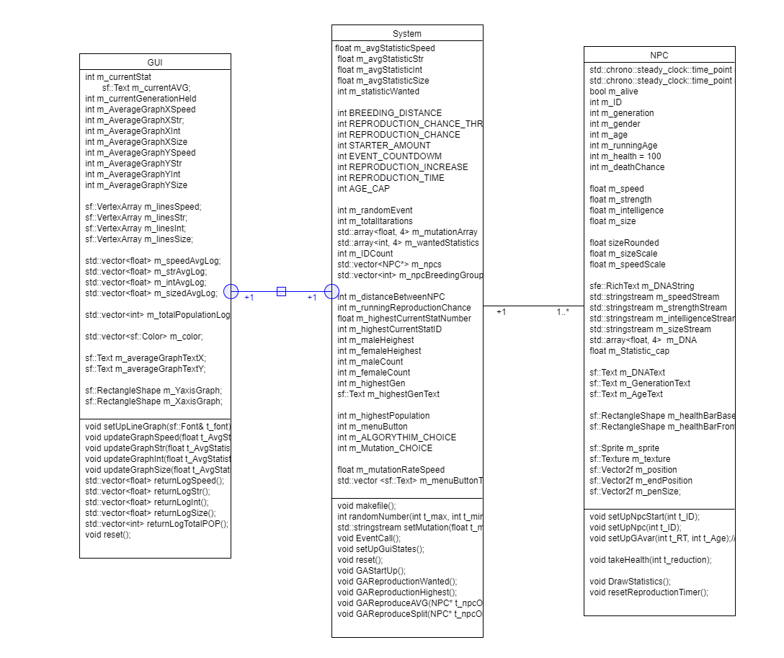

# **Features**

## ***Feature 1: custom genetic algorithm***

Tasks: take s multiple different variables that connect to an NPC e.g reproduction cycle age Wanted statistic as well as gender and other factors and pairs it off with another NPC and produces a child.

## ***Feature 2: highest fitness genetic algorithm***

Tasks: This algorithm searches through the available NPCs and chooses the highest male and female and creates a child based on their statistics.

***Feature 3: ½ split mutation***

Tasks: a ½ mutation takes the two parents data takes the first half of one parent in the second half of the second and changes the child’s genome to this new genome.

***Feature 4: average statistic mutation***

Tasks: an average mutation takes the parents genomes adds them together and then finds the average between and gives the child this new genome.

***Feature 5: Log Data***

Tasks: the data from the NPC population will be log in a vector that can be used at a later date

***Feature 6: OutPut data to file***

Tasks: takes the logged data from the run and outputs a file with all of the information as well as a second file with the system’s settings

***Feature 7: Display Statistics for Npc***

Tasks: displays the DNA strings of the ten newest NPC as well as their health and generation.

***Feature 8: Graph statistics***

Tasks: a graph that the user can view that output the current average static that is being tracked

***Feature 9: Set parameters of the simulation***

Tasks: The main menu which allows the user to set up the setting for the simulation

***Feature 10: Events***

Tasks: A periodical event which affects NPC with a high statistic of the event type **CRC Cards**

|  |  |
| --- | --- |
| Class Name: NPC | |
| Subclasses: none | |
| Superclasses: none | |
| Responsibilities | Collaborators |
| setUpNpcStart | Int iD |
| setUpNpc | Int iD |
| setUpGAvar | Int reproduction time, int age cap |
| wander |  |
| takeHealth | Int reduction |
| setGenertaion | Int generation |
| setGender | Int gender |
| setDNA | std::array<float, 4> t_DNA |

|  |  |
| --- | --- |
| ***Class Name: System*** | |
| Subclasses: none | |
| Superclasses: none | |
| Responsibilities | Collaborators |
| makefile |  |
| setMutation | Float mutation |
| EventCall |  |
| setUpGuiStates |  |
| GAReproduceAVG | NPC* t_npcOne, NPC* t_npcTwo |
| GAReproduceSplit | NPC* t_npcOne, NPC* t_npcTwo |
| GAReproductionWanted |  |
| GAReproductionHighest |  |
| GAStartUp |  |
| reset |  |

# 

|  |  |
| --- | --- |
| ***Class Name: GUI*** | |
| Subclasses: none | |
| Superclasses: none | |
| Responsibilities | Collaborators |
| SetUpLineGraph | sf::Font& t_font |
| updateGraphSpeed | Float t_AvgStatistic |
| updateGraphStr | Float t_AvgStatistic |
| updateGraphInt | Float t_AvgStatistic |
| updateGraphSize | Float t_AvgStatistic |
| reset |  |

# 

# **References**

**Web-site : UMLLetino umletino.com/umletino.html**