B.Sc Computer Games Development, Year 4, ARGO

Game Design Document

03-February-2020

**“ A Day in the Woods”**

Authors: Aaron O’Dea, Jack Fennell, Oisín Wilson, Savannah Bolger

# 

# 

**1. Overview** **4**

1.1 The Elevator Pitch/High Concept 4

1.2 Theme, Setting and Genre 4

1.3 Player Experience Goals 4

1.4 View 4

1.5 Targeted Platform(s) 4

1.6 Technical Requirement(s) 4

**2. Gameplay** **5**

2.1 Game Progression 5

2.2 Objectives/Victory Conditions 5

**3. Features** **5**

Sprint 1 5

Player 5

SDL Starter Game 6

ECS Base Starter 6

Command Pattern Base 6

Game Update Loop 6

Finalize Map 6

Controller Inputs 6

Game States 6

Design Map Connections 6

Design Map Nodes 6

Sprint 2 6

Input Component and System 6

Node System 6

Player Moving around map 7

Input handler 7

Sprint 3 7

Command Pattern with input handler 7

Controller 8

Movement Component and System 8

Clouds(Fog of War) 8

AI Movement 8

Main Menu 8

Factory Pattern 8

Player Animation 9

Sprint 4 9

Online Play 9

Tiles and Tile types 9

Audio Manager 9

Win Screen 10

Ui Animation 10

Haptic feedback 10

Game Restart 10

Server 10

Splash Screen 10

Credits 11

Dice Roll 11

Optimization of Code 11

Record Audio 11

Decision Trees 11

**4. Game Art & Audio** **11**

4.1 Audio 11

4.2 Art Assets 12

4.2.5 Visual Effects 12

4.2.6 Menu//Typefaces 12

**Paper Prototypes** **13**

# 1. Overview

## 1.1 The Elevator Pitch/High Concept

A four player game where the players take turns rolling a dice and traversing a maze as bears to gain and lose items from the picnic basket by playing minigames which will be played after all players have performed a dice roll.

## 1.2 Theme, Setting and Genre

The game will be a maze-like top-down board game. Our theme for the game will be a pastel knitted patchwork world that four teddy bears will travel through with the theme carried throughout the entire game.

## 1.3 Player Experience Goals

As the game will be like a board game, the goal of the player is to reach the of the end of the maze with the most items possible to get the best score. The player will experience benefit and loss throughout the game, as the board game tiles will have an effect on the players progression.

## 1.4 View

The main game is a top down maze. The minigames will have different sets of views with side on and top down depending on the mini game

## 1.5 Targeted Platform(s)

Windows Desktop

## 1.6 Technical Requirement(s)

SDL2

C++

# 2. Gameplay

## 2.1 Game Progression

The game progresses by the players each taking a turn to traverse a path with branching paths to try reach the goal at the end avoiding bad tiles, which hinder the player and beneficial tiles which will help the player progress the game faster. A story will be told to the player through exploration of the game map.

## 2.2 Objectives/Victory Conditions

The objective of the game is to be the first player to reach the end of the game board.

# 3. Features

## **Sprint 1**

## Player

The player should be able to move along the board game path, deciding on the routes it should take through the board. The player should be able to roll a dice and also be affected by the tile type it lands on. The player should only be able to move in one direction along the path and not be able to move back on itself unless it lands on a tile that tells the player to move back.

**Link:** [http://jira.itcarlow.ie:8080/browse/ARG-5](http://jira.itcarlow.ie:8080/browse/ARG-5?workflowName=Test+workflow+3&stepId=4)

**Story Points:** 20

**Assignee:** Oisín Wilson

## SDL Starter Game

This is the beginning point for the project, it contains a basic window and game loop using SDL.

**Link:** [http://jira.itcarlow.ie:8080/browse/ARG-24](http://jira.itcarlow.ie:8080/browse/ARG-24?workflowName=Test+workflow+3&stepId=1)

**Story Points:** 10

**Assignee:** Aaron O’Dea

## ECS Base Starter

This was a starting point for the ECS system that used the console to output what entities had what components.

**Link:** [http://jira.itcarlow.ie:8080/browse/ARG-1](http://jira.itcarlow.ie:8080/browse/ARG-1?workflowName=Test+workflow+3&stepId=5)

**Story Points:** 15

**Assignee:** Oisín Wilson

## Command Pattern Base

This served as the starting point for the command pattern. It used keyboard inputs with SDL, outputting them in console.

**Link:** [http://jira.itcarlow.ie:8080/browse/ARG-3](http://jira.itcarlow.ie:8080/browse/ARG-3?workflowName=Test+workflow+3&stepId=4)

**Story Points:** 15

**Assignee:** Jack Fennell

## Game Update Loop

A loop which runs through the game updating ,rendering and taking input for the screen that it is currently on.

**Link:** <http://jira.itcarlow.ie:8080/browse/ARG-4>

**Story Points:** 20

**Assignee:** Aaron O’Dea

## Finalize Map

Added the maps points on the screen and where they are and how they all link together. And finalized the map design for the designers.

**Link:** <http://jira.itcarlow.ie:8080/browse/ARG-8>

**Story Points:** 20

**Assignee:** Aaron O’Dea

## Game States

Created the structure for the game states of the player and which outlined the flow of the game and how each game state interacts with each other.

**Link:** [http://jira.itcarlow.ie:8080/browse/ARG-6](http://jira.itcarlow.ie:8080/browse/ARG-6?workflowName=Test+workflow+3&stepId=5)

**Story Points:** 30

**Assignee:** Savannah Bolger

## Controller

A basic controller class.The game will be controlled by an xbox controller in particular the D-pad(Up and Down) and the A,B,X and Y buttons. The D-pad will be used to navigate the main menu. The A button will be used to roll the dice for the current player. When players reach a branching path they will use either the A ( south path ), B ( east path ), X ( west path ) and Y ( north path).

**Link:** <http://jira.itcarlow.ie:8080/browse/ARG-32>

**Story Points:** 30

**Assignee:** Jack Fennell

## Design Map Connections

Designed and created multiple maps for the game which then was reduced to one and decided where each tile should go and what type it should be.

**Link:** <http://jira.itcarlow.ie:8080/browse/ARG-38>

**Story Points:** 10

**Assignee:** Savannah Bolger

## Design Map Nodes

Designed what types of tiles should be in the game and their effects on the player.

**Link:**  <http://jira.itcarlow.ie:8080/browse/ARG-36>

**Story Points:** 10

**Assignee:** Savannah Bolger

## **Sprint 2**

## Input Component and System

Created a input component and system built off the Ecs to handle outputs

**Link:** <http://jira.itcarlow.ie:8080/browse/ARG-14>

**Story Points:** 40

**Assignee:** Jack Fennell

## Node System

Taking influence from the A* algorithm, each tile will be represented as a node that has a weighted arc list that connects them.

**Link:**  <http://jira.itcarlow.ie:8080/browse/ARG-33>

**Story Points:** 40

**Assignee:** Oisín Wilson

## Player Moving around map

For movement when a dice is rolled the entity should check what nodes are linked to his current node index and traverse the number of spaces. When the entity gets to a crossroad the game will pause and give them the option to choose the desired direction.

**Link:** <http://jira.itcarlow.ie:8080/browse/ARG-9>

**Story Points:** 40

**Assignee:** Oisín Wilson

Minigames

A minigame will be played between the four players after each player has taken a turn. These minigames will be a short 10 second game as a break from the normal board game.

**Link:** <http://jira.itcarlow.ie:8080/browse/ARG-30>

**Story Points:** 30

**Assignee:** Aaron O’Dea

Screenflow

Title Screen -> Main Menu ->Game Screen-loop -> Win Screen

->Online Game -> Quit

->Credits

**Link:** <http://jira.itcarlow.ie:8080/browse/ARG-11>

**Story Points:** 20

**Assignee:** Savannah Bolger

Basic AI NPC

The ai players should act like the player, making decisions on paths, rolling the dice, moving along the game board as well as being affected by the tiles it lands on.

**Link:** <http://jira.itcarlow.ie:8080/browse/ARG-34>

**Story Points:** 20

**Assignee:** Savannah Bolger

## Input handler

Created an input handler to handle inputs from the controller

**Link:**  <http://jira.itcarlow.ie:8080/browse/ARG-19>

**Story Points:** 30

**Assignee:** Jack Fennell

## 

## 

## **Sprint 3**

## Command Pattern working with input system

Interlinked the input handler to work with command pattern with the input system using the command pattern.

**Link:**  <http://jira.itcarlow.ie:8080/browse/ARG-37>

**Story Points:** 20

**Assignee:** Jack Fennell

## Controller Inputs Concrete Commands

Created the concrete commands that use the input handler to manage the inputs

**Link:** <http://jira.itcarlow.ie:8080/browse/ARG-7>

**Story Points:** 30

**Assignee:** Jack Fennell

## Movement Component and System

Movement is controlled by the controller and the other players don’t get updated when not on their turn.

**Link:**  <http://jira.itcarlow.ie:8080/browse/ARG-15>

**Story Points:** 30

**Assignee:** Oisín Wilson

## Clouds(Fog of War)

A Set of clouds which cover the screen changing shape and location but is cleared by the player

The distance between players affect the amount of clouds cleared

**Link:** [http://jira.itcarlow.ie:8080/](http://jira.itcarlow.ie:8080/browse/ARG-20?workflowName=Test+workflow+3&stepId=1)

**Story Points:** 10

**Assignee:** Aaron

## AI Movement

The Ai takes a random choice left right up down when it reaches a crossroads in the path.Moves after dice is displayed and does a little wiggle.

**Link:** <http://jira.itcarlow.ie:8080/browse/ARG-23>

**Story Points:** 30

**Assignee:** Aaron O’Dea

## Main Menu

The main menu links multiple screens the player should be able to pick which option they want by moving the d'pad up and or down.

**Link:**  <http://jira.itcarlow.ie:8080/browse/ARG-12>

**Story Points:** 30

**Assignee:** Savannah Bolger

## Factory Pattern

The factory that can create any number of instances of the character class.

**Link:**  <http://jira.itcarlow.ie:8080/browse/ARG-2>

**Story Points:** 15

**Assignee:** Oisín Wilson

## Player Animation

The player WIggles , and the larger player wiggles as well when it is the player's turn.

Added some depth to the player by adding a shadow on the UI

**Link:**  <http://jira.itcarlow.ie:8080/browse/ARG-21>

**Story Points:** 10

**Assignee:** Aaron O’Dea

## **Sprint 4**

## Online Play

## The player joins a server when the online game button is connected from here they can enter the online game and move around .If the player does not connect to the server enter a local mode.

**Link:**  <http://jira.itcarlow.ie:8080/browse/ARG-13>

**Story Points:** 10

**Assignee:** Aaron O’Dea

## Tiles and Tile types

The tiles on the board game path should each have a different function when landed on. These types should be identified by their colours.

* Green Tile: This is the neutral tile. It is a safe tile to land on and does nothing to the player that lands on it.
* Pink Tile: This tile is the bounce tile. It will move the player forward one space in the direction the player is moving in.
* Blue Tile: This is a dice tile. It will allow the player to take an additional turn when landed on.
* Red Tile: This is the tumble tile. It will push the player backwards one space along the path it was moving.
* Orange Tile: This tile is the honey puddle tile. It will keep the player stuck on this tile until they have missed a turn. Then the player can continue playing as normal.

**Link:** <http://jira.itcarlow.ie:8080/browse/ARG-16>

**Story Points:** 35

**Assignee:** Savannah Bolger

## Audio Manager

The audio for the game should be soft, cheerful background music that will fit the theme of the game. There will be voice over audio added to the main menu and gameplay screens of the game that will state the title of the game, some story points for immersion and for when the player lands on the tile in order to state how the tiles affect the players progression.

**Link:** <http://jira.itcarlow.ie:8080/browse/ARG-17>

**Story Points:** 20

**Assignee:** Oisín Wilson

## Win Screen

When the game ends A screen appears saying who one and plays the ending scene for the game.

**Link:**  <http://jira.itcarlow.ie:8080/browse/ARG-18>

**Story Points:** 15

**Assignee:** Jack Fennell

## Ui Animation

Small amounts of animation enlarging and shrinking buttons to indicate location tittle. Doing the same .UI in the game screen which gives the player a wiggle when it is its turn.

**Link:**  <http://jira.itcarlow.ie:8080/browse/ARG-22>

**Story Points:** 5

**Assignee:** Aaron O’Dea

## Haptic feedback

When a button is pressed the controller gives a small amount of feedback. When the player rolls a dice a larger feedback is given.

**Link:**  <http://jira.itcarlow.ie:8080/browse/ARG-25>

**Story Points:** 5

**Assignee:** Aaron O’ Dea

## Game Restart

The game restarts after a game is played and reset all the players to their correct board indexes and locations.

**Link:**  <http://jira.itcarlow.ie:8080/browse/ARG-26>

**Story Points:** 5

**Assignee:** Aaron O’ Dea

## Server

A server which connects to clients together for an online game

**Link:**  <http://jira.itcarlow.ie:8080/browse/ARG-27>

**Story Points:** 5

**Assignee:** Aaron O’Dea

## Splash Screen

The game starts on the splash screen and doesn't continue till the player presses the A button which is prompted at the bottom of the screen . with a small animation.

**Link:**  <http://jira.itcarlow.ie:8080/browse/ARG-28>

**Story Points: 5**

**Assignee:** Aaron O’ Dea

## Credits

The credits screen will display a picture. You can return to the main menu by pressing B

**Link:**  <http://jira.itcarlow.ie:8080/browse/ARG-29>

**Story Points: 5**

**Assignee:** Aaron O’ Dea

## Dice Roll

The dice should be able to roll a random number between 1 and 6 and then display this number on the screen. This number should indicate the number of spaces the player is allowed to move.

**Link:** <http://jira.itcarlow.ie:8080/browse/ARG-30>

**Story Points:** 10

**Assignee:** Aaron O’ Dea

## Optimization of Code

Went through code changing things from multiple single variables to vectors and making sure surfaces are cleared and certain things are deleted as well as not reusing or creating more variables than is needed

**Link:** <http://jira.itcarlow.ie:8080/browse/ARG-31>

**Story Points:** 5

**Assignee:** Aaron O’Dea

## Record Audio

Recorded voice lines for the story sections and tile affects in the game.

**Link:**  <http://jira.itcarlow.ie:8080/browse/ARG-35>

**Story Points:** 10

**Assignee:** Savannah Bolger

## Behaviour Tree

A basic behaviour tree for AI where it finds the success probability of moving left, right, up, down, forward, back or stopping movement.

**Link:**  <http://jira.itcarlow.ie:8080/browse/ARG-39>

**Story Points:** 15

**Assignee:** Savannah Bolger

# 4. Game Art & Audio

## 4.1 Audio

Audio is used throughout the game. Each tile that has an effect on the player will play a short audio clip when they land on it. When the player lands on a story tile an audio clip will be played telling the player a snippet of the story.

## 4.2 Art Assets

The art assets : [Asset List](https://docs.google.com/spreadsheets/d/1hem2RSpPvMRqLm_spc3EQ-n254uwS7gTYKs6svQ_Fu0/edit?usp=sharing)

Audio Assets:

<https://freesound.org/people/Thirsk/sounds/121040/>

<https://freesound.org/people/FoolBoyMedia/sounds/333800/>

<https://freesound.org/people/Mrguff/sounds/369710/>

<https://freesound.org/people/AlienXXX/sounds/249894/>

### 4.2.5 Visual Effects

All of the assets used in the game will have a soft pastel colour to them to give it an appealing visual that isn’t harsh on the eyes. They will also have a patchwork/teddy bear world look to them to give the game a kind of calm storybook feel to it.

### 4.2.6 Menu//Typefaces

The menu will consist of a background with the title of the game as well as buttons to the left most side of the menu screen that have soft lettering, all of which should fit the style and feel of the type of game we are making.

# Paper Prototypes

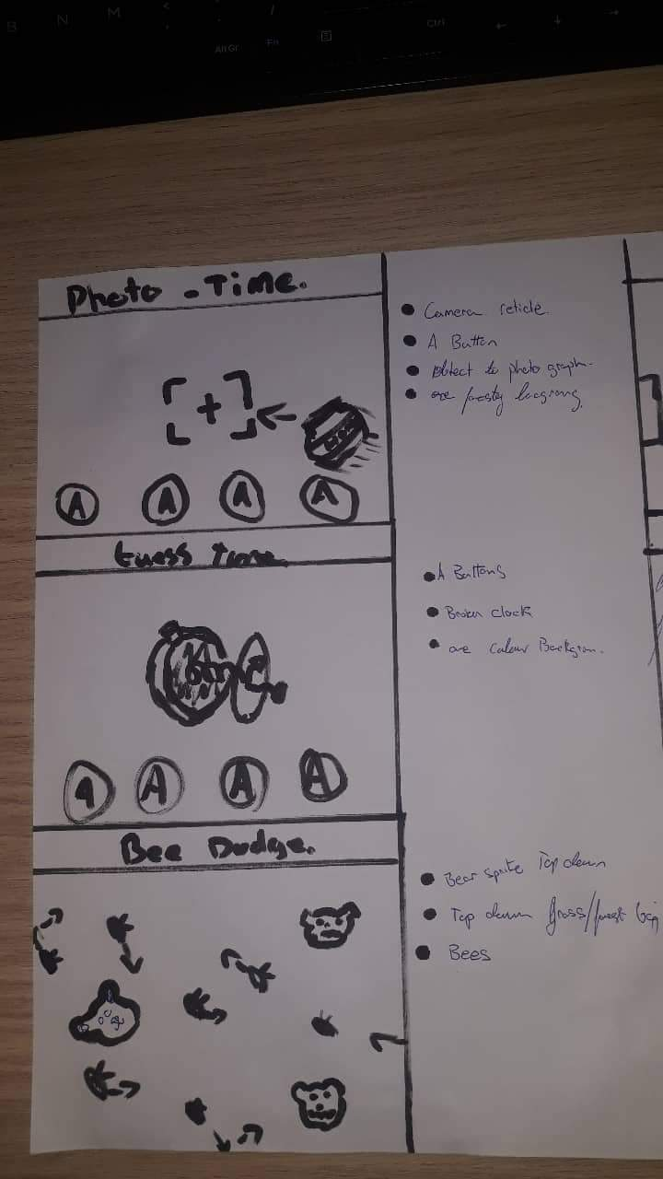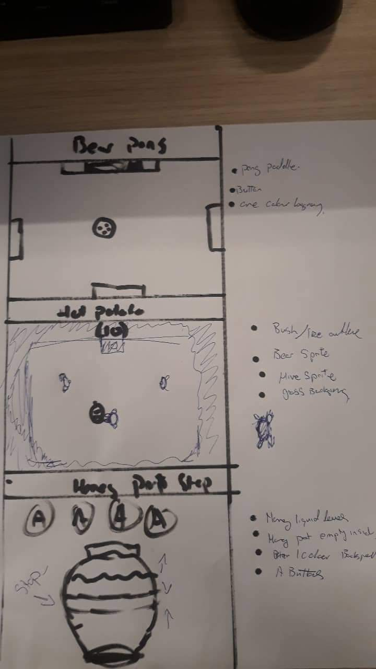

Minigames

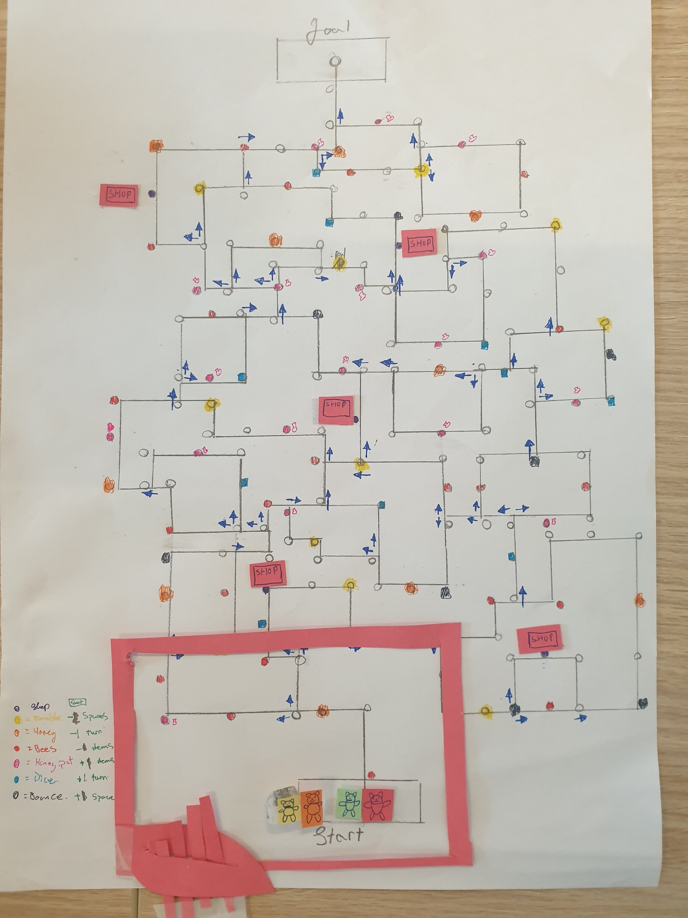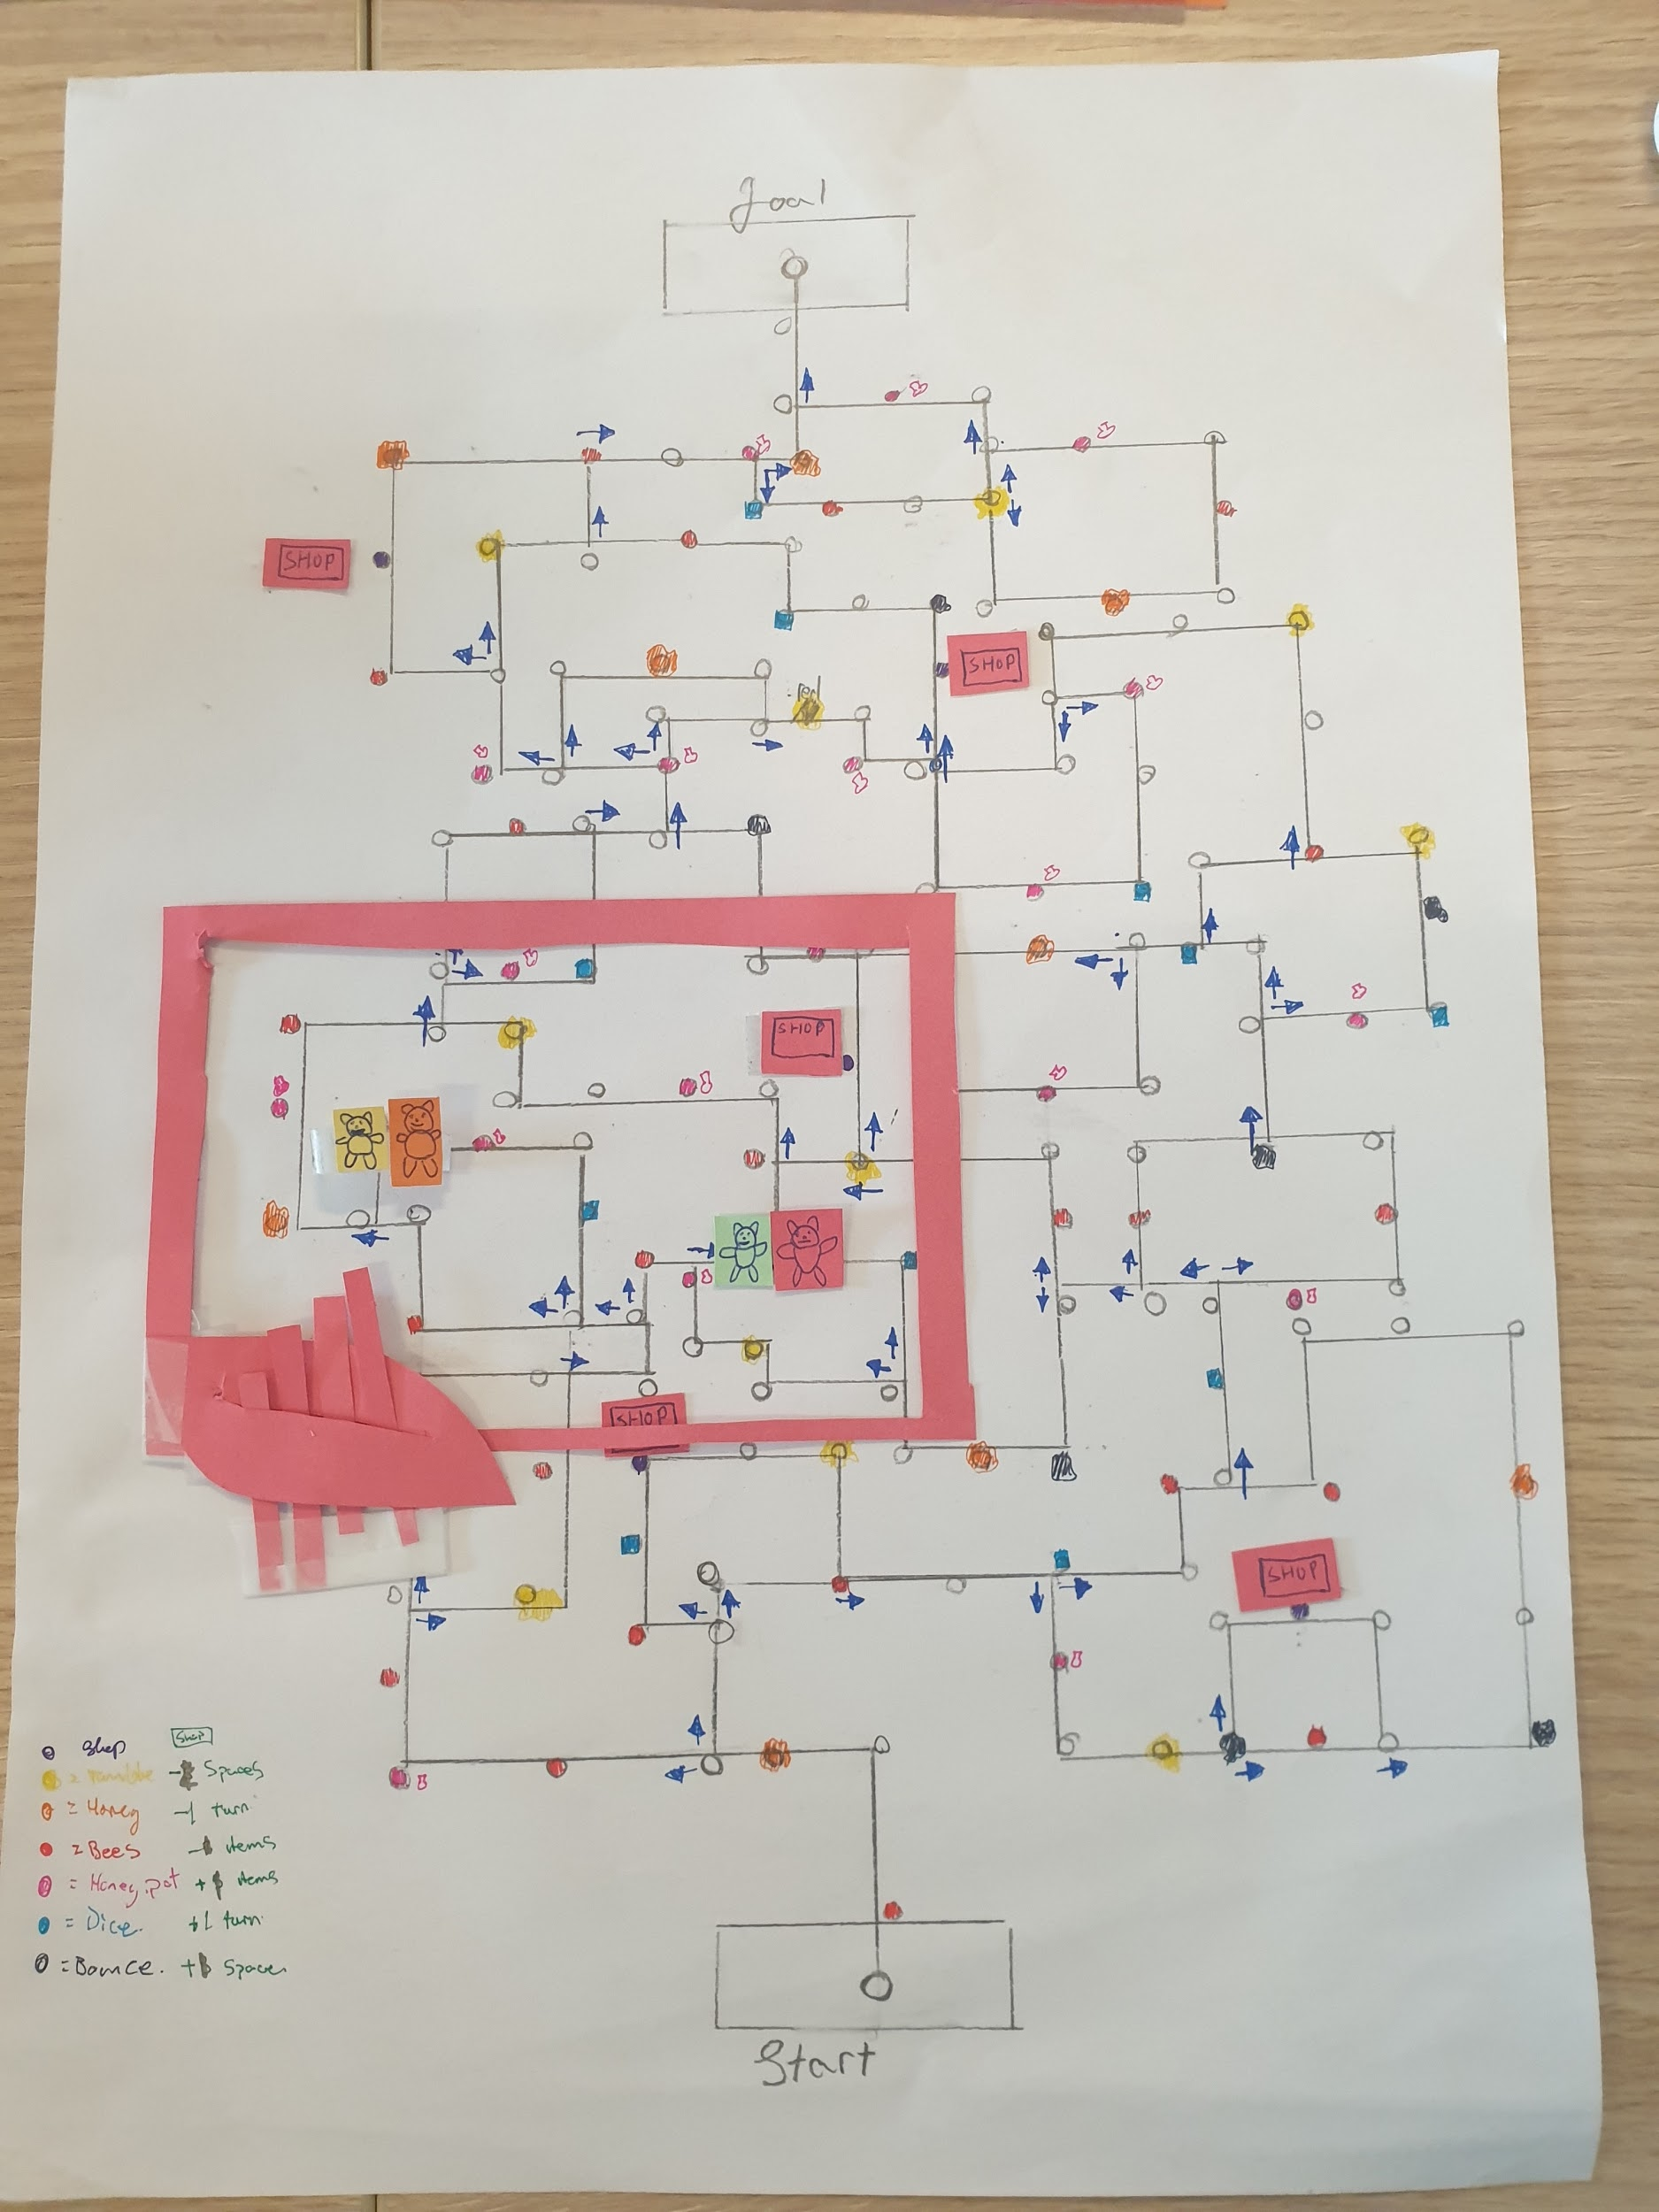

Gameboard