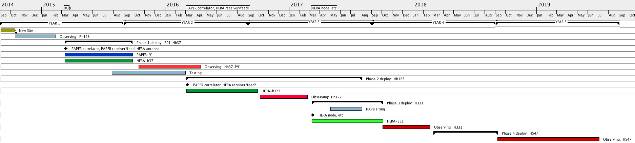

**Pre-award**

* 1 element in CA testing reflections and mechanical over time. Possibly a few in SA.

**Year 1 (9/14-9/15)**

* Move to new site and observe with relocated PAPER-128.
* Build 37 elements.
* Continue node/feed design.

**Year 2 (9/15-9/16)**

* Observe with *37+91* configuration, reusing 91 PAPER ground screens and all other PAPER hardware
* Build out to 127 (pushing into Y3)

reusing all other PAPER hardware

OR

using new HERA feeds/receivers with fallback of using PAPER feeds/receivers

**Year 3 (9/16-9/17)**

* Observe with h-127
* Move into KAPB
* Install new nodes
* Build out to 331, with fully HERA equipment (pushing into Y4)

**Year 4 (9/17-9/18)**

* Observe with H331
* Build out to 568 (pushing into Y5)

**Year 5 (9/18-9/19)**

* Observe with H568

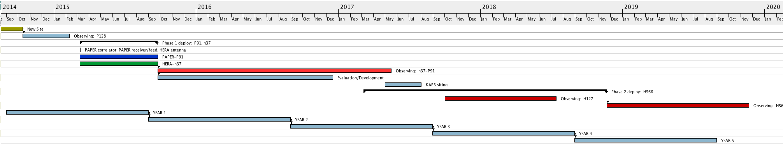

**Pre-award**

* 1 element in CA testing reflections and mechanical over time. Possibly a few in SA.

**Year 1 (9/14-9/15)**

* Move to new site and observe with relocated PAPER-128.
* Build 37 elements.
* Continue node/feed design.

**Year 2 (9/15-9/16)**

* Observe with *37+91* configuration, reusing 91 PAPER ground screens and all other PAPER hardware
* Evaluate and productize

**Year 3 (9/16-9/17)**

* Move into KAPB
* Start build-out

**Year 4 (9/17-9/18)**

* Observe with H127
* Continue build-out

**Year 5 (9/18-9/19)**

* Observe with H568