**The Hydrogen Epoch of Reionization Array (HERA)**

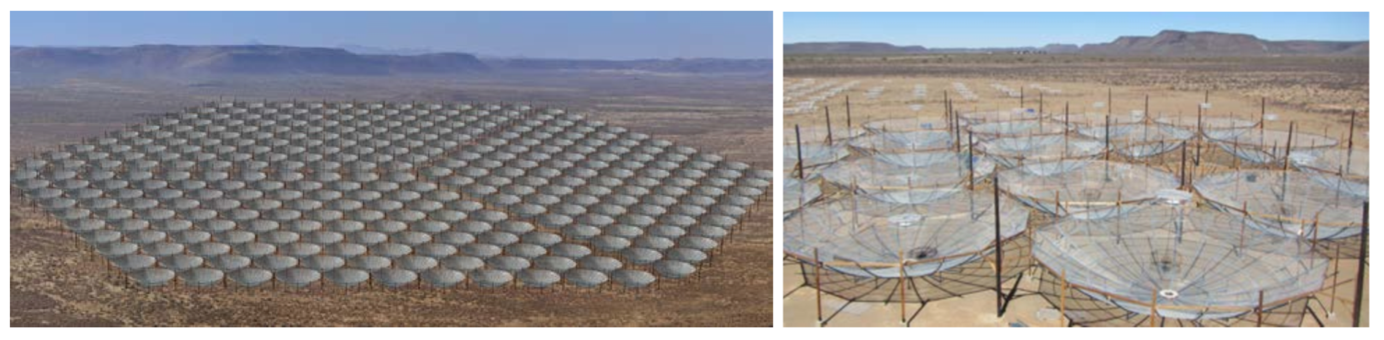

Figure : An artist's rendition of the 331-element HERA core (left) and the first 19 HERA elements constructed in South Africa (right)

The period beginning with the birth of the first luminous objects in the universe and culminating with the ionization of the intergalactic medium (IGM) about 500 million years later, is one of the last unexplored phases of cosmic evolution. Exploring this epoch of reionization (EoR) was highlighted as one of the three “priority science objectives” by the recent US astronomy decadal survey committee for the decade 2012-2021. [*New Worlds, New Horizons of Astronomy and Astrophysics:* Committee for a Decadal Survey of Astronomy and Astrophysics; US National Research Council 2010 – hereafter abbreviated **NWNH**].

The radio astronomical observation of red-shifted emission from the 21cm hyperfine transition of neutral hydrogen has gained considerable attention as a unique tracer of the primordial IGM. Indeed, in the early universe, 21cm emission provides the only direct probe of the complex astrophysical interplay between the first luminous structures and their surroundings. The direct observation of the neutral IGM via this signal would be an achievement with a scientific payoff comparable to that of the CMB and potentially garner a Nobel Prize in Physics. As emphasized in **NWNH**: “The panel concluded that to explore the discovery area of the epoch of reionization, it is most important to develop new capabilities to observe redshifted 21-cm HI emission, building on the legacy of current projects and increasing sensitivity and spatial resolution to characterize the topology of the gas at reionization.” The Hydrogen Epoch of Reionization Arrays (HERA) program submitted to the US Decadal Panel was given “***top priority in this*** [Radio, Millimeter, Sub-millimeter] ***category of recommended new facilities for mid-scale funding***”.

HERA is a program of the investigators of the US-based EoR community in partnership with South Africa. It builds on the legacy of the Precision Array Probing the Epoch of Reionization (PAPER) sited in South Africa and the Murchison Widefield Array (MWA) sited in Australia. Using the lessons and technology gained from these arrays, HERA put together a 4-year, $15.9M program for detecting the 21cm reionization signal and producing a new window into our early universe. HERA’s program was selected for funding by the National Science Foundation (NSF) from among 28 competing proposals in the latest cycle of its competitive Mid-Scale Innovations Program. However, due to budgetary constraints, the NSF was only able to fund a 3-year, $9.5M program.

This reduced program supports the bulk of HERA’s construction and core science, but descopes the more aggressive development of HERA into an instrument capable of directly mapping in 3D the universe as it was 13 billion years ago. The HERA project is now looking for support to reinclude this powerful, forward-looking component of its science program. It includes additional HERA dishes arranged around its central core, along with an ambitious software development program for combining and calibrating the data from 350 dishes into maps that pierce through the bright foreground of our own galaxy to see the 3D structure of the gas out of which the first stars and galaxies formed.

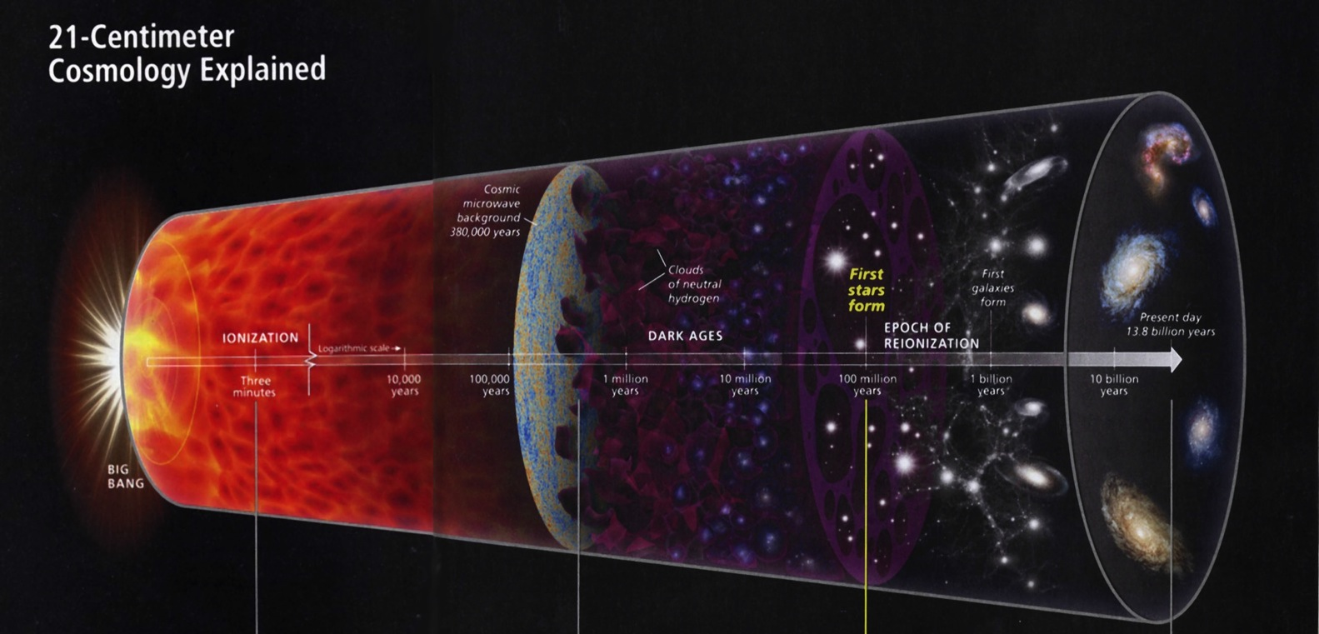

Figure : A schematic history of the universe (Discover Magazine, April 2014)

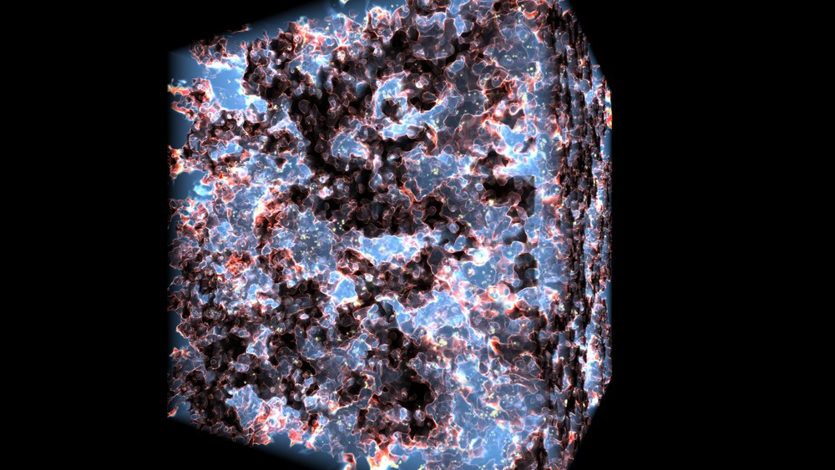

Figure : Visualization of a simulated 3D reionization cube (Alvarez et al. 2012)